U N I T E D S T A T E S A I R F O R C E R E S E R V E O F F I C E R T R A I N I N G C O R P S
LIEUTENANT Colonel KYLE G. BELLUE

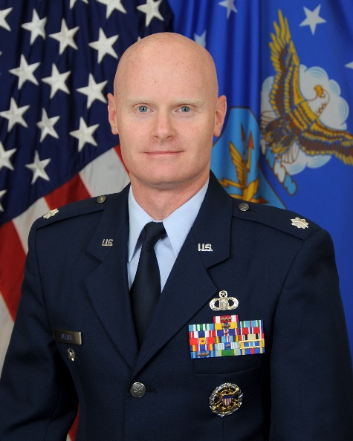
Lieutenant Colonel Kyle Bellue is the Commander of Air Force ROTC Detachment 785, located at the University of Memphis in Memphis, Tennessee. He serves as Department Head of Aerospace Studies and is an Aerospace Studies Professor.

Lieutenant Colonel Bellue received his commission through the Air Force Reserve Officer Training Corps at Texas A&M University in 1992. He has served as a meteorologist in support of both the Army and Air Force and has been deployed multiple times in support of Operation IRAQI FREEDOM. He has supported the Space Shuttle launch recovery team as the chief meteorologist for the DoD Manned Space Flight Support Office where he was responsible for weather support for all Space Shuttle Transoceanic Abort Landing Sites.
Lt Col Bellue also oversaw program management for Air Force Weather’s fielded observing systems, an enterprise consisting of 20 major programs valued at over $700M. He was then selected as the Director of Operations and Commander of the 15th Operational Weather Squadron at Scott Air Force Base. Lt Col Bellue most recently served as the Chairman of the Joint Chiefs of Staff’s Meteorology and Oceanographic (METOC) staff officer, leading in the development and coordination of Joint METOC doctrine and policy. In this position he served as the US representative to the North Atlantic Treaty Organization (NATO) Military Committee Working Group coordinating meteorological support for all NATO coalition missions.

EDUCATION:
1992 Bachelor of Science, Meteorology, Texas A&M University, College Station, TX
1999 Master of Science, Meteorology (AFIT), Texas A&M University, College Station, TX
2000 Squadron Officers School, Maxwell Air Force Base, Alabama
2004 Air Command and Staff College, by correspondence
2008 Air War College, by correspondence

ASSIGNMENTS AND DATES
1. Feb 93 – Dec 95: Weather Officer, Det 4, 617th Weather Sq, Traben-Trarbach, GE
2. Dec 95 – Aug 97: Weather Flt OIC, 100th Operational Support Sq, Mildenhall, UK
3. Aug 97 – Jun 99: AFIT Student, Texas A&M University, College Station, TX
4. Jun 99 – Jun 02: Chief, Weather Plans and Policy, HQ AETC, Randolph, TX
5. Jun 02 – July 05: Chief, Systems Division, 45th Weather Sq, Patrick AFB, FL
6. Jul 05 – Jul 08: Chief, Lead Command & Program Mgmt Branch, AFWA, Offutt AFB, NE
7. Jul 08 – Jun 10: Director of Operations, 15th Operational Weather Squadron, Scott AFB, IL
8. Jun 10 – Jul 12: Commander, 15th Operational Weather Squadron, Scott AFB, IL
9. Jul 12 – Jul 15: METOC Operations Officer, Joint Staff, Pentagon, Washington, D.C
10. Jul 15 – Present: Commander, AFROTC Detachment 785, University of Memphis, Memphis, TN

MAJOR AWARDS AND DECORATIONS:
Defense Meritorious Service Medal
Meritorious Service Medal with three oak leaf clusters
Joint Service Commendation Medal
Joint Service Achievement Medal
USAF Commendation Medal with two oak leaf clusters
Joint Service Achievement Medal

EFFECTIVE DATES OF PROMOTION:
Second Lieutenant 14 Nov 92
First Lieutenant 14 Nov 94
Captain 28 Sep 95
Major 1 May 03
Lieutenant Colonel 1 May 08

(Current as of Jul 2015)

