- What is the Hammett ρ value for the following reaction and calculate K when X = p-NO₂ and when X = p-Cl.

- What do you expect the signs and relative magnitudes of the σ values to be for the substituents S(O)CH₃ and SCH₃ in the meta and para positions? Explain.

- What do you expect the signs and relative magnitudes of the meta and para σ values to be for the substituent N(CH₃)₃⁺? NHCOCH₃? Explain.

- Explain the relative magnitudes and signs of σ for NHCOCH₃? And NH₂.

- Show the product of the reaction below, and explain the sign of the Hammett ρ value.

- What is the sign of the Hammett ρ value for the following reaction? Explain.

- Sketch a plot like Figure 13.7 if A_{ac}1 were always operative. Explain.
- Sketch a plot of Figure 13.8 if step 2 were always rate determining. Step 3 were always rate determining. Explain.
- Determine the signs and estimate the relative magnitudes of the Hammett ρ values for the following reactions relative to each other and ionization of benzoic acids. Explain.
- The rate constant when X is an ortho N(CH₃)₂ does not fit with the data for other substituents of a σρ plot for the following reaction. Show the reaction detailing why this occurs and discuss what factors determine whether the reaction should be faster or slower than predicted by the line.
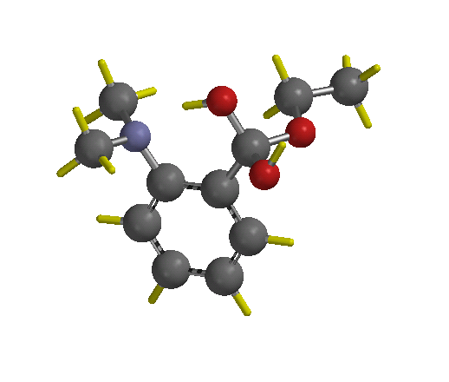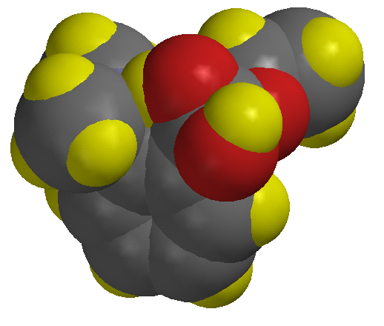
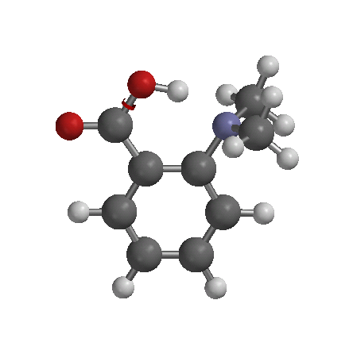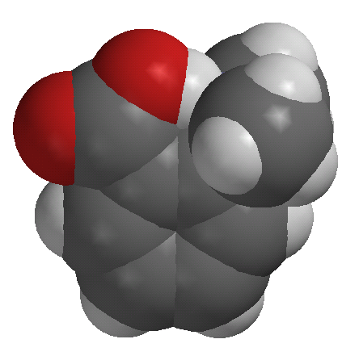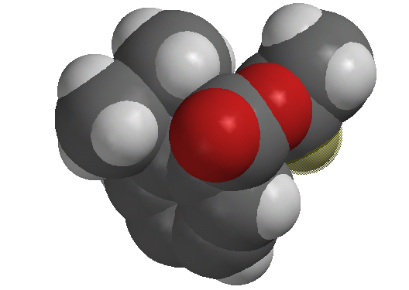

- Estimate and explain the signs and relative magnitude of Es for the cyclohexyl and triflouromethyl groups.

