#### Exam 19th, CH8 9th CH 9 12th, CH10 21th

1. Carbanion Formation
   1. reduction of halides
      1. Grignard, Lithium reagents, pka conjugate acid?



* + 1. what is the LUMO of methyl bromide (4.78 ev) or ethane (7.6 ev)

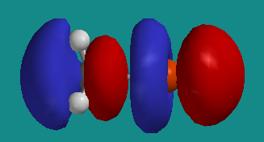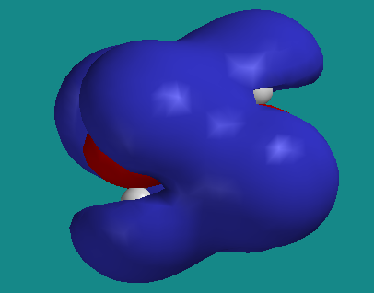

* + 1. *Mechanism for Gignard formation: Eur. J. Org. Chem.* **2008**, 6043-6049, **F. Bickelhaupt, M. Newcomb, C. B. DeZutter, H. J. R. de Boer\***The Grignard Reagent Formation Reaction of 2-Chloro-1,1,1-triphenylethane Re-visited”: What are missing species/steps?



* 1. carbanion without delocalization are nominally sp3, pyramidal
  2. enolate and other stabilized anions
     1. use a strong base: NaNH2, BuLi, LDA (lithium diisopropyl amide) pKa’s of conjugate acids? Compare NaOH, why LDA? Stoichiometric!!



 must recognize delocalization, NO bond lengths?

* 1. geometry restrictions on  delocalized anions
     1. sp2 orbitals on carbon, p orbital co planar with  orbital
     2. estimate pKa of 1,3-cyclohexandione?
     3. double bond and 4 attached atoms must be coplanar
     4. estimate pKa of 1,3-bicyclo[2.2.2]octandione (What is most acidic CH?)



* 1. enols form **reversibly** in presence of acid or base catalyst, pka





* + 1. enol is isomer of ketone - tautomers – readily interconvertible isomers
    2. tautomerization is normally two step intermolecular process
    3. enol and carbanion in general **can be used to label ketone** with deuterium
    4. -dicarbonyls have significant enol content fix dash



* + 1. hydrogen bonding and additional delocalization
    2. solvent is important, 92% enol in hexane, 15% in water, why?



* 1. don’t forget reactant state
     1. anti conformation has favorable dipole-dipole interaction
     2. lowers energy relative to pentadione



* 1. proton loss is slow even for stronger carbon acids



1. Carboxylation
   1. organometallic with electropositive metal (Na, Li, Mg) form strong base.



1. Elimination reactions (are possible)
   1. stabilized anion intermediate, pka?



1. decarboxylation can form carbanion intermediate, pKa?





1. alkylation of carbanions
   1. must avoid elimination as in 3.1, since many carbanions are strong bases
   2. weak base, pka?



* 1. use electrophiles that can’t or don’t easily eliminate and base with low steric hindrance
     1. allyl chloride does not have acidic hydrogen  to Cl (avoids allene formation)
     2. acetylide is not bulky, but is a very strong base, pka?



1. Reimer-Tiemann
   1. Phenol is an enol of 2,4-cyclohexandienone
   2. enolate is good nucleophile, full mechanism and delocalized electrons as an exercise
   3. dichlorocarbene: a good electrophile, empty p orbital



* 1. some *para* product forms
  2. Kolbe reaction yields nearly exclusive *ortho* with sodium counter ion



* + 1. para substitution is more important for potassium, why?

1. Darzens reaction



1. Favorski reaction



1. Base-Catalyzed Halogenation of Ketones (figure)



* 1. rate = kobs[ketone][base]
     1. independent of [Br2], what does this mean?



* 1. isotopic labeling
     1. typically rate of exchange with deuterium is the same as racemization
        1. then deuteration occurs equally from both sides
        2. anion symmetrization must be faster than deuteration



* 1. A deuterium isotope effect is observed
  2. indicates deprotonation is RDS



* 1. back to halogenation
     1. replacement of subsequent hydrogens by bromine is faster
     2. electron withdrawing Br stabilizes anion



* 1. methyl ketones form bromoform (haloform reaction)
     1. Why doesn’t OH leave instead of CBr3? Experimental test for OH leaving?



1. Acid catalyzed halogenation, **equilibrium at beginning is two steps (see above)**



* 1. enol is formed, reacts with halogen
  2. enol of product less reactive than reactant, bromo enol is poor  donor, why?
  3. Stop at mono-halogenation
  4. rate is same for iodination, what is RDS?
  5. what removes proton from cation intermediate? What is the solvent?