1. Electronic excitation
   1. UV (200-400 nm) and visible light (400-700 nm)
   2. Electron promoted from occupied to unoccupied orbital
   3. E = h = 28600/ (kcal/mol)
   4. Spin inversion is forbidden by quantum mechanical selection rules (conservation of spin)
2. Franck-Condon Principle – nuclei do not move during electron promotion (fs)
   1. initial excited state geometry
   2. Hydrogen molecule
      1. H2+, orbital occupation is (1)
      2. H2, orbital occupation is (2), add 1 e, nuclear move together
      3. H2-, orbital occupation is (2)(1), add 1e, nuclei move apart
      4. equilibrium positions for each is different, different nuclear-electron attraction
      5. , orbital occupation is (1)(1), nuclei fall apart
      6. more complex molecules have more electrons and often do not fragment
   3. ethene
      1. consider only bonding between carbons
      2. lowest energy transitions is HOMO-LUMO transition,  to 

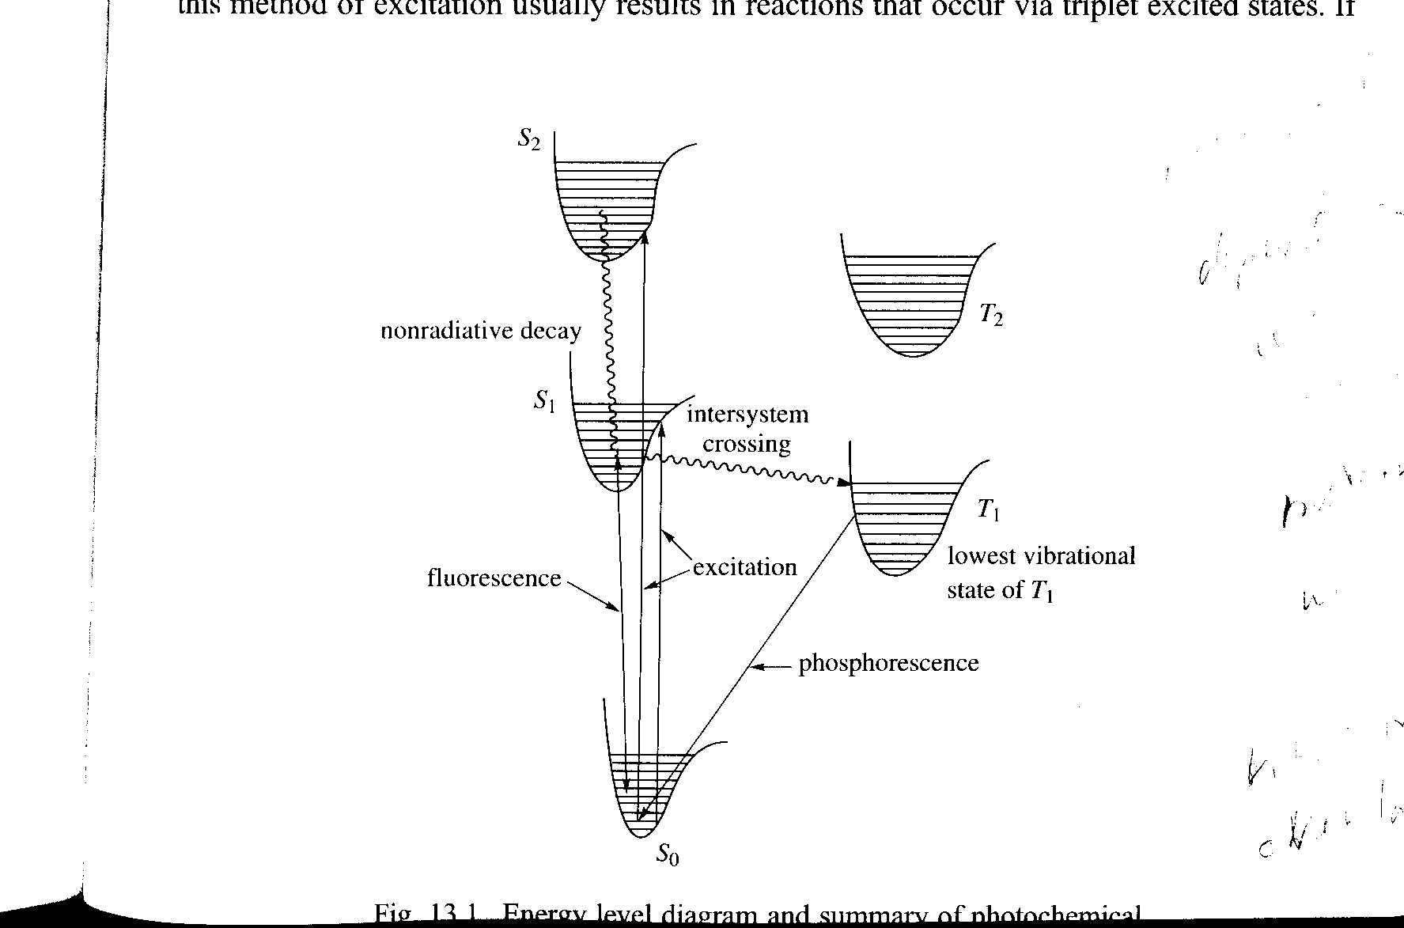

* + 1. excited state is (2)(1)(1). What happens to  bonding?
    2. initial  bond has double bond length, repulsion greater than attraction
    3. energy changes are vertical, nuclear changes are horizontal, figure 13.1 in Carey and Sundburg
    4. different electronic excited states have different geometries
    5. excited states usually have longer bond distances
    6. vibrational excitation and relaxation
       1. collisions and reorganization (ps)
       2. other than bond dissociation most reactions happen after relaxation
    7. intersystem crossing
    8. internal conversion
    9. emmision- fluorescence and phosphoresence

1. Energy transfer
   1. Excitation energy transferred to another molecule
      1. Energy donor is sensitizer, acceptor is sensitized
      2. Energy acceptor is quencher, donor is quenched
   2. Stern Volmer plot
      1. reaction of excited state competes with other process







* + 1. the fraction of photons yielding product is the quantum yield , depend on relative rates



* + 1. invert and assume quenching is diffusion control ~ 1010 M-1 s-1.



1. Electrocyclic reactions
   1. Orbital Symmetry only applies as long as reaction is concerted
   2. Relaxation results in geometry change, symmetry has changed
   3. ISC – triplet reactions compete with concerted reaction
2. Carbonyl compounds



* 1. n → \* (first two states)
     1. singlet - 80-85 kcal/mol
     2. triplet – 75-80 kcal/mol
     3. dipole changes from 2.3 to 1.6 D, electron density moves from O to C
     4. n is on oxygen, \* is on both but greater coefficient (density) on carbon.
     5. carbon is pyramidal
  2.  → \* (third and fourth states)
     1. IC-  →  often converts to n → \*
  3. kISC = 1010 s-1. faster than most reactions
     1. triplet behaves like alkoxyl radical
     2. hydrogen abstraction dominates in solution



* + 1. R=R’=Ph, abstraction from alcohol yields radical that can couple or be reduced
    2. ortho aromatic substituents can react rapidly with carbonyl





* + 1. photoenolization- thermal reaction rapidly returns product to ketone
  1. Unimolecular reaction dominates in gas phase:  cleavage followed by abstraction reactions





1. Photolysis of alkenes
   1. trans-2-butene, cis-2 butene
      1. Loss of  bond in excited state
      2. cis-trans isomerization
   2. cis and trans stilbenes
      1. photostationary state: equilibrium between cis and trans isomers





* + 1. , 
    2. 
    3. 
  1. sensitized cis-trans isomerization
     1. trans absorbance to 280 nm, cis to 270 nm
     2. sensitizer with ET > 60 kcal/mol yields [cis]/[trans] = 1
     3. sensitizer with ET = 52 to 58 kcal/mol yields [cis]/[trans] > 1 because t/ c > 1.

1. Dienes undergo cis-trans isomerization and electrocyclic reactions
   1. s-cis and s-trans have different energy excited state
   2. changing sensitizer changes selectivity for excitation of conformers
   3. both s-cis and s-trans can undergo 2 +2 cycloaddition
   4. only s-cis undergoes 2+4 cycloaddition
      1. s-cis has lower excited state energy
      2. producing more s-cis excited state produces more cyclohexene product
      3. can be accomplished with lower energy sensitizer



problems: 2ae,3ac,4acln,6,9,15