

Earth Science News

*Fall 2014*

From the Chair……

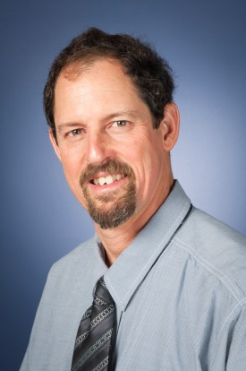

Dr. Dan Larsen

2014 has brought many changes to Earth Sciences at the University of Memphis. As the new Department Chair, I thought this would be a great opportunity to reconnect with alumni and friends of various departments at the University of Memphis and Memphis State that now form Earth Sciences. I want to express my deep appreciation to Dr. Jerry Bartholomew for his able leadership of the Department of Earth Sciences for the past 12 years. His shoes will be difficult to fill, but I will do my best.

The Department of Earth Sciences formed in 2002 through the alignment of the departments of Geography and Geological Sciences (including Geology and Geophysics). Archaeology faculty from the Department of Anthropology joined the Department in 2006, such that Earth Sciences now includes Archaeology, Geography, Geology, and Geophysics. To facilitate the missions of both Center for Earthquake Research and Information (CERI) and

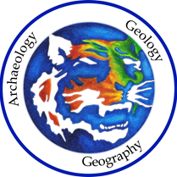

Earth Sciences Archaeology, Geography, and Geology faculty, the Department of Earth Sciences separated into two administrative units: CERI and Earth Sciences. CERI, under the leadership of Dr. Charles Langston, is currently developing their academic identity further by enhancing their graduate programs in geophysics.

Earth Sciences’ fourteen tenure-track faculty members reside in Johnson Hall, but have far reaching interests and collaborations across campus, the city and the world. Please explore the many facets of our program through our web site at <http://memphis.edu/des/> and feel free to contact me or any other faculty members – we would love to hear from you. Please join us for our ***departmental open house*** on ***Saturday, November 1st, 2014*** (see announcement below). Below, our faculty members provide a little background on their interests and activities.

*Earth Sciences Faculty*

**Dr. Angela Antipova** – My recent research activities were in fields of urban, retail, and medical geography. A recent urban geography project included analyzing job market and labor force. I was interested to study the impact of location attributes on employment concentrations by race and gender. The results of the project were accepted for a publication (A. Antipova. Black, White, male, and female concentrated employment: The effect of spatial and aspatial labor factors. *Cities.* In Press, DOI: 10.1016/j.cities.2014.06.004). During spring 2014 I embarked on a project to studythe sustainability aspect of urban areas, with a focus on retail places. The study examines the viability of businesses including retail, food services, and offices in different urban forms. The viability is proxied by the amount of sales generated by business establishments. Urban forms are represented by urban and suburban settings. The focus of the study was to explore the “health” of businesses anchored by big-box retailers such as Walmart neighborhood center measured by the relationship between the sales volume and different urban forms. Most recently, I began a new study of women’s health in the areas of increased seismicity across Arkansas, especially during a period of “Guy earthquakes” from August 2010 to February 2011. ​

**Dr. Jerry Bartholomew** – My interests span a wide range of geologic subjects and regions. I am currently working with colleagues and students both at the University of Memphis and elsewhere on projects in China and Ecuador as well as in Montana and Wyoming, Virginia, Georgia and the Carolinas. I, along with several other members of the department, am especially interested in relationships among active faults, associated seismicity, and geomorphologic expression of those faults.

The Northern Basin and Range in Yellowstone’s wake is one of my major interests where there are many faults with Late Quaternary surface ruptures. One of my former graduate students (Mike Bone, MS 2008) and I have worked with other colleagues on trenches, shallow seismic lines (with Jose Pujol), gradiometer surveys (with Andrew Mickelson), and OSL dating (with Tammy Rittenour at Utah State University). The Eastern Tibetan Plateau is another major interest of mine. My current PhD student, Taylor Armstrong (MS, 2012), Lian Feng (MS expected 2015), and I have been involved in a cooperative project for several years with Dewei Li, Demin Liu, and other colleagues at China University of Geosciences, Wuhan, on active faults in the eastern Tibetan Plateau. I plan to begin new work on theGiles County Seismic Zone, VA, based on the work of Bartholomew and Whitaker (2010), who showed the orientations of the youngest post-Alleghanian faults along the structural front of Appalachian fold-thrust belt, in relation to fault-plane solutions of the nearby Giles County seismic zone. I am also interested in tectonic analysis of Quaternary features and fracture sets in the Atlantic Coastal Plain, including the epicentral region of the 1886 Charleston earthquake (SC). I also continue to pursue research on paleoseismites of

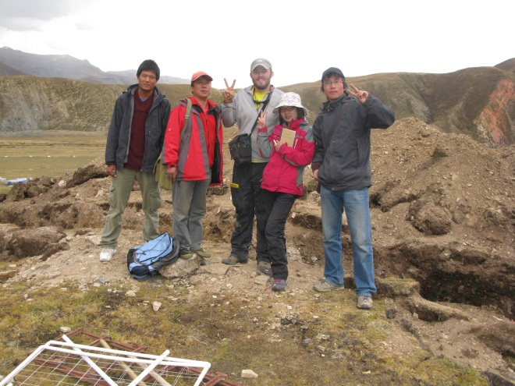

Graduate students Taylor Armstrong and Lian Feng with assistants at a trench site along the eastern Tibetan Plateau, China.

various ages and the Grenvillian basement of North America.

**Dr. Dorian J. Burnette** – My research interests are in historical meteorology and climatology, climate reconstruction from tree rings, severe storms meteorology, societal impacts of weather and climate extremes, and computer programming applications. Over the past year, I have been working on a project funded by the National Science Foundation. It is a collaborative project between the University of Memphis, the University of Arkansas, Lamont-Doherty Earth Observatory of Columbia University, and NASA’s Goddard Institute for Space Studies. This project has four primary goals. 1) To develop tree-ring reconstructions of cool and warm season moisture on a 0.5 latitude/longitude grid over as much of North America as possible. 2) To investigate the intensity, duration, and spatial impact of decadal drought and pluvials (wet periods) during both seasons over the past 500 to 1000 years. 3) To test hypotheses concerning decadal climate variability using modern instrumental climate data, the new tree-ring reconstructions, and coupled climate models. 4) To develop a web-based analysis and visualization tool so that the instrumental and reconstructed seasonal moisture data can be accessed and used by the scientific community. During the first year of this three-year project, we reconstructed the Palmer Drought Severity Index (PDSI) for June-August (JJA) over much of subtropical North America including the entire Republic of Mexico (see below). This Mexican Drought Atlas is based on 251 tree-ring chronologies, including 82 from Mexico and another 169 from the southern U.S. and western Guatemala. An abstract has been submitted to the American Geophysical Union fall meeting in December, and two manuscripts are in preparation, including an invited paper to *Quaternary Science Reviews*.

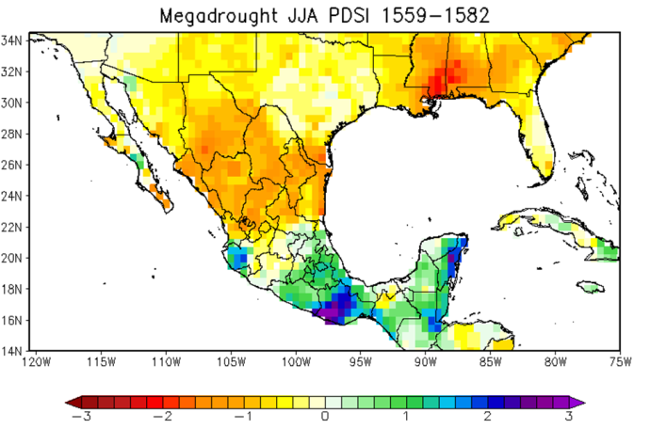

**Dr. Robert Connolly** – This past summer, I participated with Elizabeth Cruzado Carranza (ES Graduate Student) in the opening of a cultural heritage center and museum along with several other projects in the village of Hualcayán, Perú. Students in my Museum Practices seminar this year will create products for the next stage of the museum development.

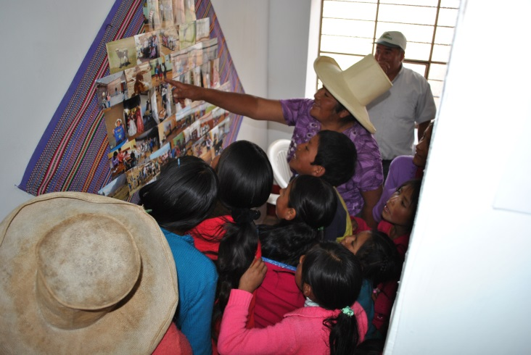

Visitors to the opening of the Museo de Hualcayán, Peru, viewing one of the photograph displays.

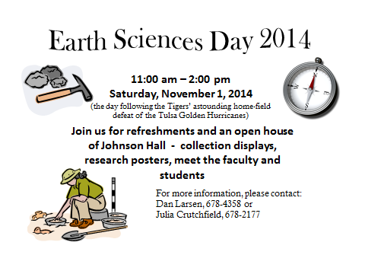

The Museo de Hualcayán is part of the multi-faceted applied archaeology approach of the Proyecto de Investigación Arqueológico Regional Ancash (www.piaraperu.org) of which Cruzado is a Co-Director along with Vanderbilt PhD student Rebecca Bria. We will return to Peru for a short visit in January to arrange for 2015 collaborative activities. In 2015, PIARA will partner with the C.H. Nash Museum and the municipality of Huaylas, Peru in a host of cultural heritage projects including the submitting a Museum Connect grant through the American Alliance of Museums. The project will continue to provide opportunities in both museum studies and archaeological research.

**Dr. Randy Cox** – It was another busy year with some projects coming to fruition in 2013-14. Former graduate students Chris Gardner and Luke Hall co-authored a paper with me in Tectonophysics, “Tectonic

history and setting of a seismogenic intraplate fault system that lacks microseismicity: the Saline River fault system, southern United States” and I wrapped up two other projects along with several colleagues with a paper in the Journal of Geology, “Possible relict meanders of the Pliocene Mississippi River and their implications” and a paper in Seismological Research Letter, “A revised paleo-earthquake chronology on the southeast Reelfoot rift margin near Memphis, Tennessee.”

I was fortunate enough to be invited to the University of Illinois, Chicago to present “Holocene faulting and earthquakes along the southern edge of the North American.” A couple of funded projects put me in the field quite a bit. I was PI on “Investigation of the magnitude and timing of paleo-earthquakes in southeast Arkansas” ($48,000) from USGS National Earthquake Hazards Reduction Program and “Earthquake Seismology in the East TN Seismic Zone” ($53,000), a contract from Nuclear Regulatory Commission and UT-Knoxville.

I was promoted to Full Professor in 2013, and I joined the Frontiers in Earth Science journal Quaternary Science, Geomorphology and Paleoenvironment as an Associate Editor. I had the opportunity to read plenty of new theses in 2013 because I served on the committees of 13 students. I’m keeping busy working on several papers on things like paleo-earthquake magnitudes on the Coastal Plain and active faulting in the East Tennessee seismic zone. Students and a number of professional colleagues are helping with these manuscripts. The lively discussions we have over nachos and refreshments in my graduate classes are always a pleasure and thought provoking. I also continue to tag-team teach Geology Field Camp with Dan Larsen in South Dakota, Wyoming, and Montana and teach lots of eager freshmen here in Memphis.

**Dr. David Dye** – I am working on late prehistoric ceramics from the Central Mississippi Valley in order to better understand Native American belief system and culture change at the time of European contact. I have a number of book chapters and journal articles in press.

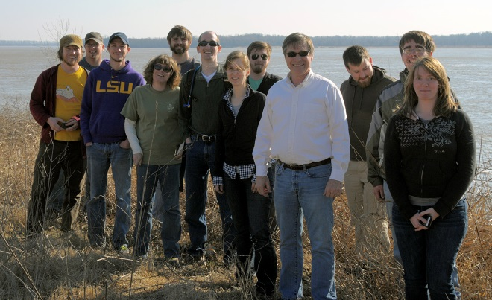

Spring 2014 field trip – Tracing Hernando DeSoto’s path through the Mid-South led by Drs. Dye, Hill, and Burnette.

**Dr. Arleen Hill** – I am an engaged and applied hazards researcher specializing in the impacts of catastrophic events on our society and environment. I am chiefly concerned with what makes people and places vulnerable to hazards and the ways that communities can establish resilience.  My ongoing projects have involved leading field teams in Haiti, the Mississippi Gulf Coast, and Florida.  Serving as a partner member of the Memphis Urban Area Security Initiative (UASI) Working Group provides an opportunity for me to participate in local and regional emergency management efforts and fits with my applied geography research focus.  All of my projects are intentionally interdisciplinary, multi-hazard and fit into the planning/preparedness, response, relief, or recovery phases of the disaster cycle.  Collaborations that promote preparedness and involve students and community partnership are the ones I find particularly rewarding.  I received the Distinguished Research Award for Excellence in Engaged Scholarship (2013-2014) and the First Responder Award by the Tennessee Department of Safety and Homeland Security (2012)​.  In addition to being an Associate Professor in the Department of Earth Sciences, I am a faculty affiliate of the Center for Partnerships in GIS and advisor for the University’s Emergency Management Minor.

**Dr. Hsiang-te Kung** – My areas of interests are in water resources, urban environment, and China. I am working with two chemistry professors (Paul and Gary) and Dr. Kwon on using the hyperspectral remote sensing in detecting the water quality for drinking water supply in Middle Tennessee; collaborate and partner and working together with Dr. Andrew Kouba, Dr. Jennifer Mandel, etc. from Memphis Zoo on global change and human interference on panda habituated areas in China. I also collaborate and work with Chinese geographers and scientists on the environmental impacts of China Three Gorges Dam on the ecosystem and environment.  I am directing the Confucius Institute and Asian Studies and International Trade Program and have received many grants, totaling more than one million dollars. I was recently recognized by the University as a Principal Investigator Millionaire. I am currently advising one Ph.D. student and two MS students.

**Dr. Youngsang Kwon** – My research interests lie in forest dynamics, terrestrial carbon cycling and climate change with a specific focus on the application of GIS and Remote Sensing to derive biophysical properties of ecosystem. My recent work involves monitoring tick abundance in AMES plantation and modeling causality of its spreading using remote sensing and field work.

**Dr. Dan Larsen** – I still get away from the administrative desk to work with students and continue my research efforts. My research is generally in the areas of sedimentary geology, hydrogeology, and low-temperature geochemistry. I have been working as the Interim Associate Director of the Ground Water Institute since 2011, and continue to do many research hydrogeology projects in the Memphis area. Other research projects include my continuing efforts in the Tecopa Basin of southeastern California and paleoseismic studies in the Mid-South region (with Randy Cox). I recently finished 4 years on the Council of the Geological Society of America, which was a very rewarding experience. I also continue to teach our geology field camp in South Dakota with Randy Cox, which is always a lot of fun field work.

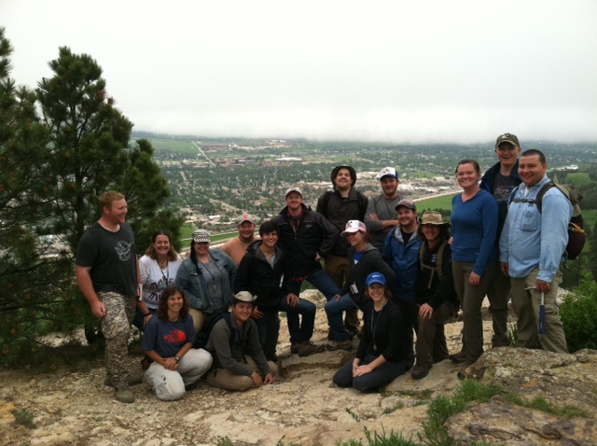

2014 Geology field camp – Top of Lookout Mountain overlooking Spearfish, SD.

**Dr. Andrew Mickelson** – I am continuing to work on a long-term research project studying prehistoric Native American land use in western Tennessee ca. 1000-1300 AD.  I have just completed my eighth year of fieldwork at the Ames town site.  My research utilizes traditional archaeological techniques as well as advanced geophysical prospecting and manipulation of LIDAR data.

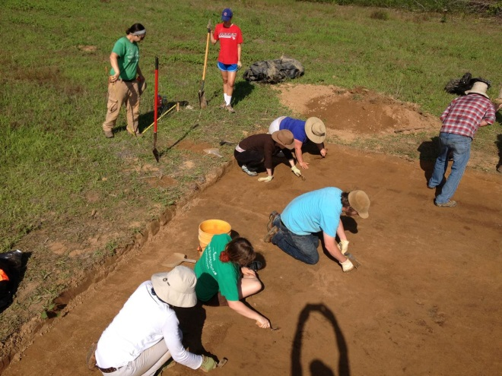

2014 Archaeology Field Camp at Ames Plantation, TN - students excavating the remains of a prehistoric Native American house dating to ca. 1150 AD.

**Dr. Esra Ozdenerol** – My interests are in GIS and Medical Geography. I presented a talk entitled “Building Research Bridges between Kultur University and University of Memphis” in January of 2014, at Kultur University in Istanbul. I also received a Community Engagement Grant through Leadership Memphis that led to workshops with local High schools working on a “Real Places Curriculum”  to revitalize neighborhoods in Memphis. I am also currentlyworkingon mybook, entitled**,** “Spatial Health Inequalities: Adapting GIS tools and data”, to be published by CRC Press.

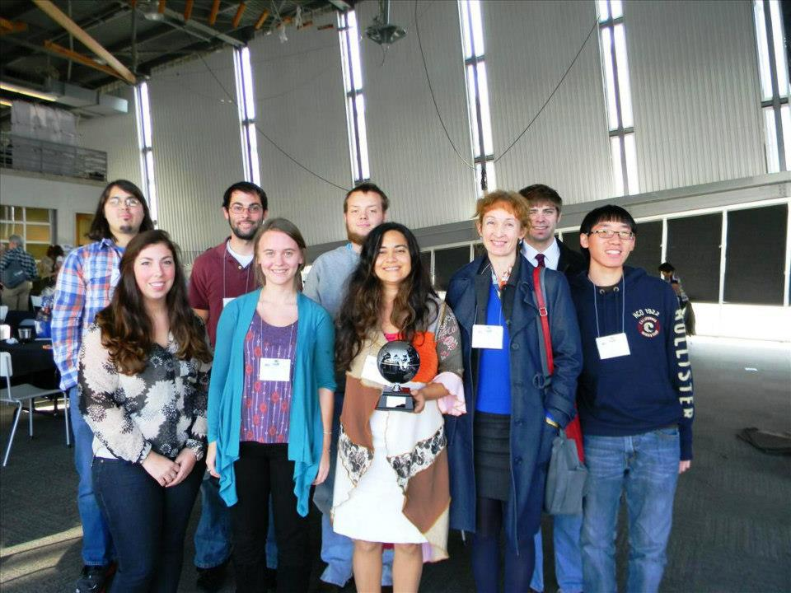

Drs. Antipova and Ozdenerol with students at MAGIC conference.

**Dr. Ryan Parish** – My interests involve studying the prehistoric inhabitants of the Eastern Woodlands by tracking their movements and interactions through sourcing cultural materials back to the resource on the landscape.  Using spectroscopy instrumentation developed in chemistry and physics, I have built a database of 3,000 chert (flint) samples from 100 deposits in IL, KY, TN, MS, AL and GA.  Chert was the preferred tool stone for the indigenous peoples of the Southeast.  Through analysis of their stone tools, I am able to “visualize” migration patterns, trade networks, resource selection decisions, and other people/people and people/place interactions.  Funding for the project is provided by National Science Foundation and the National Park Service.

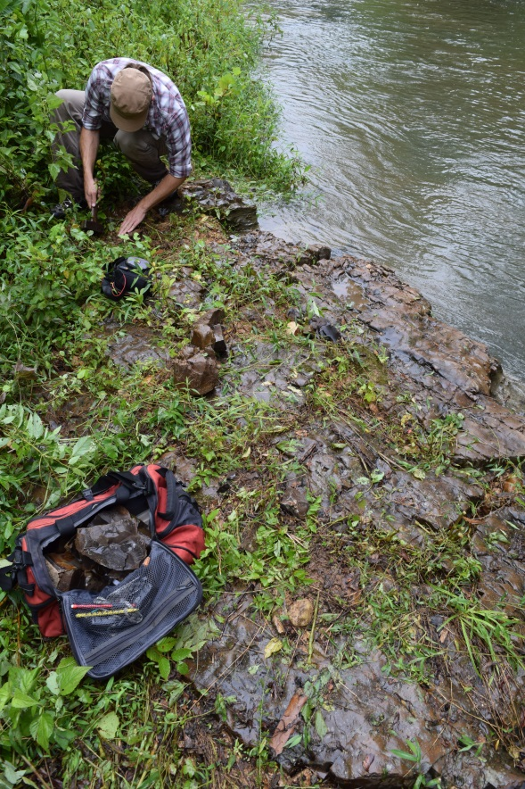

Colleague of Dr. Parish collecting chert samples along the Green River in Waynesport, TN.

**Dr. Jose Pujol** – I have several research interests, including earthquake location and seismic tomography, inversion of geophysical data, shallow reflection seismology, and use of surface waves to determine shallow shear-wave velocities. My work on earthquake location resulted in the development of software used by colleagues in several countries and a book chapter on the same subject. My work on tomography resulted in an encyclopedia article. More recently I have been interested in the theory of rotations in seismology and in their history in general, which resulted in papers published in mathematical and engineering journals.

**Dr. Roy Van Arsdale** – As many alumni know, most of my research is in the Mississippi River Valley.  Most recently my graduate students, colleagues, and I have focused on the Quaternary structure, history, and geomorphology of the central Mississippi River Valley.  In 2013 and 2014 we published a total of nine papers, some of which discuss earthquake recurrence, Reelfoot rift Quaternary structure, Pliocene and Pleistocene history of the Mississippi River, and several other topics.  If you are interested in these topics please see my abbreviated vita at the department web site and let me know via email which papers you would like to have.  Perhaps the most exciting professional news is that we obtained two Al-Be age dates for the Upland Complex that average 3.2 million years in age.  This is the first isotopic (hard) date for this unit that previously had been estimated to be as old as Miocene to as young as Pleistocene.

Most exciting in my life of recent years is that I am now a grandfather of a handsome grandson and beautiful granddaughter.  I look forward to reconnecting with former graduate students and hope that you will stop by the department whenever possible.

*Emeritus faculty in residence:*

**Dr. Phili Deboo** – I retired many years ago as professor and chair of the Department of Geology. I spent four years in a post-retirement program in the department and now, as an adjunct and part-time member of the department, I teach one course a semester: Physical or Historical Geology in the Fall semesters and Invertebrate Paleontology in the Spring semesters. I also keep in touch with many of our students who have progressed on to successful careers.

**Dr. David Lumsden** – I am enjoying semi-retirement, spending much of the summer at the Lumsden Lake Ontario estate. I continue to teach part time, Historical Geology and Basin Analysis this semester.  I continue to collaborate with Drs. Van Arsdale and Cox on a study of the origin of the Upland complex, the brown chert gravel commonly present under the loess of the Chickasaw Bluffs.  Although not directing thesis anymore I am active on several MS committees.

**Dr. Charles McNutt** – I have visited the pre-Clovis Gault site in Texas and the Sam Noble Oklahoma Museum to study material from the Packard site.  I am attempting to test a relative chronological technique that can be applied to flaked stone artifacts using an IR Raman laser.  Also have papers on sites in South Dakota, Arkansas, and Tennessee submitted for publication.

*Instructor:*

**Dr. Julie Johnson** - My primary interests are in the field of igneous petrology and geochemistry.  Past projects have focused broadly on igneous activity, mantle melting and magma differentiation within subduction zones and ophiolites (specifically, supra-subduction zone ophiolites).  My work has used mineralogy and geochemical signatures of highly fractionated crustal rocks from the southern Izu-Bonin-Mariana arc system to provide insight into the magmatic and differentiation processes that occur during subduction initiation.



*Student Spotlight*

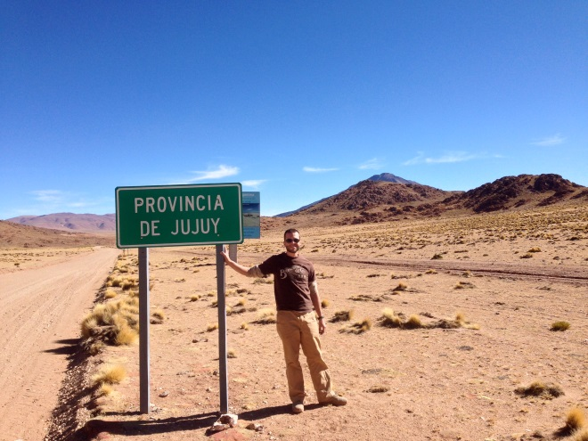

Undergraduate student, Peter Matheny, in Argentina, summer 2014

When Dr. Van Arsdale called my name from the other side of the hall on the second floor of Johnson hall I had no idea what he wanted with me. Had I done something wrong? I nervously entered his office and sat down. He then told me Dr. Smalley from the Center for Earthquake Research and Information (CERI) needed an undergraduate student in Geology to go to Argentina with him for the summer to help conduct geophysical research. As soon as I heard the word Argentina there was only one thought racing through my mind, how can I convince my wife to let me go? After getting permission from home and setting up an interview with Dr. Smalley and his graduate student Demian Gomez, it seemed like I would be going with them despite my complete lack of Spanish - I was extremely excited!

A lengthy plane ride and bus trip later, I found myself at the foot of the Andes. I have been to a few mountain ranges before, but none of them prepared me for the awe-inspiring size and beauty of the mountains that cradled the city of Jujuy in northwestern Argentina. A day after arriving Dr. Smalley, Demian, and I began our ascent up the newly paved roads while Dr. Smalley recounted stories of the last time he had gone up this route towards Bolivia in the early 90’s. All around were beautiful specimens of geologic phenomena and I nearly snapped my neck turning my head left and right taking pictures all along the way trying to take it all in. After realizing I couldn’t document it all, I decided to just sit back and take in it all. As we climbed higher and higher in elevation there was less vegetation, which made it that much easier to appreciate the folds and colors of the rocks. After checking just about every box off over the course of the summer in terms of mountainous geology, my favorite was the extinct volcano with perfectly preserved lava flows. After making it to 4900 meters in elevation, it was time to head back to civilization.

Having only ever studied geology in the classroom, this trip opened my eyes to the scope of the science. It was an opportunity I treasure and will never forget.

