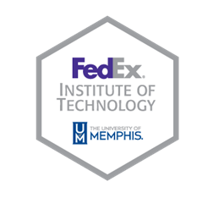

Contact: Mary Ann Dawson
901.678.1592
mdawson@memphis.edu

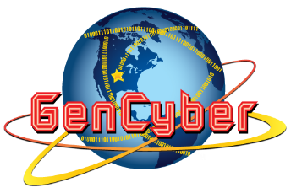

FedEx Institute of Technology Welcomes GenCyber Boot Camp 2016

June 10, 2016 – The University of Memphis will host the 2016 GenCyber Boot Camp this summer, funded by the National Security Agency and the National Science Foundation. There will be one-week sessions for middle- and high-school students interested in the cyber security field. The camp will cover various aspects of cyber hygiene. Students will learn about privacy, security and safe browsing while on the Internet. They will be introduced to cyber ethics and engage in hands-on sessions that will allow them to experience real-world data security issues.

Those who attend will have a chance to meet cyber experts and industry professionals. The week will culminate in a competition where students will demonstrate online activities following best practices. The federally funded camp is free for all participants.

The high school camp will be held June 20-24 and the middle school camp will be July 25-29. This is a unique opportunity for students to learn about Cyber Security programs at the University of Memphis, a nationally designated Center for Academic Excellence in Information Assurance (CfIA). For questions regarding the camp please email cfia@memphis.edu. To register for the camp, visit memphis.edu/cfia/projects/gencyber.php.

###

