Creating an Event and Sending an Invitation Using Google Calendar

From your gmail homepage, click on the icon in the upper right corner that is a grid of squares.

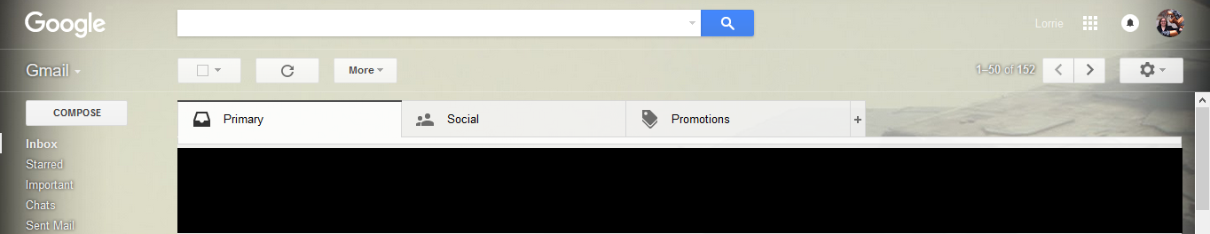

This will bring up the options for your google accounts. Click on Calendar.

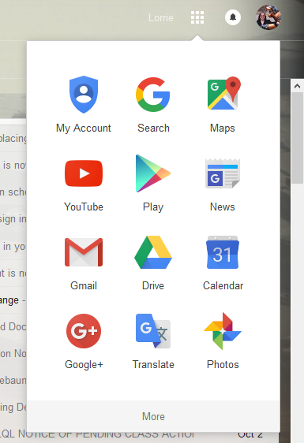

This will open up a new window with your calendar on it. On the left side of the screen, you will see a red button that says “Create.” Click on this button.

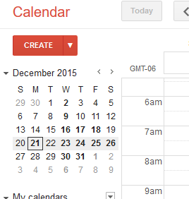

This will open up a new page for you to fill out to create the event.

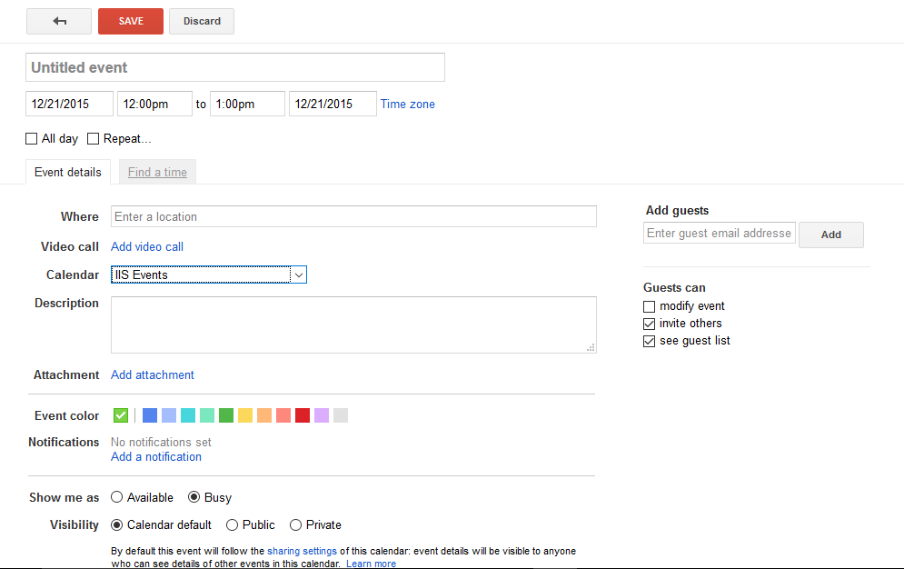

Fill in the details asked for on the form.
- Enter the subject of the meeting.
- Enter location (usually Dean Aden’s office, #258).
- Select the correct start and end date and time.
- For the description in the big box at the bottom, you may include any information about the meeting that you would like Dean Aden to know in advance.
- If you have multiple calendars for your google calendar, be sure to select the correct one.
- If you use different colors for different types of events, select the correct color.

On the right hand side in the “Add guests” box, be sure to type Dean Aden’s email (maden@memphis.edu) and click add.

Once you verify that all the information is correct, click “Save” in the upper left corner.
After clicking save, a pop-up will ask if you want to send invitations. Click “Send.”
