Creating an Event and Sending an Invitation in Outlook Online

After logging into your account, click on the downward facing arrow next to the word “New” above the list of the emails in your inbox. Clicking on the arrow will make some options appear.

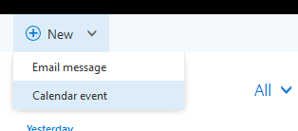

From here, click on “Calendar event.” If you have a pop-up blocker installed, it might block the new event window from opening. If it does, you will see this bar appear on the top of the screen.

Click on the “Options” button and a menu will appear.
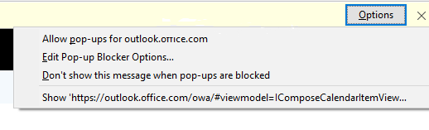
Click on the first option “Allow pop-ups” and the window to create an event will appear on the screen.

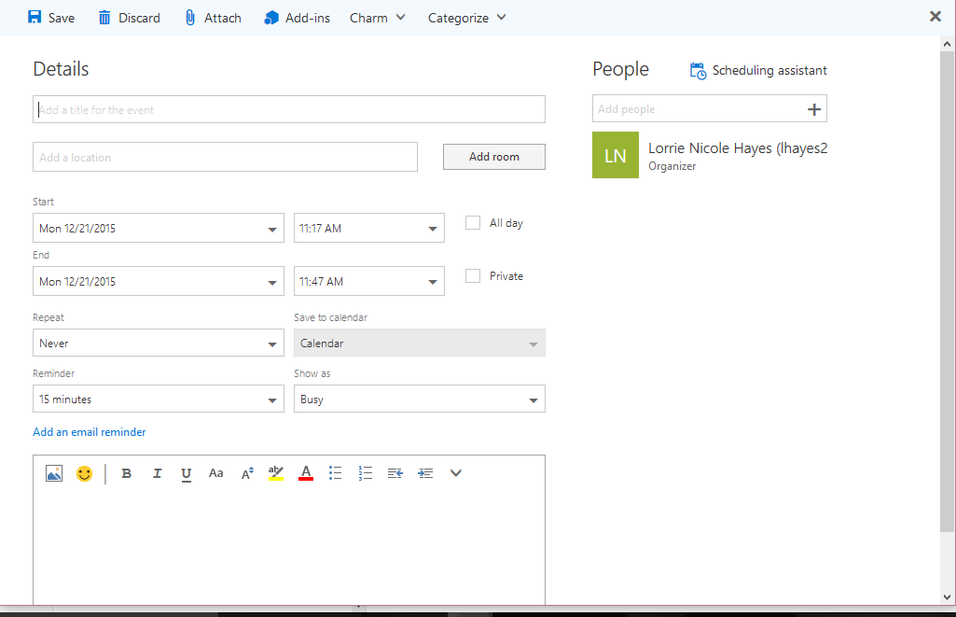

Fill in the details asked for on the form.

- Enter the subject of the meeting.
- Enter location (usually Dean Aden’s office, #258).
- Select the correct start and end date and time.
- For the description in the big box at the bottom, you may include any information about the meeting that you would like Dean Aden to know in advance.

After verifying that that information is correct, click on the button towards the middle of the window that says “Invite Attendees.”

On the right-hand side of the screen, you will see your name and above that, the option to “Add people.” You need to add Dean Aden’s email (maden@memphis.edu).

Make sure that request response is checked.

After you verify that you have filled out the form correctly, click on the “Send” button in the upper left-hand corner.
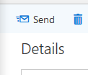

Now, you have created an event that will appear on your calendar and have sent it to Dean Aden.

