Using Virtual EMS

The Cecil C. Humphreys School of Law now has access to the Virtual EMS tool to view events and request spaces through the web. This tool is available to all Law Faculty and Staff and members of designated Registered Student Organizations. Requests made through this system will go to Cheryl Edwards (cedwrds2@memphis.edu) and Ida Bounds (ibounds@memphis.edu) for approval.

(Hold the Ctrl key on your keyboard and then Left Click with your mouse on any of the topics listed below to jump to the appropriate section, such as “Reserving a Room” or “Creating a Filter”.)
Contents
Logging In 1
Viewing the Calendar 4
Creating a Filter 6
Views 9
Default View – The page will automatically show you a daily list of all the events sorted by date. 9
Weekly List View 9
Daily List - Location View 10
Daily List – Client View 10
Weekly Calendar View 11
Browse Facilities 12
Browse for Space 12
Reserving a Room 13
Help 21

Logging In

- Using your browser, go to http://vems.memphis.edu.
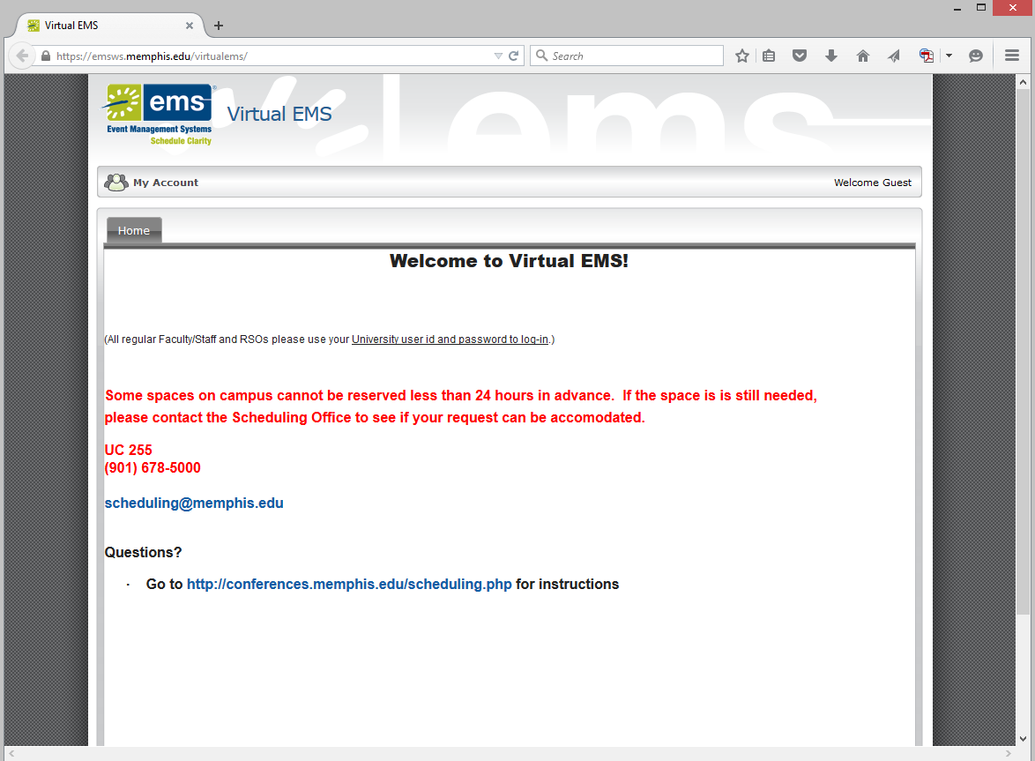
- Move your mouse to the “My Account” button in the top left-hand corner of the page, and a “Log In” button will appear. Click on the “Log In” button.

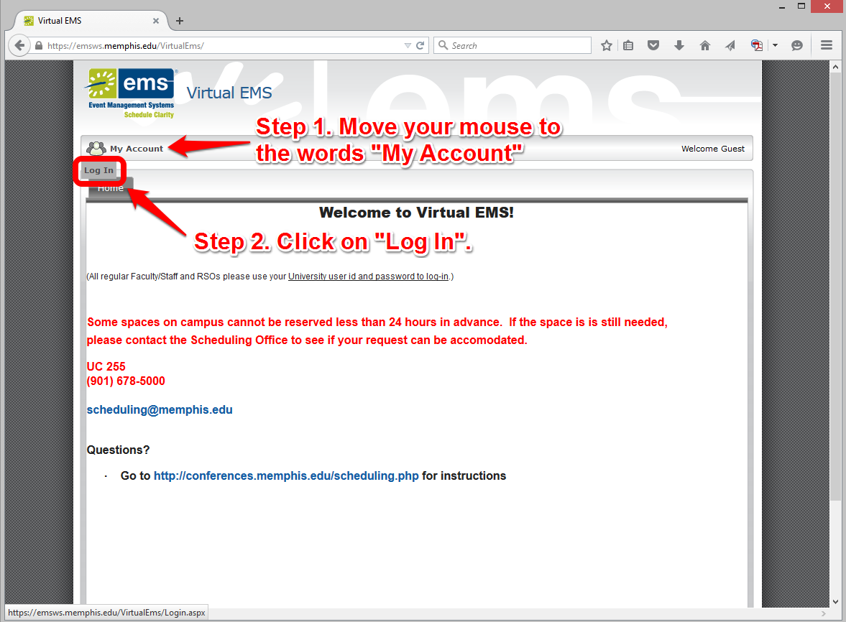

- On the Login screen, enter your University of Memphis user id and password, then click “Login”.

Viewing the Calendar

- Now that you have logged in, you can begin to use the system

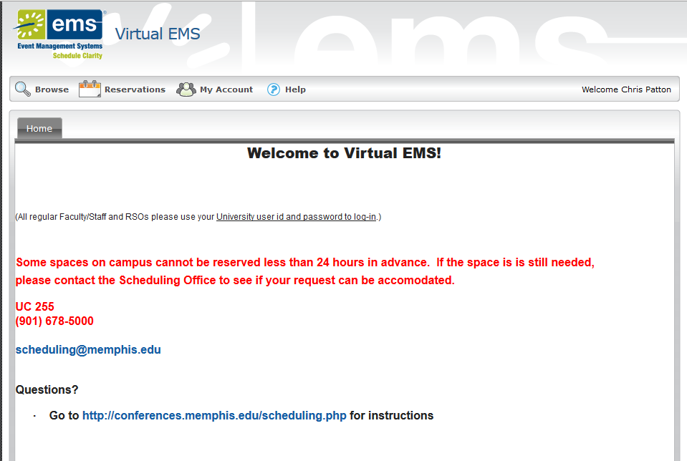

- Notice the icons at the top above the welcome message. These each correspond to a different feature within the calendar.
  - Browse – view events on the calendar
  - Reservations – reserve a room
  - My Account – allows you to logout when you are finished
  - Help – view the Virtual EMS user manual or go to the Knowledge base.

- Move your mouse to the “Browse” button, and a menu will appear:
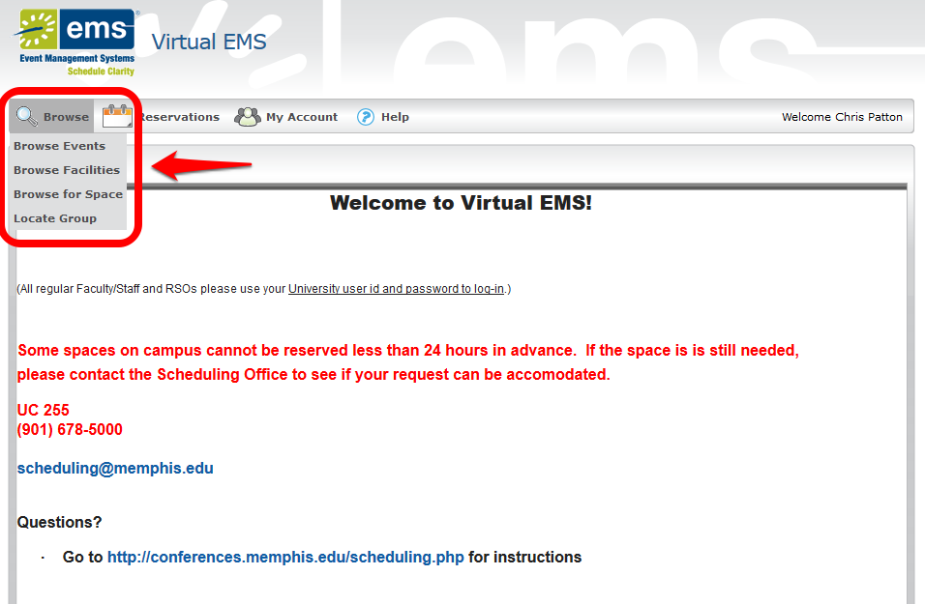

- Click on “Browse Events”:
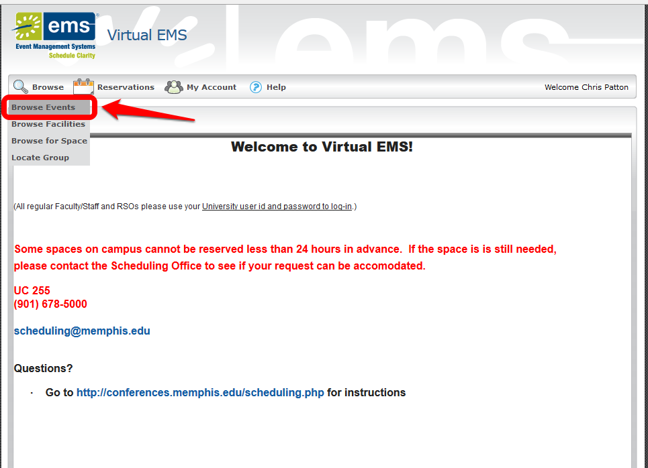

Creating a Filter
- By default, this will show all events in the school. Instead, we only want to see Law School events, so click on the “Filter” button in the top-right corner of the screen:

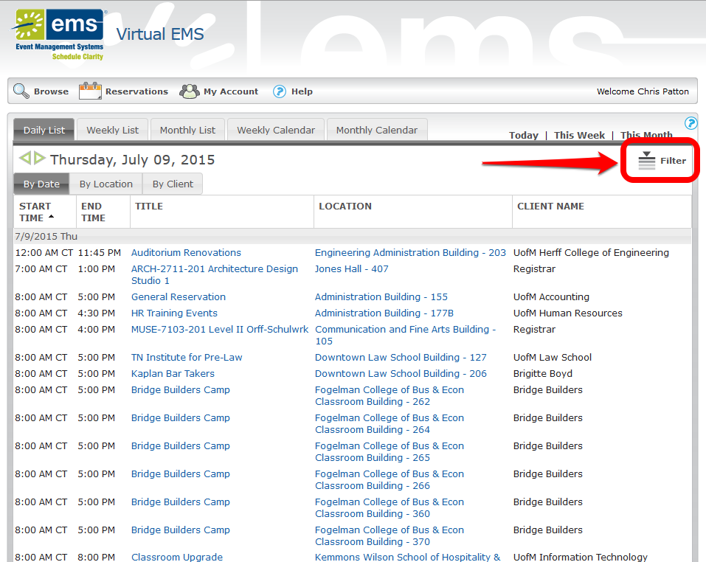

- From the Filter box, click on the drop-down menu next to “Facilities” and then click on “Downtown Law School Building”:

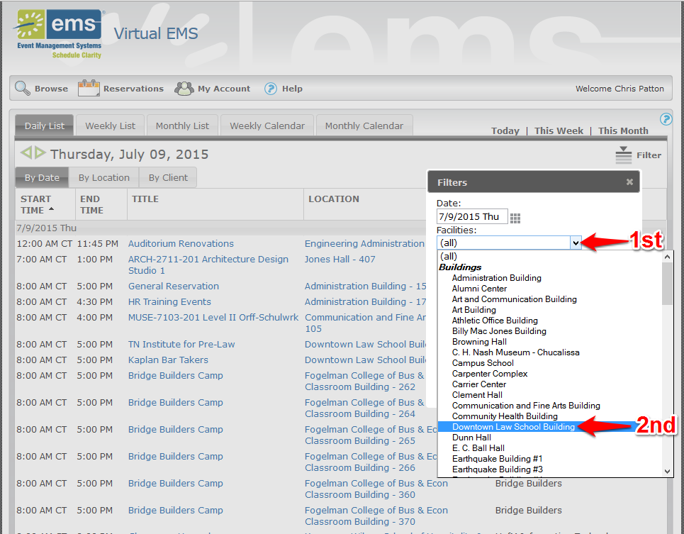

- Next click the box next to “Save” so that a checkmark shows up, then click “Apply”. By clicking save, the browser will save your setting, and will ensure that the calendar will only show you Law events in the future. You should only need to set this filter up the first time you use it, and it will apply automatically from then on.

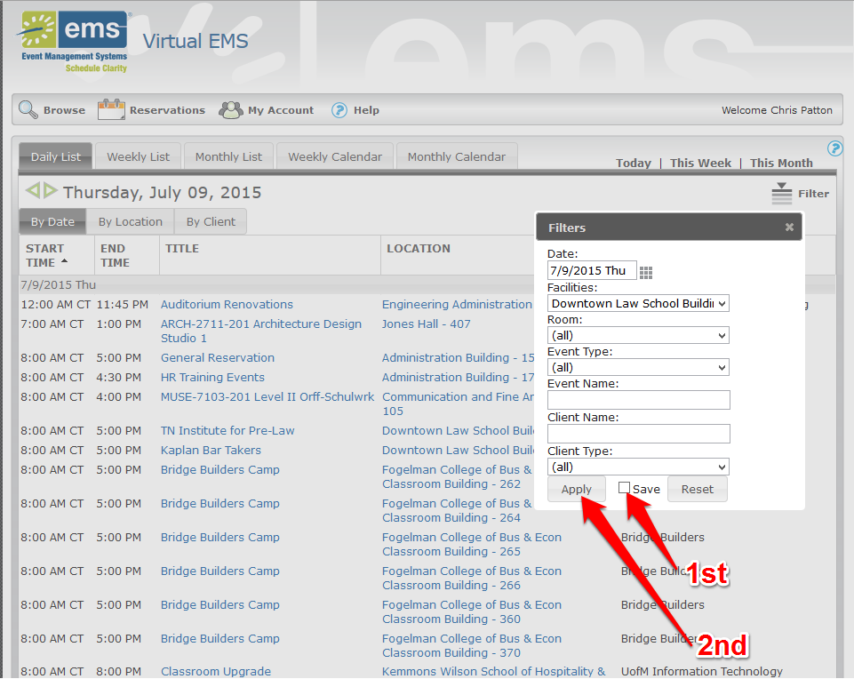

- Now that your filter is setup, you can view the calendar a number of different ways. These are selected by using the “tabs” at the top of the window.

Views

Default View – The page will automatically show you a daily list of all the events sorted by date.
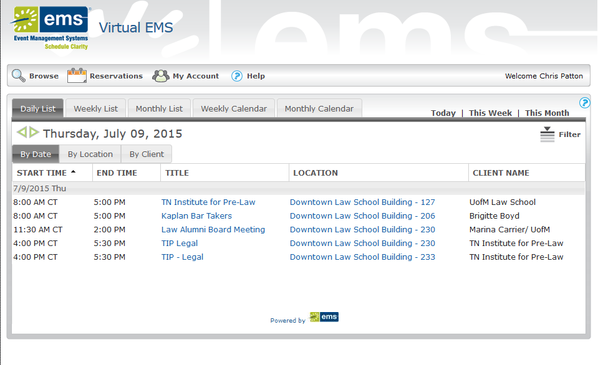

Weekly List View
Click on the “Weekly List” view option to view more events at once, and “Monthly List” view for an even further expanded list.
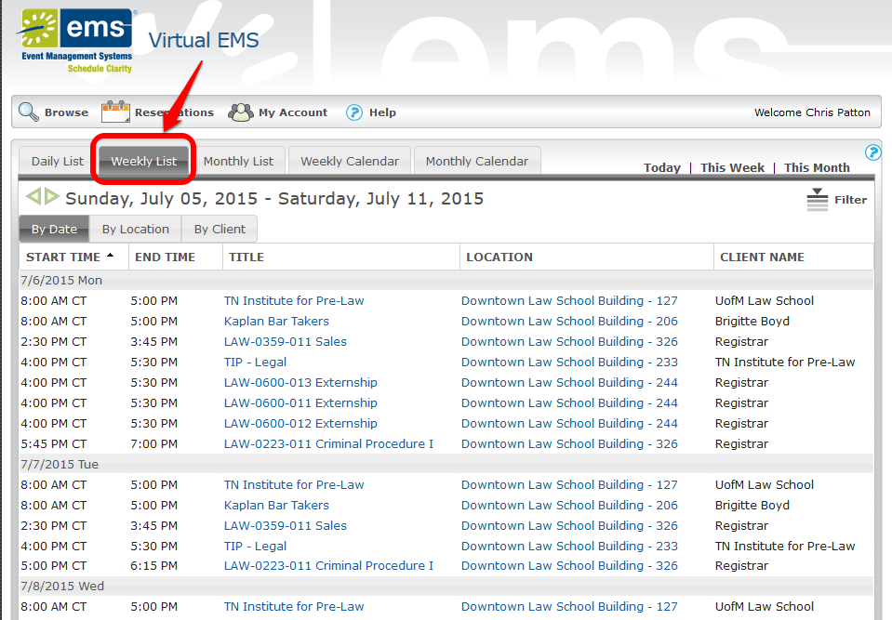

The “Daily”, “Weekly” and “Monthly” list also all have sub-categories, allowing you to sort events by “Location”, or “Client”.

Daily List - Location View
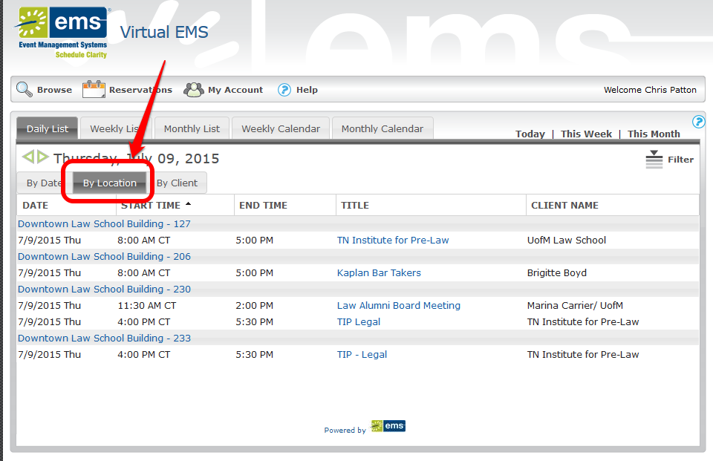

Daily List – Client View
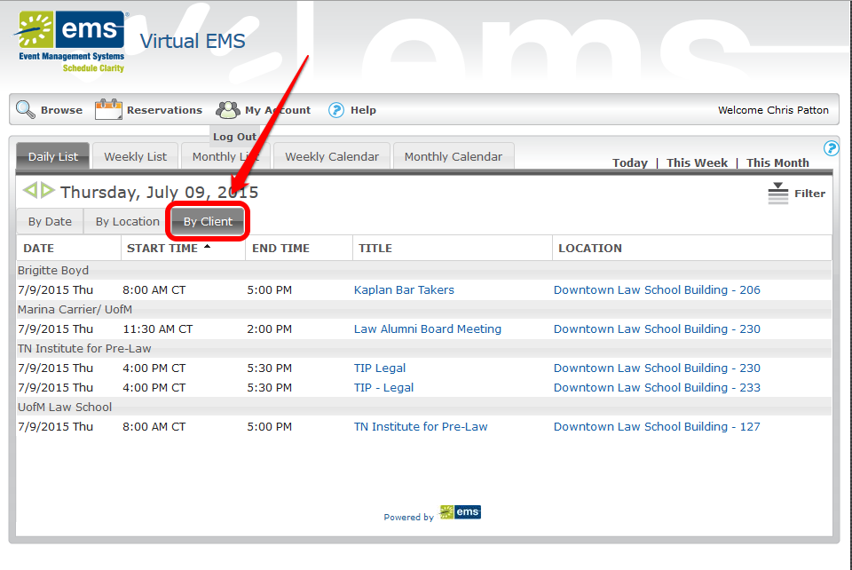

Weekly Calendar View
Click on “Weekly Calendar” or “Monthly Calendar” for a calendar layout of upcoming events:
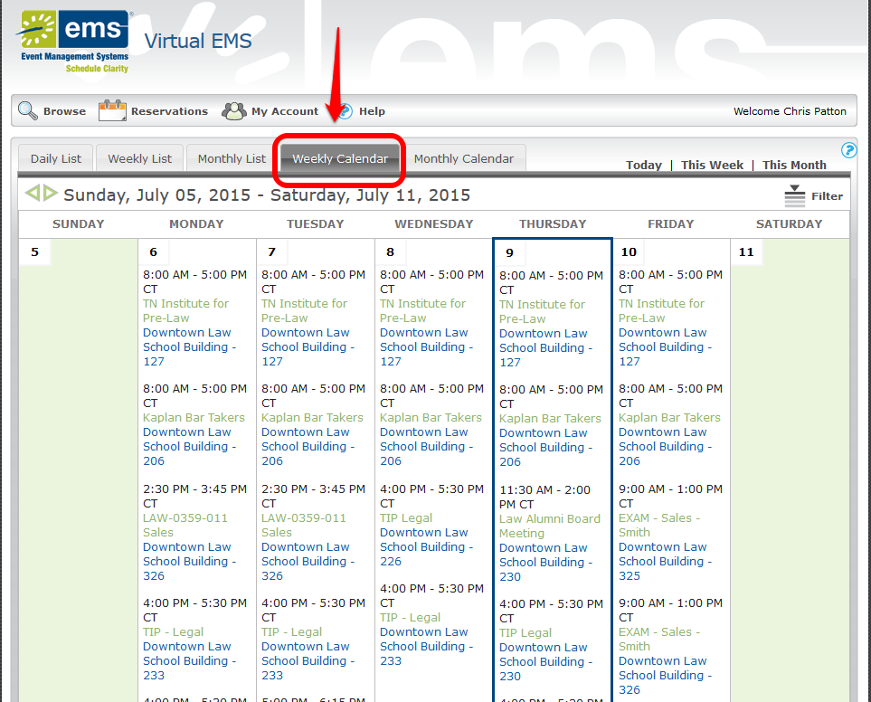
Beneath the “Browse” button are other options including “Browse Facilities” and “Browse for Space”. The first time you use these, you will need to follow steps #5 - #7 again to setup a filtered view of just the Law school. Once you click “Save” on the appropriate filter, you will not have to set it up again.

Browse Facilities
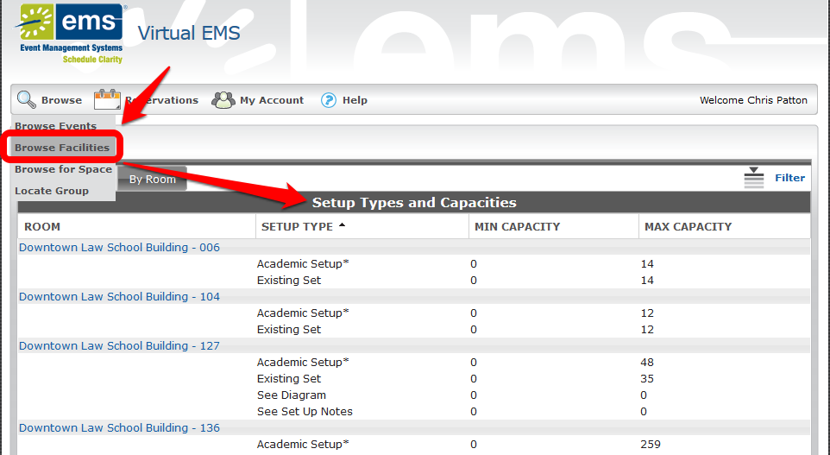

Browse for Space
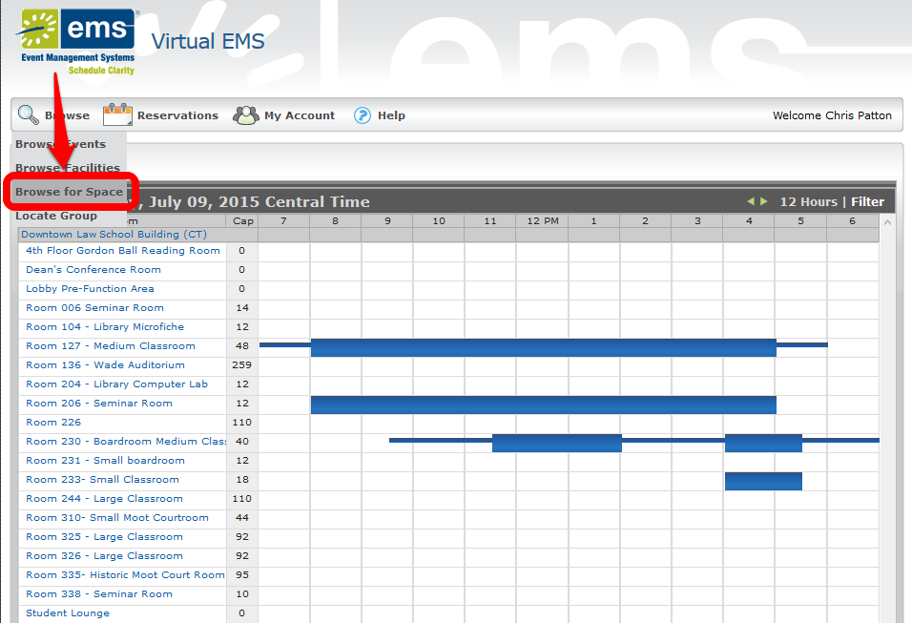

Reserving a Room
- Move your mouse to the “Reservations” button in the top left-hand corner of the page, and then click “Faculty Staff Selections”.
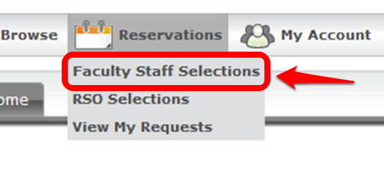
- This will bring up the reservation page, as seen below:

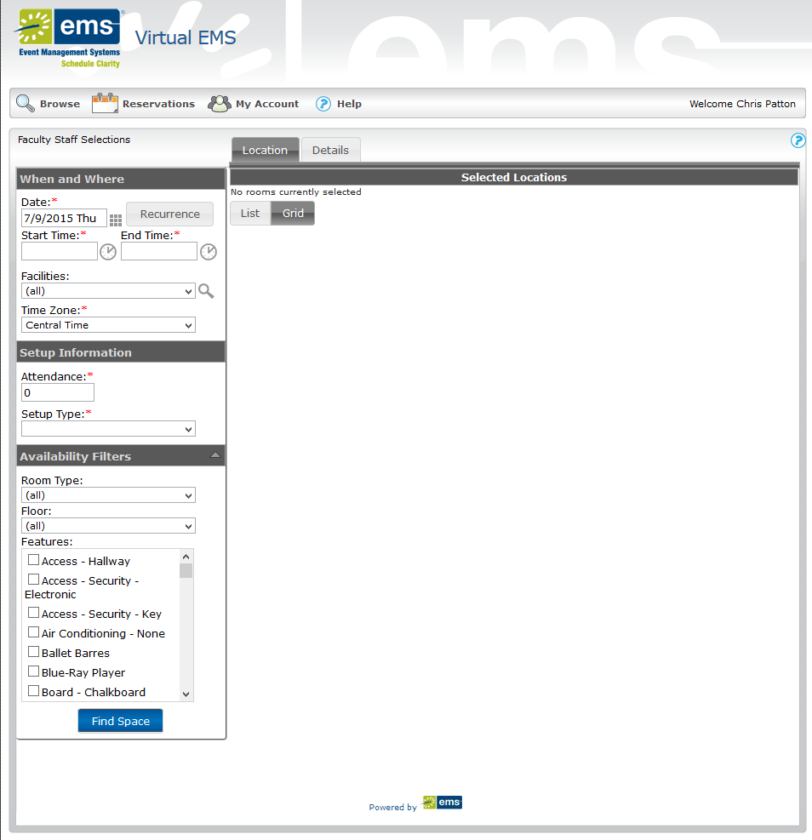

- Start with the “When and Where” section on the right-hand side.
  - Under “Date”, enter the date of your event
  - Next, enter the start time of your event. Click on the clock will produce a drop-down menu of times you can select from. By default, it will set the end time automatically to be one hour past your selected start time, but you can manually change this
  - Under “Facilities” select “Downtown Law School Building”.
  - Recurring Events: In the event you want to book an event for the same time on a number of different days, you may go to the "Recurrence" button and select the date pattern you want the event to meet. (When you use recurrence you may limit the number of spaces available to you, because a location may be available on one date and not on another). Ex: you may want to schedule a meeting the first Wednesday of every month for 6 months starting July 4th. Then click “Apply Recurrence”.
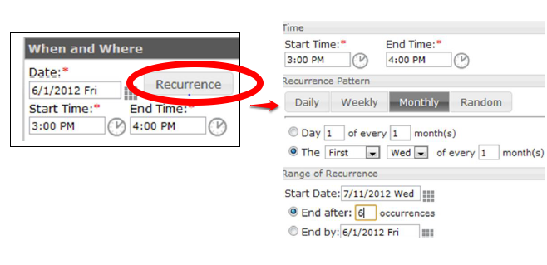

- Next, go down to the “Setup Information” section.
  - You must put in an attendance amount, and you must also choose a “Setup Type”.
  - The type of setup you choose will affect which rooms are shown as available. For example, Rooms 226 and 230 both have an Academic setup, but Room 226 does not have a “Conference Table/Chairs” setup, while Room 230 does. To see all the rooms, choose “Existing Set”.
- You may setup further limitations using the “Availability Filters” on the right, but it is probably best not to use these so that you can see everything in the building.

- Clicking on the “Details” tab will allow you to put in important information about your event.
  - All of the boxes with a red asterisk are required to be filled out.
  - You can also add attachments to the event from this page, such as flyers or pictures.
  - The box stating “Please indicate whether this event is to be posted to the Master Calendar” should be set to “Yes” so that the event will show up on the public law school calendar at http://www.memphis.edu/lawcalendar.
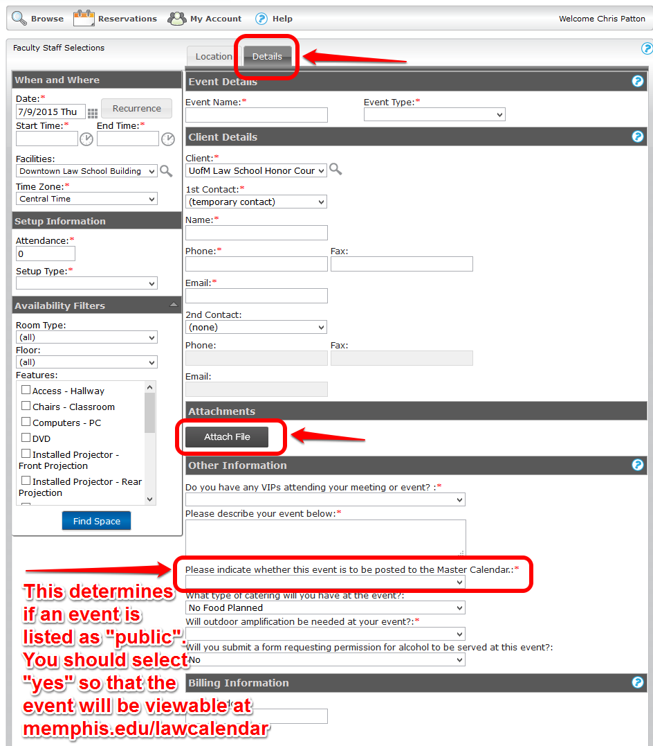

- Once everything is setup, click on the “Find Space” button, and a Grid of rooms matching your criteria will display, along with any other current reservations:

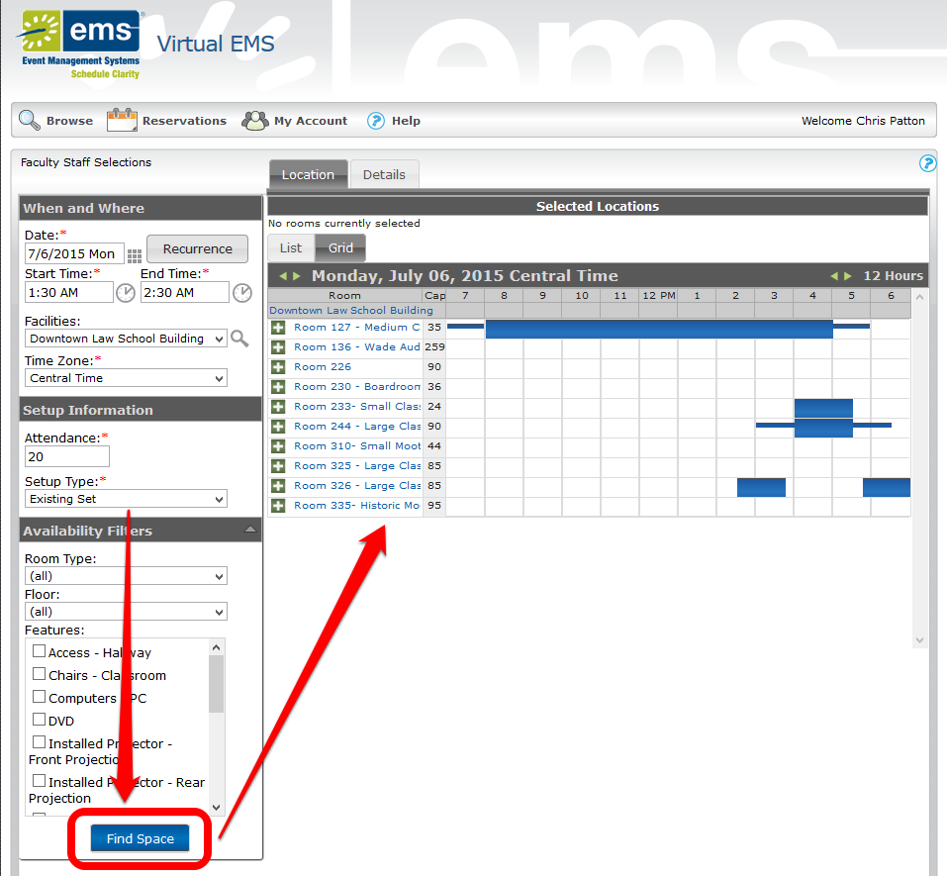

- Placing your mouse on an existing reservation will cause it to pop-up a window a showing information about the reservation:
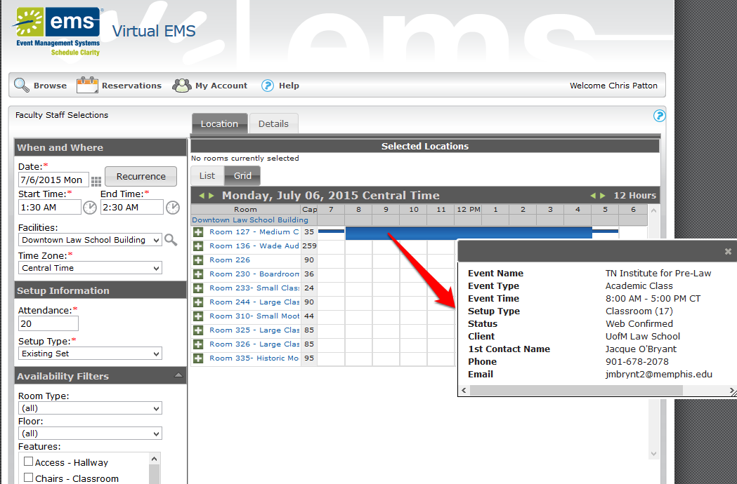

- Clicking on a Room will show a pop-up giving you further details about the room itself.

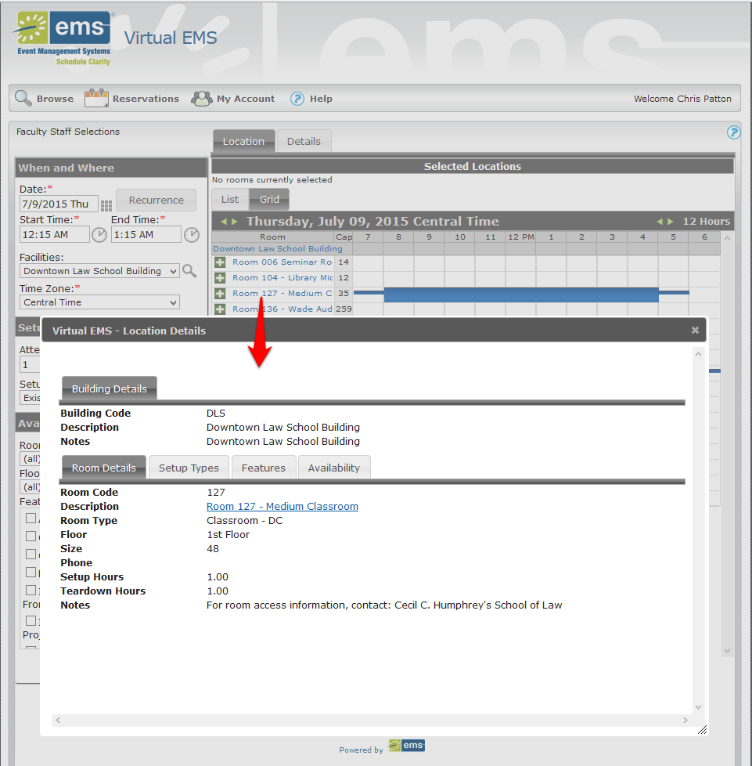

- Once you have chosen a room, click on the while plus sign in the green box to select it.
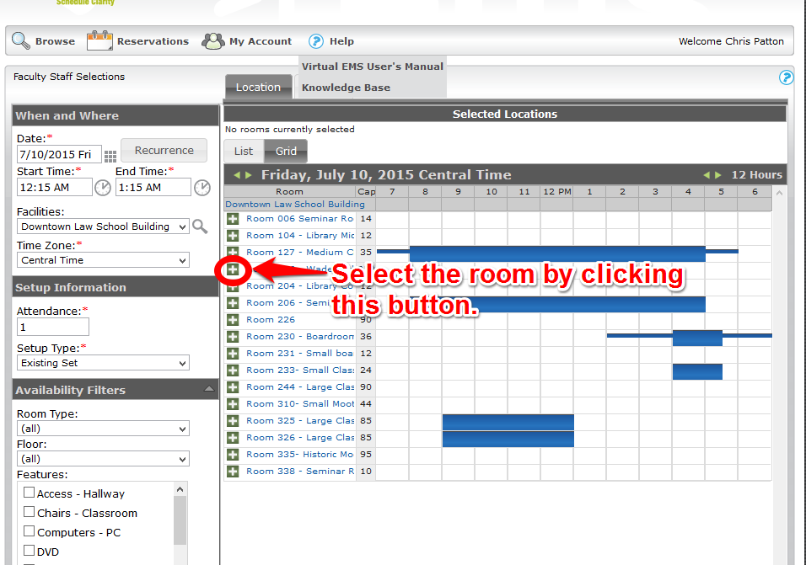

- Rooms you have selected will show up under the “Selected Locations” heading. You can select more than one location for the same event, but you may want to book each separately if you want to put unique event descriptions for each location in the “Details” tab.

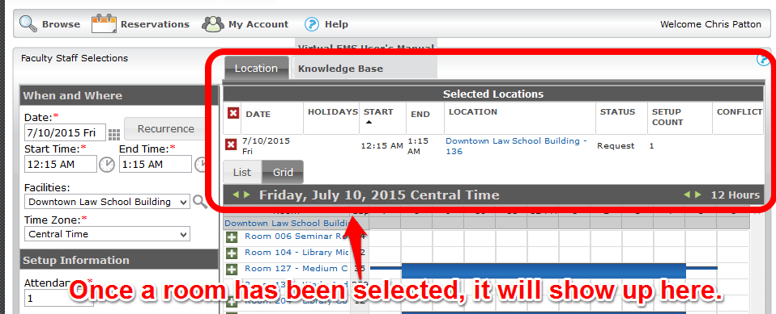

- Once all of your rooms have been selected, you must click the box next to “I have read and agree to the terms and conditions”, and the click the yellow “Submit” button at the bottom of the page.

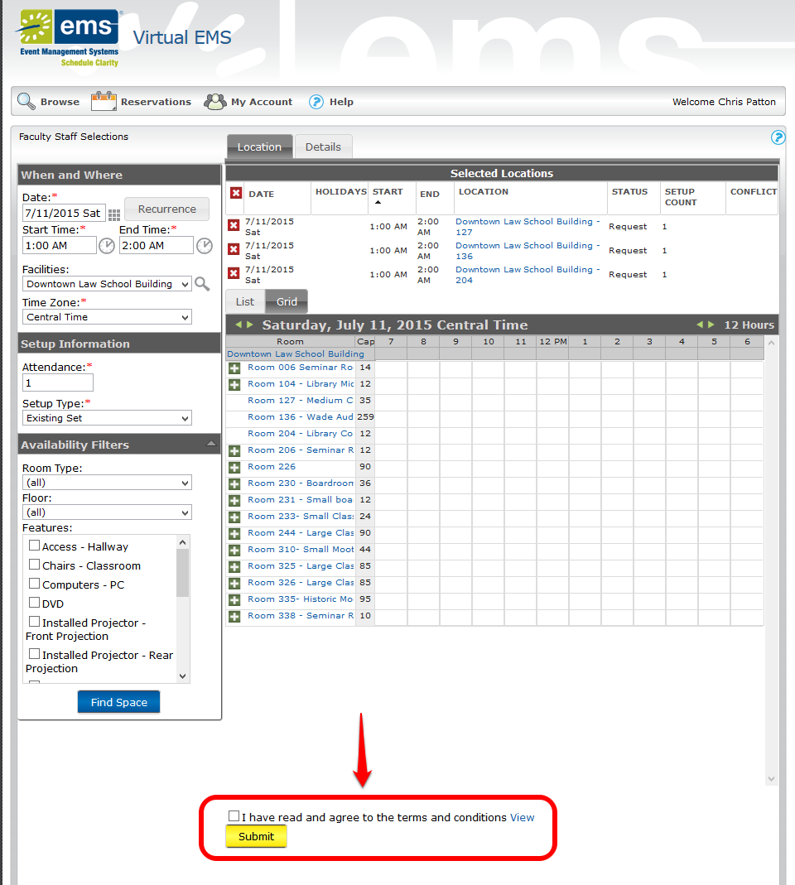

- Once you have clicked submit, an email will be generated to Cheryl and Ida, and they will approve your reservation, or contact you if they have any questions or concerns about your event.
- You can check your reservations at any time by moving your mouse over the “Reservations” button and then click “View My Requests”.

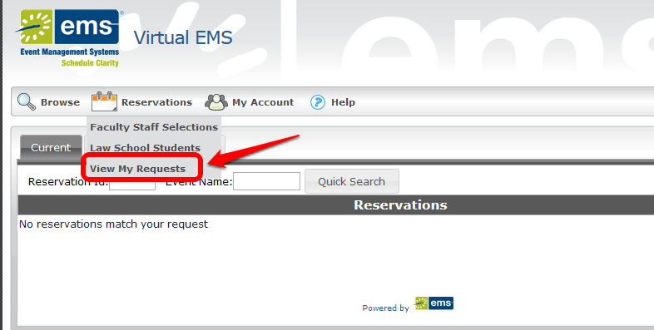

Help

If you have any problems or questions regarding this guide in specific or Virtual EMS in general, feel free to contact IT by email at lawit@memphis.edu, or reach out to us individually:
- Chris Patton (cpatton2@memphis.edu) – 901.678.3245
- Andrew Hughes (tahughes@memphis.edu) – 901.678.2823

