Memphis poverty fact sheet

The 2018 Update of the Memphis Poverty Fact Sheet, Produced Annually by Dr. Elena Delavega of the School of Social Work at the University of Memphis. Data from the 2017 American Community Survey Released in September 2018.

2018 Update



**2018 Memphis Poverty Fact Sheet**

**(Data from 2017 ACS)**

***Who are the Memphis Poor?***

The city of Memphis has a poverty rate of 24.6%. Child poverty is 39.0%, while the poverty rate for people over age 65 is the lowest of any age group at 14.2%. Poverty in Memphis has declined for almost all groups since 2016. The City of Memphis poverty rate for non-Hispanic Blacks is 28.9%; an important decrease from 32.3% last year. At the same time, the poverty rate for non-Hispanic Whites in the city of Memphis has decreased to 12.3%. In the Memphis Statistical Metropolitan Area (MSA), which includes parts of Tennessee, Arkansas, and Mississippi, the overall poverty is 17.1%, child poverty is 27.1%, poverty for people over age 65 is 9.8%, non-Hispanic Black poverty is 24.5%, non-Hispanic White poverty is 8.1%, and Hispanic or Latino poverty is 29.4%.

***The Poverty Rate in Memphis and Shelby County Compared to National Rates***

In general, poverty rates for the City of Memphis continue to be higher than poverty rates in Shelby County for every category. Both are higher than poverty rates in Tennessee, and Tennessee poverty rates are higher than U.S. poverty rates in almost every category (racial and ethnic groups, and age groups). The exception to this is the poverty rate for non-Hispanic Whites, which is lower in Shelby County than elsewhere. The poverty rate for non-Hispanic Whites in the MSA is, at 8.1%, also much lower than in the Tennessee or the United States, hinting at deepening racial disparities.

***Table 1 – Diverse Poverty Rates in Memphis, Shelby County, Tennessee, and the United States***

|  |  |  |  |  |  |  |  |  |
| --- | --- | --- | --- | --- | --- | --- | --- | --- |
| **2017 Poverty Rate** | **Overall** | **Under 18** | **18-64** | **Over 65** | **Non-Hispanic White** | **Non-Hispanic**  **Black** | **Latino** | **Asian** |
| **United States** | 13.4% | 18.4% | 12.6% | 9.3% | 9.6% | 22.9% | 19.4% | 11.0% |
| **Tennessee** | 15.0% | 21.2% | 14.2% | 9.2% | 12.1% | 24.3% | 24.5% | 10.6% |
| **Shelby County** | 18.8% | 30.2% | 15.9% | 10.5% | 8.0% | 25.4% | 30.1% | N/A |
| **Memphis city, Tennessee** | 24.6% | 39.0% | 20.7% | 14.2% | 12.3% | 28.9% | 33.3% | N/A |
| **Memphis, TN-MS-AR Metro Ar.** | 17.1% | 27.1% | 14.6% | 9.8% | 8.1% | 24.5% | 29.4% | N/A |

***New in 2018***

***Figure 1 – Percent of the Population under Poverty***

Memphis is no longer the poorest MSA with a population over a million people, and this is accompanied with reductions in poverty rates among all categories. Even the poverty rate of Hispanics, while higher than in the 2016 ACS, is much lower than in the 2015 ACS and exhibits an overall downward trend. This may be the result of reduced unemployment, but we must be cautious because unemployment is a lagging indicator and does not show improvements until after the rest of the economy has improved for a while. However, a very concerning problem, is the fact that poverty for adults over 65 increased for every geographical area. This may be the result of people turning 65 with less accrued income in Social Security as a result of the 2008 economic downturn at a critical juncture in their working lives.

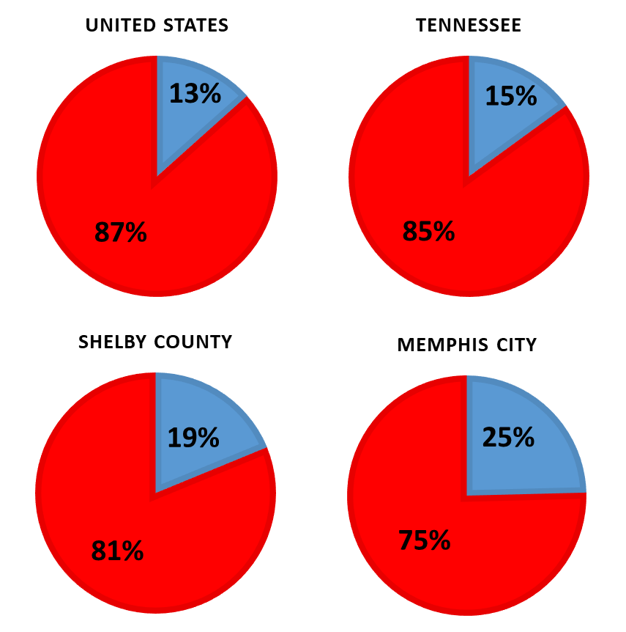

***Not-So-New in 2018***

What is not so new in 2017 is that Poverty continues to be much higher in Memphis than in the state or the United States, and racial disparities continue to exist. While poverty went down for Non-Hispanic Blacks and for Hispanics, the poverty rate for non-Hispanic Whites is much lower than in Tennessee and the U.S.

***Figure 2 – Poverty Rates in 2016 and 2017 in Memphis and Shelby County***

***Good News Overall – Maybe***

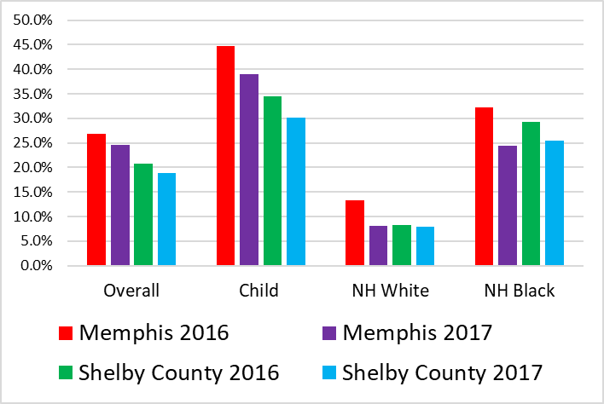Poverty in the U.S. continues to drop, and it appears that the Memphis area is finally beginning to catch up, particularly in Memphis and particularly for racial minorities. However, since the minimum wage has not increased since 2009, the drops in poverty may be the result of inaccurate measuring rather than actual decreases. At the same time, the increases in poverty for people over 65 in every geographical area is very concerning, but it is too early to tell if this is simply a statistical anomaly.

***Table 2 – Percent Change in Poverty Rates in Memphis and Shelby County***





***DETAILED POVERTY TABLES***

***Table 3 – The Poverty Intersection of Race and Age: United States***



***Table 4 – The Poverty Intersection of Race and Age: Tennessee***



***Tables 5 and 6 – The Poverty Intersection of Race and Age: Shelby County and Memphis***



***Table 7 – The Poverty Intersection of Race and Age: Memphis Metropolitan Statistical Area (MSA)***



***Disparities***

There are a number of disparities in poverty and income throughout the United States, and particularly in Memphis. Racial disparities, and disparities by age group jump at the observer, but there are other, more subtle disparities that must also be noted. In reporting income, the median is usually used because it provides a more accurate picture of the “typical” income, or the amount of money that a “typical” household receives for a given time period. The mean (average) is not used because outliers can really inflate this number. The median marks the middle of a distribution, that is, half of those at the median make less, and half of those above make more money. When the mean is much larger than the median, it hints at deep disparities within groups. In the city of Memphis, the mean (average) income for non-Hispanic Whites is a whopping 61% larger than the median income for this group. This indicates great disparities among non-Hispanic Whites, and reflects the entrenched problem of disparities in Memphis. Poverty is a problem, but perhaps a larger problem and a driver of crime and social disintegration is the social inequality that cuts across geography, age, and race.

***COMPARING MEMPHIS***

***Poverty Rankings***

In 2017, Memphis dropped to second place in both overall poverty and child poverty among Metropolitan Statistical Areas (MSA) with populations greater than 1,000,000. This drop in rank for both overall poverty and child poverty was accompanied by an overall decrease in poverty, which follows the general pattern in the United States. When including MSAs with populations greater than 500,000, Memphis has shown improvements as well.

***What the Rankings Mean***

The rank number denotes the position of a city or MSA relative to others. The higher the rank number, the higher the poverty rate for that locality. In other words, a higher ranking is not desirable. Note that there are fewer cities with more than a half-million people than Metropolitan Statistical Areas (MSA) with more than a million people. This is because MSAs comprise a larger territory. As a result, Memphis is both a city with more than 500,000 people and an MSA with a population greater than one million, but not all

MSA with more than 1,000,000 people include cities with more than half a million people. It is important to note that geographies with smaller sizes tend to have greater poverty rates. Poverty can be as high as 100% of the population in certain small rural localities.

Rankings provide the necessary context to understand poverty rates. A low poverty rate that is still higher than other similar populations is not necessarily a good thing; and a high poverty rate when examined in the context of other populations may indicate that the city is performing better than others. In 2018 (from the 2017 ACS), Memphis appears to have gained ground vis-à-vis other cities and has ”gained” in rank, “falling” to second place.

***Note:*** *There are 53 MSAs with populations over 1,000,000 and 107 MSAs with populations over 500,000 in 2017. There was no change in the number of MSAs of each size from 2016. In 2014 there were 52 MSAs with populations over 1,000,000 and 104 MSAs with populations over 500,000.*

***Table 9 – Memphis’ Rank in Poverty Rates***

|  |  |  |  |  |  |  |
| --- | --- | --- | --- | --- | --- | --- |
| **Memphis** | | **2016** | | **2017** | | |
| **Poverty Rate** | **Poverty Rank** | **Poverty Rate** | **Poverty Rank** | **Rank Change** |
| **Among Cities with Populations Greater than 500,000 (34 Cities)** | **Overall** | 26.6% | 3rd | 24.6% | 4th | -1 |
| **Under 18** | 44.7% | 2nd | 39.0% | 2nd | ---- |
| **Among MSA with Populations Greater than 500,000 (107 MSA)** | **Overall** | 19.4% | 5th | 17.1% | 6th | -1 |
| **Under 18** | 30.8% | 5th | 27.1% | 6th | -1 |
| **Among MSA with Populations Greater than 1,000,000 (53 MSA)** | **Overall** | 19.4% | 1st | 17.1% | 2nd | -1 |
| **Under 18** | 30.8% | 1st | 27.1% | 2nd | -1 |

***Table 10 – Highest Poverty Rates in Cities and MSA in the United States***

|  |  |  |  |  |  |
| --- | --- | --- | --- | --- | --- |
| **Highest Poverty Rates**  **Rank 1** | | **2016** | | **2017** | |
| **Rank 1** | **Poverty Rate** | **Rank 1** | **Poverty Rate** |
| **Among Cities with Populations Greater than 500,000 (34 Cities)** | **Overall** | Detroit City, Michigan | 35.7% | Detroit City, Michigan | 34.5% |
| **Under 18** | Detroit City, Michigan | 50.8% | Detroit City, Michigan | 48.2% |
| **Among MSA with Populations Greater than 500,000 (107 MSA)** | **Overall** | McAllen-Edinburg-Mission, TX Metro Area | 31.4% | McAllen-Edinburg-Mission, TX Metro Area | 30.0% |
| **Under 18** | McAllen-Edinburg-Mission, TX Metro Area | 44.2% | McAllen-Edinburg-Mission, TX Metro Area | 42.4% |
| **Among MSA with Populations Greater than 1,000,000 53 MSA)** | **Overall** | Memphis, TN-MS-AR Metro Area | 19.4% | New Orleans-Metairie, LA Metro Area | 18.6% |
| **Under 18** | Memphis, TN-MS-AR Metro Area | 30.8% | New Orleans-Metairie, LA Metro Area | 27.1% |

***Table 11 – Top Ten MSA in Overall Poverty***



***Table 12 – Top Ten MSA in Child Poverty***



***In Memphis, poverty rates have fallen, and this is good news. We are not “number 1” in poverty in 2018, in either overall or child poverty. While positive, we must approach this with cautious optimism.***

***THE RACIALIZATION OF POVERTY***

***The Relationship between Poverty and Race***

It has now been observed for several years that the poverty rate among non-Hispanic Whites Only is much lower in Shelby County than in the state or the nation as a whole. However, poverty among non-Hispanic Whites did not decrease as much as for all other groups. At the same time, poverty for the entire MSA fell significantly. It is important to emphasize that although increasing in the Memphis MSA, the poverty rate for this group continues to be lower in Shelby County than in the rest of the nation.

The poor in Memphis tend to be minorities. The poverty rates for Blacks and Latinos (although decreasing for Latinos) are higher than the overall poverty rate, and poverty rates for minorities are higher in every age category than poverty rates for non-Hispanic Whites. Moreover, poverty rates for non-Hispanic Whites are lower in Shelby County than in Tennessee as a whole or the United States in every age category.

***The Poverty Rate and Rank for Non-Hispanic Whites***

It is very interesting to note that while Memphis ranks first in poverty among large metro areas (population greater than 1,000,000), when the rate for non-Hispanic Whites is considered by itself, Memphis is positioned much lower in the list, ranking 28th among 53 metro areas. The differences between the poverty rates of minority groups and non-Hispanic Whites are striking. However, it is important to note that the poverty rate among non-Hispanic Whites in the city of Memphis is much higher than the poverty rate for this same group in Shelby County and in the Metropolitan Statistical Area. Memphis will not be able to become the first-class city it could become while racial disparities continue.

***Table 12 – Comparison of Poverty Rates and Poverty Trends for non-Hispanic Whites Only and Blacks Only***

|  |  |  |  |  |
| --- | --- | --- | --- | --- |
| **Memphis**  **non-Hispanic Whites Only** | **2017** | | | |
| **Overall Poverty Rate** | **Overall Poverty Rank** | **non-Hispanic White** **Poverty Rate** | **non-Hispanic White Poverty Rank** |
| **Among Cities for which data are provided (34 cities)** | 24.6% | 4th | 12.3% | 7th |
| **Among MSA for which data are provided (53 MSA)** | 17.1% | 2nd | 8.1% | **28th** |

***Figures 3-4 – Comparison of Poverty Rates and Poverty Trends for non-Hispanic Whites Only and Blacks Only***

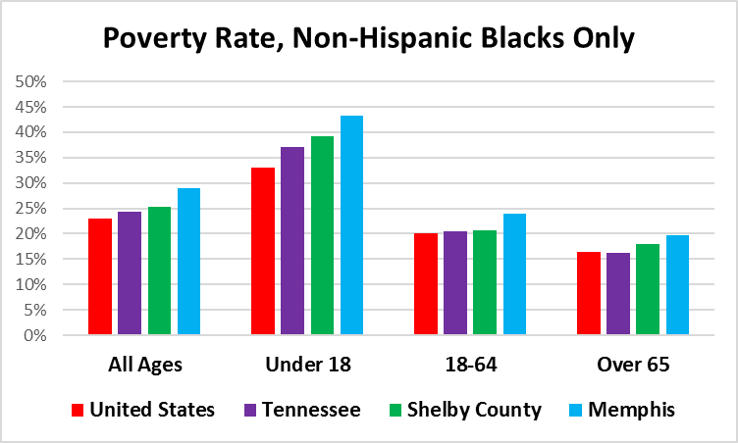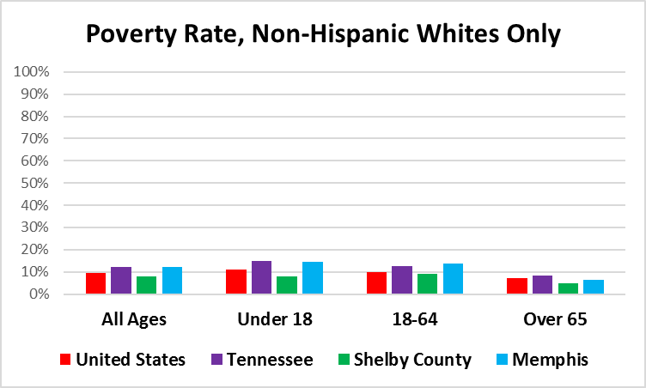

***Minorities suffer greater rates of poverty than non-Hispanic Whites in Memphis and Shelby County.***

***Trends in Poverty Rates***

The poverty rates for non-Hispanic Whites are better in Shelby County than for the same group in Tennessee or the United States, while the rates for Blacks are generally worse in Memphis and Shelby County than Tennessee or the nation. It is also interesting to note that for non-Hispanic Whites, the worst poverty rates are at the state and the city level. Given that the majority population in the state (in contrary to the city of Memphis) is White, it is clear that the driver for poverty in the state is White poverty.

***Poverty Trends – Has Poverty Gotten Better?***

Since 2005, poverty rates in Memphis rose steadily and the 2008 economic crisis resulted in increased poverty rates for all racial and age groups at that time, and although declining this year, remain high. It is important to note that some groups were able to recover much sooner, clearly an indicator of the pervasive disparities in the region. The overall picture in Memphis in 2018, from the 2017 Census estimate, is encouraging, but it is too soon to tell whether this is a statistical anomaly or it is a trend. It is also possible that the way we measure poverty, with the Orshansky method, which has not changed in decades, even though the needs of people in the modern world are very different.

***Why Is Poverty High in Memphis?***

One possible explanation is that the labor market in Memphis tends to consist of unskilled workers in the warehouse industry. The lack of comprehensive, effective, and efficient public transportation also makes progress against poverty very difficult. Finally, the divide between the city and the county, as evidenced by the racial and geographical differences in poverty, tends to deprive the city of Memphis of the funds it needs to support the region.

***Falling to second place is good news, but it is not great news when we continue having high poverty rates; when the child poverty rate is still so high that four in ten children live in poverty; and when racial disparities continue glaringly.***

***Figure 5 – Trends in Poverty Rates by Age, Memphis***

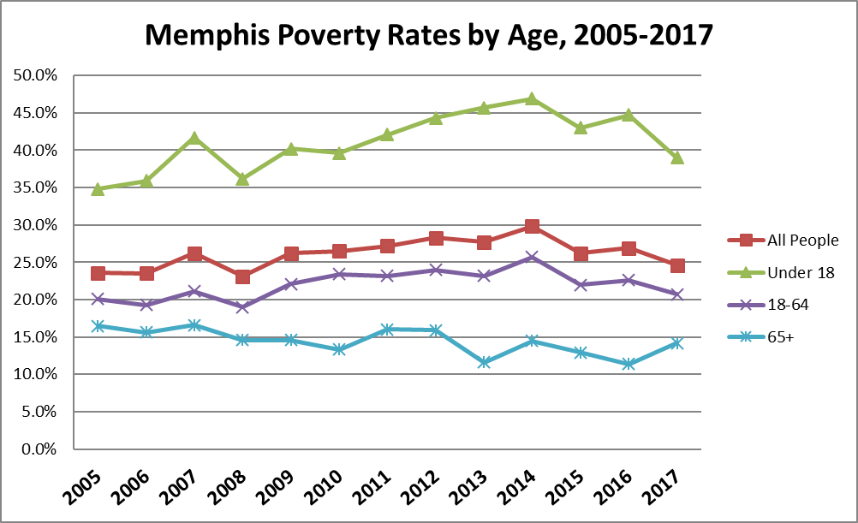

***Figure 6 – Trends in Poverty Rates by Age, Shelby County***

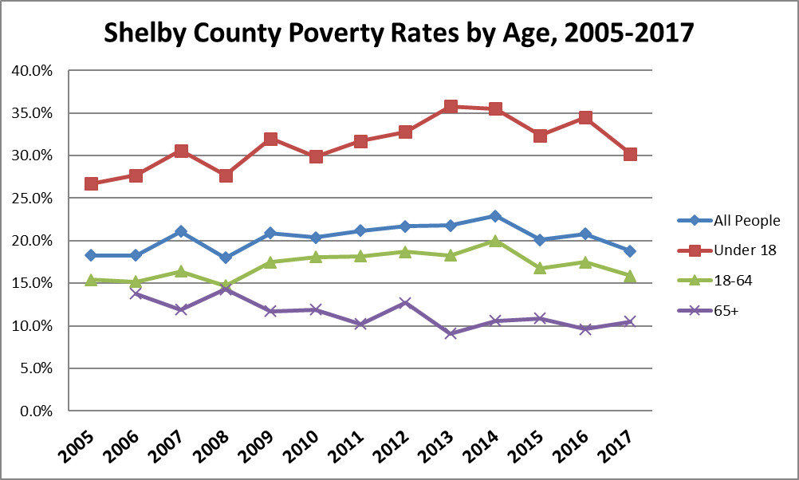

***Figure 7 – Trends in Poverty Rates by Race, Memphis***

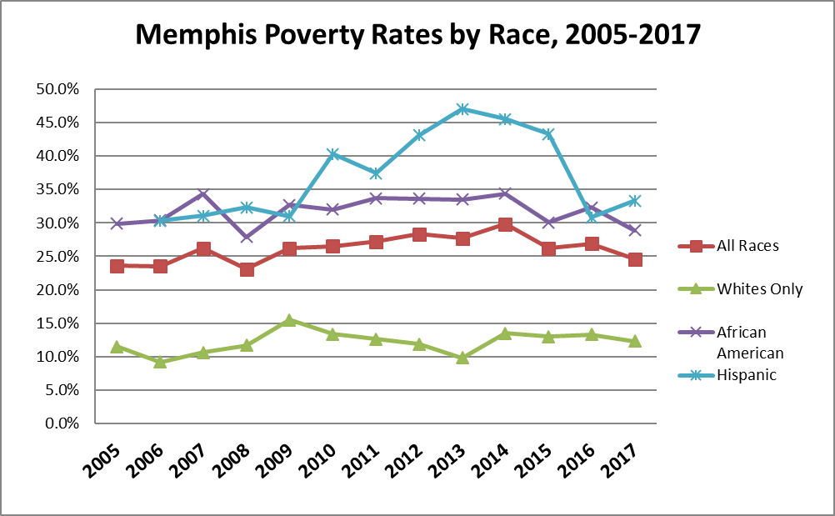

***Figure 8 – Trends in Poverty Rates by Race, Shelby County***

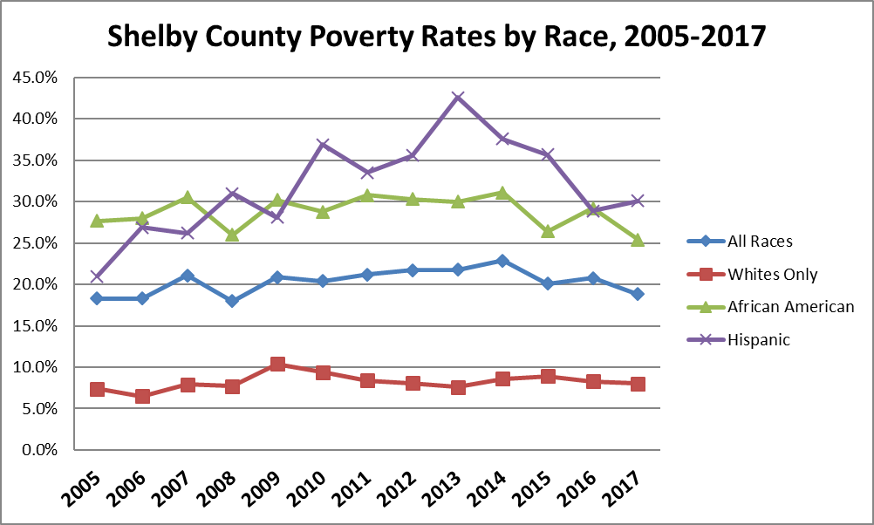

***A community cannot have such high percent of people in poverty without affecting everyone. We have to understand that to eliminate poverty, we need to work together for the benefit of all.***

***#SharedRiskforSharedProsperity***

*The School of Social Work at the University of Memphis is dedicated to understanding poverty and its causes through research and engaged scholarship. Our purpose is to identify the most effective ways to eliminate poverty and promote social and economic development for our region.*

*The mission of the Benjamin L. Hooks Institute for Social Change is to promote civil rights and social change, primarily through teaching, research, innovative campaigns, and community engagement*

*If you would like more information on Memphis poverty, please contact Dr. Elena Delavega at* [mdlavega@memphis.edu](mailto:mdlavega@memphis.edu)

All tables and graphs by the author. All rights reserved.

Sources:

Data obtained from the US Bureau of the Census, September 13, 2018

All Data except Latino (Hispanic): 2011, 2012, 2013, 2014, 2015, 2016, and 2017ACS 1-Y Estimates (Table S1701: Poverty Status in the Past 12 Months. Other Tables: DP03, C01001); 2005, 2006, 2007, 2008, 2009, 2009, 2011, & 2012 American Community Survey 1-Year Estimates (US Bureau of the Census)

Latino (Hispanic) Data: 2007, 2008, 2009, 2010, & 2011 American Community Survey 3-Year Estimates and 2016 5-Year Estimates (US Bureau of the Census).