Mid-South ACT Hosts Mini-Demonstration and Informational Session for VR Clients
October 9, 2012
Mid-South Access Center for Technology (ACT) is hosting an informational session for Vocational Rehabilitation (VR) clients on Friday, October 12, 2012 in the Mid-South ACT lab, Patterson 111. This event will feature a mini-demonstration session for individuals who would like to learn more about Assistive Technology (AT) devices and Accessing GED® /GRE® test preparation materials.
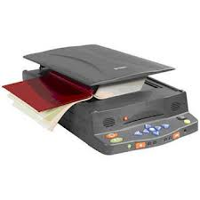
The AT mini-demonstration will feature the SARA (Scanning and Reading Appliance) by Freedom Scientific from 10 am until 12 noon. This Assistive Technology (AT) device is a talking scanner and an easy approach to reading books and other documents.

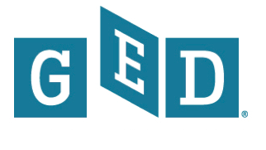
Also, an informational session from 11am until 1pm will highlight the Accessing GED® /GRE® Test Preparation Materials. This informational session will guide VR clients through accommodations, test-taking strategies, and practice tests to prepare for the GED® or GRE® Exams. The GED® test is the nationally accepted high school equivalency test. The Graduate Records Examination® (GRE®) is a nationally accepted test for students with an undergraduate degree that is applying for graduate school admission.

