Enabling Personal Availability Link

- Access My Availability tab on the Staff Home
- Select “Edit” to edit existing availability or select “Add Time” from the Actions dropdown to add additional availability

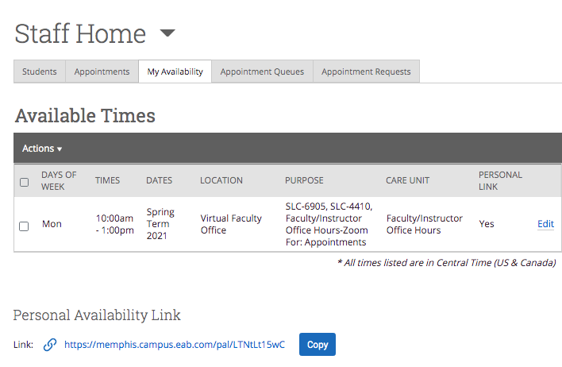

- Select the checkbox for “Add this availability to your personal availability link?”

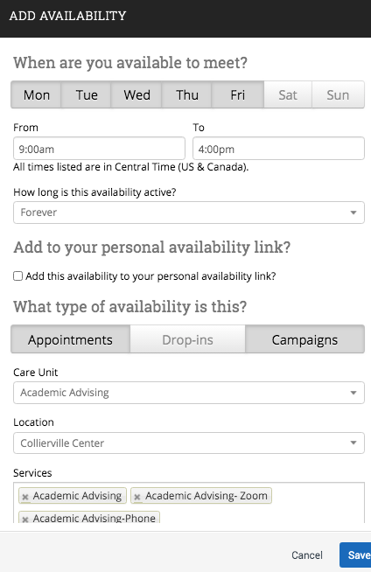

- Click Save
- Copy the personal availability link displayed at the bottom of the My Availability tab

Frequently Asked Questions
- What does the personal availability link do?
The personal availability link provides a direct link to your scheduling screen and eliminates several steps for students. Without using the personal availability link, students must login to Navigate and click on the Schedule An Appointment button and then select the type of appointment (i.e. advising, tutoring, etc,), service (i.e. Advising- Phone, Advising- Zoom, etc.), and location before making it to your scheduling screen. This link simply expedites that process and eliminates the possibility that a student makes an incorrect selection.

- How can I best use the personal availability link?
  - Update your email signature to include your scheduling link
  - Update your college/department website to include your scheduling link
  - Send students who haven’t been cleared or scheduled an appointment a text message with the personal availability link. Tip: Use bitly.com to convert your personal availability link into a much shorter link in order to save more characters for your message (https://memphis.campus.eab.com/pal/LTNtLt15wC can be shortened to https://bit.ly/39MdNEf )

- If a student who is not one of my advisees accesses my personal availability link, will he/she be able to schedule with me?
No, the personal availability link still enforces the use of any restrictions in place that keep students who are not your advisees from scheduling with you.

