Login to Navigate at https://memphis.campus.eab.com or through the link in the myMemphis portal

Click on the blue Schedule an Appointment button in the upper right of the screen


Make the appropriate selections from the three drop down menus based on the type of appointment you wish to schedule and click Next. The example below shows the selections for an In Person appointment with your Academic Advisor
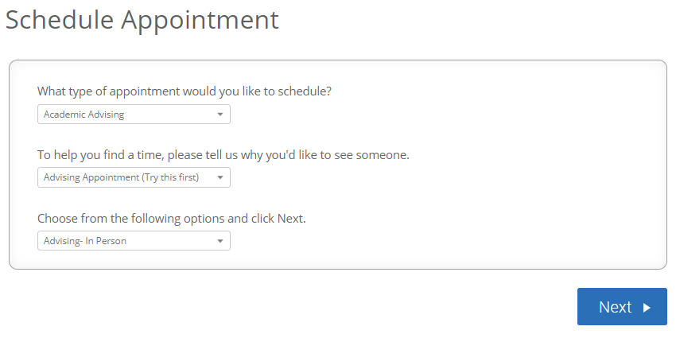

Select the appropriate location and click Next. In most cases, you will only have 1 option.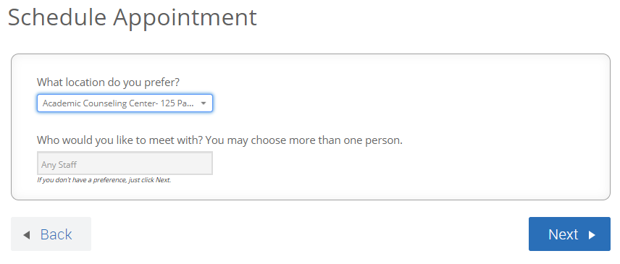

You can scroll from one week to the next and click on Morning or Afternoon to see available times
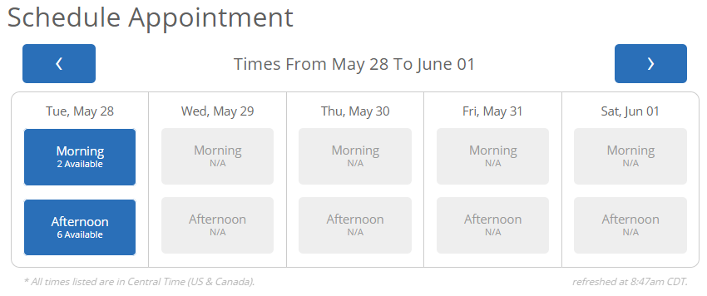

Select the date/time that works for you and click Next

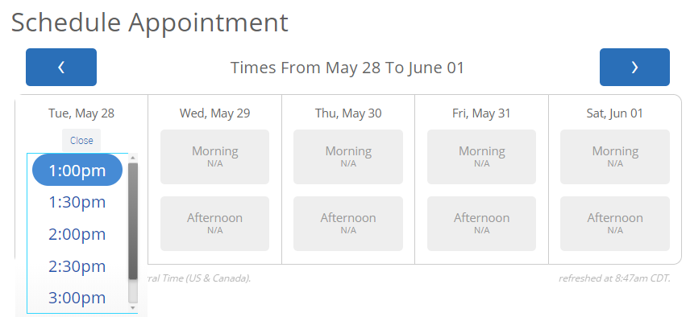

Confirm that all details are correct including the mobile number displayed for your text message reminder. Click the blue Confirm Appointment button to schedule your appointment.
