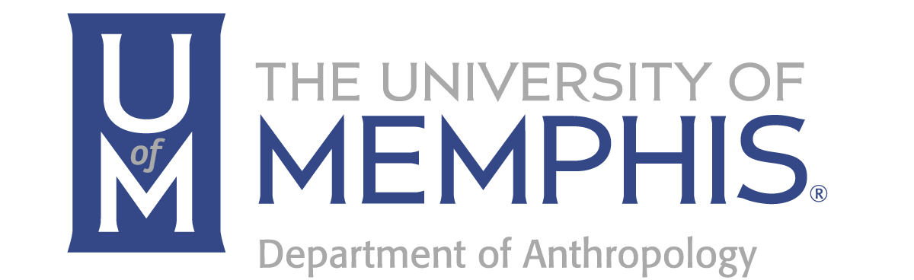
Engaged Scholarship: Honoring the Legacy of Tim Bolding
The passing of Tim Bolding, 77’ ANTH, '80g ANTH, 2003 Outstanding Alumnus award recipient and adjunct faculty member, greatly impacted many of us across the applied anthropology and community development communities.

As the founding director of United Housing, Inc. (UHI), Tim led the transformation of community development in Memphis. His vision for an engaged model of affordable housing development and homeownership training became a driving force in how many of Memphis’ CDC’s operated and leveraged community assets. He grew this model to include not only training for prospective buyers and the development of affordable homes but also established lending resources for those often unable to qualify in the traditional market. The impact of his leadership can be seen in the ongoing work of UHI and the impact on the lives of over 6,800 individuals and families who received homeownership counseling and the over 2500 homes purchased with assistance from UHI in Memphis and Shelby County.

For over 30 years, Tim built a system of engaged scholarship through internships and student engagement opportunities at UHI. While increasing homeownership may be Bolding's biggest impact, what he did to build the young leadership throughout the community truly stands out.
Tim’s ability and desire to train students, particularly from the University of Memphis, to be involved in community development projects was rooted in the anthropology department, but crossed all disciplines.

To honor the legacy of Tim’s work, Paige Walkup, ANTH ‘99, the University of Memphis Anthropology faculty, and its Community Advisory Board have created the Tim Bolding Award in Urban Anthropology & Community Development. This fund is dedicated to growing Tim’s legacy, exposing University of Memphis Anthropology graduate students to community development opportunities, and expanding their professional skills through the extensive community networks maintained by the University of Memphis Anthropology alumnus.

This award will be designated for a first year University of Memphis Anthropology graduate student focused on urban anthropology and community development and renewable for one year.

Together, we can grow Tim’s legacy through this award fund. We encourage each of you to consider making a gift to support developing new leaders in the anthropology community. Over the coming weeks, you will be hearing from us about this exciting opportunity. Through generous gifts, our team has raised $10K of our $30K goal to build this award into an endowed scholarship. Follow the link below to contribute to this effort and help us realize Tim Bolding’s vision for engaged scholarship.

Mairi Albertson, Chair Paige Walkup, Chair
Anthropology Advisory Board Tim Bolding Award Committee

