**NURSE CADET**

**HANDBOOK**



**TABLE OF CONTENTS**

**Page 3 – Academics**

**Page 5 – Army Physical Training**

**Page 6 – Cadet Training**

**Page 8 – Accessions (branching) Process**

**Page 10 – Clinical Nurse Transition Program**

**Page 11 – Patient CaringTouch System**

**Page 12 - Reimbursable/Non-reimbursable Fees**

**Page 14 – Websites**

**Academics**

Always strive for academic excellence. Nursing is a very demanding major. Working hard from the start will set you up for success as you continue through the nursing curriculum. In order to stay on track for progressive or competitive entry in your nursing program, follow the published school course guidelines and strive to maintain a 3.5 or better in your science prerequisites.

Take time to read through your ROTC contract (DA Form 597-3 or 597) and remember to maintain a copy for your records. This contract represents an agreement between the US Army and you. See below excerpt from the ROTC contract.

ACADEMIC GRADE POINT AVERAGE AGREEMENT. I agree to maintain, at a minimum, a cumulative academic grade point average of 2.0 on a 4.0 or equivalent scale. This GPA must also be maintained for each semester or quarter. *If I am required by my academic major or by the school I am attending to maintain a higher cumulative and semester or quarter GPA, I agree to maintain that higher standard until the completion of the academic requirements for my degree.* I understand and agree that failure to maintain the minimum academic GPA may subject me to disenrollment from the ROTC program.

If your program requires you to apply to their school of nursing, please be aware that published minimum standards may not be competitive for acceptance. Due to the numerous applicants applying into Upper Division (UD), a school’s published requirement may be a 2.5 GPA for entry, while a competitive GPA may require a 3.6 or above. If you are uncertain of specific admission requirements, consult your brigade nurse counselor (BNC) or school of nursing faculty advisor for guidance.

There are three basic options for students who are not accepted into upper division:

1. Remain at the school and re-apply the following year.
2. Transfer to another school’s nursing program with approval of the Professor of Military Science (PMS).
3. Remain at the school with a change of major, which will result in loss of one semester of benefits if your change of major is approved or complete loss of scholarship.

Balancing the demands of nursing school and ROTC during your junior year can be very difficult. The junior year of nursing school may have various clinical rotations at many different times while the junior year of ROTC involves concentrated preparation and evaluation for Leadership Development and Assessment Course (LDAC) the following summer. There are options to mitigate this challenge. Nurse Cadets have found it helpful and beneficial to participate in the Alignment Option Program (AOP), see below graph. Realigning the military science curriculum may help maximize participation in ROTC while focusing on nursing academics your junior year. This AOP needs to be approved and supported at the battalion (BN) level.

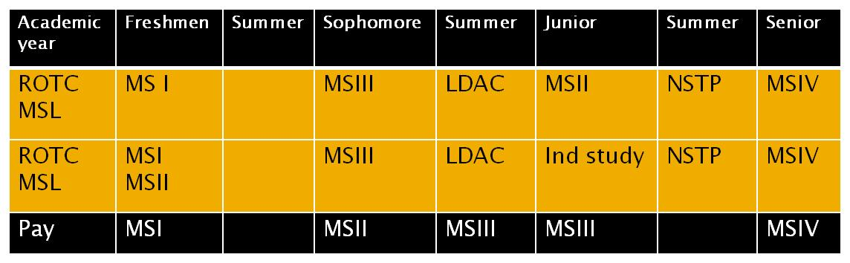 The Cadet Command Form 104-R is a required tool used to track your academic progression through school. Each semester it needs to be updated and signed by your academic nursing advisor. It is important to bring this to each nurse counseling session and review with your BNC. The 104-R must be 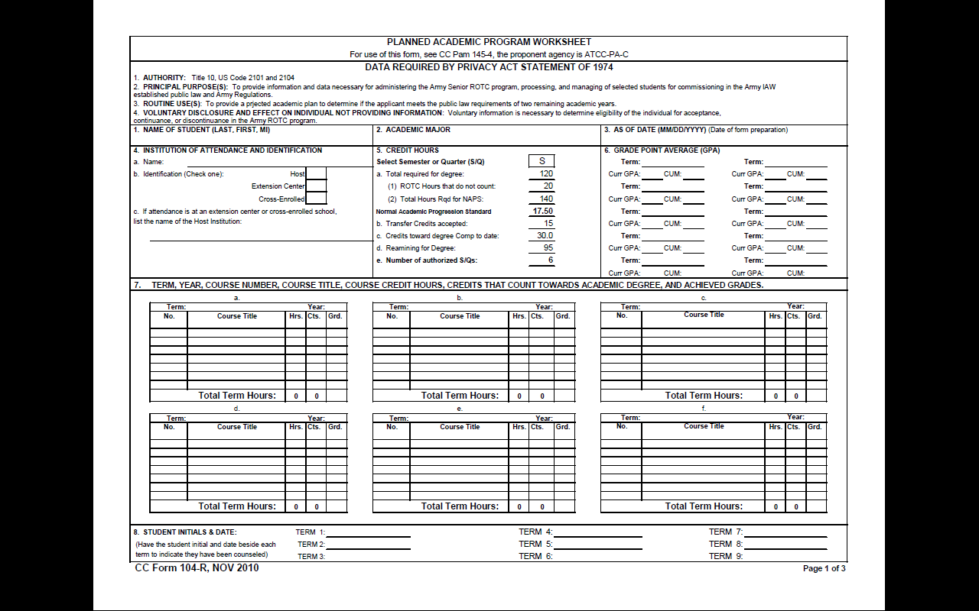legible or typed.

**Army Physical Training**

# The APFT consists of push-ups, sit-ups, and two-mile run—done in that order—on the same day. Soldiers are allowed a minimum of 10 minutes and a maximum of 20 minutes rest between events. Soldiers must attain a score of at least 60 points in each event and an overall score of at least 180 points. The maximum score a Soldier can attain on the APFT is 300 points. APFT results will be recorded on a DA Form 705, Physical Fitness Scorecard. Body composition is the amount of body fat a soldier has in comparison to his/her lean body mass.

# ROTC cadets are required to pass the APFT each semester. PT is not optional. There are exceptions for shift-work and special circumstances but all exceptions must be coordinated through your battalion chain of command (COC).You are expected to have self-discipline and do what it takes to maintain fitness standards. ROTC battalions have multiple diagnostic and record APFT’s each semester. Failure to meet fitness and/or height and weight standards will result in a suspension of benefits for one semester. While on suspension you have the opportunity to improve your physical condition and pass the APFT. Disenrollment or reinstatement of benefits rely on your ability to pass the APFT and height/weight standards.

# Your Brigade Nurse Counselor will review your Physical Fitness Scorecard during each semester Nurse Cadet counseling to track your performance.

|  |
| --- |
|  |

**Leader’s Training Course (LTC)**

Depending on when you join ROTC, you may be required to attend Leader’s Training Course (LTC). LTC is an accelerated version of the two years of leadership development training Cadets receive their freshman and sophomore years of ROTC. It provides concentrated classroom and field training held in the summer at Fort Knox, KY.

This 29-day course includes:

1. Basic soldiering skills to include; drill and ceremony, military bearing, army etiquette, basic rifle marksmanship and squad tactics.
2. Basic leadership skills to include: squad leader of up to 12 soldiers and Platoon leader of up to 40 soldiers.

Upon completion of LTC participants academically align with fellow ROTC Cadets entering their junior year. Many people explain this course as a "good prerequisite leadership development and assessment course.”

LTC is also used by many universities as an AOP to set nursing Cadets up to attend LDAC a year earlier (see page 3). This use of the AOP re-arranges your training schedule to allow more study time for nursing courses when academics become the most challenging and not compete with preparation for LDAC.

**Leadership Development and Assessment Course (LDAC)**

An experience common to all Officers commissioned through ROTC is the Leadership Development and Assessment Course (LDAC) at Joint Base Lewis-McChord, Washington. Most ROTC Cadets attend the course during the summer between their junior and senior year, however there are alternate options available for those that have academic requirements that preclude them from attending that summer.

The purpose of LDAC is to assess the leadership ability and potential of Cadets during a common experience. The assessment is a 29-day experience that contains both garrison and field based training. The entire focus of the course is to assess leadership. The Cadets take turns leading squads (10 people), platoons (30 people), and companies (120 people). Each Cadet is assessed several times in various leadership positions throughout LDAC. There are also self evaluations and peer evaluations. At the end of the course the leadership ability and potential of the Cadet is known with a fairly high level of certainty.

LDAC is generally seen as the “final exam” for ROTC, where Cadets are given the opportunity to demonstrate the skills they have learned on their campus and perfect their leadership abilities. Often, Cadets have another year of training prior to commissioning. Therefore, they can then use their experience at LDAC to train other Cadets preparing to attend LDAC the following summer.

Nurse Cadets often wonder why it is necessary to learn infantry skills and attend LDAC with all the other Cadets. The reality is that all officers are leaders, even nurses. The leadership development that every cadet receives in ROTC will sustain the Army Nurse Corps with capable leaders to proficiently function in an array of positions to support the Army as a whole.

**Nurse Summer Training Program (NSTP)**

The Nurse Summer Training Program (NSTP) is the capstone clinical exercise for nursing cadets. Its primary focus is to provide nurse cadets with at least 120 hours of clinical experience during a three to four week rotation. During the experience, Cadets will utilize military, leadership, clinical nursing, administrative and interpersonal skills. The 120 hours of clinical will be completed in an Army Medical Treatment Facility (MTF) alongside an Army Nurse Corps Officer. This training is intended to expose you to the mission, structure and personnel of the U.S. Army Medical Department (AMEDD) and solidify your basic nursing skills. This is also an excellent opportunity to see what you can expect your daily routine to be like once you are on active duty.

As a general rule, you will attend NSTP during the summer between your junior and senior year. For those who attend LDAC the summer prior, NSTP will last four weeks at all locations for pay purposes. Cadets who attend LDAC and NSTP during the same summer will attend NSTP for three weeks unless assigned to an overseas MTF. You are eligible to attend NSTP once you have met the following criteria:

1. Successfully complete LDAC.

Exceptions to policy may be granted on a case-by-case basis, specifically for End of Camp Commissionees – speak to your BNC to determine your eligibility.

1. Complete at least one semester or two quarters of an inpatient nursing clinical (Psychiatric and Community Health Nursing clinical do not meet this requirement).
2. A valid ID card and approved security clearance.
3. Up-to-date immunizations and certifications as required by the medical treatment facility.

NSTP locations vary from year to year based on the number of slots each MTF has the ability to support. Any MTF is subject to sponsoring NSTP. Please see the current fiscal year NSTP application for current locations or speak with your BNC for an updated list. Each MTF hosts NSTP Cadets for a specific date range; therefore, where you attend NSTP will be based primarily on the dates that you are available. Factors that determine your NSTP rotation include: LDAC attendance, summer school, date your spring term ends, date your fall term begins and ranking on the Order of Merit List (OML). NSTP will be discussed during your fall semester counseling prior to the summer you are eligible to attend.

**Accessions (Branching) Process**

The Order of Merit List (OML) Model calculates OML Scores which are rank ordered to create the ROTC National OML. The ROTC National OML is used to determine component status (Active Duty or Reserves). Nurse Cadets will always be branched Nurse Corps and do not go before the Department of the Army Branching Board. Your Order of Merit Score (OMS) establishes your standing on the OML. Your OMS is computed based on performance in three main categories: Academic (both general studies and Military Science), Leadership, and Physical. Your grades are very important. GPA is the single most important criteria determining the OML score accounting for 40% of your Order of Merit Score. Generally, the top 10% of Nurse Cadets get their assignment of choice.

Nurse Corps Branch determines every Fiscal Year (FY) how many new 2LT will assess Active Duty.

**FY 13 ROTC OML MODEL**

**Physical (15%)**

For each event/activity:

* Green numbers are activity weighting

**1. Academic Program (40%)**

(40.00)Cumulative GPA (includes ROTC GPA) (Spring Semester, most current)

**Warrior Forge, Platoon Top Five** = 1 point added to final OMS

**RECONDO** = 0.5 point added to final OMS

**Leader (45%)**

APFT (90%)

- Campus (most current fall semester)

- Campus (most current spring semester)

- LDAC (1st score)

Athletics (10%)

(1.50) - Varsity, Intramural, or Community Team

(6.75) - LDAC Performance (E/S/N)

- Leadership positions

- Leadership attributes/skills/actions

(11.25) - LDAC PLT TAC Evaluation (E/S/N)

(4.50) - LDAC Land Navigation (1st score)

PMS Experienced Based Observations

(6.75) - PMS MSIII CER OML

(4.50) - PMS Accessions OML

(4.50) - PMS Accessions Potential Comments

(4.50) - Cadet Training / Extracurricular Activities

(2.25) - Language / Cultural Awareness

**2. Leadership Program (60%)**

**Science Technology Engineering and Math (STEM) Incentive**

**0.5 Incentive to ADM 3 (Math/Science) and 1.0 Incentive to ADM 4 (Engineering)**

(2.36)

(1.69)

(9.45)

|  |  |  |  |  |  |  |  |  |  |  |  |  |  |  |  |  |  |  |  |  |  |  |  |  |  |  |  |  |  |  |  |  |  |  |  |  |  |  |  |  |  |  |  |  |  |  |  |  |  |  |  |
| --- | --- | --- | --- | --- | --- | --- | --- | --- | --- | --- | --- | --- | --- | --- | --- | --- | --- | --- | --- | --- | --- | --- | --- | --- | --- | --- | --- | --- | --- | --- | --- | --- | --- | --- | --- | --- | --- | --- | --- | --- | --- | --- | --- | --- | --- | --- | --- | --- | --- | --- | --- |
| When you enter your senior year, you will complete a CC Form 218-R, Assignment Preference Sheet, where you will indicate your duty assignment preferences. New graduate nurses choose from one of twelve military treatment facilities for their first assignment in order to complete the Clinical Nurse Transition Program (CNTP). In order to complete this form, the computer system requires each cadet to request a minimum of four overseas choices. However, new nurses have only Tripler and Landstuhl as possible overseas assignments; therefore choices nine and ten are administrative fillers and must be overseas choices. See example below.  **Assignment Preference Sheet** | | | | | | | | | | | | | | | | | | | | | | | | | | | | | | | | | | | | | | | | | | | | | | | | | | | |
|  | | | | | | | | | | | | | | | | | | | | | | | | | | | | | | | | | | | | | | | | | | | | | | | | | | | |
|  | | | | | | | | | | | | | | | | | | | | | | | | | | | | | | | | | | | | | | | | | | | | | | | | | | | |
|  | | | | | | | | | | | | | | | | | | | | | | | | | | | | | | | | | | | | | | | | | | | | | | | | | | | |
|  | | | | | | | | | | | | | | | | | | | | | | | | | | | | | | | | | | | | | | | | | | | | | | | | | | | |
| 1. NAME: | | | | **CADET, IAM A.** | | | | | | | | | | | | | | | | | | | | | | | | | | | | | | 2. SSN: | | | | | | **123-45-6789** | | | | | | | | | | | |
|  | | | | (*LAST, FIRST & MI*) | | | | | | | | | | | | | | | | | | | | | | | | | | | | | |  | | | | | | | | | | | | | | | | | |
| 3. GRADE: | | | | **2LT** | | | | |  | | | | | | | | | | | | | | | | | | | | | | | | | | | | | | | | | | | | | | | | | | |
|  | | | | | | | | | | | | | | | | | | | | | | | | | | | | | | | | | | | | | | | | | | | | | | | | | | | |
| 4. ROTC REGION: | | | | | | | n/a | | | 5. SEX: | | | | **Female** | | | | | | 6. RACE: | | | **C – White** | | | | | 7. PPN: | | | | | | | **Date of Birth** | | | | | | | | 8. MARITAL STATUS: | | | | | | | | **Single** |
|  | | | | | | | | | | | | | | | | | | | | | | | | | | | | | | | | | | | | | | | | | | | | | | | | | | | |
| 9. DEPENDENTS: | | | | | | | **0** | | | 10. DUTY: | | | | | | | **AD** | | | | | 11. BRANCH: | | | | | | | | | **AN** | | | | |  | | | | | | | | | | | | | | | |
|  | | | | | | | | | | | | | | | | | | | | | | | | | | | | | | | | | | | | | | | | | | | | | | | | | | | |
| 12. ACAD MAJ: | | | | | | **NURSING** | | | | | | | | | | | | | | | | 13. GRAD DATE: | | | | | | | | | | **10 May 2012** | | | | | | | | | | 14. COMM DATE: | | | | | | **10 May 2012** | | | |
|  | | | | | | | | | | | | | | | | | | | | | | | | | | | | | | | | | | | | | | | | | | | | | | | | | | | |
| 15a. HOST INSTITUTION and ADDRESS: | | | | | | | | | | | | | | | | | **Auburn University, Nichols Center Drive, Army ROTC Bn, Auburn, AL 36849-5513** | | | | | | | | | | | | | | | | | | | | | | | | | | | | | | | | | | |
|  | | | | | | | | | | | | | | | | | | | | | | | | | | | | | | | | | | | | | | | | | | | | | | | | | | | |
| b. POC: | | | **LTC John A. Doe** | | | | | | | | | | PHONE #: | | | | | | **(123) 456-7890** | | | | | | | | | | | | | | | | BN FAX #: | | | | | | **(098) 765-4321** | | | | | | | | | | |
|  | | | | | | | | | | | | | | | | | | | | | | | | | | | | | | | | | | | | | | | | | | | | | | | | | | | |
| 16a. | | PERMANENT (NO POST OFFICE BOX) | | | | | | | | | | | | | | | | | | | | | | |  | b. | | | ADDRESS FROM WHICH (NO POST OFFICE BOX) | | | | | | | | | | | | | | | | | | | | | | |
|  | | HOME ADDRESS: PHONE #: | | | | | | | | | | | | | | | | **(987) 654-3210** | | | | | | |  |  | | | TRAVEL COMMENCES: PHONE #: | | | | | | | | | | | | | | | | | | **(987) 654-3210** | | | | |
|  | | | | | | | | | | | | | | | | | | | | | | | | | | | | | | | | | | | | | | | | | | | | | | | | | | | |
| **2000 Nowhere Lane** | | | | | | | | | | | | | | | | | | | | | | | | | **149 GBR Street** | | | | | | | | | | | | | | | | | | | | | | | | | | |
| **Huntsville, AL 35242** | | | | | | | | | | | | | | | | | | | | | | | | | **Apt AD** | | | | | | | | | | | | | | | | | | | | | | | | | | |
|  | | | | | | | | | | | | | | | | | | | | | | | | | **Auburn, AL 36849** | | | | | | | | | | | | | | | | | | | | | | | | | | |
|  | | | | | | | | | | | | | | | | | | | | | | | | | | | | | | | | | | | | | | | | | | | | | | | | | | | |
| **PART II – PREFERENCE/OTHER INFO** | | | | | | | | | | | | | | | | | | | | | | | | | | | | | | | | | | | | | | | | | | | | | | | | | | | |
|  | | | | | | | | | | | | | | | | | | | | | | | | | | | | | | | | | | | | | | | | | | | | | | | | | | | |
| 1. Assignment Preferences (List in order of Preference, must be 4 Overseas): | | | | | | | | | | | | | | | | | | | | | | | | | | | | | | | | | |  | | | | | | | | | | | | | | | | | |
|  | | | | | | | | | | | | | | | | | | | | | | | | | | | | | | | | | | | | | | | | | | | | | | | | | | | |
| 1. | **Fort Lewis, WA** | | | | | | | | | | | | | | | 5. | | **Fort Gordon, GA** | | | | | | | | | | | | | | | | | | | 9. | | **Seoul, Korea** | | | | | | | | | | | | |
|  | | | | | | | | | | | | | | | | | | | | | | | | | | | | | | | | | | | | | | | | | | | | | | | | | | | |
| 2. | **Walter Reed AMC, D.C.** | | | | | | | | | | | | | | | 6. | | **Fort Hood, TX** | | | | | | | | | | | | | | | | | | | 10. | | **Fort Wainwright, Alaska** | | | | | | | | | | | | |
|  | | | | | | | | | | | | | | | | | | | | | | | | | | | | | | | | | | | | | | | | | | | | | | | | | | | |
| 3. | **Landstuhl RMC, Germany** | | | | | | | | | | | | | | | 7. | | **Tripler AMC, Hawaii** | | | | | | | | | | | | | | | | | | |  | |  | | | | | | | | | | | | |
|  | | | | | | | | | | | | | | | | | | | | | | | | | | | | | | | | | | | | | | | | | | | | | | | | | | | |
| 4. | **Fort Bragg, NC** | | | | | | | | | | | | | | | 8. | | **Fort Sam Houston, TX** | | | | | | | | | | | | | | | | | | |  | |  | | | | | | | | | | | | |
|  | | | | | | | | | | | | | | | | | | | | | | | | | | | | | | | | | | | | | | | | | | | | | | | | | | | |
| 2. I desire to enter active duty on/or about: | | | | | | | | | | | | | | | | | 1st: | | **1 June 2012** | | | | | | | | | 2nd: | | | | **20 July 2012** | | | | | | | | | | | | 3rd: | **15 Aug 2012** | | | | | | |
|  | | | | | | | | | | | | | | | | | | | | | | | | | | | | | | | | | | | | | | | | | | | | | | | | | | | |
| 3. I desire the following additional training: | | | | | | | | | | | | | | | ( ) | | | | AIRBORNE | | | | | ( ) | | | AIR ASSAULT | | | | | | | | | | | ( ) | | | RANGER | | | | | ( ) | | | OTHER | | |
|  | | | | | | | | | | | | | | | | | | | | | | | | | | | | | | | | | | | | | | | | | | | | | | | | | | | |
|  | | | | | | | | | | | | | | | | | | | | | | | | | | | | | | | | | | | | | | | | | | | | | | | | | | | |
|  | | | | | | | | | | | | | | | | | | | | | | | | | | | | | | | | | | | | | | | | | | | | | | | | | | | |
|  | | | | | | | | | | | | | | | | | | | | | | | | | | | | | | | | | | | | | | | | | | | | | | | | | | | |
| 4. I will travel to OBC by | | | | | | | | | | | | | | | ( **X** ) | | | | POV | | | | | ( ) | | | COMMERCIAL AIR | | | | | | | | | | | | | | | | | | | | | |  | | |
|  | | | | | | | | | | | | | | | | | | | | | | | | | | | | | | | | | | | | | | | | | | | | | | | | | | | |
| 5. I | (DO) | | (DO NOT) | | | | | desire to serve as a GOLDBAR RECRUITER | | | | | | | | | | | | | | | | | | | | | | | | | | | | | | | | | | | | | | | | | | | |
|  | | | | | | | | | | | | | | | | | | | | | | | | | | | | | | | | | | | | | | | | | | | | | | | | | | | |
| 6. I | (DO) | | (DO NOT) | | | | | desire to serve as CADRE at LEADERSHIP DEVELOPMENT ASSESSMENT COURSE (LDAC) | | | | | | | | | | | | | | | | | | | | | | | | | | | | | | | | | | | | | | | | | | | |
|  | | | | | | | | | | | | | | | | | | | | | | | | | | | | | | | | | | | | | | | | | | | | | | | | | | | |
| 7. I | (DO) | | (DO NOT) | | | | | desire to serve as CADRE at LEADER’S TRAINING COURSE (LTC) | | | | | | | | | | | | | | | | | | | | | | | | | | | | | | | | | | | | | | | | | | | |
|  | | | | | | | | | | | | | | | | | | | | | | | | | | | | | | | | | | | | | | | | | | | | | | | | | | | |
| 8. I | (DO) | | (DO NOT) | | | | | request consideration for a JOINT DOMICILE assignment | | | | | | | | | | | | | | | | | | | | | | | | | | | | | | | | | | | | | | | | | | | |
|  | | | | | | | | | | | | | | | | | | | | | | | | | | | | | | | | | | | | | | | | | | | | | | | | | | | |
| (If yes, indicate name, SSN, grade, branch, and location of spouse): | | | | | | | | | | | | | | | | | | | | | | | | | | |  | | | | | | | | | | | | | | | | | | | | | | | | |
|  | | | | | | | | | | | | | | | | | | | | | | | | | | | | | | | | | | | | | | | | | | | | | | | | | | | |
|  | | | | | | | | | | | | | | | | | | | | | | | | | | | | | | | | | | | | | | | | | | | | | | | | | | | |
| 9. If I am selected for IA, I desire | | | | | | | | | | |  | | | | | | days excess leave OR | | | | | | | | |  | | | | | | | days of advanced leave | | | | | | | | | | | | | | | |  | | |
|  | | | | | | | | | | | | | | | | | | | | | | | | | | | | | | | | | | | | | | | | | | | | | | | | | | | |
|  | | | | | | | | | | | | | | | | | | | | | | | | | | | | | | | | | OFFICIAL USE ONLY: | | | | | | | | | | | | | | | | | | |
|  | | | | | | | | | | | | | | | | | | | | | | | | | | | | | | | | | | | | | | | | | | | | | | | | | | | |
| I certify the above information is correct and current. | | | | | | | | | | | | | | | | | | | | | | | | | | | | | | | | |  | | | | | | | | | | | | | | | | | | |
|  | | | | | | | | | | | | | | | | | | | | | | | | | | | | | | | | | | | | | | | | | | | | | | | | | | | |
|  | | | | | | | | | | | | | | | | | | | | | | | | | | | | | |  | | | DATE: | | |  | | | | | | | | | | | | | | | |
| SIGNATURE OF CADET | | | | | | | | | | | | | | | | | | | | | | | | | | | | | |  | | |  | | |  | | | | | | | | | | | | | | | |
|  | | | | | | | | | | | | | | | | | | | | | | | | | | | | | | | | | | | | | | | | | | | | | | | | | | | |
|  | | | | | | | | | | | | | | | | | | | | | | | | | | | | | | | | | | | | | | | | | | | | | | | | | | | |
| CC USE: | | |  | | NAME OF SCHOOL | | | | | | |  | | | | | | | | | COURSE NO | | |  | | | | | | CLASS NO | | | | | |  | | | | | REPORTING DATE | | | | | | | | |  | |
|  | | | | | | | | | | | | | | | | | | | | | | | | | | | | | | | | | | | | | | | | | | | | | | | | | | | |
|  | | | | | | | | | | | | | | | | | | | | | | | | | | | | | | | | | | | | | | | | | | | | | | | | | | | |
| **CC Form 218-R, 18 Mar 02** | | | | | | | | | | | | |  | | | | | | | | | | | | | | | | | | | | | | | | |  | | | | | | | | | | | | | |

**Clinical Nurse Transition Program (CNTP)**

In October 2008, the Army Nurse Corps formally fielded the BG Anna Mae Hays Clinical Nurse Transition Program (CNTP). BG Hays was the first women in the U.S. military to be promoted to the rank of general and the 13th Chief of the Army Nurse Corps. Over 750 Army Nurses have graduated from the program since its inception. CNTP is designed to bridge the baccalaureate education and professional practice of the New Graduate Army Nurse. It consists of three phases: orientation, preceptorship, and clinical immersion. All phases foster critical thinking, communication, and deployment skills that will be needed for successful practice in overseas contingency operations and complex clinical challenges Army Nurses encounter both home and abroad. Incorporated throughout the phases are didactic seminar, journal club, and research review with a focus on leadership, professional role development, and improvement of patient outcomes. CNTP is 12 months in length and is at select Army Medical Centers (MEDCENs) that have the capability to provide exposure to patients with a variety of injury/disease conditions and acuity levels. After completion of CNTP, you may be eligible for Permanent Change of Station (PCS) depending on the needs of the Army and Nurse Corps. However, if you are assigned to Hawaii or Germany you will remain on station for four years. Please review the below of CNTP site locations. CNTP is congruent with the National College of State Boards of Nursing’s intent, that new graduate nurses have completed a nursing preceptorship/residence program.

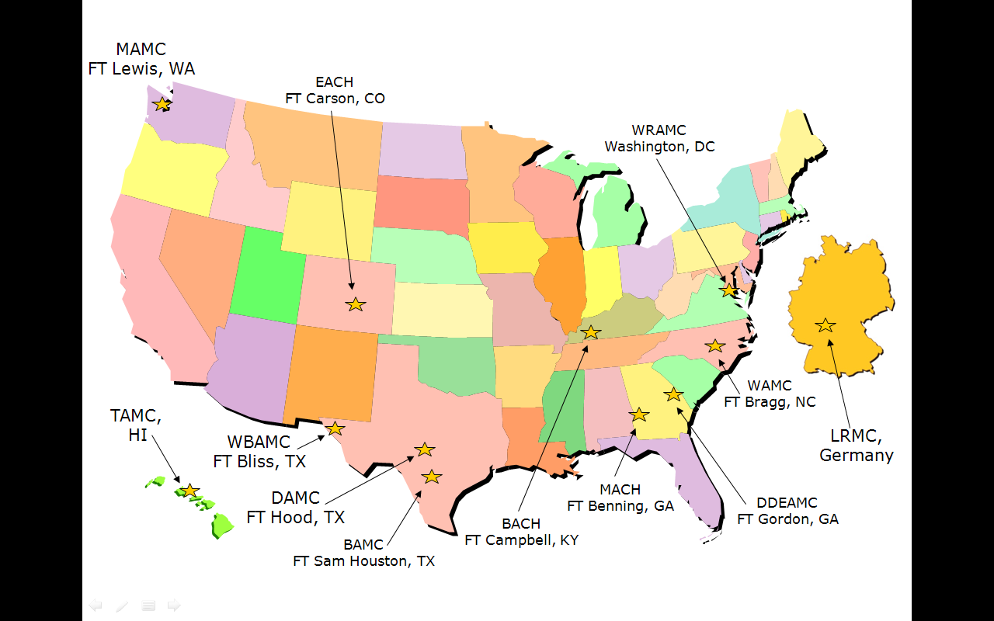

**Patient CaringTouch System**

**What is it?**

This is a standardized nursing care model that enables high-quality nursing practice across the Army Medicine Enterprise. It was implemented in 2011 and facilitates a transition from a healthcare system to a “system of health.”

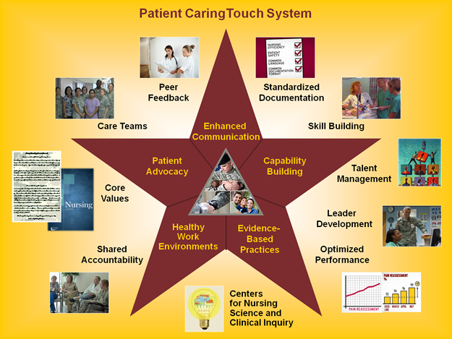

**Reimbursable/Non-Reimbursable Fees**

Army ROTC nursing scholarship Cadets will receive a one-time payment of $650.00 for required nurse uniforms/clinical supplies/equipment to be paid no earlier than the start of clinicals. Payment will be processed as part of the scholarship fees.

The battalion will prepare a memorandum requesting reimbursement for required uniforms and clinical supply purchases. The Memorandum will include Host FICE, Academic FICE, Name(s), last 4 SSN, and term. Submit the memorandum with an Obligation Listing Report generated through Validations in CCIMS for payment to the Cadet. Payment must be certified by the PMS or designee and forwarded to HQ, U.S. Army Cadet Command, ATTN: ATCC-RMP, Fort Knox, KY 40121.

**Websites**

1. Army Knowledge Online (AKO)

[www.us.army.mil](http://www.us.army.mil)

2. Human Resources Command

<https://www.hrc.army.mil/site/index-flash.aspx>

3. Army Nurse Corps Home Page

<http://armynursecorps.amedd.army.mil>

4. Army Medical Department

[www.armymedicine.army.mil](http://www.armymedicine.army.mil)

5. AMEDD Center and School

<http://www.cs.amedd.army.mil/>

6. Army Nurse Corps Association

<http://e-anca.org/>

7. Student Loan Repayment Information

<https://www.hrc.army.mil/SITE/Education/LRP.html>

8. Military One Source

<https://www.militaryonesource.com>

9. Army Family Websites

<http://www.armyfamiliesonline.org/skins/WBLO/home.aspx> Army Families Online

<https://www.armyfcc.com/index02.cfm> US Army Family Child Care

<http://www.myarmylifetoo.com> Family Advocacy Program Online

10. Military Healthcare

[www.tricare.osd.mil](http://www.tricare.osd.mil)

11. Defense Travel System – Government Travel

[www.defensetravel.dod.mil/](http://www.defensetravel.dod.mil/)

12. Education

<http://call.army.mil/> Army Center for Lessons Learned

<https://usarmy.skillport.com/SkillPortFE/login/usarmylogin.cfm> Army E-Learning

<https://atrrs.army.mil/> Army Training Requirements and Resources System

<http://armynursecorps.amedd.army.mil/development/MG%20Readinglist.pdf> MG Horoho’s recommended reading list