 |  | CAAS Fun!  Staff Olympics  Comprised of various activities (NFL Picks, Pumpkin Carving, Bowl Games, March Madness, Corn Hole, Bowling, Kentucky Derby) and points are associated with each activity.  Staff Holiday Party  Each December we have a staff holiday party including a pot luck and Secret Santa.  End of Year Party  At the end of the Spring Academic Year, we have a CAAS party to celebrate another successful year and send off our interns and GA’s.  We may have a pool party, go to the movies, or simply have a dinner.  Staff Meeting Snacks  A staff member is in charge of bringing snacks to one staff meeting during their assigned month.  That individual also provides the staff with an inspiring quote and explains what it means to them and how it can impact our professional lives.
  Fun Facts!
  Where Are They Now?
  The following are a few examples of where interns have gained full-time positions in Athletic Academics after their CAAS internship:
  - University of Memphis
  - Georgia State
  - Indiana University
  - University of Cincinnati
  - Samford University
  - Coastal Carolina University
  - Georgia Tech
  - East Carolina University
  - Western Carolina
  - Colorado State
  - Kennesaw State
  - Eastern Illinois
  - University of Maryland
  CAAS Staff
  CAAS Staff includes Associate Athletic Director, Assistant Athletic Director, 2 Assistant Directors, Academic Counselors, Learning Specialist, PAWS Coordinator, Interns & GA’s.
  Staff Meeting Snacks
  Center for Athletic Academic Services
    - 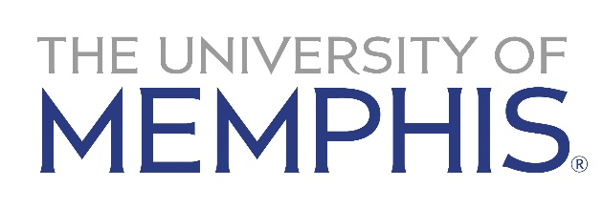
  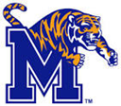

  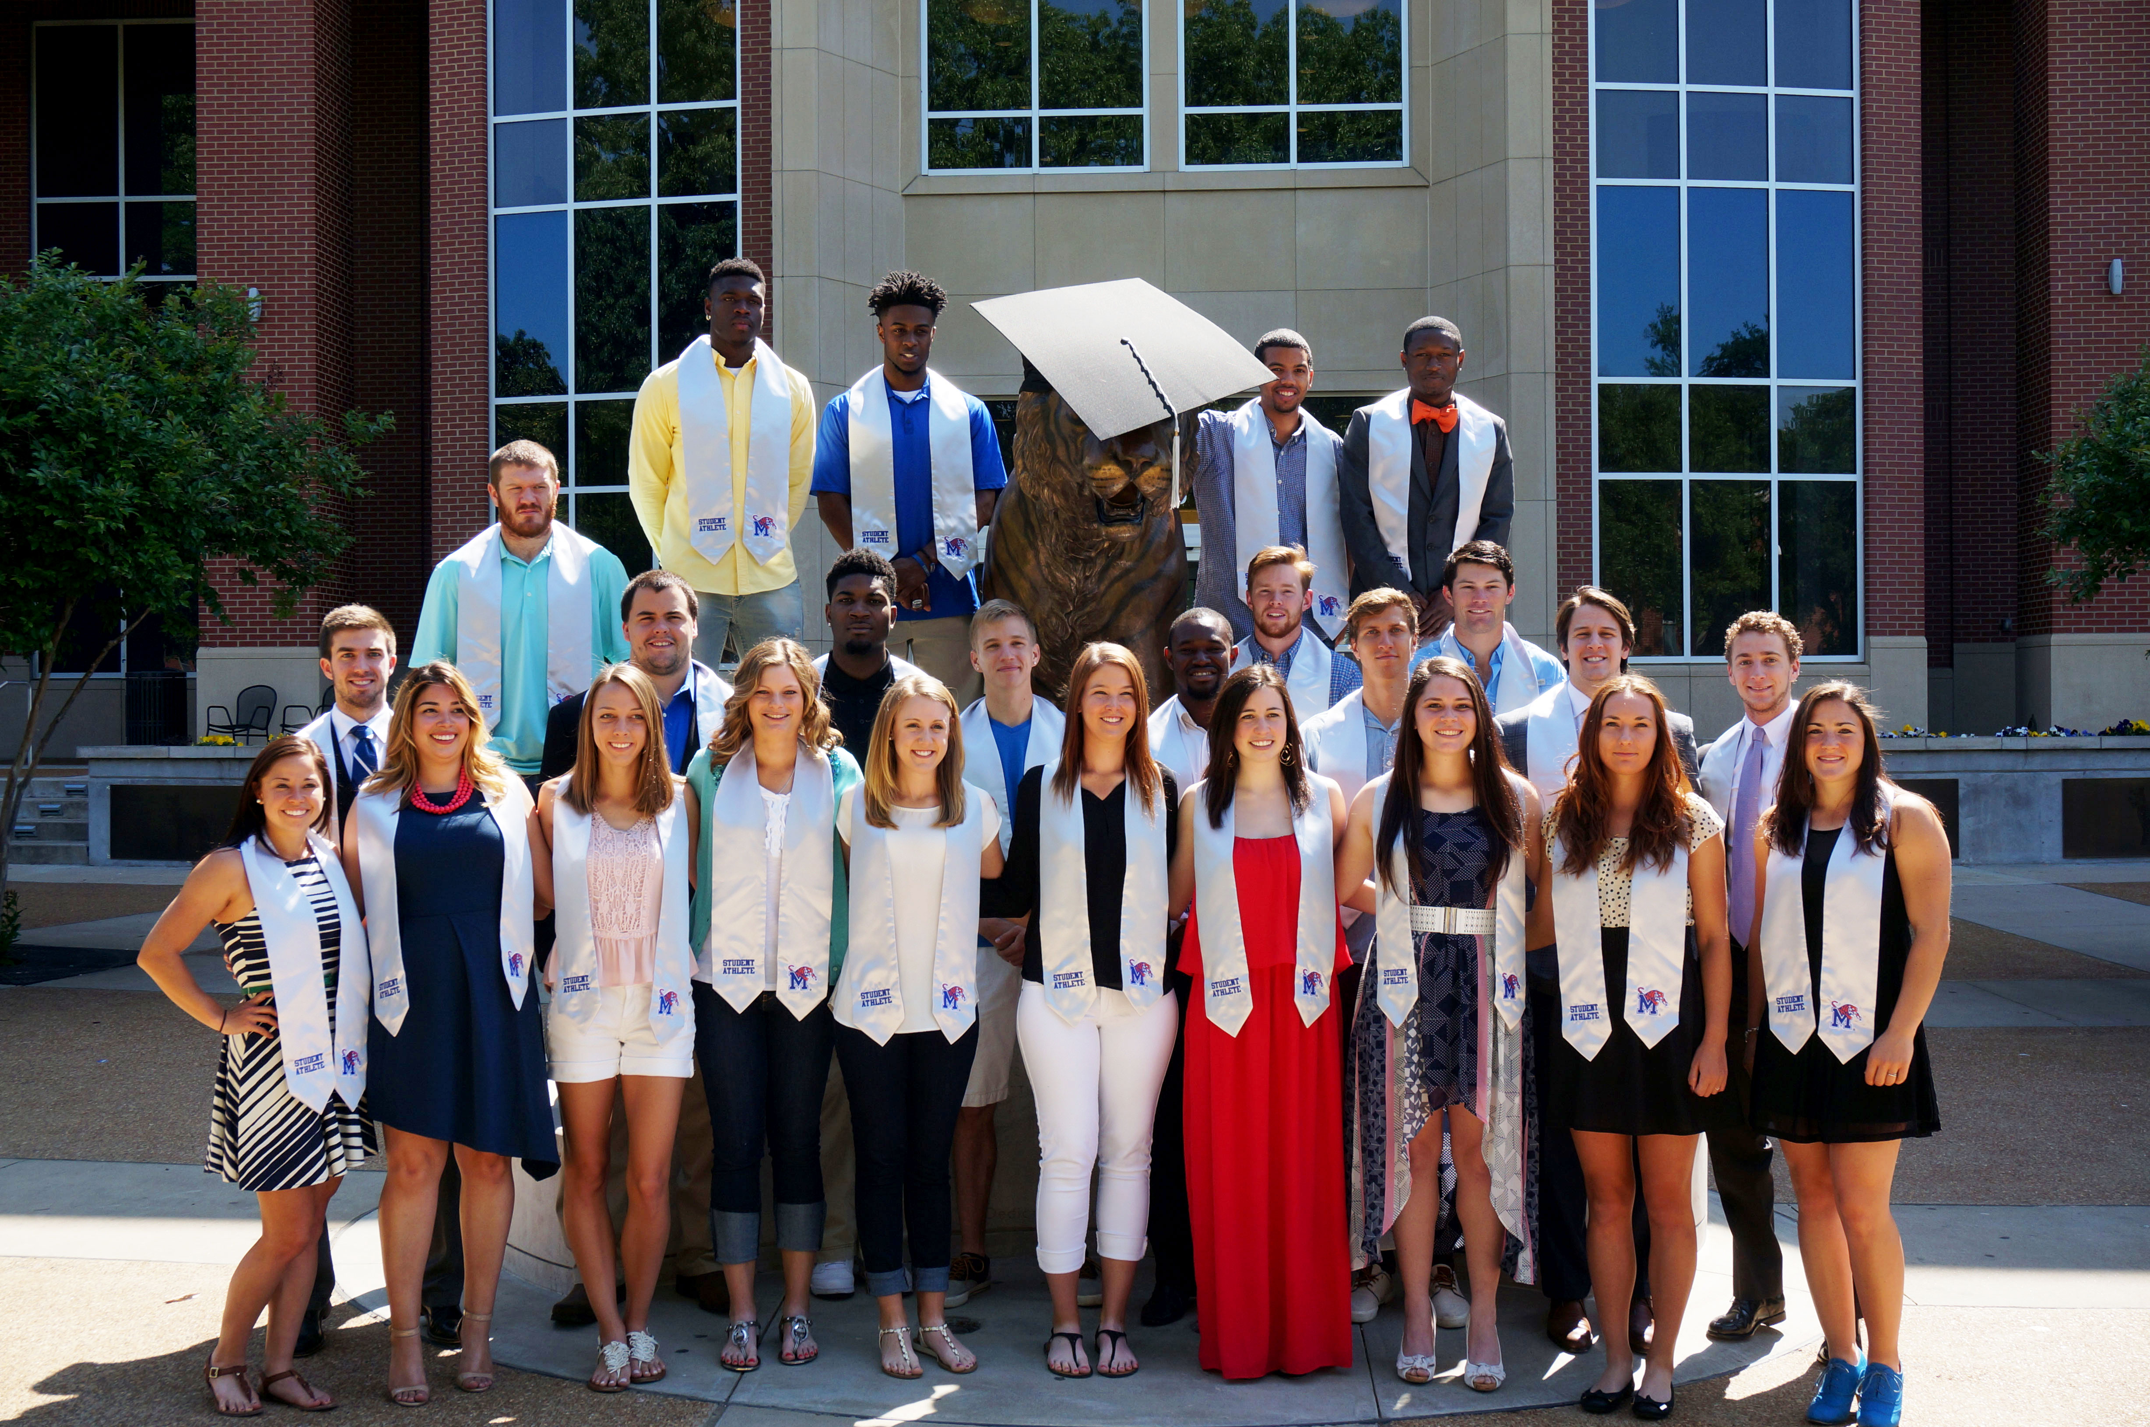
  Hands-On Experience
  - Complete Initial Eligibility Evaluations for PSA’s using LSDBi & NCAA Eligibility Center
  - Assist with Recruiting Visits
  - Attend/Present at Team Meetings
  - Assist with New Student-Athlete Orientation
  - Complete Degree Audits/Update Advising Folders & 4-year Plans
  - Monitor/Track Student-Athlete Grades/Progress
  - Advise Student-Athletes
  - CAT (Cultivating Academic Tigers) Summer Bridge Program
  - Weekly Staff Meetings
  Weekly Training Session Topics
  - GPA Calculations, Course Grade Calculations, Academic Standards
  - Learning Disabilities
  - Advising Philosophy/Process/Scenarios
  - NCAA Eligibility Homework and Scenarios
  - Team Meetings/Head Coaches Meetings
  - APR/GSR – APP Program as a whole
  - Tutor Coordination/Program
  Additional Opportunities
  Student-Athlete Development
  ACAD 1100: Academic Strategies
  Freshman course which assists student-athletes in making the transition to college-level academics and learning about campus resources; focus on time management, career/major exploration and life skills.
  UNIV 3740: Preparing to Be a Professional
  Junior/Senior course which focuses on the development of personal and professional life skills; effective communication skills, interview skills, cover letter, and resume preparation; proper business etiquette, financial planning; professional working environment.
  PAWS (Preparing Athletes for Winning Success)
  Student-Athlete development program which provides comprehensive guidance in regards to personal and professional growth for its student-athletes. The customized programming focuses on the areas of career development, personal development, and community service.
  Connect with Us!
  memphis.edu/caas
   @CAASMemphis
  @UofMemphis_PAWS
   CAASMemphis
  - MemphisTigerPAWS
  GA’s & Interns are very important to CAAS and our daily operations. These individuals are held to a high expectation and will be prepared for a full-time position in athletic academic services.
  There are multiple intern/GA offices equipped with desks, computers with two screens (game changer!), iPads, phones, printing connections, etc.
  Professional Development Training
  Our internship/GA programs thrives on preparing individuals for a career in athletic academic services. A key piece to obtaining a full-time position is professional development training. This training includes:
  - Mock Interviews
  - Interviewing Tips/Advice
  - Beginning the Job Hunting Process
  - Preparing for the N4A National Convention
  N4A Involvement
  CAAS has earned N4A Certification
  All Full-Time Staff have N4A Membership
  Full-Time Staff attend the N4A National Convention Yearly
  Hosted N4A Regional Conference
  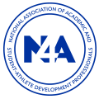
  Multiple Presentations at the N4A National Conference
  Utilize N4A Best Practices
  CAAS Staff are on many N4A Committees
  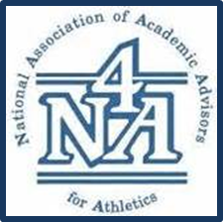
  Contact Us
  [Company Name]
  [Address]
  [City, ST ZIP Code]
  [Telephone]
  [Email]
  Visit us on the Web:
  [Web Address]

