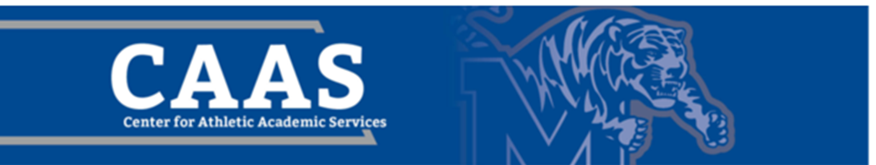
Guide to Memphis

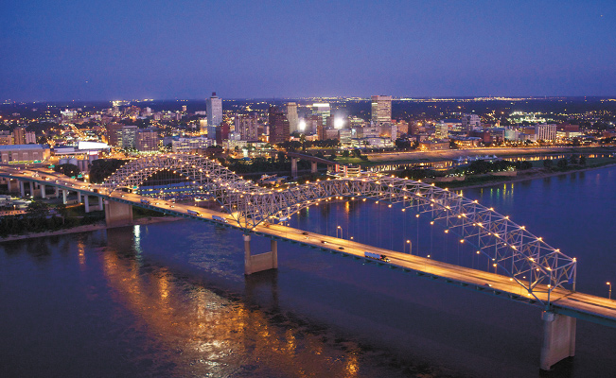

#Choose901
Choose901.com

Table of Contents

Food 3
Places to Go 8
Shopping 11
Night Life 13
Sports 16
Music 18
Festivals 20
Things to Do 23
I Love Memphis 26
Appendix A: 100 Things to Eat in Memphis 27
Appendix B: 100 More Things to Eat in Memphis 28
Appendix C: The Ultimate Guide to Drinking Cheap in Memphis 29
Appendix D: Summer in Memphis 31
Appendix E: Nearby Travel Destinations 32

Food
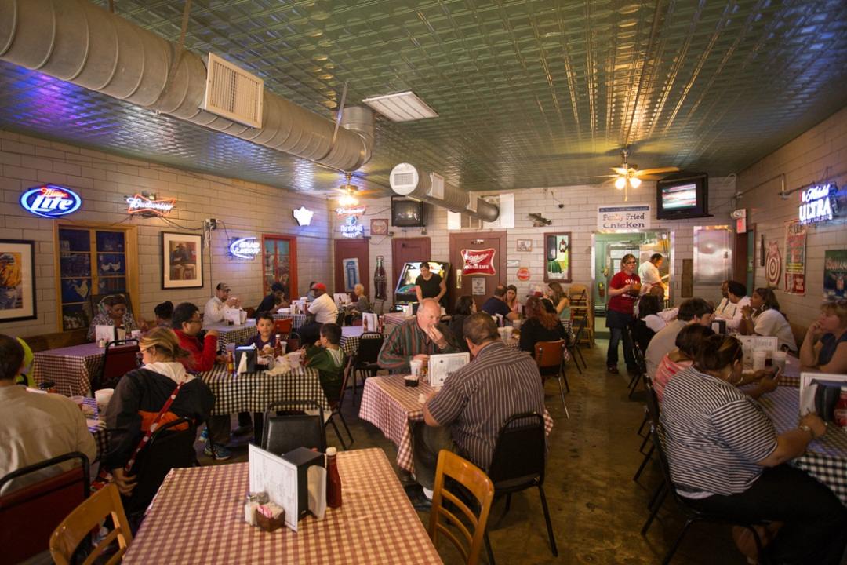
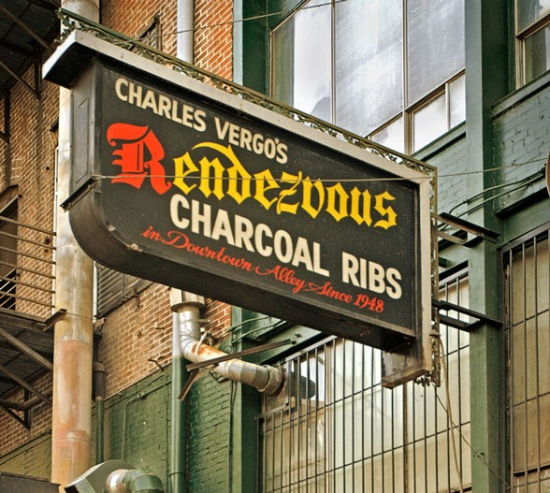
Food
- Trolley Stop Market: http://www.trolleystopmarket.com/
  - Delicious food made from ingredients sourced from local farms
  - Also has a mini-farmers market inside
- Aldo’s Pizza Pies: http://www.aldospizzapies.com/
  - New York-style pizza and sandwiches, plus wine and draft beer, and eating the cheesecake is like you died and went to heaven. They also have a great patio!
- City Silo Table & Pantry: https://www.thecitysilo.com/
  - Food you can feel good about eating!
  - Delicious small plates, smoothies, acai bowls and juices.
- Highland Super Submarine Sandwich Shop: https://www.facebook.com/chinesesubshop
  - The BEST sub sandwiches around—it’s like there’s magic in there. Get the soft bread (versus the hard bread), you won’t regret it! But remember that it is cash only.
- Gus’s Fried Chicken: http://gusfriedchicken.com/
  - A Memphis staple, Gus’s has the best fried chicken, made from a top-secret recipe with just the right amount of spice and heat. Even people who don’t like fried chicken like Gus’s—it’s a must-try.
  - Three locations: downtown on Front Street, East Memphis on Mendenhall, and in Collierville
- Kooky Canuck: http://www.kookycanuck.com/
  - Canadian-owned restaurant with a lodge-like atmosphere with cabin walls and animal trophy decorations, has an extensive menu where you can’t go wrong with anything. They have great desserts (you can make s’mores at your table with a little flame!) and awesome drinks, some of which are specialty drinks and come in 34 oz. mugs. It’s also home to the Kookamonga burger, which is a 7.5 lb. burger that has been featured on Man vs. Food.
- Huey’s: http://hueyburger.com/
  - Memphis burger spot with several locations
  - Thing to do is try to shoot toothpicks into the ceiling
  - Live music fairly frequently
- Swanky’s Taco Shop: http://www.swankystacoshop.com/
  - Also has 2 for 1 margaritas on Tuesday
- Las Delicias: http://lasdeliciasrestaurant.com/
  - Authentic Mexican voted Best in Memphis
  - Family-owned, locally-operated, and extremely affordable!
- BBQ! (all of these are a must-try)
  - Central BBQ: http://cbqmemphis.com/
  - Rendezvous: http://www.yelp.com/biz/charlie-vergos-rendezvous-memphis
  - Germantown Commissary: http://www.commissarybbq.com/
  - Tops Bar-B-Q: http://www.topsbarbq.com/
  - Corky’s: http://www.corkysmemphis.com/
  - The BBQ Shop: http://www.yelp.com/biz/the-bar-b-q-shop-memphis-5
- Hog and Hominy: http://www.hogandhominy.com/
  - “Italian Cooking Meets Southern Roots”
  - Named one of GQ Magazine’s 12 Most Outstanding Restaurants of 2013
  - Bocce ball court on the side
  - Has a back porch/patio that turns into a dive bar on the weekends and serves things like crockpot peanuts and griddle-cooked cheeseburgers
- YoLo Frozen Yogurt: http://www.yelp.com/biz/yolo-frozen-yogurt-memphis-4
  - Local self-serve frozen yogurt shop that also locally sources their products
- Tamp and Tap: http://tampandtap.com/
  - Beer + coffee = awesome. (And also really delicious local food)
- Dinstuhl’s Fine Candy Company: http://www.dinstuhls.com/
- RP Tracks: http://www.rptracks.com/
  - Right next to campus on Walker, super convenient location to grab a quick bite or drink
  - Bar-B-Q Tofu is a specialty of theirs; they even put it on nachos
  - You can’t go wrong with anything on the menu and they have an extensive drink selection as well
- Ubee’s: http://www.ubeesmemphis.com/
  - Salads, sandwiches, and burgers
  - They deliver to the U of M area (they’ll even bring it upstairs to us or at least into the Wilder lobby!) until 3 a.m.
- The Majestic Grille: http://majesticgrille.com/
  - Built in 1913 as a movie theater, it’s now a restaurant with an old Hollywood theme that shows silent films and classic movies on a screen inside
  - Good for lunch and dinner and also has a renowned Sunday Brunch
- Flight Restaurant and Wine Bar: http://flightmemphis.com/
  - Fine dining option (with complimentary valet parking, which is helpful downtown)
  - Extremely extensive wine list; recipient of 2013 Wine Spectator Award of Excellence
  - Centers around the concept of a “flight” of foods or wines—3 smaller portions versus 1 larger portion, although you can order a full entrée size or full wine glass of anything. There are pre-arranged flights or you have the freedom to design your own.
- Ching’s Hot Wings: https://www.facebook.com/chingshotwings
- The Half Shell: http://www.halfshell-memphis.com/
  - Seafood restaurant, open late, 2 locations
- Memphis Pizza Café: http://www.memphispizzacafe.com/
  - Voted Memphis’s Best Pizza and has several locations
- Gibson’s Donuts: https://www.facebook.com/gibsonsdonuts
  - A Memphis staple!
  - Delicious, homemade standard and specialty donuts and it’s open 24 HOURS!
- Muddy’s Bake Shop: http://www.muddysbakeshop.com/
  - Local and family run with delicious cupcakes, cakes, pies, cookies, pies, and brownies
  - Not to mention they also have great coffee and espresso drinks to go with your tasty treat!
- The Beauty Shop: http://thebeautyshoprestaurant.com/
  - Hip and trendy restaurant in Cooper Young
  - Great brunch!
- Ugly Mug Coffee: https://www.uglymugcoffee.com/
  - Great, local coffee! Try the buttermoon latte!
- Red Koi: https://www.redkoimemphis.com/
  - The BEST sushi in town, hands down!
- Other Staff Favorites:
  - Elwood’s Shack
  - Soul Fish Café
  - Brother Juniper’s
  - The Arcade
  - Bounty on Broad
  - Memphis Pizza Café
  - Babalu Tapas & Tacos

- Loflin Yard: http://www.loflinyard.com/
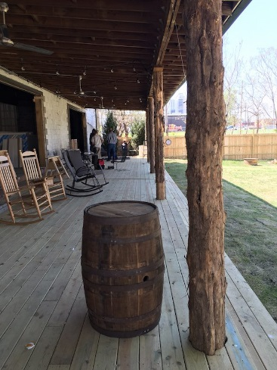
  - A bar, restaurant, and event space, but above all else, it's a haven in the heart of downtown. Grab a bottle from the wine rack, order from anywhere, and settle inside or out. No matter which house you pick, you'll feel right at home in the Yard.
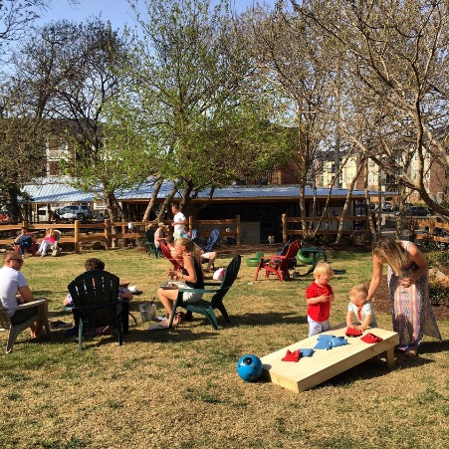

- For a great way to explore the city while also getting the best food the city has to offer, check out these two lists:
  - 100 Things to Eat in Memphis: http://www.ilovememphisblog.com/2012/05/100-things-to-eat-in-memphis/ (See Appendix A, attached)
  - 100 MORE Things to Eat in Memphis: http://ilovememphisblog.com/2013/06/100-more-things-to-eat-in-memphis/ (See Appendix B, attached)
Places to Go
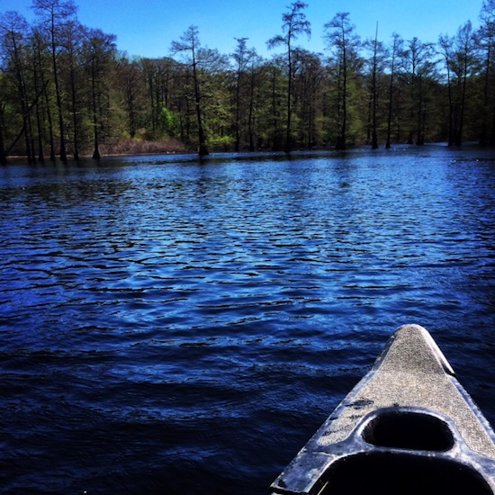
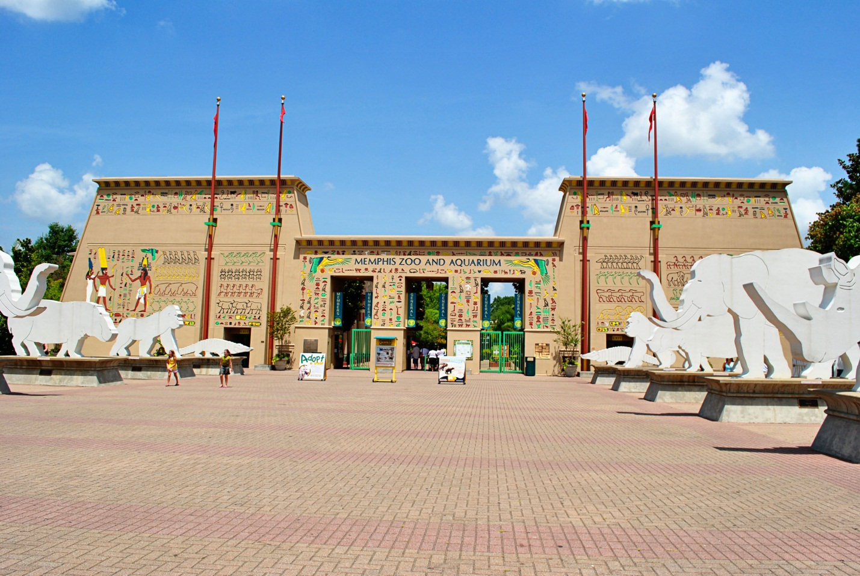
Places to Go
- The Memphis Zoo: http://www.memphiszoo.org/
  - Zoo Lights
    - At Christmas, the zoo is decorated with Christmas lights and they also have a Ferris wheel and an ice skating rink!
  - Free admission on Tuesday afternoons (2pm-close) to Tennessee residents with valid photo ID
- Graceland: http://www.graceland.com/
- The Pink Palace: http://www.memphismuseums.org/
  - Museum with rotating exhibits and permanent exhibits of “Cultural History of the Mid-South: Begin Here to Discover Memphis,” “Natural History of the Mid-South: Skeletons, Pythons, Birds, and Much More,” and “The Mansion: 20th Century Memphis”
  - Home to the Bella Caffe inside, serving sandwiches, soups, salads, and desserts
  - Also hosts a 3-day crafts fair in Audubon Park in October
- Wiseacre Brewery: http://wiseacrebrew.com/
  - You can visit the taproom Thursdays from 4-8pm, Fridays from 4-10pm, and Saturdays from 1-8pm
- Summer Drive-In Movie Theater: http://www.malco.com/cinema_shows.php?theatre_pick=33
  - One of the last existing drive-in movie theaters, this movie theater has been open since 1966!
- Meeman-Shelby Forest State Park: http://tnstateparks.com/parks/meeman-shelby
  - 13,476 acres 13 miles north of Memphis filled with trees, swamp area perfect for hunting, and all kinds of wildlife, such as over 200 species of birds, including the American Bald Eagle
  - Has 6 two-bedroom cabins on site that can sleep up to 6 people as well as a large campground
  - Visitors can go boating or fishing, bike the 3 mile bike trail, or hike any part of the 18 miles of hiking trails
- Shelby Farms: http://www.shelbyfarmspark.org/
  - 4,500 acres of land, horseback riding, off-leash dog area, lake with paddle boats, 6.5 mile-long greenline connecting Midtown Memphis to the park, as well as several other trails of various lengths within the park itself
- Sun Studio: http://www.sunstudio.com/
- The Stax Museum: http://www.staxmuseum.com/
- Memphis Rock n Soul Museum: http://memphisrocknsoul.org/
  - Free admission on Tuesday afternoons (2pm-7pm) to Tennessee residents with valid photo ID
- The Civil Rights Museum: http://civilrightsmuseum.org/
- Mud Island: http://www.mudisland.com/
  - Park, museum, and concert amphitheater
- Gibson Guitar Factory: http://www2.gibson.com/Gibson/Gibson-Tours.aspx
- Rec Room: http://recroommemphis.com/
  - Vintage arcade games; table games; board games; cornhole; flip cup.
  - Living room rentals.
- Trader Joes: who doesn’t love a trendy grocery store?! https://locations.traderjoes.com/tn/germantown/738/
- Bass Pro Ship @ The Pyramid: https://stores.basspro.com/us/tn/memphis/1-bass-pro-dr.html

Shopping
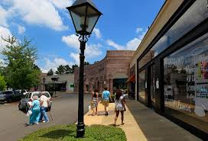
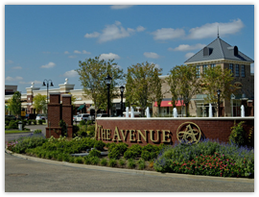
Shopping
- Carriage Crossing: http://www.shopcarriagecrossing.com/
  - Outdoor mall in Collierville
  - Highlights: Banana Republic, Sephora, Macy’s, Jos. A. Bank
- Oak Court Mall: http://www.mallseeker.com/oak-court-mall.aspx
  - Indoor mall in East Memphis
  - Highlights: High level Macy’s (designer goods, including furs), Dillard’s, Bath & Body Works
- Laurelwood Shopping Center: http://www.laurelwoodmemphis.com/
  - High-end shopping center in East Memphis
  - Highlights: Booksellers at Laurelwood, Joseph (designer store carrying luxury shoes, handbags, and other goods), Orvis, Fleet Feet Sports, King Furs and Fine Jewelry, James Davis, Hot Yoga Plus, The Grove Grill, Frost Bake Shop
- The Shops of Saddle Creek: http://www.shopsofsaddlecreek.com/
  - Shopping center in Germantown
  - Highlights: Anthropologie, Apple Store, J. Crew, Free People, Madewell, Kate Spade, Indigo (local trendy designer women’s store)
- Wolfchase Galleria: http://www.simon.com/mall/wolfchase-galleria
  - Premier indoor shopping mall along with many different restaurant options in and surrounding the mall (including West Tennessee’s first Cheesecake Factory!)
- Tanger Outlets, Southaven, MS: https://www.tangeroutlet.com/southaven/stores
- IKEA: https://www.ikea.com/us/en/store/memphis/indexPage

Night Life
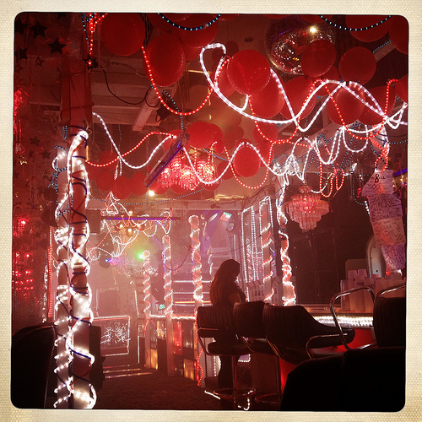
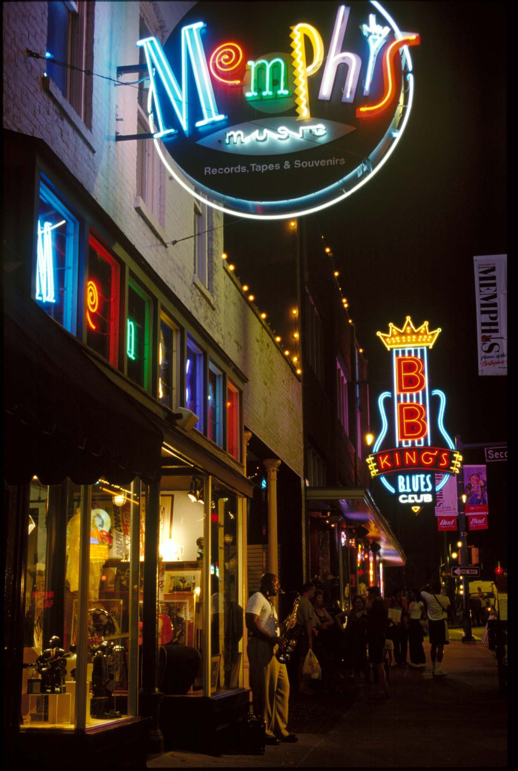
Night Life
- One of the best things ever created—The Ultimate Guide to Drinking Cheap in Memphis: http://www.ilovememphisblog.com/2013/07/the-ultimate-guide-to-drinking-cheap-in-memphis/comment-page-1/ (See Appendix C, attached)
- Twilight Sky Terrace (The Madison Hotel Rooftop): http://www.twilightskyterrace.com/index.php
- Seasonal Parties: Spring/Summer only
  - Peabody Rooftop Parties: http://www.peabodymemphis.com/rooftop-parties/
  - Thursdays Squared (Outdoor concert series in Overton Square): http://www.overtonsquare.com/
- Dancing
  - Paula and Raiford’s Disco: http://paularaifords.com/home.html
  - Club 152: http://www.club152memphis.com/
  - Spectrum: http://www.yelp.com/biz/club-spectrum-memphis
    - LGBTQ friendly
- Greencork Wine Bar: http://www.greencorkwine.com/
  - Self-serve wine available in 2-, 4-, or 6-ounce pours in addition to small plates of modern Southern food
- Bars with an Extensive Beer Selection
  - The Flying Saucer: http://www.beerknurd.com/stores/memphis/
  - Young Avenue Deli: http://www.youngavenuedeli.com/
- Sports Bars
  - Max’s Sports Bar: http://maxssportsbar.com/
    - A hidden gem in the South Main district, this place was discovered by friends trying to find someplace that wasn’t packed to watch Men’s Basketball play in the 2013 NCAA tournament. They have seriously fantastic wings that are clearly a well-kept secret and have really good BBQ nachos as well. Order those with one of their reasonably priced pitchers or a bucket of bottled beer and you are all set to watch the game without the craziness of a chain like BWW.
- Midtown: Cooper-Young
  - Celtic Crossing: http://www.celticcrossingmemphis.com/
    - Irish pub with a huge, newly refinished patio (that gets covered and heated in the winter so it’s still functional), has a DJ on Friday and Saturday nights
  - Young Avenue Deli: http://www.youngavenuedeli.com/
  - Alchemy: http://alchemymemphis.com/
    - A little more upscale Midtown cocktail bar that also serves small plates
  - Sweet Grass Next Door: http://www.sweetgrassmemphis.com/
    - The bar/smaller restaurant and hangout attached to the restaurant Sweet Grass (which is delicious)
- Midtown: Overton Square
  - Local on the Square: http://www.localgastropub.com/
  - Bar Louie: http://www.barlouieamerica.com/locations/memphis.aspx
  - Bosco’s: http://www.boscosbeer.com/
    - Also a really good restaurant, but has its own brewery inside and brews several beers
- East Memphis
  - Brookhaven: http://www.brookhavenpubandgrill.com/
  - The Windjammer: http://www.citysearch.com/profile/9457426/memphis_tn/windjammer_restaurant.html
    - Kind of a dive, but they have karaoke every night if you want to do that
  - Dan McGuinness: https://www.zomato.com/memphis/dan-mcguinness-east-memphis
- Downtown
  - Blind Bear Speakeasy: http://www.blindbearmemphis.com/
    - Set up like a Prohibition-era speakeasy, so if you don’t want to pay the cover, like them on Facebook to get the nightly password, which gets you in free when you tell the bouncer
  - Bardog Tavern: http://bardog.com/
  - The Silly Goose Lounge: http://www.sillygoosememphis.com/#/home
  - Absinthe Room: http://www.eatdrinkboogie.com/kingspalacecafesabsintheroom
    - Quite possibly the only bar on Beale Street that never has a cover, no matter what day of the week it is
  - Silky O’Sullivans: http://www.silkyosullivans.com/
    - Big part of Memphis history
    - Irish-themed
    - Dueling pianos inside every night
    - Large patio with live music on the weekends
  - Local: http://www.localgastropub.com/

Sports
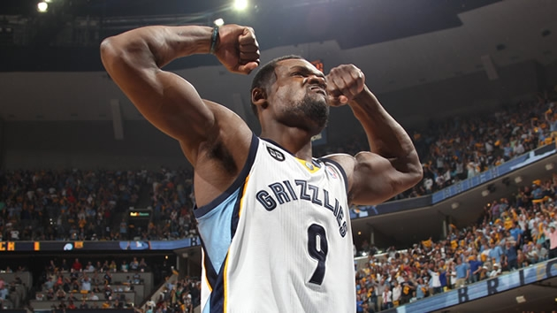
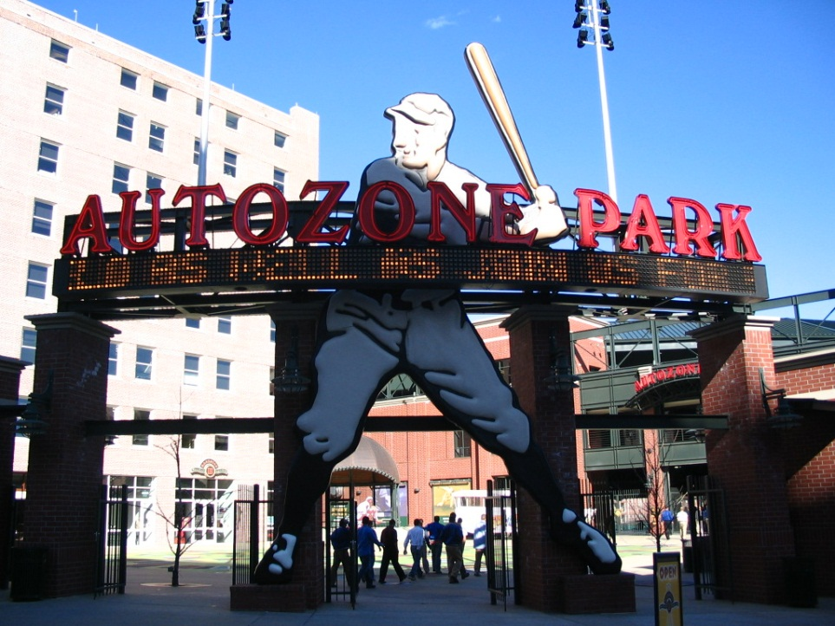
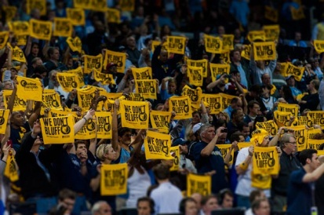
Sports
- Memphis Tigers!! (duh.)
- MEMPHIS GRIZZLIES (NBA): http://www.nba.com/grizzlies/
  - Where they play: FedEx Forum
  - Nicknames: Z-Bo (Zach Randolph), Big Spain (Marc Gasol), The Grindfather (Tony Allen)
  - The Growl Towel: yellow towels with Grizzlies taglines and phrases printed on them that are placed on the seats at the FedEx Forum for the crowd to wave. These are now a nationally famous piece of sports fan-ism and you will likely see them hanging in local businesses, in people’s cars, etc.
  - Team taglines/phrases: We Don’t Bluff; All Heart, Grit, Grind
  - The New Fan Guide to the Memphis Grizzlies 2013-2014 Season: http://www.ilovememphisblog.com/2013/10/memphis-grizzlies-players-guide-2013-1/
- Memphis Redbirds (Minor League Baseball): http://www.milb.com/index.jsp?sid=t235
  - Where they play: AutoZone Park
  - Lots of good deals and promotions (including fan giveaways) on tickets and games depending on the day, so checking the website or following them on Facebook or Instagram to stay updated is a good idea
  - The Bluff: A big, grassy hill to which cheap tickets are sold and you can bring a blanket and enjoy a game with your friends or family sitting outside on the grass. It’s a fun thing to do at least once, and it has a great view of the fireworks shows.
  - Fireworks show every Saturday night after the game
- Mississippi RiverKings (Hockey): http://www.riverkings.com/

Music
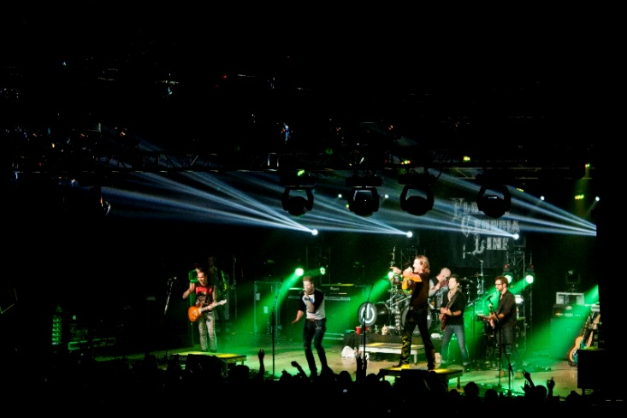
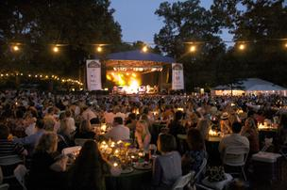
Music
- Concert Venues
  - FedEx Forum: http://www.fedexforum.com/homepage.aspx
  - Minglewood Hall: http://www.minglewoodhall.com/
  - Orpheum Theatre: http://www.orpheum-memphis.com/
  - Levitt Shell: http://levittshell.org/
- Live at the Garden (Summer/Early Fall only): http://memphisbotanicgarden.com/liveatthegarden
  - Outdoor concert series at the Memphis Botanic Garden
- Beale Street Music Festival (BSMF): http://www.memphisinmay.org/musicfestival
  - First weekend in May every year, kicks off the month-long Memphis in May celebration

Festivals
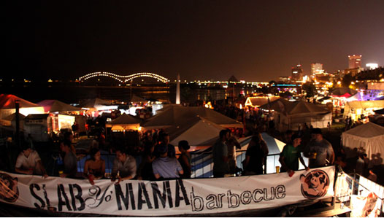
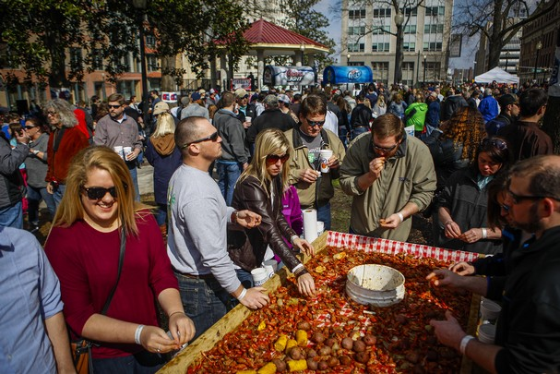
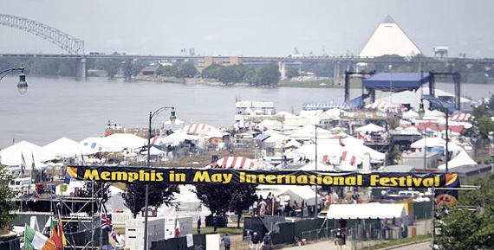
Festivals
(chronologically listed)
March
- Mudbugs in March (last Saturday in March): http://www.memphisflyer.com/memphis/mudbugs-in-march/Event?oid=3152623
  - Includes a crawfish gumbo cookoff and live entertainment
April
- Overton Square Crawfish Festival (second Saturday in April): http://www.overtonsquarecrawfishfestival.com/
- Brewfest (last Saturday in April): http://www.memphisbrewfest.com/
  - International beer festival held the last weekend in April at AutoZone Park
- Southern Hot Wing Festival (last Saturday in April): http://www.southernhotwingfestival.com/
  - Usually the same weekend as Brewfest
- Rajun Cajun Crawfish Festival (last Sunday in April): https://www.everfest.com/e/rajun-cajun-crawfish-festival-memphis-tn
  - Downtown on Riverside Drive between Union and Beale
May
- Beale Street Music Festival (first weekend in May): http://www.memphisinmay.org/musicfestival
- Collierville Fair on the Square (first weekend in May): http://www.colliervillefaironthesquare1950.org/faironthesquareinfo.htm
  - Locally handmade items for sale, entertainment, face painting, rock climbing , a mechanical bull, and a petting zoo out in Collierville
- Greek Fest (second weekend in May): http://www.memphisgreekfestival.com/
- BBQ Fest (third weekend in May): http://www.memphisinmay.org/worldchampionshipbbqcontest
- Italian Fest (last weekend in May): http://memphisitalianfestival.com/
September
- Germantown Festival (first weekend in September): http://germantownfest.com/
  - Arts and crafts vendors, local food, and an auto show out in Germantown
- Cooper-Young Fest (2nd weekend in September): http://www.cooperyoungfestival.com/
  - Starts with the Cooper Young 4-Miler Race on the Friday night of the festival weekend, lots of people come out to watch the race and then stay out for the drink specials that night
  - Saturday is the main festival of various vendors and food trucks where most of Cooper-Young is shut down for a street-market type thing
- Best Memphis Burger Fest (third or fourth Sunday in September): http://www.bestmemphisburgerfest.com/
- Gonerfest (last weekend in September): http://www.goner-records.com/gonerfest/
  - Indie, punk, garage band festival that includes bands from locally and around the world
October
- Cooper-Young Regional Beer Festival (second Saturday in October): http://www.cybeerfest.org/
  - Beer festival of only local craft beers
- River Arts Fest (last weekend in October): http://riverartsmemphis.org/
  - Huge street fair in the South Main Arts District of artists, vendors, artists doing live demonstrations of their work, hands-on art stations, and lots of local food vendors
- Indie Memphis Film Festival (begins last week in October and goes into first weekend of November): http://indiememphis.com/
November
- India Fest (first weekend in November): https://www.facebook.com/indiafestmemphis

Things to Do
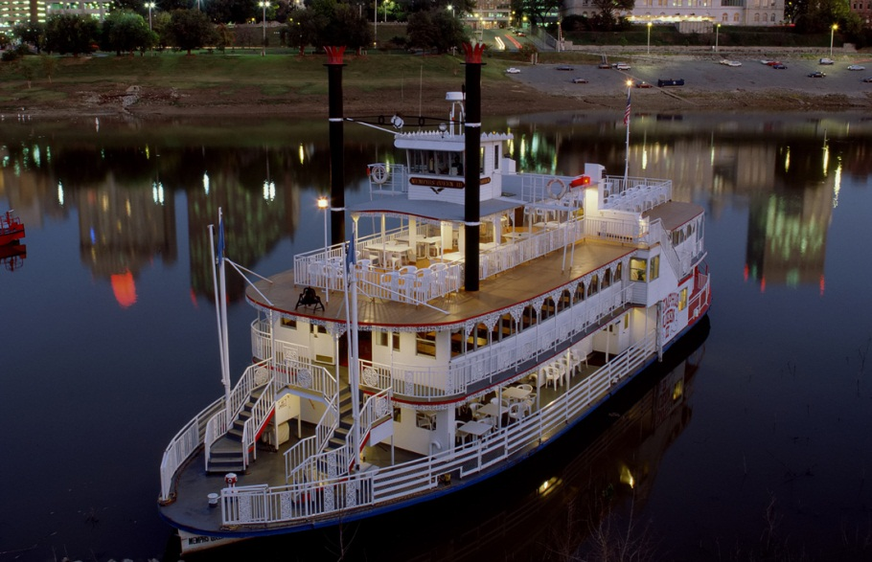
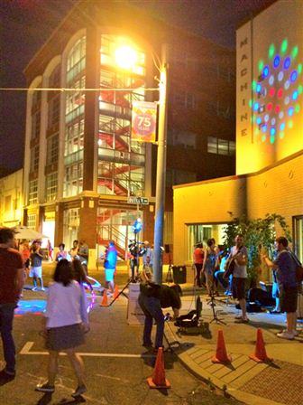
Things to Do
- Five in One Social Club: http://www.fiveinone.org/
  - Self-proclaimed “kindergarten for grown folks,” they host 2 crafting activities a week taught by the artists who sell their goods there (you can pay per class or buy class packages) and also have bingo, comedy nights, and other events. Past craft activities include tissue paper stained glass, wire word necklaces, kaleidoscopes, and seasonal activities like pumpkin carving (Halloween) and chocolate casting (Valentine’s Day).
- Mississippi Riverboats: http://www.memphisriverboats.net/
  - You can take a speedy, adventurous ride on one of the jetboats (and get wet!) or you can take a cruise on one of the showboats. They also have dinner cruises where you can go out onto the river and enjoy a BBQ meal and live music while cruising.
- Orpheum Summer Movie Series: http://www.orpheum-memphis.com/orpheum_theatre_info/news/detail/2014-summer-movie-series
  - During the summer, the Orpheum Theatre downtown shows classic movies on the big screen. Before the films, there is live organ music, trivia, costume contests, showings of cartoons, and themed cocktail hours
- South Main Trolley Tour: http://www.gosouthmain.com/trolley-night.html
  - Last Friday of every month from 6-9pm
  - It’s completely free and the vendors have complimentary snacks, mimosas, and wine for the patrons checking out their stores, artwork, etc.
  - Free trolley rides during this time
- Trivia
  - Local Gastropub (Downtown): Mondays @ 8pm
  - Flying Saucer (Cordova and Downtown): Tuesdays @ 7pm
  - Brookhaven Pub: Tuesdays @ 7:30pm
  - The P&H Café: Tuesdays @ 8pm
  - Huey’s Midtown: Tuesdays @ 8pm
  - The Cove: Tuesdays @ 9pm
  - Celtic Crossing: Wednesdays @ 7pm
  - Blind Bear: Wednesdays @ 8pm
  - Poplar Lounge: Wednesdays @ 8pm
  - Huey’s Downtown: Wednesdays @ 8:30pm
  - Blue Monkey (Midtown): Wednesdays @ 8pm
  - Young Ave. Deli: Thursdays @ 8pm
  - Huey’s Southwind: Thursdays @ 8pm
  - Swanky’s (Memphis): Thursdays @ 8pm

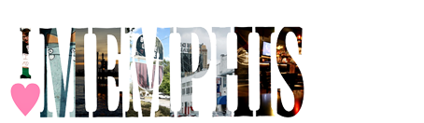

I Love Memphis
When in doubt, check out: http://www.ilovememphisblog.com/
- There’s a guide to just about everything (i.e. Going Gluten-Free, Brunch in Midtown, Best Margaritas, St. Patrick’s Day, Valentine’s Day, etc.)
- “5 Things to Do This Weekend” posted every weekend
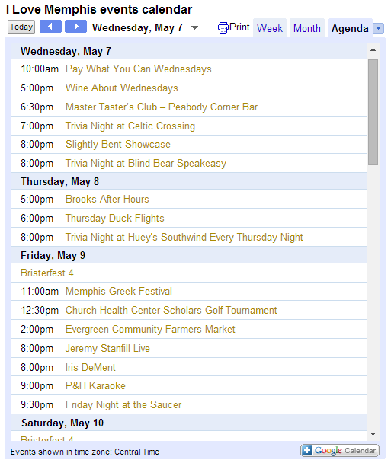
- Constantly updated calendar of every event the site has knowledge of by day and time (example below)

Appendix A: 100 Things to Eat in Memphis

1. Tuna sandwich from Chinese Sub Shop
2. BBQ plate from Germantown Commissary
3. Fried chicken breast from Gus's
4. Soul Burger from Earnestine and Hazel's
5. Peach cheesecake from Cheesecake Corner
6. Chorizo tortuga from Las Tortugas
7. Sea bass at Tsunami
8. Ribeye from Folk's Folly
9. John Deere snow cone from Jerry's
10. Joyce roll from Sakura
11. Dry rub ribs from Bar-B-Que Shop
12. San Diegan from Brother Juniper's
13. Guacamole from Las Delicias
14. Homeroom Chicken and Grids from Lunchbox Eats
15. Red velvet donuts from Gibson's
16. Greek burger from Alex's Tavern
17. Gas station sushi
18. Uptown burger from Roxie's Grocery
19. Muffaletta from Kwik Chek
20. Gyro from Castle
21. Key Lime Pie ice cream from La Michoacana
22. Twice-baked potato salad from One and Only BBQ
23. Cheesesteak from Yang's
24. Shrimp and grits from Sweet Grass
25. Buffalo tenderloin from Erling Jensen
26. Barbecue pizza from Coletta's
27. Cornish game hen from Cozy Corner
28. Grilled cabbage from Deja Vu
29. Bulgogi from Du Won Jong
30. Roast duck from New Asia
31. Rib tips from Tom's Barbecue
32. Capote cupcake from Muddy's Bakeshop
33. Barbecue tofu nachos from R.P. Tracks
34. Chips (aka fries) from Brass Door Tavern
35. Ravioli from Vanelli's Deli
36. Mac'n'cheese from Mollie Fontaine Lounge
37. Voodoo Chocolate Passion Cake at King's Palace
38. Banana pudding from Cozy Corner
39. Turkey leg from a vendor outside of a Melrose High football game
40. Salmon cakes from Elegant Farmer
41. Almond croissants from Off the Square Catering
42. Crazy noodle bowl from Bhan Thai
43. Banana pudding from Germantown Commissary
44. Tiger Bleu Chips from Brookhaven Pub
45. Barbecue nachos from Central BBQ
46. Blueberry donuts from Gibson's
47. Hot wings from Ching's
48. Pimento cheese stuffed okra from Restaurant Iris (this item no longer available)
49. Shrimp salad from Bogie's
50. Chilean sea bass from McEwan's
51. Wedding cake supreme snow cone from Jerry's
52. Hummus and falafel from Casablanca
53. Chicken salad sandwich from Young Ave. Deli
54. French fries / sweet potato fries from Young Ave. Deli
55. Pineapple shake from Shanghai
56. Coconut cake from Beauty Shop
57. Spicy crab soup from Ryu
58. Goat taco from La Guadalupana
59. Turkey and dressing from the Four Way
60. Reuben from Trolley Stop Market
61. Thai Gumbo from Tao
62. Honey gold wings from All-Star
63. BLT from Links of Galloway
64. Pan-fried dumplings from Panda Garden
65. Hot wing rolls from Blue Monkey
66. Barbecue pizza from Pete and Sam's
67. Mussels from Bari
68. Ribs from A&R Barbecue
69. Salsa Tayde from Las Tortugas
70. Baklava from Cafe Med
71. Pickled green tomatoes from Soul Fish
72. Vegan Memphis barbecue sandwich from Imagine Vegan Cafe
73. Lentil tacos from Fuel Food Truck
74. Brussels sprouts from South of Beale
75. Bi Bim Bop from Kwik Check
76. Ribs from Central Barbecue
77. Wings from Molly's La Casita
78. Burger from Huey's
79. Cheese grits from Republic Coffee
80. Homemade chips from Pop's Deli
81. Nachos from Interstate Barbecue
82. Steak sandwich from Jack Pirtle's
83. Pork chop sandwich from Tom's BBQ
84. Stone Hero hoagie from Skunx Chef's Pub
85. Meat-stuffed pizza at Little Italy
86. Chocolate milkshake from Wiles-Smith
87. Breakfast sampler from Bryant's
88. Crab eggs benedict from Sweet Grass
89. All-in-one from Las Delicias
90. Pronto Pup
91. Lobster roll from Slider Inn
92. Nuts and chocolate from Peanut Shoppe
93. Lunch buffet from Pho Hoa Binh
94. Self-serve frozen yogurt from Yolo
95. Dirty Fries from Revival Food Truck
96. Island Club from Bardog Tavern
97. Lobster pronto pup from Rizzo's Diner
98. Monte Cristo from Half Shell
99. High tea from Chez Philippe
100. Chili pineapple paleta from La Michoacana

Appendix B: 100 More Things to Eat in Memphis

1. After School Scooby Snack from Lunchbox Eats
2. All the cheese (as in, the cheese menu sampler) from Bari
3. AM Breakfast from Andrew Michael Italian Kitchen
4. Bananas Foster from Deja Vu
5. Bar popcorn from South of Beale
6. Barbecue nachos from FedExForum
7. Benton's Bacon from all kinds of good places (Iris, Andrew Michael, Hog and Hominy)
8. Banh mi from Pho Saigon
9. Black cherry milkshake from Sweden Kream
10. Brussels sprouts from Alchemy
11. Bubble tea from Asia Palace
12. Buffalo deviled eggs from Eighty3
13. Buffalo pig tails from Hog and Hominy
14. Burger (fried in 100 year old grease) from Dyer's Hamburgers
15. Carne Asada Fries from Elena's Taco Shop
16. Ceviche from Playita Mexicana
17. Cheesecake from Aldo's Pizza Pies
18. Chef's TV Dinner from River Oaks Restaurant
19. Chicken Hash from Calvary Waffle Shop (open annually during Lent)
20. Chicken wing pizza from Ski-mo's
21. Chocolate covered pineapple from Dinstuhl's
22. Key lime chocolates from Chocistry
23. Cold sesame noodles from East Tapas
24. Combo Duet No. 1 from Kabob International
25. Cookie sliders from Bluff City Coffee
26. Corn fritters from Bar DKDC
27. Corn ice cream from La Michoacana
28. Crab eggs benedict from Cafe 1912
29. Deep dish apple pie from Sweet Grass / Sweet Grass Next Door
30. Any of the dessert shot glasses from Majestic Grille
31. Drunken noodles from Bangkok Alley
32. Elote from Las Tortugas Deli Mexicana
33. Ezekiel bread from Bluff City Bakery
34. Falafel from Al Rayan
35. Fino sandwich from Fino's
36. Flaming Fireball of Freedom from Kiwk Chek
37. Fried oysters from Flying Fish
38. Fuul from Derae Restaurant
39. Ginger donuts from Tsunami
40. Green detox juice from Cosmic Coconut
41. Green goddess popcorn from OC Vegan (sold at Whole Foods Poplar)
42. Halo Halo from VGM Market and Deli
43. Hey Meat! pizza from Memphis Pizza Cafe
44. Hibiscus mint popsicles from Mama D's
45. Home fries from Brother Juniper's
46. Homemade cinnamon rolls from Shoaf's Loaf
47. Honey butter biscuits from Uncle Lou's Fried Chicken
48. Honey gold wings from Bosses
49. Honey rosemary cookies from Muddy's Bakeshop
50. House chips from Central Barbecue
51. Jerk chicken skewers from Side Street Grill
52. Juantons from Chiwawa
53. K-Pie from Paulette's
54. Kanisu roll from Ryu
55. Kobe beef gnocchi from Ciao Bella
56. Kobe beef noodle soup / vegetarian noodle soup from Beauty Shop (They're the same soup, but one has meat and the other doesn't.)
57. Kookamonga Burger from Kooky Canuck
58. Lacey Special from Little Tea Shop
59. Lardo from Bari
60. Late-night ramen noodles from Hog and Hominy
61. Lemongrass tofu from Pho Hoa Binh
62. Live burger from Balewa's
63. Lobster knuckle sandwich from Restaurant Iris
64. Lotus wrapped chicken and rice from Asian Palace
65. Lunch buffet at Bharat Indian Restaurant
66. Macarons from Pistache Pastry
67. Mango lassi from India Palace
68. Maple bacon blondie from Local Gastropub
69. Maple bacon donut from Gibson's
70. Mapo tofu from New Asia
71. Mascarpone gelato from YoLo
72. Pancho's cheese dip from just about any local grocery store
73. Peppermint patty from Felicia Suzanne's
74. Potato salad from Bogie's Deli
75. Potato soup from Huey's
76. Pretzels with cream cheese and mustard from Flying Saucer
77. Ramen noodles from Edo
78. Ribs from Alex's Tavern (Best in the city, according to me.)
79. Cheese pizza from Rock'n'Dough
80. Ropas Vejas from Havanas Pilon
81. Salmon cakes and grits from Evelyn and Olive
82. Santa Fe Wrap from Elliot's
83. Sausage and cheese plate from the Rendezvous
84. Scotch eggs from Celtic Crossing
85. Sea salt caramels from Shotwell Candy
86. Smoked sausage from Payne's Barbecue
87. Steak on a stick from Stick'em Food Truck
88. Swedish crepes from Stone Soup Cafe
89. Sweet potato cobbler from Alcenia's
90. Tacos el pastor from Caminos de Michoacan
91. The Other Side pizza from Aldo's Pizza Pies
92. Tom Yum Soup from Shanghai
93. Tomato bleu cheese soup from Booksellers Bistro
94. Tuscan butter from Spindini
95. UFOs from Arepa & Salsa
96. Vietnamese pancake from Saigon Le
97. Water ice (any flavor) from Parker's Water Ice
98. Yuk Gae Jang from Crazy Noodle
99. Yum Scallops from Jasmine
100. Zydeco Wings from Bayou Bar and Grill

Appendix C: The Ultimate Guide to Drinking Cheap in Memphis
Weekday Happy Hours

●Automatic Slim's: $5 martinis and half-price appetizers from 4 p.m. – 7 p.m., Monday – Friday.
●Bar Louie: Memphis' Bar Louie location has $1 off 14 oz. drafts, $2 off 20 oz. drafts, half price bottles of wine and $2 off martinis and specialty cocktails from 3 p.m. until 6 p.m., Monday through Friday.
●Bardog Tavern: $2 Fireball shots, $1 off all pints from 5 p.m. – 7 p.m., Monday – Friday.
Blind Bear: Happy hour is Monday through Friday from 5 p.m. until 8 p.m. Domestic bottles are $2.50, well drinks are $4 and wines are $5.
●Bon Ton Cafe: Happy hour means $4 margaritas and Long Islands, $2 off premium liquor and $1 off house wine every Monday – Friday from 4 p.m. until 6 p.m.
●Bosco's Squared: Discounts on well drinks, beers and wine (and a daily cellerman ceremony) from 3:30 p.m. until 6:30 p.m., Monday – Friday. Since most of the beers at Bosco's are high-alcohol content, this is one of the most efficient happy hours in town.
●Brass Door: Happy hour is from 4 p.m. until 7 p.m. every weekday. You can take $1 off all pints of beer (other than Guinness), house wine and well drinks.
●Brookhaven Pub: Happy hour from 11 a.m. – 7 p.m., Monday through Friday. $1 off all beers and well drinks.
●Ciao Bella: Half price drink specials and bar food from 4 p.m. – 7 p.m., Sunday through Thursday.
●Corner Bar: Happy hour is from 5 p.m. – 7 p.m. and is different every day. On Mondays, select martinis, margaritas, and mojitas are $3. On Tuesday, Tennesse beers and spirits are $3 each. Wednesdays, you can choose from a selection of house red and white wines for $2.50, $5, and $7 each . Thursdays is Girls' Night Out, and you can choose from a selection of pink drinks for $3 each.
●The Cove: The Cove has cocktail and oyster specials from 5 p.m. until 8 p.m., every Tuesday – Friday.
●East Tapas: Happy hour is Monday – Friday from 4:30 p.m. until 6:30 p.m. Get $1 off domestic beers and small plates and $.50 off wines by the glass and specialty cocktails.
●Fleming's: Sit at the bar and get five appetizers, cocktails and wines for $6 each by the glass every night until 7 p.m.
●Green Beetle: Happy hour is from 3 p.m. until 7 p.m., Monday through Friday. All well drinks, draft beers and house wines are $3.
●Huey's: Happy hour is from 4 p.m. – 7 p.m. every Monday through Friday at all Huey's locations. Most drinks are $0.75 off.
●Huey's Cordova: Two-for-one domestic bottles and well drinks every weekday at Huey's Cordova location.
●Jim's Place: Happy hour happens in the bar from 3 p.m. – 7 p.m., Mondays through Saturdays. Well drinks are $4.50, domestic beers are $3.
●Local Gastropub: $3 well drinks and draught beers, $1 off bottled beers, specialty cocktails and wine by the glass from 4 p.m. – 7 p.m., Monday – Friday.
●Raffe's Beer Garden: Happy hour is from 4 p.m. until 7 p.m. every Monday – Friday, and you can get $3 draft beers and two-for-$3 domestic bottles.
●Sekisui: two-for-one hot sake at all Sekisui from 4 p.m. – 7 p.m., Monday – Friday.
●Side Street Grill: Happy hour runs until 7 p.m. All well drinks, draft beers and house wines are $3.
●Silly Goose: $2 domestic beers, $3 well drinks, $4 wine and $5 appetizers from 4 p.m. until 7:30 p.m., Monday – Friday.
●South of Beale: Have $3 draft beers, $4 well drinks and $4 glasses of wine at SOB from 4 p.m. – 7 p.m., Monday – Friday.
●Swanky's Taco Shop: Happy hour is Monday – Friday from 4 p.m. – 7 p.m. All domestic beers are $2.75 and house margaritas are $4.
●Tamp and Tap: Tamp and Tap has two happy hours every week day, one from 10 a.m. – 11 a.m. and one from 5 p.m. – 6 p.m. During both happy hours, all drinks (beer, coffee, whatever) are $1 off.
●The Tower Room: All drinks are half price from 4 p.m. – 7 p.m., Monday – Friday.

Pint Nights

●Aldo's Pizza Pies: All pints are $3 on Monday nights beginning at 5 p.m.
●Bardog Tavern: All pints $3 on Tuesdays from 7 p.m. to close.
●Brookhaven Pub: All pints $2.50 on Monday nights.
●Bayou Bar and Grill: All pints $3 on Tuesdays.
●Celtic Crossing: Pints start at $2.50 on Monday nights.
●Flying Saucer: Almost all pints are $3 on Monday nights.
●Huey's Downtown: $3 pints on Wednesday nights from 4 p.m. until 10 p.m.
●Mama Mia's: $.90 PBRs on Monday nights, which is possibly the cheapest PBR in the Memphis area.
●Side Street: All import bottles are $2 on Tuesdays.
●Slider Inn: All Pints $3 on Tuesday.
●South of Beale: All pints $3 on Wednesday and Sunday nights.
●Young Ave. Deli: All pints $3 on Wednesday night.

Wine Specials
    - Brass Door: $3 house wines every Wednesday night.
    - Celtic Crossing: Wine is $2 off per glass or $5 off per bottle on Tuesday nights.
    - Jim's Place: On Tuesdays, house wine is half price.
    - Le Chardonnay: Wine by the glass is half price every Monday through Friday from 4 p.m. until 7 p.m.
    - Old Venice Pizza: House wine is half price on Wednesdays.
    - Spindini: Half off of all pizza and wine on Monday nights.
Martini Specials
    - Bangkok Alley : Tuesday is two-for-one martini night.
    - The Cove: Martini Madness on Saturdays means $5 martinis from 5 p.m. until 8 p.m.
    - East Tapas: Tini Tuesday (every Tuesday) means $5 specialty martinis all day every Tuesday.
    - Felicia Suzanne's: Start your weekend with a three-martini lunch. Felicia's has $0.25 martinis on Fridays during lunch service.
    - Jim's Place: Well martinis are $4 on Mondays.
    - Side Street: $5 martinis on Mondays.
Beer Busts, Special Occasion Shooters and Other Cheap Drinks
    - The Cove : $1 PBRs during karaoke on Wednesday nights.
    - Ferraro's: PBR is $1 every Tuesday night during trivia.
    - The Pumping Station: Friday night beer bust at 10 p.m. Most of the Pump's draught beers are on an all-you-can-drink special with the lowest priced beer starting at $3. (1382 Poplar Avenue)
    - R.P. Tracks : All shooters are $1 off when a train goes by. (3547 Walker Avenue)
    - Raffe's Beer Garden: Thursday is bottle night. All bottled beers are $1 off.
    - Swanky's Taco Shop : Two-for-one margaritas on Tuesdays means that you get two 12 oz. drinks (frozen or rocks) for $5.50. (both locations)
    - Ubees : $8 beer bust (all you can drink) on Wednesday and Thursday nights. On Sundays, you can get $1 off all drinks all day, and it's half-price tab night. $3 you-call-it shots on Monday nights. (521 South Highland St.)
Brunch Specials
    - Automatic Slim's: $2.50 bloody Marys and mimosas all day on Sunday.
    - Bayou Bar and Grill: $3 mimosas, bloody Marys and screwdrivers on Sundays.
    - Majestic Grille: During brunch, you can get a bottle of champagne and a caraffe of OJ for $14.
    - R.P. Tracks: Mimosas are $3.50 during brunch on Saturday and Sunday.
    - Side Street: All-you-can-drink bloody Marys for $22 on Sundays.
    - Thai Bistro: On Sundays, mimosas are $1 during brunch and pints are $3 all day.

Appendix D: Summer in Memphis

- Live at the Garden: http://memphisbotanicgarden.com/liveatthegarden
  - Outdoor concert series at the Memphis Botanic Garden
- Orpheum Summer Movie Series: http://www.orpheum-memphis.com/orpheum_theatre_info/news/detail/2014-summer-movie-series
  - Showing of classic movies on the Orpheum’s big screen; before the films, there is live organ music, trivia, costume contests, showings of cartoons, and themed cocktail hours
- Thursdays Squared: http://www.overtonsquare.com/
  - Outdoor concert series in Overton Square
- Peabody Rooftop Parties: http://www.peabodymemphis.com/rooftop-parties/

Appendix E: Nearby Travel Destinations

Major Cities
- Nashville: 3 hours
- Birmingham: 4 hours
- St. Louis: 5 hours
- New Orleans: 6 hours
- Atlanta: 6 hours
- Chicago: 6 hours
College Towns
- Ole Miss (Oxford, MS): 1.5 hours
- Mississippi State (Starkville, MS): 3 hours
- University of Alabama (Tuscaloosa, AL): 3.5 hours
- University of Tennessee-Chattanooga (Chattanooga, TN): 5 hours
- University of Tennessee (Knoxville, TN): 6 hours
- Louisiana State University (Baton Rouge, LA): 6 hours
Drive-able Vacation Spots
- Gulfport/Biloxi, MS: 6.5 hours
- Orange Beach, AL: 8 hours
- Gulf Shores, AL: 8 hours
- Destin, FL: 9 hours
- Panama City, FL: 9 hours
Other Places to Go
- Tunica, MS (home to several casinos): 1 hour
- Southaven, MS (cute downtown area; farmer’s market on Saturday’s; visit Lady Bug Bakery for the best lunch and cupcakes!): 20 minutes

