Advising Dashboard – on the Advising page in myMemphis

- Click on Advising
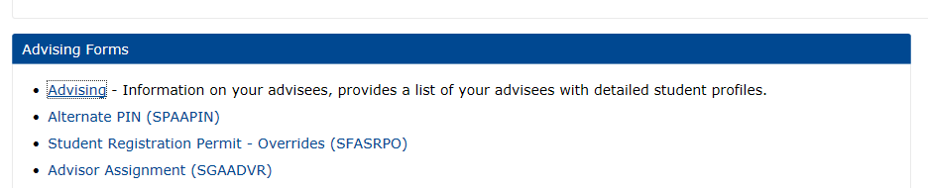

- Choose Spring 2019 (or whatever term you need to see).

- To look up a single student: Enter the student’s U number in the “Student ID” field and click “View Profile.”

- To look up your list of advisees, click on “View My Advisee Listing.”

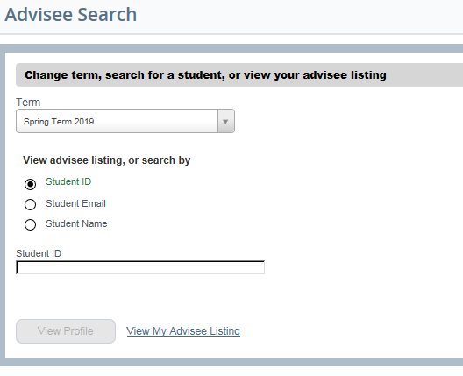

Once you click on an individual student, you will see links in a column on the left side of the screen that let you link to the student’s courses, test results, transcript, registration, schedule, permits, application to graduate, week at a glance schedule, grades, and UMdegree. (Registration and Planning is not available even though the link is there.)
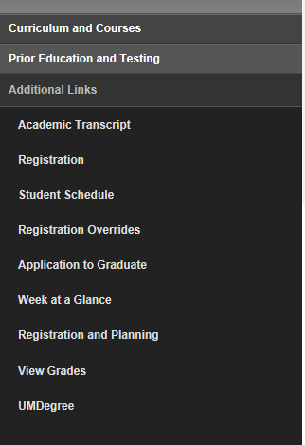

In the middle of the screen will be student “Bio Information.” Note the link to the graduation application can be found here also (at the blue arrow).
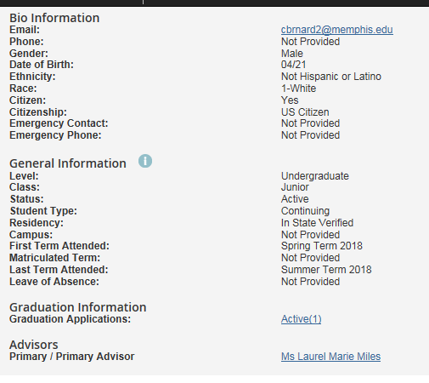
On the right side of the screen will be the following information: curriculum, hours, admit type, courses if already registered for the term you selected. At the top right in the black line, you can access Holds and Registration Notices (beneath the green arrow).

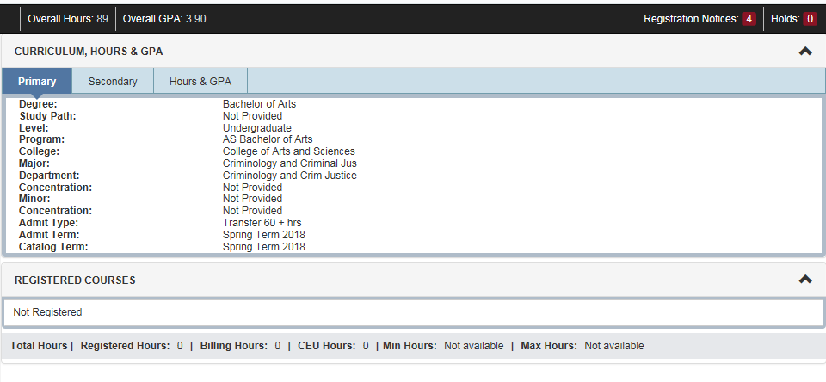
“Registration Notices” shows Academic Standing (good, probation, suspension), Status (active or inactive), Enrollment status, and Time Tickets (which shows when the student can register for the upcoming term).
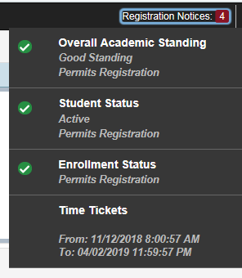

If you click on “Advisee Listing,” you will be able to e-mail your advisees (blue arrow below).
Also, you can filter (yellow arrow) the list by any of the columns in the table, for example, by primary and secondary advisor, active or inactive, or minor.

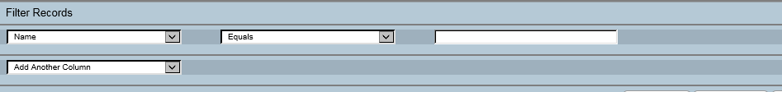

You can pull the list of your advisees into an Excel file by clicking on the gear icon next to your name at the upper right and then clicking on “Export Advisee Listing”:

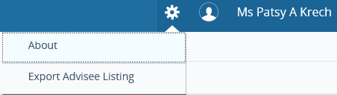

NOTE: The one thing that this dashboard does not show is which of your students have been cleared and which have not. You can pull that information using EAB Campus using these instructions: advisees_not_cleared_or_cleared (found in the Technology section of the CAS Guide for Advisors)

Or you can go to myMemphis, click on the Advising page, open the Faculty and Advisors folder, click on Student Information, and then click on Advisee Listing. In the Alternate Pin column, any students with the initials you use for clearing students have been cleared for that semester; any students with 6 random letters or numbers in that column have not been cleared. (If the student has 2 or more advisors, the initials used by another advisor would mean the student had been cleared by the other advisor.)

