Checking Advisees Not Cleared (or Cleared) in EAB CAMPUS

Log into Campus – https://memphis.campus.eab.com
Click on Advanced Search on the left side panel (the microscope icon):
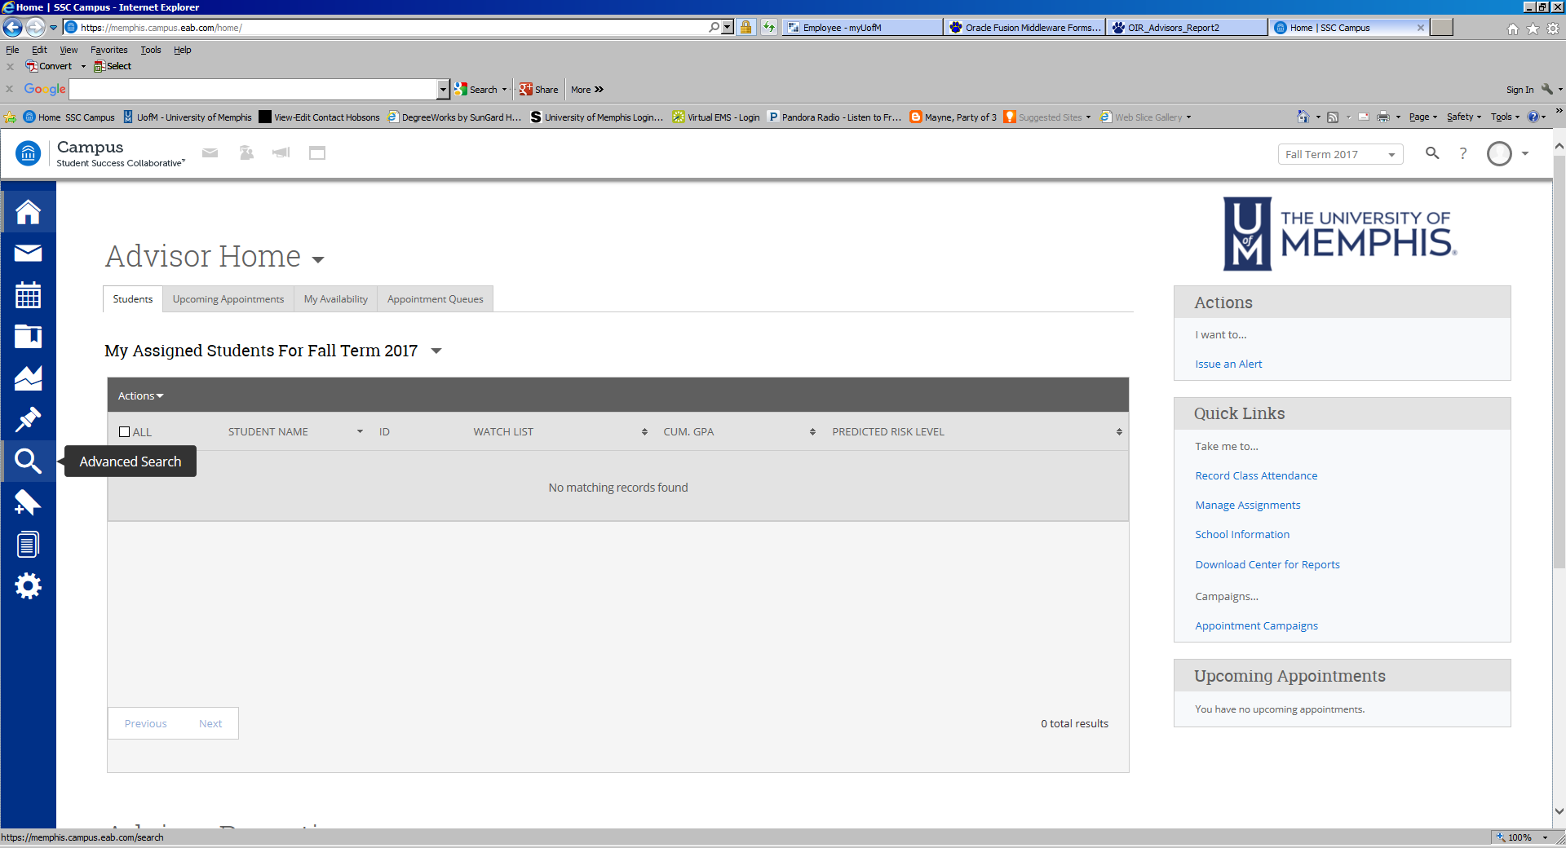
Click on Show Advanced Filters on the right side:
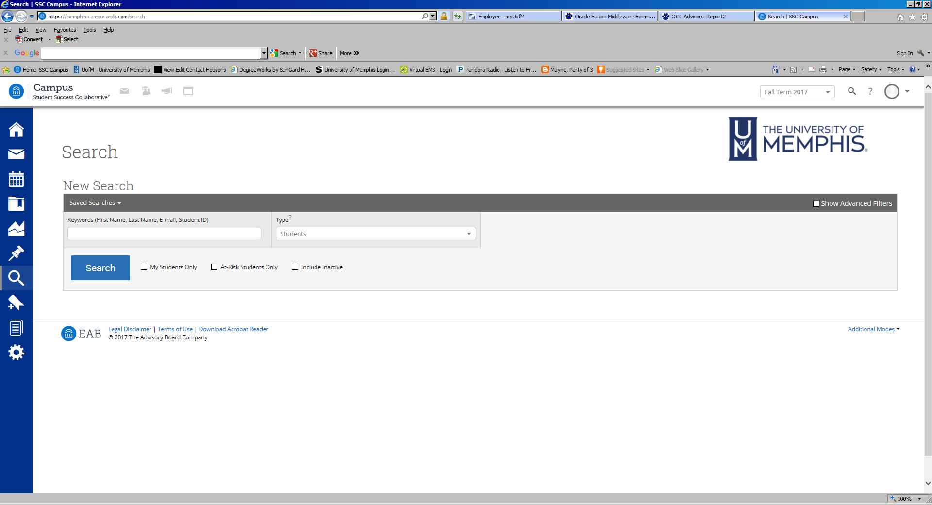
Category –Any of these – choose “Pin Not Cleared Spring”
Assigned to – choose your name
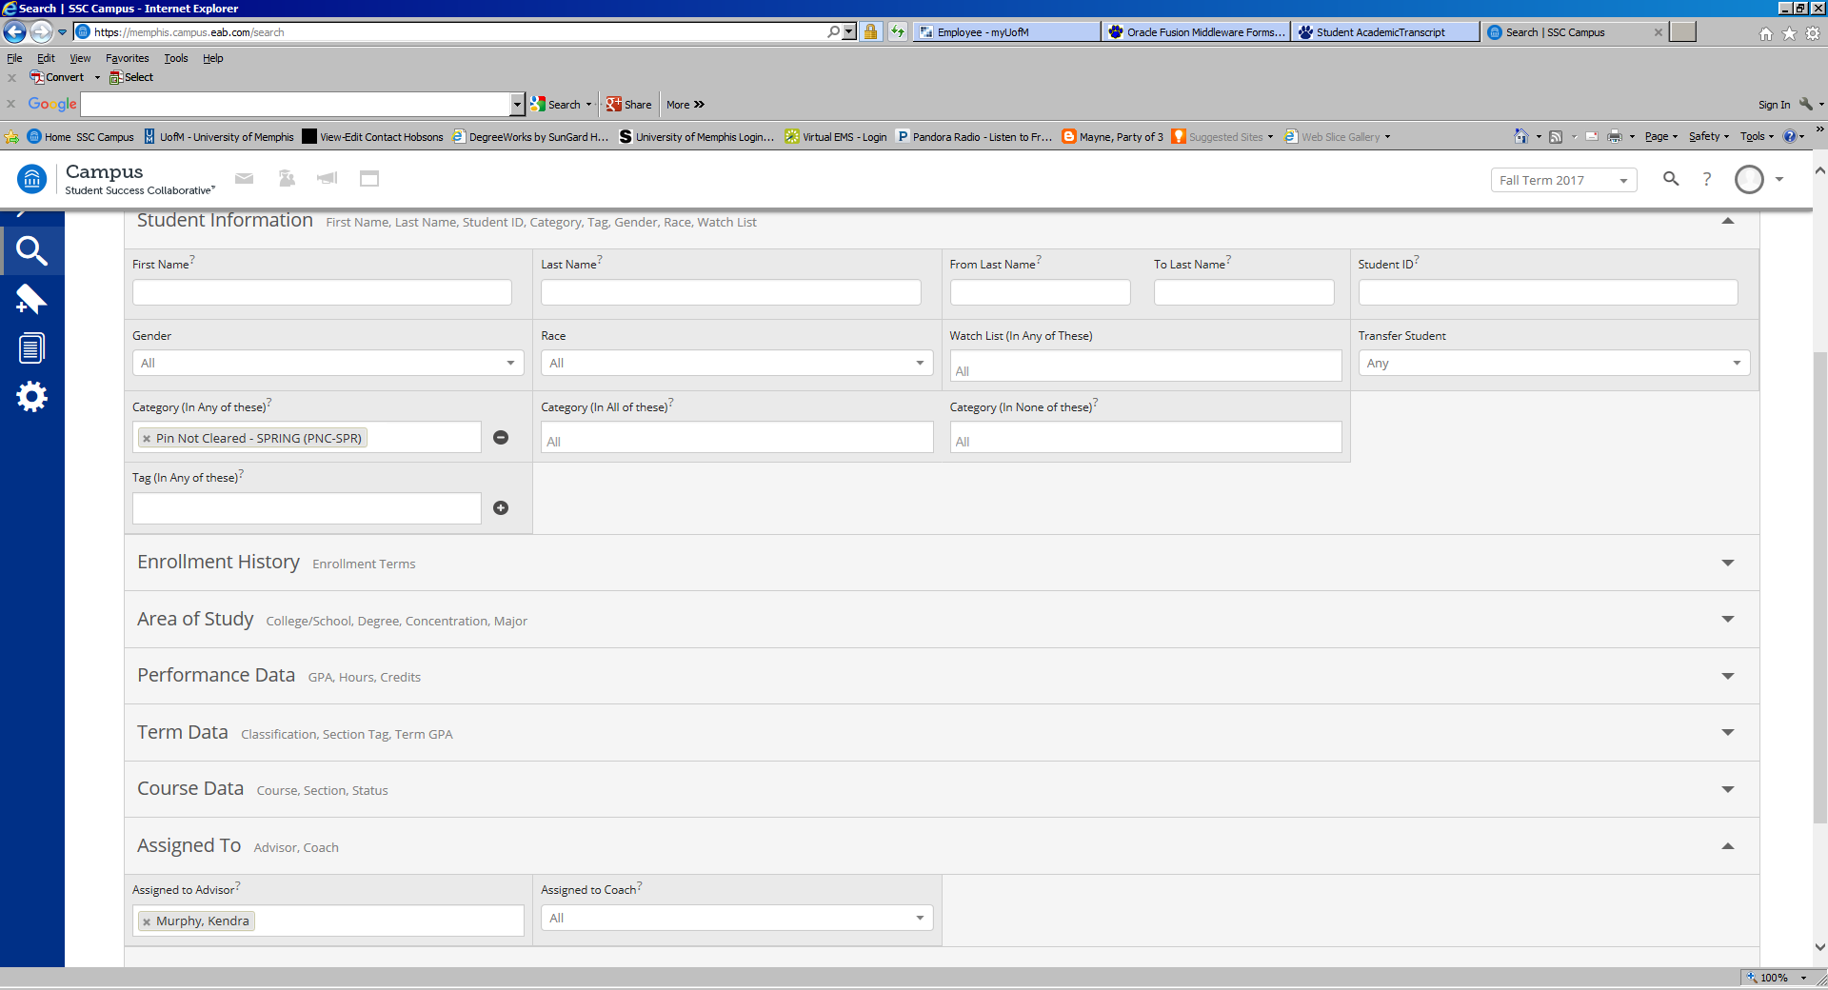

Click Search and the list will pop up.
To save it as Excel, click Actions and Export Results:
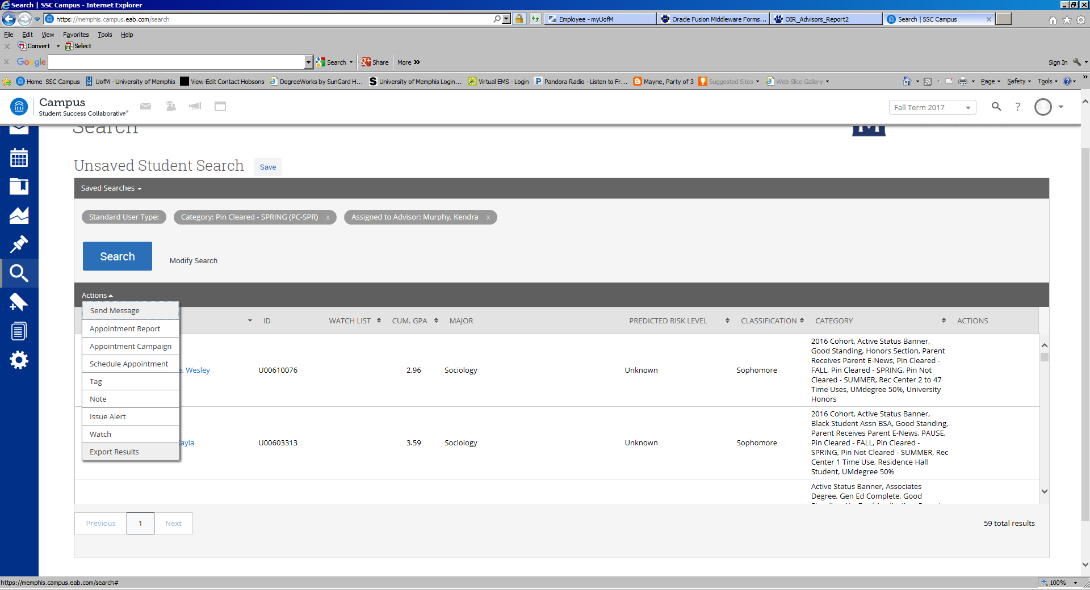
A prompt will appear to Open or Save the report.

You can use the same search format and choose “Pin Cleared Spring” to find those who still need to be cleared.
You can also search by major by clicking on “Student Information” and then choosing “Major” in “Area of Study”:
