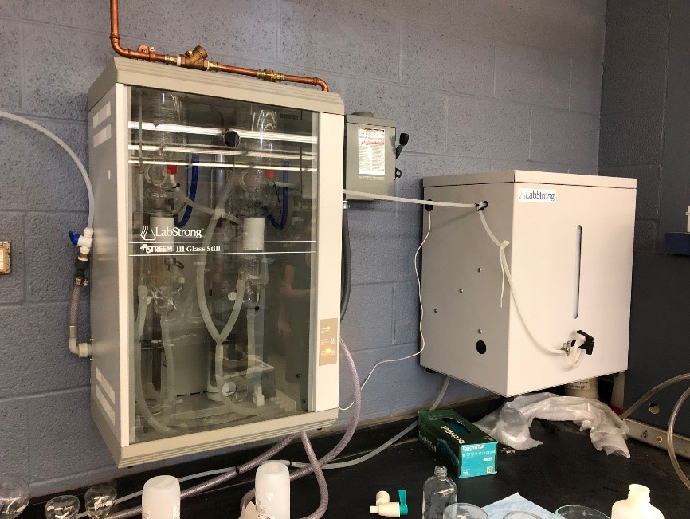
High purity reagent water is often taken for granted but its importance cannot be underestimated in the research efforts of the experimentalists in the Department of Chemistry as well as our colleagues in the molecular cell sciences. Currently, the Department of Chemistry provides reagent water largely at our own expense for many researchers in these previously mentioned disciplines. While the quality of the reagent water we prepare has been acceptable, it could certainly be improved. The Lab Strong FI-STREEM system is set up and operating in Rm 27 of Smith Chemistry Building. It greatly improves of reagent water quality from ~18.2 MΩ water to at least 18.6 MΩ. This may not seem like much of an increase, but it important to explore what these numbers actually mean.
Resistivity (the value expressed in units of MΩ) is the inverse of the conductance – the ability of a water to conduct current. Water that is 18.2 MΩ is typically considered "pure water", but what this means is that this water is relatively pure of ions and thus does not efficiently conduct current. However, this measure of 18.2 MΩ does not take into account the "total organic content" of the water in terms of "purity". The fact is that that there are many DNAse and RNase compounds left over from bacteria can potentially complicate bioanalysis. Additionally, in studies of disinfection chemistry, the same compounds can contribute to oxidant demand and skew results. The Lab Strong FI-STREEM system takes "pure" 18.2 MΩ reagent water that we produce already and subjects it to a double distillation process that essentially make our reagent water free from such complicating chemical compounds.
The LabStrong Corp FI-STREEM Bi Distillation system is an extremely high quality automated distillation system capable of distilling 8 liters per hour. This particular system provides for 24-hour automatic control meaning that the still is activated only as needed to maintain a full water storage reservoir. This saves wear and tear on components as well as energy of operation. The system is easily shut down for extended time periods without having to replace costly consumables. Finally, the fully automated controls in FI-STREEM III stills simplify operation while assuring high reliability and the highest quality water. In our case, the "house" water we produce in the penthouse of Smith Chemistry Building will still be used in connection with our current RO systems, but then the water we currently use as reagent water will then be subjected to "double distillation" in the Lab Strong FI-STREEM system.
The LabStrong 40 Liter Storage Tank is not just a water storage tank, it is a key component for fully automatic operation when interfaced to the above FI-STREEM double distiller unit. The tank is formed from high density polyethylene in a space saving, wall mounted design. The tank is constructed with window for observation of the water levels and also with a vent filter that prevents airborne contamination. A spigot is attached for easy dispensing of water. A distribution accessory kit included in the estimate is used to connect the 40 liter tank to a secondary output other than from the spigot at the front of the tank. The distribution accessory kit allows for distribution of distilled product water to point of use deionization (DI) system or any system requiring distilled water as a feed source, while leaving the spigot at the front of the tank free to manually draw water from at any time.

Usage Policy
The LabStrong 50 Liter Carboy allows for fully automatic operation when connected to FI-STREEM double distillation systems. The carboy is formed from low density polyethylene. The portable design is ideal for transporting distillated water to different lab sites. In our case, we are making ultra-high purity reagent water easily accessible to all departmental researchers in Chemistry meaning that at least one carboy will be continuously available on three different floors, with one in reserve near the main unit so that one full carboy is always available for quick changeouts. Other departments will be asked to purchase their own carboys to participate in the program. Included with the reservoir is a spigot for easy dispensing of water. The specialized cap is modified to accept the FI-STREEM Float Switch to prevent overflows. Researchers from other departments simply need to bring an appropriate container (carboy) to Smith Chemistry Building RM 27 during normal office hours or by appointment to collect appropriate volumes of the high purity reagent water. The contact person is Joseph Burns (jburns7@memphis.edu ). Please contact him by email to arrange a fill time.

