Bright/Dark field microscope system (LV 150 N) was acquired from Nikon Inc. this past Spring semester, 2018. The microscope came with a set of Bright/Dark field objective lenses, including 5X, 10X, 20X, 50X (extra-long working distance), 100X magnifications and a sensitive Photometrics Dyno CCD camera. These objective lenses, when integrated with other optics components in the Nanophotonics Lab, allow one to look at single nanostructures such as single molecules, quantum dots, nanowires or plasmonic nanoparticles from visible to near IR frequency. Besides the white light illumination, the microscope system is also customized with an optical path which enable a tunable laser to optically excite the fluorescence of nanomaterials. Optical signal from the microscope is guided and collected by the camera or by a spectrometer for frequency analysis and time-resolved measurements.
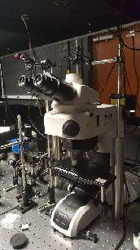
Figure 1 shows a picture of the microscope installed in the lab along with other optics which allows external optical excitation and detection. In short, besides having most functions of a regular microscope (viewing and imaging structures at small scales), this Bright/Dark field microscope system when integrated with other spectroscopic components in the Nanophotonics Lab can provide:
- Single nanostructure imaging
- Single nanostructure fluorescence imaging
- Single nanostructure spectroscopy
- Raman spectroscopy of nanostructures
- Time-resolved fluorescence
- Fluorescence of upconversion nanocrystals
- Antibunching measurements
- Coincidence correlation measurements
- Single molecule spectroscopy
(Figure 1 to the right: Picture of the newly installed microscope, which has been integrated with other optical components in the Nanophotonics Lab (MN 107).)
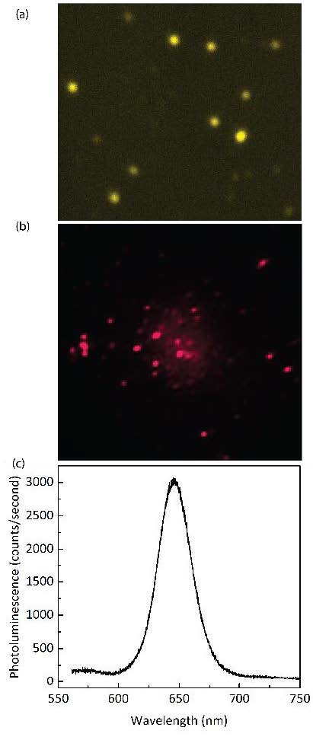
This microscope system offers a powerful capability to the optical study of the broad areas of physics, materials science, chemistry, and biology. Specifically, this system offers possibilities to study the spectral, spatial and temporal dynamics, photon statistic and ultrafast optical, electronic processes that occur in novel nanomaterials (including nanocrystals, semiconductor nanowires and rods, 2-dimensional dichalcogenides), organic materials (such as organic dyes or photochromic molecules) and ultrafast optical processes in nanophotonic and plasmonic nanostructures.
An example of preliminary data taken with this newly installed microscope setup is shown in Figure 2. Figure 2a shows a dark field scattering image of gold nanoparticles. These individual nanoparticles have sizes around 50-70 nm and they become very bright under white light illumination as a result of localized surface plasmon resonances. Figure 2b shows a fluorescence image of CdSe quantum dots when excite with a laser, each individual quantum dot shows up as a bright spot. Figure 2c shows corresponding emission spectrum of the quantum dots displayed in Figure 2b. By using a spatial filter (not be shown here), the microscope system can also measure the spectrum of individual quantum dots.
(Figure 2 to the right. Example of preliminary data taken with the new microscope setup. (a) Image of individual gold nanoparticles under white light illumination. The nanoparticles are approximately ~ 50 nm. (b) Fluorescence image CdSe quantum dots, under 400 nm laser excitation and (c) Emission spectrum of the quantum dots shown in (b).)

Usage Policy
For user access from outside of the Department Physics and Materials Science, no special arrangement is needed. Users will first need to contact appropriate personnel (Presently, Dr. Hoang, email tbhoang@memphis.eduresponsible for maintaining of the system) for available time. The system can be used together with other spectroscopic equipment in the Nanophotonics Laboratory, including an ultrafast laser, high spectral, temporal and spatial resolution spectroscopic setups and other polarization optics. Tothis end, the users are required to have some basic training regarding the laser safety and operations, and uses of spectroscopic equipment.
A fee structure is established for use of above facilities for both internal and external users. The fee structure is determined with reference to Integrated Microscopic Center (IMC) on campus as shown below. For those faculty who contributed their own research funds to the purchase of facilities in the Nanophotonic Lab, their contributed funds will be considered as prepaid user fees for future service. The recovered cost will go towards regular maintenance, contract service, and consumable items.

All rates hourly. Fees are charged in whole hour increments with the minimum charge of 1 hour.
Instrument | Internal User Rates | External User, Non-Profit Organization Rates | External User, For Profit Organization Rates
Nanophotonics Lab | $50 | $80 | $100
Technical Assistance | $50 | $80 | $120

