A state-of-the-art surface area analyzer, NOVAtouch LX-2 for Quantachrome Instruments (F L, USA), has been acquired through CAS Research Instrumentation Initiative in March 2018. The system has been successfully installed and tested for its capabilities for measuring surface area, pore size, and pore size distribution of nanopowders. The system has four controlled baking station for removing moisture from samples and two measuring stations for performing controlled adsorption-desorption experiments simultaneously. The system is fully automated and requires minimum user input. All measurements are performed at liquid nitrogen temperature at 77K.
Surface area and porosity are physical properties that impact the quality and character of solid phase materials. Materials with identical physical dimensions may exhibit entirely different performance profiles based on variations in the physical surface area of the two materials.
Surface area measurement if an important analysis used in many research laboratories and industries, including catalysts, zeolites, batteries, absorbents, artificial bone, pharmaceuticals, metal powders for additive manufacturing along with a wide variety of other applications and industries.
The surface area is measured using BET analysis (Brunauer–Emmett–Teller (BET) theory), which provides precise specific surface area evaluation of materials by nitrogen adsorption measured as a function of relative pressure. The surface area is determined by calculating the amount of adsorbate gas corresponding to a monomolecular layer on the surface of the material.
The technique encompasses external area and pore area evaluations to determine the total specific surface area. BET is used to determine a range of disperse, solid microporous to mesoporous materials. In addition, BJH analysis can also be utilized to define pore area and specific pore volumes through adsorption and desorption techniques. Using BJH analysis one can conclude pore size distribution independent of the external area due to a particle size of the sample. Both information, surface area, and pore size analysis of the sample is highly sought information in the field of nanomaterials having varied nanoarchitecture, pores, and surfaces.
In addition, several other methods are available to measure surface area and to perform pore size analysis in the software. Figure 1 shows absorption-desorption isotherms of cobaltites measured using surface area analyzer. The inset shows pore size distribution as calculated using BJH analysis.
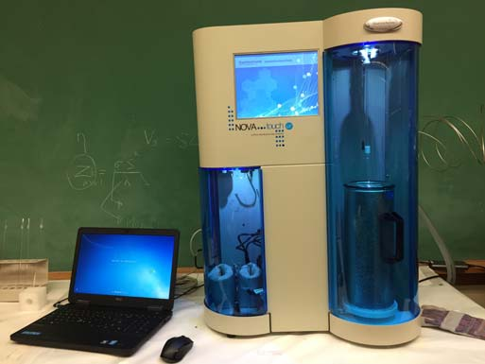
Figure 1a: NOVAtouch LX-2 set-up in MN 117B.

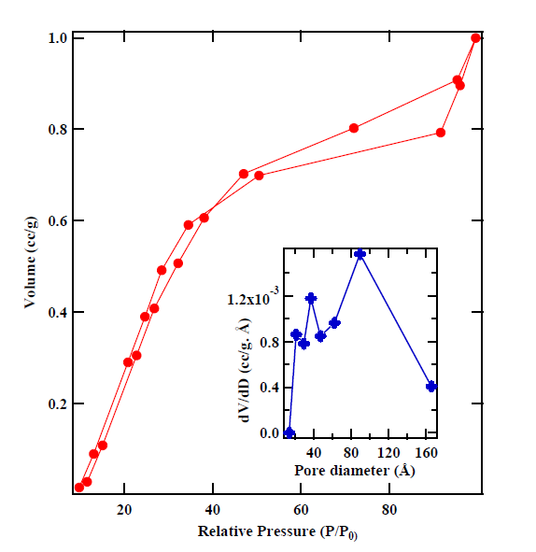
Figure 1(b): Absorption-desorption curves of cobaltite. The inset shows pore size distribution as measured using BJH analysis.

User Policy
The surface area analyzer is available for campus and public use. In order to schedule use of the instrument, the user needs to directly contact Dr. Mishra at srmishra@memphis.edu. The system will be available on the first come first serve basis. Prior to using instrument Dr. Mishra will provide initial training to the user. Due to the turn-key nature of the instrument, minimum training for the user is required. A proper user logbook will be maintained for the instrument usage. Data will be secured and will be transferred out of the computer on a secured disk as a part of the yearly maintenance of the equipment.
A fee structure is established for use of above facilities for both internal and external users. The fee structure is determined in tandem with the Integrated Microscopic Center (IMC) on campus as shown below. For those faculties who contribute their own research funds using Dr. Mishra's Nanomaterials Research Facility, will be considered as a prepaid user for the future service. The
recovered cost will go towards regular maintenance, contract service, and consumable items.

All rates hourly. Fees are charged in whole hour increments with the minimum charge of 1 hour.
Instrument | Internal User Rates | External User, Non-Profit Organization Rates | External User, For Profit Organization Rates
Nanomaterials Lab | $50 | $80 | $100
Technical Assistance | $50 | $80 | $120

