


MEN HEALING MEN AND COMMUNITIES NETWORK

STRATEGIC PLAN

“Healthy Communities---Thriving, Safe, & Secure”

NOVEMBER 2015

TABLE OF CONTENTS
Shelby County Office of Early Childhood and Youth Office Administrator’s Letter………….i
Training Coordinator’s Letter.......................................................................................................................ii Executive Summary…………………………………………………………………………………………………..iii
Defending Childhood…………………………………………………………………………………………………..1
Network for Overcoming Violence and Abuse……………………………………………………………….2
Community Assessment Report Summary……………………………………………………………………3
Community Assessment Implications…………………………………………………………………………...4
Men Healing Men and Communities Network History……………………………………………………5
Mission and Vision……………………………………………………………………………………………………….6
Strengths, Weaknesses, Opportunities, and Threats Analysis………………………………………….7
Five Focus Areas…………………………………………………………………………………………………………14
Goals/Future Projects…………………………………………………………………………………………………14
Objectives…………………………………………………………………………………………………………………..15
Appendix – Strategic Planning Partners……………………………………………………………………….16



Office of Early Childhood and Youth
160 N Main Suite 250
Memphis, TN 38103
November 8, 2015
Dear Memphians and Shelby County Residents:
I am proud to introduce the Men Healing Men and Communities Network (MHMCN) Strategic Plan. This document represents the humble beginnings of a set of strategies to make the Memphis and Shelby County one of the safest cities and livable cities in America. We join with MHMCN to improve the well being of our most important assets--our children, families, and communities. We believe that improving our city's safety is a quality of life goal that we all share, and so I hope that, you share our commitment and determination to rid our communities of the violence and ensuing trauma that haunts our city and haunts many of our citizens.
By working together in collaborative efforts and focusing on the goals of our plan, we keep our eyes on the prize of improving the quality of life for all the residents of Shelby County. While the programs and services needed to be successful to achieve our goals, we believe that identifying and solving our problems from the “inside-out and from the bottom-up” we believe that together we can make a difference.
The stakes are high. The crime and violence statistics are saddening and worsening. Unfortunately, adding even more urgency to this issue, far too many young people have witnessed violence, some multiple times. These trauma-impacted youth are left emotionally scarred. Together we can reach them and help them to heal. Joining with MHMCN, we can and must be doing more to prevent our youth from a life of violence.
I would like to thank the leadership of the strategic planning efforts. Join us as we implement this plan. Together, we will build a safer city that gives all of our citizens the freedom and the opportunity to make our city shine even brighter.
Sincerely,

Keisha Walker, Administrator
Office of Early Childhood & Youth

i


October 15, 2015

Dear Memphians and Friends,

It is with great pleasure that I invite you to examine the Men Healing Men and Communities Network (MHMCN) Strategic Plan. The mission and vision of the MHMCN serve as a guide in the development and ultimately the implementation of this strategic plan. Beginning in the Spring of 2015, the leadership of the Shelby County Office of Early Childhood and Youth in cooperation and consultation with Social Work faculty, students, staff, consultants, and community leaders began a series of trauma informed and culturally appropriate trainings and planning meetings. The stakeholders worked collectively to build consensus to create the network’s mission and vision, identify strengths, weaknesses, opportunities, and threats to the realization of impending goals, and to begin the work of charting the path for the network’s future.

The plan is “the first step in a journey of a thousand miles”. Yet, the plan is clearly a giant step for the City of Memphis and Shelby County. The plan is a living document bringing together a wide range of African American Male leaders of communities and organizations. The plan builds on the strengths of the Network, seeks to generate actionable projects, activities, and initiatives, develops internal processes, facilitates greater community relations and begins the process of coordination across organizations, advances community and regional participation, incorporates the lessons of the last decade of community-based efforts, and prepares the Network for future challenges. Most importantly, the strategic plan provides a framework to guide the ongoing efforts of MHMCN to reduce the violence and trauma faced by the residents of Memphis and Shelby County.

Thank you for your concerns, consideration, and involvement. We look forward to new and exciting prospects for the MHMCN. If you have any further questions, comments or suggestions, please contact Dr. Lamont Simmons Email: ldsmmons@memphis.edu.

Sincerely,

Lamont D. Simmons, EdD
Assistant Professor, Social Work
University of Memphis
Training Coordinator, Network for Overcoming Violence and Abuse

ii
EXECUTIVE SUMMARY

“Coming together is a beginning, staying together is progress, and working together is success.” - Henry Ford
National policing efforts have long encouraged and supported a collaborative approach to crime prevention and reduction in a variety of models including Weed and Seed - community-based, Project Safe Communities - agency-based, and Meth Collaborations - issue-based. The Men Healing Men and Communities Network (MHMCN) recognizes the importance of collaboration and that luck and serendipity are not strategies. In birthing MHMCN, we recognize the importance of tremendous effort and commitment. From the beginning we have benefitted from organizational support at the highest levels for which we are eternally grateful. We have developed a strategic approach, not ad hoc, with goals and objectives and a clear understanding of what we are attempting to achieve. We realize that our work is not done. In fact, we are clear, “We have just taken the first steps of a thousand mile journey!”
At this moment in the history of the communities in Memphis, Shelby, County Tennessee, the importance of innovation to our communities’ future is unquestionable. We need change to reduce and ultimately eliminate the violence and trauma which plaques our youth, families and communities. Energized by Shelby County’s Office of Early Childhood and Youth’s leadership and subsequent funding support, we have embarked on a training and strategic planning effort. A broad-based collaborative of African American Men are creating and guiding a Network to empower youth, families, and communities to address the violence and trauma that are endemic to our communities.
During this collaborative planning process we utilized culturally appropriate Rites of Passages training to facilitate community trust and cooperation, openness, and to encourage input into the initial development of the plan.

“Collaboration is the ability to work together toward a common vision; the ability to direct individual accomplishment toward organization objectives. It is the FUEL that allows common people to attain uncommon results.” -Andrew Carnegie

In this plan we provide the background information in the form of the Defending Childhood Initiative (DCI), the Network for Overcoming Violence and Abuse (NOVA), and the Community Assessment Report along with Implications. The plan continues presents our Mission and Vision statements and follows with thorough SWOT analysis thereby assisting in the development of the Network’s Five Focus Areas and strategies going forward. The plan concludes with the introductory goals, objectives, and future projects.

Jerry Watson
November 9, 2015

iii

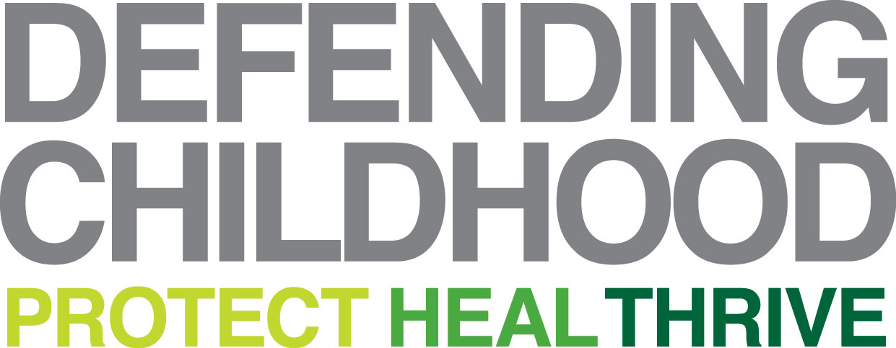

BACKGROUND
“For me, the issue of children’s exposure to violence has been both a personal and professional concern for decades. As our nation’s Attorney General and as a parent, it remains a top priority,” said Attorney General Holder. “Through renewing and refocusing our efforts to serve our nation’s most vulnerable and most distressed children we can transform the country we love for the better – one child at a time.” | Attorney General Eric Holder launched the Defending Childhood initiative on September 23, 2010 to address a national crisis: the exposure of America’s children to violence as victims and as witnesses. The Attorney General has been personally and professionally committed to this issue for many years, dating back to early in his career when he served as the U.S. Attorney for the District of Columbia and through his tenure as Deputy Attorney General in the Clinton Administration.  In addition to the demonstration program grants, the Department of Justice is committing additional funding for research, evaluation, public awareness and training for professional members and affiliates of national organizations through the initiative. Our Federal partners include: the Executive Office of United States Attorneys, Federal Bureau of Investigation, Office of Community Oriented Policing Services (COPS), Office on Violence Against Women, and the Office of Justice Programs.

Children’s exposure to violence, whether as victims or witnesses, is often associated with long-term physical, psychological, and emotional harm. Children exposed to violence are also at a higher risk of engaging in criminal behavior later in life and becoming part of a cycle of violence. This problem affects each one of us. Effectively addressing it must become our shared concern and our shared cause. Building on lessons learned from previously funded research and programs such as Safe Start, the Child Development Policing Program and the Greenbrook Initiative. Defending Childhood leverages existing resources across DOJ to focus on preventing, addressing, reducing, and more fully understanding childhood exposure to violence.
In 2010, DOJ awarded grants to eight sites in cities and tribal communities around the country to develop strategic plans for comprehensive community-based efforts that will further demonstrate the goals of this initiative. Each of these sites received additional support in 2011 to help launch, sustain, and expand programs and organizations focused on the development of community-based solutions to address the problem. Four sites will be supported to develop comprehensive demonstration projects.
1

The Network for Overcoming Violence and Abuse (NOVA)
The Memphis Experience

The Network for Overcoming Violence and Abuse (NOVA) is a Shelby County system of care being initiated in Memphis neighborhoods in the Raleigh-Frayser and Hickory Hill areas that connects children exposed to violence and abuse - and their families - to counseling and other support services. Too many families in our communities - and far too many children - have experienced the trauma that comes with seeing or experiencing violence of all kinds. The good news is help is available.
NOVA is a response to the problem of trauma that happens after exposure to violence. NOVA offers all the help that children and their families need to put the hurt behind them, to heal, and to live their lives with hope. Real hope.
We are building a corps of community partners -- schools, police precincts, churches, child care centers, youth-serving groups and more -- to help connect children to NOVA's coordinated care. NOVA partner agencies employ Family Service Providers (FSPs) to help children and their families determine their needs and connect to services. NOVA will help children and youth who are exposed to violence -- at home, in school or in their community. The children will be screened for levels of trauma and family needs.
 | NOVA: Bright hope for children and families  Shelby County was one of eight localities in the country chosen to participate in the U.S. Department of Justice Defending Childhood initiative to establish collaborative models for care for children exposed to violence and experiencing the trauma that often results. The network has begun its work in Frayser and Hickory Hill neighborhoods.

NOVA – A network of providers bringing comprehensive resources together for children and youth.

2
Community Assessment Report Summary
Prepared by Phyllis Betts, Director
Center for Community Building and Neighborhood Action University of Memphis

“Much of the gap analysis was derived from the series of listening sessions and working group input throughout the planning process. Gaps were documented in summaries from those meetings” Betts. | The needs assessment was designed to access and analyze data that could be transformed into “actionable knowledge.” For the purposes of the MHMC Strategic Plan, the needs assessment identified overall gaps in “the system” and the “pipeline” from exposure to accessing support systems that should be targeted for reform: Gaps in the system can be summarized in terms of specifics gleaned from key informants and broad-based input from listening sessions and working groups and by a bottom-line statement: we have for too long been satisfied with some very good programs that neither cohere to constitute a comprehensive strategy nor operate at sufficient scale to systematically reduce exposure in our high poverty-high risk factor environment.

Underlying our inertia there appears to be some sense that poverty and the violence that is associated with it are inevitable in Memphis, and that there are resources for those well-enough motivated to seek them out. That means that if first responders leave victims, for example, of domestic violence with a brochure that might point them to counseling and support for themselves and their children – and they choose not to take advantage of it – that we too often remain complacent that we have done our job.
Defending Childhood should position us to overcome complacency and ace on key challenges and gaps:
- Cultural norms which view violence as normal and inevitable
- Lack of proactive identification, outreach, referral and supportive follow-up with children
known to have been exposed to violence
- Lack of policies, agreements and tools to support service delivery coordination that would take a more proactive approach
- Lack of specialized resources to work with children exposed to violence all along the
spectrum from exposure to neighborhood violence to domestic violence; we appear to direct attention most often to extreme cases of abuse and neglect where the law is forced to intervene.
- Finally, we have little grasp of who is receiving what kind of supportive intervention, let alone shared outcomes and data collection processes to measure program and system-level impacts and drive continuous improvement.

3
COMMUNITY ASSESSMENT IMPLICATIONS
The most basic implication of our community needs assessment is the need for greater public awareness and awareness on the part of professionals and others who come into contact with children on a daily basis. Child care centers, schools, churches, community centers
and other places where children live their daily lives are in effect our community’s first responders. Adults in these places simply need to be better prepared to identify exposure-related issues and intervene as part of a systematic community campaign. More broadly, the ultimate implication is system reform that moves us in the direction of a coordinated community response. A coordinated community response will proactively identify, reach out, and engage children in supportive referral when there is a need to mitigate the effects of exposure to violence.
“We are choosing a place-based strategy to facilitate reaching children and families where they live and connect them to multi-layered and customized support systems. If we are able to demonstrate the power of place-based mobilization and intervention, we will likely surpass the ability of existing providers to meet the demand. With a demonstration project, we can identify less obvious gaps and prioritize next steps” Betts. | 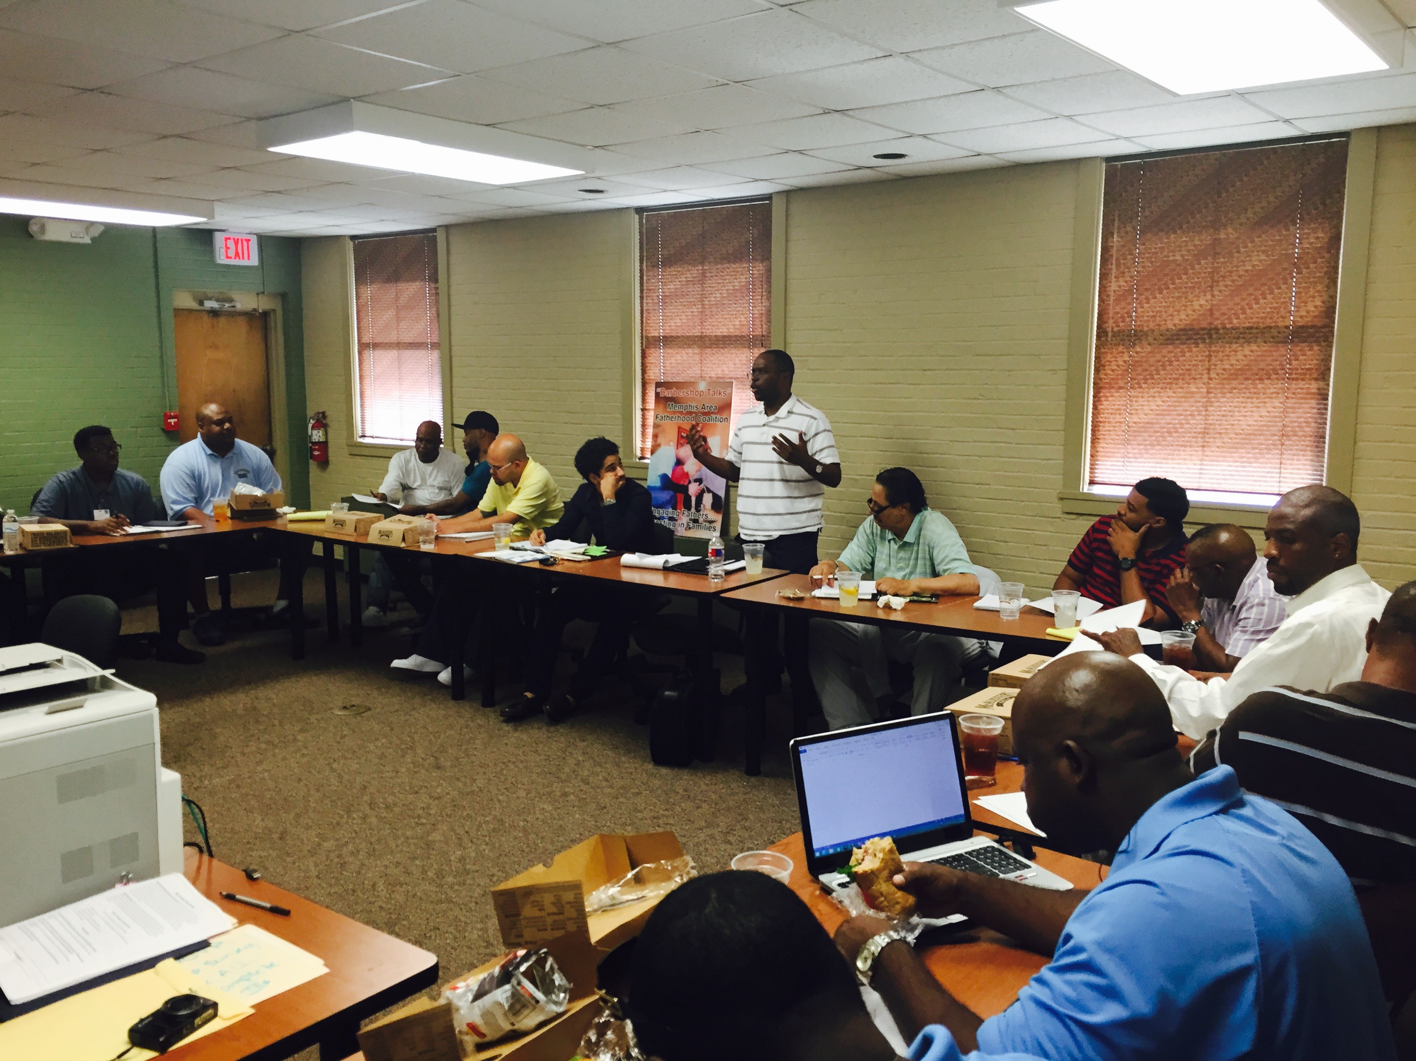
Our conviction that poverty and concentrated neighborhood poverty produce environments in which the probability of exposure to violence is high--means that a place-based strategy cannot be limited to narrow concepts of safety and prevention. Community restoration and economic opportunity enter the picture alongside a more traditional role for mental health and human services providers. The kind of connectedness our community needs assessment finds wanting points clearly in the direction of system reform.
4
Men Healing Men and Communities Network (MHMCN)
“A Community-based, Wellness Informed, Culturally Appropriate Response to Trauma”

OUR HISTORY
The Shelby County Office of Early Childhood & Youth (SCOECY) coordinates programs, advises policymakers, and promotes community understanding that all children deserve to be healthy, safe, and nurtured. As an Office that doesn’t provide any direct services, we demonstrate Shelby County Government’s commitment to children and families and attract dollars from outside the community for strategic placement of those dollars. We align funding received with the strategies outlined in the Memphis Fast Forward’s People First! Human Capital Development Plan, a plan adopted by Mayors Mark H. Luttrell and A C Wharton.

We advocate for, coordinate, and work to ensure the quality, accountability, and success of informal and formal resources for all children and their families most in need. In so doing, Keisha Walker, Administrator of SCOECY and Malrie Shelton, Director of the Defending Childhood Initiative (DCI) were summoned in 2012 to a national meeting of Site Directors. During the convening of directors, Sam Simmons from Minneapolis was a featured keynote speaker. He presentation focused on historical trauma, and the role of Black Men in empowering communities. Both Shelton and Walker were moved and inspired by Simmons’ presentation and were convinced that more information was needed to determine if the approach utilized by Simmons in Minneapolis could be replicated and benefit the citizens of Shelby County and Memphis. | “Amazingly, the voices, ideas, perspectives, and most importantly the solutions offered up by African American men were being listened to—the experiences and successes were considered to be valuable and presented possible solutions to the problems faced by African American youth, families, and communities.” The journey was initially the brainchild of Keisha Walker, Administrator (SCOECY) and Malrie Shelton, Director of the Defending Childhood Initiative.

Upon returning to Memphis, Walker and Shelton work diligently and intentionally to connect with African American Men who were already engaged with projects focusing on healing their communities. After several discussions, the decision was made that the Defending Childhood Initiative would provide the initial seed funding support required to launch the Men Healing Men and Communities Network.

5

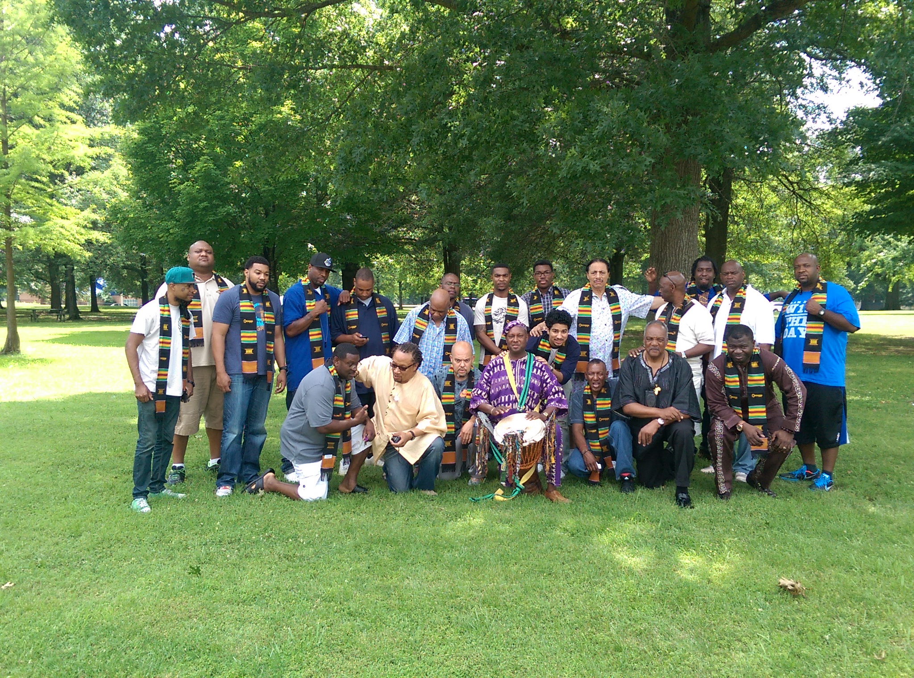

OUR MISSION
We are African American Men committed to healing and empowering our youth, families, and communities. We work together to build and empower healthy communities, prevent violence, and to reduce and ultimately eliminate trauma among our youth, families, and communities.

OUR VISION
We understand that violence and trauma are chronic conditions that can be successfully prevented and treated. Our vision is healthy communities--thriving, safe, and secure.
A place where “We are not afraid of our neighbors.”
A place where feel safe and comfortable.
A place where we participate in social, educational, and cultural activities together with our neighbors.
A place where we live, play, work, and recreate.
A place where we enjoy a sense of ownership.
A place where we can experience a shared cultural identity.
A place where we can maintain and honor our uniqueness and diversity.
A place where, “We know our neighbors”.
A place where we work together cooperatively to identify and solve our problems!
6
The SWOT ANALYSIS

7
STRENGTHS
Communicate effectively with diverse audiences | MHMCN participants work daily with diverse populations and have developed superior communication skills with children, youth, adults, seniors, gang members, students, persons with a wide range of religious beliefs, and persons of different gender or sexual orientations. MHMCN are expert multi-cultural communicators.
Experience in healing, mentoring, and a wide variety of community-based programs | MHMCN members have a great deal of experience in mentoring youth, working in re-entry programs, creating, developing and leading community-based job training and job readiness programs, community health and trauma prevention initiatives, violence and gang prevention programs in schools, mental health social work, and higher education focusing on community wellness.
Our elders possess valuable wisdom, knowledge, and experience resulting in insight and foresight | MHMCN has a critical mass of Elder brothers with more than 20 years experience working in community improvement, violence reduction, community safety, crime prevention, mentoring, criminal justice, and higher education. This cumulative experience converts to valuable knowledge, in fact “wisdom” and is accompanied by a significant number of contributions over time to individuals, families, and communities.
We genuinely care, we are concerned and empathetic | MHMCN members are genuinely invested out of a sense of responsibility and duty. Many of the participants are volunteers and some work for much lower wages and salaries than if they worked in other industries. Also, members very often willingly put their lives and safety on the line to work in crime-ridden and dangerous communities.
We are passionate and compassionate | MHMCN members are excited, energized, and dedicated to make a positive difference in their respective communities and programs. These Network members have both personal resilience and an orientation toward learning and improvement that helps the Network to develop the resilience to endure and withstand the growing pains associated with the birth of a new organization and its associated efforts along with the predictable and unpredictable accompanying challenges and disruptions.
8
STRENGTHS (Continued)
We are powerful | Through many years of working in communities, MHMCN members understand and realize their power. Members have relationships with local city, county, and state officials that could make a difference in the development of new programs or policy changes.
We are creative | While implementing their community programs, MHMCN members have “Done more with a dollar than others have done with a hundred dollars”. Some of the participants are creative artists, musicians, and performers and utilize the arts to work with youth and communities. Most members that lead programs created these programs and sustain their efforts with creative strategies when others declared “You can’t do it!”
We are committed | All MHMCN members are committed and voluntary participants in the Network. In addition, some of the participants do their work in the programs and initiatives in which they are associated without any salary or pay. Essentially, they are volunteers and are willing to be volunteers with MHMCN. Some members are students and unemployed and are seeking gainful employment.
We represent diverse programs, approaches, and communities | MHMCN members are leaders of and are associated with a wide range of community efforts addressing different problem areas in different localities in Memphis and Shelby County including: community improvement programs, educational attainment initiatives, violence reduction projects, community safety programs, crime prevention projects, mentoring and youth development activities. These programs are implemented in North Memphis, Frayser, South Memphis, Soulsville, and Hickory Hills.
We are united | MHMCN members collectively and unanimously agree to work together to identify and to solve the problems faced by their youth, their families, and their communities. The Network members are unified on the importance of culture as a community asset and the importance of maintaining that unity in order to achieve the goals of the Network and the community.

9
WEAKNESSES
Lack of Financial Resources | While the Network has “good” ideas, the members are acutely aware that there are no funds presently dedicated to the work of the Network or its sustainability.
Unfamiliarity with Network Members | While Network members have been working in communities in Memphis, many of the members are unfamiliar with one another. They have been separated by space and geography while their work has been closely related given their respective missions and activities. Their work is disconnected and uncoordinated leading to less than optimal results.
Identity Confusion | Given the “newness” of the Network, the identity is in the early formation stage. Essentially in terms of growth, the Networking is clearly in the “forming” stage where the identity of the group is being created and developed.
Emotional Instability of Service Recipients | It is expected and projected that a considerable number of potential or real service/program participants have been and/or are currently experiencing emotional instability. It is understood by Network members that this emotional state is an appropriate response to the trauma and violence experienced by community members. It is also projected that the emotional instability is mostly undiagnosed and perhaps more widespread the we think.
Time Constraints | The time is now! There is a very clear sense of urgency among Network members to begin implementing and coordinating training, trauma and violence response, intervention, and prevention activities.
Broken or Dismantled Families | An anecdotal survey of Network members resulted in total agreement that one of the most significant issues facing the African American community and directly related to the violence and trauma experienced by youth, families, and communities is “Fatherless” and broken families.
Lack of Political Power | In spite of their history of relationships, with local, city, county, and state political officials, Network members feel as if they do not possess political power.
10
OPPORTUNITIES
We can make an impact in violence and trauma reduction | Network members are convinced that together by coordinating activities, providing training to professionals and community members, and participating in violence and trauma response activities, the Network members strongly believe that they can make a difference.
We can work together with (public & private partners) to make positive change | MHMCN offers participants to work cooperatively with numerous partners to identify and solve the problems related to violence, crime, and trauma reduction and all of the citizens/residents of Memphis will benefit. Working together in partnership creates a “Win-Win” situation for everybody. Finally, working together is synergistic. Together one plus one plus does not equal three. It equals four, five, or even six. The ability and power to get things done is multiplied. MHMCN members understand the value of working cooperatively in collaborative activities to get the job done. Simply put several members echoed that, “Alone we can do so little; together we can do so much”.
We can change and improve the public image of African American Men | By working together to solve our problems, changing the destiny and reality of our communities and intentionally telling our own stories in the media, we can change the public image of African American Men and African Americans.
We can and must create an organization that will make a difference and keep the Network going | Members are well aware of the importance of creating an organization that will provide the structure needed to guide and support the activities and efforts of the Network. Creating an organization is critical and requisite to the success and sustainability of the Network.
We can educate our community about our cultural heritage | The members of MHMCN are committed to integrating and infusing culturally appropriate strategies and approaches to address violence and trauma among youth, families, and communities. By educating community residents and service providers about our cultural heritage we can reach people through non-traditional approaches. It is evident that previous approaches have been unsuccessful in making significant progress in reducing trauma and violence.
11
OPPORTUNITIES (Continued)
We can help our youth grow up in healthy ways | Through creating new and strengthening already existing mentoring programs, MHMCN members can have a positive impact on youth. MHMNC members can also participate in violence and trauma response activities to intervene, prevent, and reduce the continuing violence and trauma. By working in and with existing organizations, institutions, and programs, members aim to reduce factors that place youth at risk for perpetrating violence, and promote factors that protect youth at risk for violence. Network activities will address a variety of influences on youth violence including: individual, relationship, community, and society (such as television, movies, and social media). Through social marketing MHMCN can promote awareness about youth violence and to foster the commitment to positive changes among youth, families, and communities.
We can reduce the fear that many of our people live with every day | Network members are aware that many residents live in fear and that some communities are “fear-ridden”. Network members realize the importance of creating, developing, and implementing prevention, intervention, and cooperative law enforcement initiatives while supporting already existing efforts to target youth, families, residents, service providers, educators, and criminal justice professionals to reduce violence and trauma and change the perceptions and realities of residents and communities.
We can empower our youth, families, and communities to live positive and productive lives | Network members understand that , “Youth are not the problem! In fact, youth are the key to the solution.” Youth are assets and key stakeholders in the community, the economy and our shared future. Youth are our next generation of business and civic leaders. We must incorporate youth at all levels of our efforts to make positive changes. We believe that we can empower youth to lead and adapt programs to better prepare them for citizenship in a global world. By using a culturally appropriate approach, we can build more successful and impactful programs, doing so with youth rather than for them.

12
THREATS
Lack of Commitment (Internal and External) | Government officials, local leaders, community residents, service providers, and the general public are not committed to reduce violence and trauma in the African American communities. A culture of tolerance to trauma and violence followed by a widespread sense of helplessness and hopelessness persists in many communities. One shot projects, pilot programs, and short- term initiatives are all signs of the lack of commitment by foundations, government funders, faith-based institutions and others.
Leadership Challenges “Too many Chiefs” | The vast majority of the membership of MHMCN consists of men who are leaders of programs, projects, agencies, and initiatives. Members expressed concern that there may exist a lack of persons to actually do the work of the Network. There are ample persons to provide leadership, ideas, strategies, and suggestions but a very real absence of workers.
Mission Drift (Movement away from original mission) | Members expressed concern from their past experiences that the Network will either unconsciously move away from its original mission; or the Network will consciously by decision move into a new direction from its mission statement. Either this movement may be by accident and not intended to occur or the Network may intentionally decide and mean to change mission and direction.
Focus may be problematic for others | Culturally appropriate models and approaches are not received in positive ways in all quarters for a variety of reason. Culturally appropriate approaches are relatively new and untried in some communities and can meet with resistance in the community and with potential funders as well. In addition, projects focusing on African American males are a relatively new phenomenon in the social-human services and violence and trauma prevention-intervention arena.
Lack of vision | Community leaders, government officials, faith-based leaders, public and private funders, as well as community residents do not possess the vision to see violence and trauma reduction and resultant community improvement.
13
Five Focus Areas
After a careful review of the strengths, weaknesses, opportunities and threats analysis of the MHMCN, the review of the Community Assessment Report, and the results and recommendations from the stakeholder discussions yielded the following initial FIVE FOCUS AREAS:
- Technical assistance and support to professionals, organizations, and communities (training, program evaluations, and consultation)
- Trauma and violence response for victims
- Peer support for practitioners
- Trauma and violence intervention programs
- Policy and program development with partners

Hooks African American Male Initiative (HAAMI)
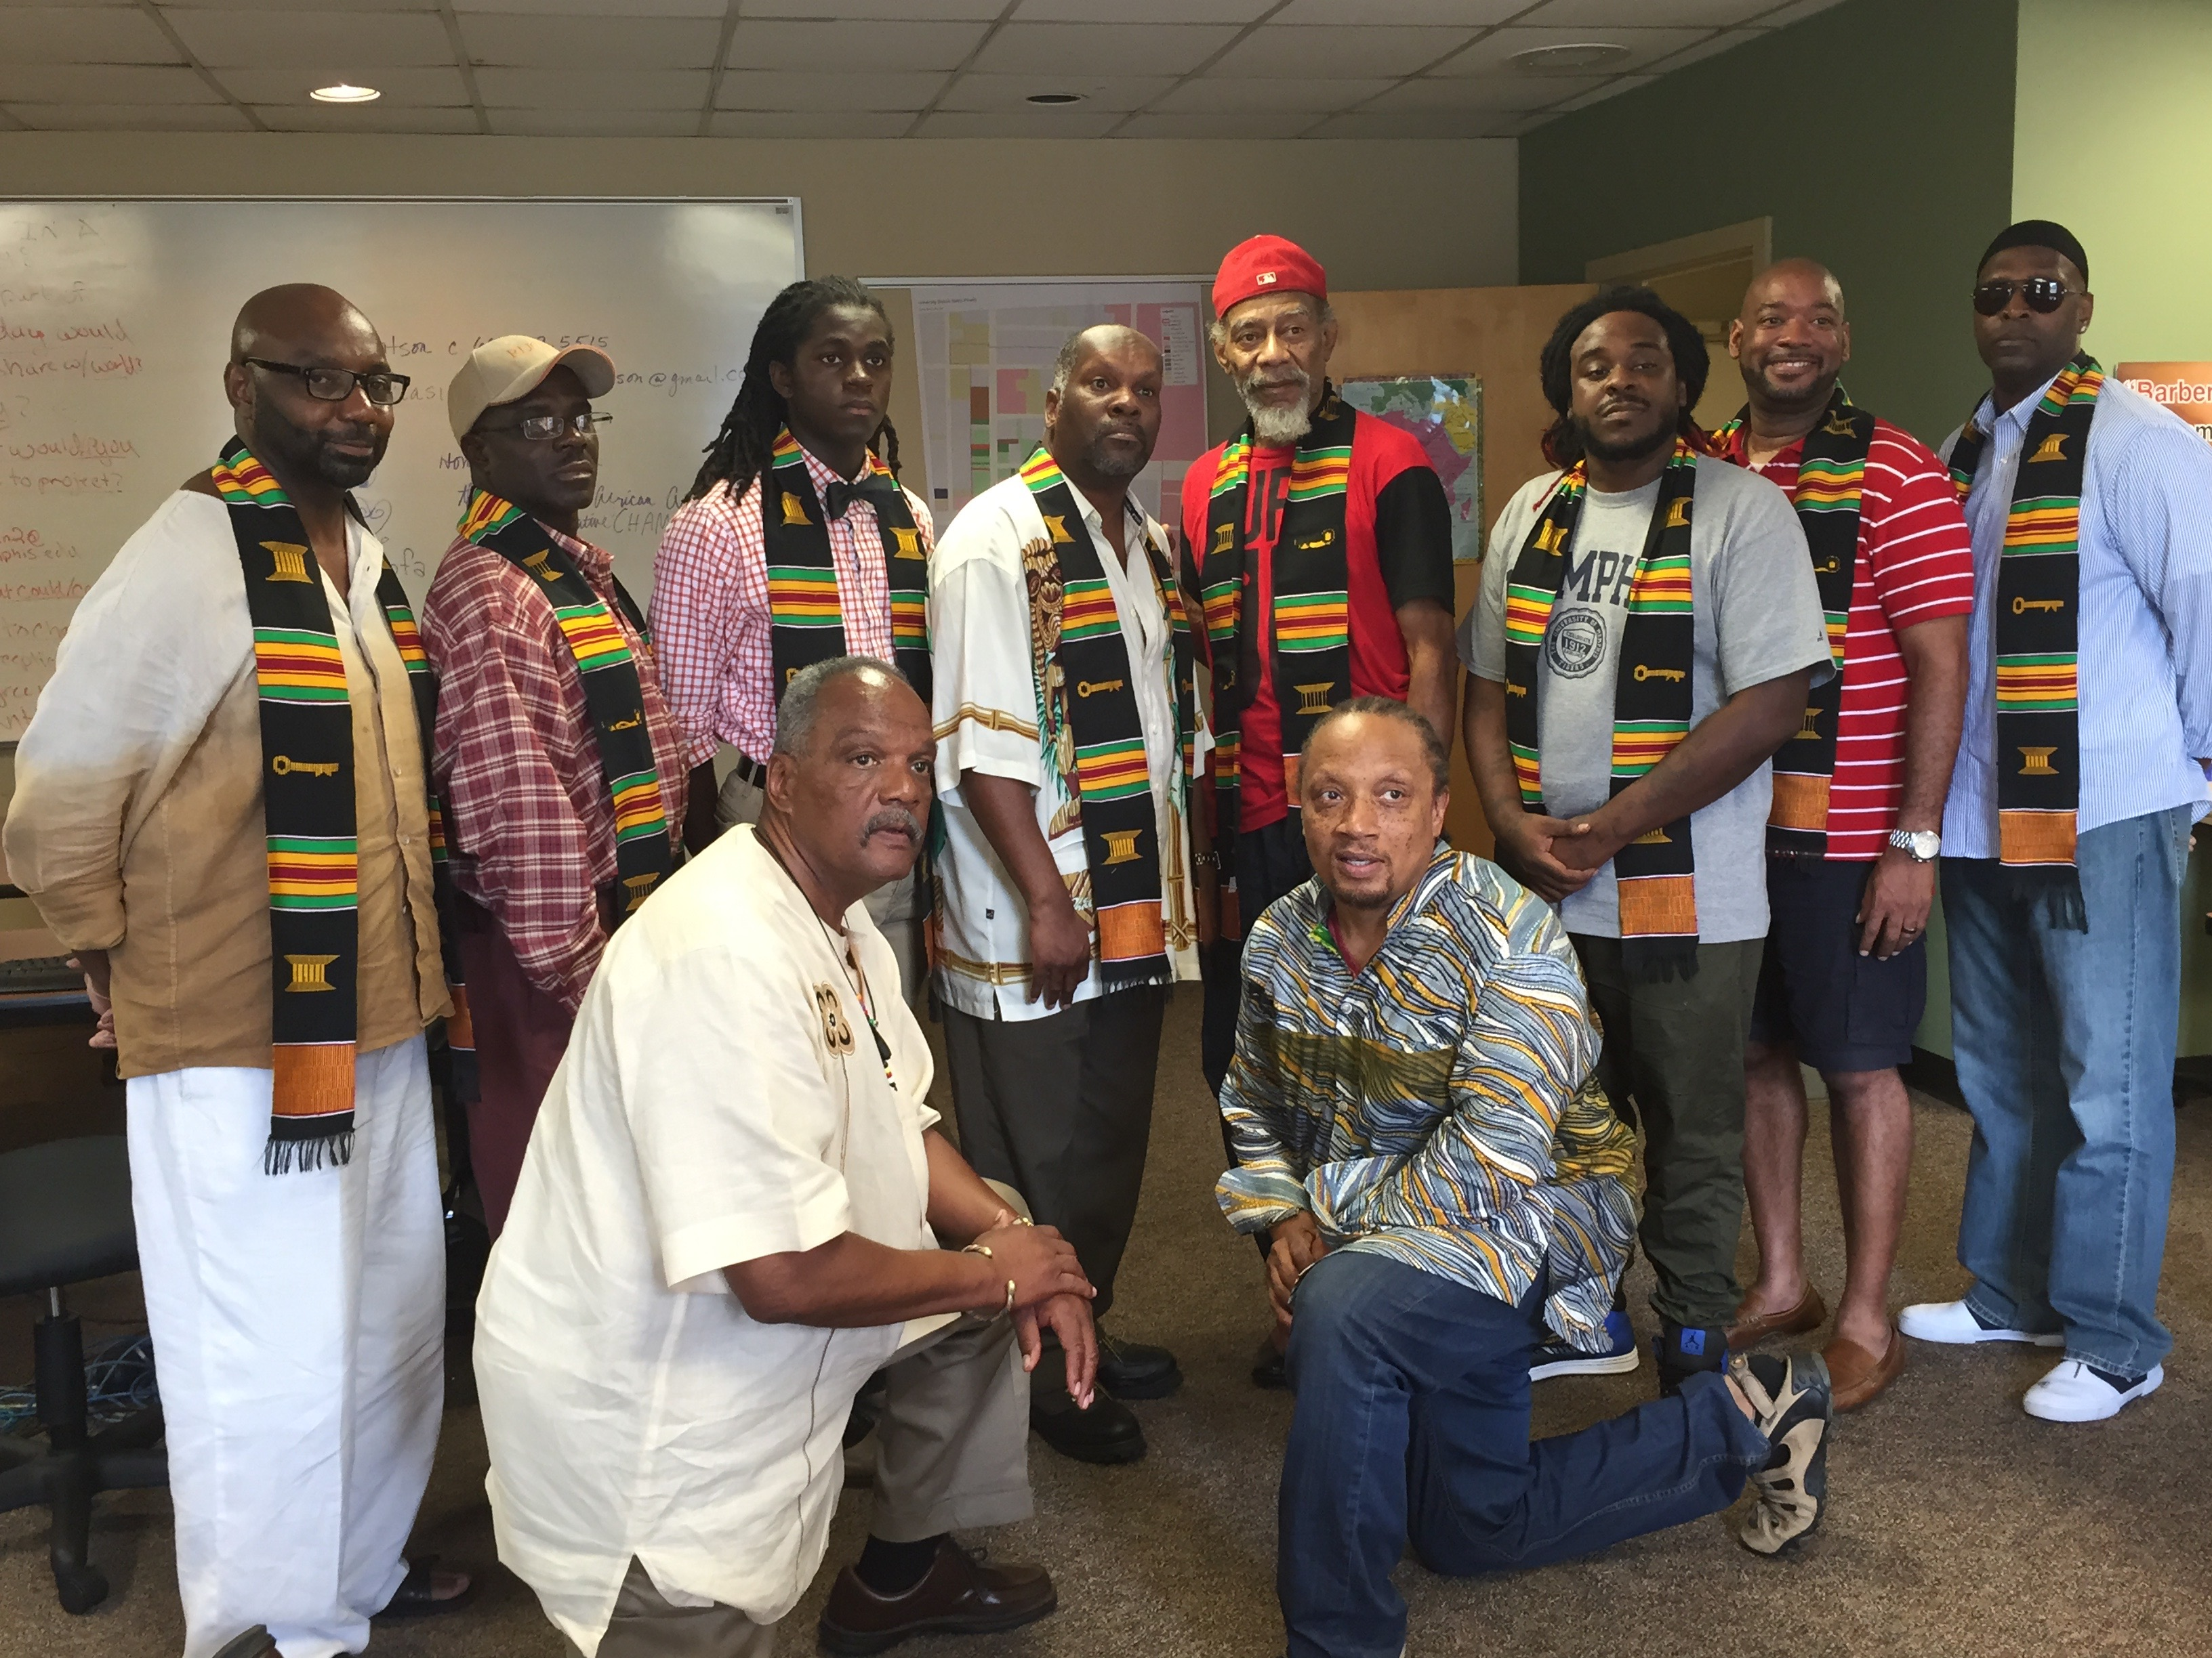

Goals/Future Projects
- Formalize the organizational structure of MHMCN through the formation of a not-for-profit organization with a staff of minimally two persons (a Director and a Technical Assistance Coordinator)
- Finalize the Strategic plan to include: Sustainability, Funding, Marketing, Geo-Targeted Implementation complimenting DCI efforts, and Asset Mapping.
- First Inaugural Conference
- Create Healthy Social Activities for Communities (2015) Pre Kwanzaa
- Establish and maintain MHMCN (Support Group Meetings)
- Support existing healthy and positive social activities in communities (NGOMA 2015)
- Network with public and private partners to influence policy and programs locally and nationally (Washington University, St. Louis)
14
Men Healing Men & Communities Network
Our Planning Leaders

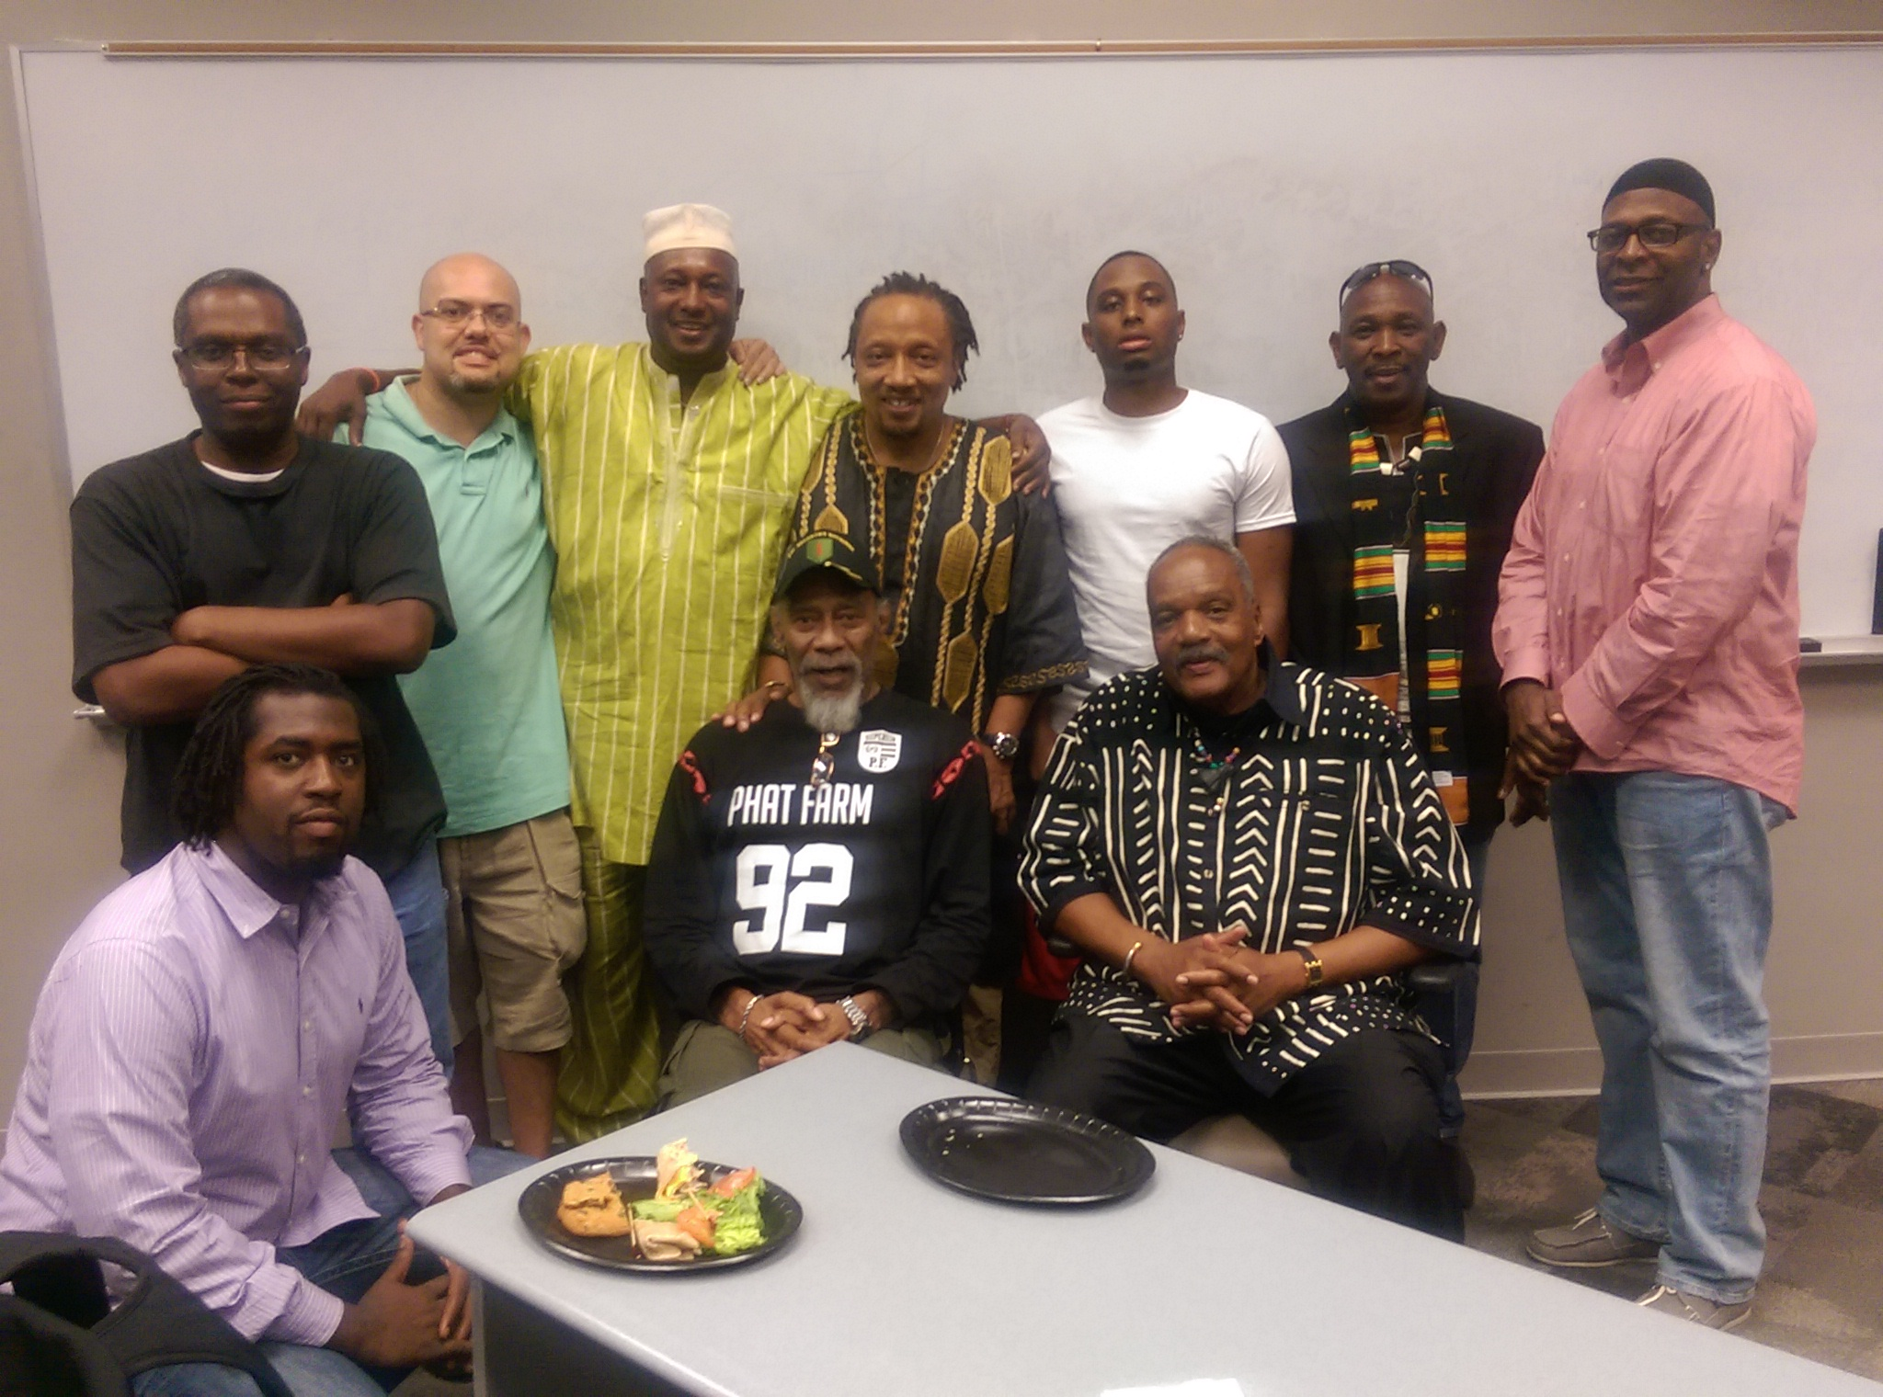

OUR OBJECTIVES
“This is how we do it!”
- We promote and provide Community-based Wellness Informed, Culturally Appropriate Responses to Trauma through leveraging resources for direct contact with individuals, families, and organizations.
- We conduct culturally appropriate psycho-social-emotional support activities for African American male community leaders, servants and healers.
- We challenge African American male community leaders, servants and healers to work together to address through intervention and prevention the violence and trauma that plagues our communities.
- We provide training, technical assistance, support, policy and program development and implementation, linkages and coordination of resources, assets, and services.
- We utilize evidence-based, strengths, and asset-based models to heal and empower our youth, families, and communities.
15

