# Nucleophilic Substitution at a saturated carbon

<http://chemistry.berkeley.edu/links/reactions.html>

1. Nucleophilic substitution
   1. Base hydrolysis- hydroxide substitution of alkyl halides prototypical reaction
   2. 
   3. Mechanism follows two extreme kinetic laws
      1. 2nd order: first-order in each component: rate = k[Nu][RX]
      2. 1st order: independent on nucleophile rate = k[RX]
      3. some reaction are mixed: rate = k1[Nu][RX] + k2[RX], plot?
2. bimolecular mechanism: d[product]/dt = k[Nu][RX]
   1. RDS – rate determining step includes hydroxide and and alkyl halide
   2. . single step, concerted
   3. Concerted – energy of bond with hydroxyl used to break one with halide
   4. Activation entropy is unfavorable -17 J mol-1 K-1 ~ 4 kcal mol-1 K-1



* 1. How many electrons around carbon in transition state
  2. Transition state – linear: O-C-Br – optimum overlap
     1. Methyl bromide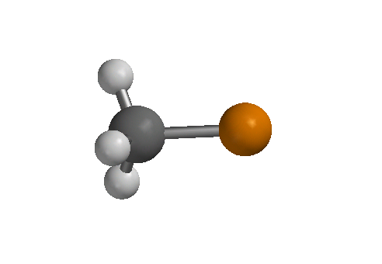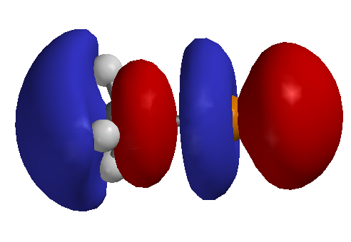
     2. * is lowest unoccupied orbital – linear, accepts OH lone pair
     3. Charge distributed over O and Br
     4. pentavalent TS (trigonal bipyramidal)
     5. SN2, Substitution Nucleophilic Bimolecular

1. Unimolecular mechanism
   1. Tertiary halide d[product]/dt = k[RX]
   2. Nucleophile cannot be involved in rate determining step, hybridization of cation
   3. 
   4. Rate is independent of hydroxide, reacts after RDS
   5. Omnipresent water competes, cannot be distinguished- same kinetics
   6. Energy of C-Cl dissociation obtained from collision, solvation of ions and entropy of activation: 51 J mol-1 K-1, (~12 cal mol-1 K-1)
   7. tButyl group relaxes to planar geometry
      1. releaves steric interactions
      2. sp3 to sp2 : stronger bonds!!
      3. Remaining orbital sp3 to p, increase in energy!! Inhibit reaction?
   8. Substitution Nucleophilic Unimolecular: SN1
2. Solvent effects
   1. Solvolysis of tBuCl in 50% H2O/50% ethanol 3x104 faster than in ethanol
      1. Transition state for SN1 has large charge development
      2. More polar solvents will stabilize charges in transition relative to ground state
      3. Solvation of nucleophile makes it less reactive: does not participate in RDS
      4. 
   2. Charge separation for SN2 less in transition state
   3. Ions less stable, more reactive in less-polar solvent
   4. 
   5. Polar solvent is require to dissolve ions though
   6. Polar prortic to polar aprotic, azide substitution 4x104 faster in DMF then MeOH
   7. 
   8. Some SN2 reaction increase 109, dimethylsulfoxide/methanol
3. Structure effects
   1. SN2 slower as substitution increase: steric effects
      1. inhibition of nucleophile
      2. Crowding of transition state, pentacoordinate
      3. 
   2. SN1faster as substitution increases
      1. Steric effects relieved in nearly tricordinate transition state
      2. Electron donating alkyl groups disperse charge
      3. Hyperconjugation
         1. supported by 10% increase in kH/kD per deuterium
         2. secondary isotope effect – CH bond is not broken in TS
   3. Methyl and ethyl derivative are always SN2 in solution, methyl and ethyl cations are too unstable. SN1??



* 1. tertiary derivatives are almost always SN1
     1. too much steric inhibition for SN2
  2. secondary derivatives – often have mixed kinetics: d[P]/dt = k1[Nu][RX] + k2[RX]





* 1. What about benzyl and allyl halides?
  2. Vinyl halide? Where does a nucleophile attack (LUMO)
  3. Concerted SN2 never observed for vinyl or aryl halide
  4. SN1 rare for vinyl or aryl halide, why?
  5. Bridging
     1. strain to make planar cation
     2. How could you demonstrate rates were not for SN2?
     3. 
  6. Cyclopropyl methylgroup unusual primary cation
     1. Bent bond delocalize with cation?

1. stereochemistry
   1. SN2 results in inversion of configuration



* + 1. Displacement of idodide by radioactive iodide ksub = (3.00+0.25)x10-5 (30 0C)
    2. Note half inversion results in complete racemization
    3. kinv = ½ krac = (2.88+0.03)x10-5 (30 0C) – ksub = kinv



* 1. simple SN1 results in racemization of configuration, not inversion
     1. Ion paring protects one side of cation
     2. Rarely is complete racemization realized
     3. Longer lived cations racemize more



1. SNi retention of configuration (no racemization)- double inversion?
   1. Rate = k[ROH][SOCl2]
   2. ROSOCl isolated from reaction: intermediate





* 1. Inversion occurs in presence of pyridine, choride addition is faster than thionyl ester decomposition



1. Neighboring group effects
   1. kinetics of intramolecular nucleophilic displacement can be favored entropically
   2. .intramolecular leaving group facile due to strain or positive charge



* 1. Evidence of the participation of sulfonium ion mechanism? rule out simple inductive effect. Hint: symmetry of intermediate.
  2. intermediate is necessarily a ring, 3-6 members are favored
  3. common groups: Ph, COO-, COOR, COAr, OCOR, OR, OH, O-, NH2, NHR, NR2, NHCOR, SH, SR, S-, I > Br > Cl.
  4. assistance of neighboring group is unnecessary for very good leaving groups, stable carbocations or nucleophiles
  5. Stereochemistry (always?) is important



1. Effect of nucleophile structure
   1. SN1, rate is independent of nucleophile structure because addition is after RDS
   2. SN2, better base (thermodynamic) makes better nucleophile (kinetic) is a general trend
      1. Works well for same atom: EtO- > PhO- > MeCO2- > NO3-
      2. Not for atoms of very different polarizability: RS- > RO-
   3. Good nucleophile will favor SN2 v. SN1. i.e. OH- v. H2O. carbon cation doesn’t care
2. Effect of leaving group
   1. Weak bases are good leaving groups examples?
   2. Some good leaving groups are good nucleophiles as well
      1. I- is a nucleophilic catalyst
      2. Adds and is later displaced