# Aliphatic Nucleophilic Substitution

I. ANDN (SN2) <http://chemistry.berkeley.edu/links/reactions.html>

A. attack on opposite side of leaving group on saturated carbon

1. single step, concerted, second-order kinetics

2. frontier orbitals: * and n, optomizes overlap and minimizes repulsion

3. pentavalent TS (trigonal bipyramidal)

Methyl chloride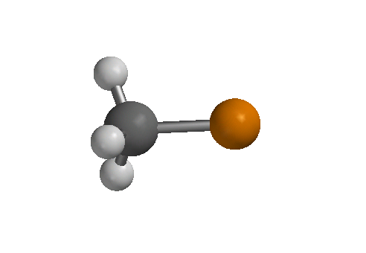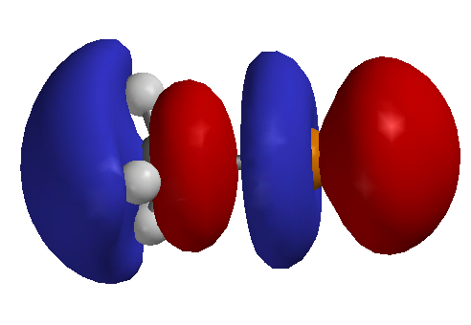

B. evidence for mechanism

1. rate is first-order in each component: rate = k[Nu][RX]

2. Walden inversion

3. unreactivity of substituted bridged complexes

II. DN + AN (SN1)

A. first step is always assisted by solvation

1. ionization is on order of 150 kcal/mol

2. solvation can be 130 kcal/mol and larger

B. evidence

1. kinetics - first order ( beginning of reaction) changes to mixed order if [X-] and [Y-] are similar



2. solvolysis complicates, -d[RX]/dt d[RY]/dt

3. solvent and salt effect- ionization strength

4. rate independent of nucleophile

C. ion pairing

1. partial racemization in reactant

(a) recover ester after partial hydrolysis: exchange is faster than racemization so an intermediate prior to dissociated ion pairs

(b) azide stops racemization

III. theory of mixed SN1 and SN2

A. apparent SN2 really is (ion pair type process) SN1

B. both SN1 and SN2 occur

partial retention of configuration can occur by solvent reactions

IV. SRN1, SET mechanism



 T

 DRN

 ARN

 T

See Chapter 12??, page

mechanism shows racemization

V. Neighboring Group Mechanism

A. kinetics of intramolecular nucleophilic displacement can be favored entropically

B. intramolecular leaving group often is easily displaced (second step) due to strain or positive charge



C. intermediate is necessarily a ring, 3-6 members are favored

D. common groups: Ph, COO-, COOR, COAr, OCOR, OR, OH, O-, NH2, NHR, NR2, NHCOR, SH, SR, S-, I > Br > Cl. See Chapter 3, phenyl displacement of brosylate

E. assistance of neighboring group is unnecessary for very good leaving groups, stable carbocations or nucleophiles

VI. Neighboring Group -electron donors (V.D above were all lone pair donors except Ph)

A. X = tosylate and R = H, for acetolysis ktrans-x = 1011 kcis-x

B. X = p‑O2NC6H4CO2, R = p-MeOC6H4, for hydrolysis in acetone/water ktrans-x kcis-x

C. endo tricyclic octane

X = p‑O2NC6H4CO2, R = H

kendo = 1014knorbornyl-X March

VII. Neighboring Group  bonds

A. norbornyl cation, non-classical

1. X = OSO2C6H4Br, exo 350 times faster than endo, no endo product

2. 13C NMR at 5 K shows norbornyl cation has equivalent nuclei at 1 and 2 positions, barrier is < 0.2 cal/mol

B. cyclopropyl methyl cation (like allyl)

cyclopropylmethyl, cylobutyl and 3-butenyl compounds give the same products



C. methyl and H migration (hydride shift)– evidence of bridge intermediates equivocal

VIII. SNi inversion/retention of configuration depends on solvent



IX. SN1' (1/DN + 3/AN) and SN2' (3/1/ANDN)- alyllic leaving group

A. conjugate and direct substitution compete

B. rearrangement and internal returns occurs in polar solvents

## C. isomers do not give same product distribution for SN2' (example?)



XI. Reactivity

A. substrate structure: note steric, strain, electronic, neighboring group effects

B. nucleophile: charge, basicity, polarizability, steric effects, -effect: NH3 v H2NNH2

**factors that determine site of attack by ambident nucleophiles**

a. hard/soft base attack hard/soft acid (carbocation/tetrahedral carbon)

b. coordinating metals promote carbocation formation (hard acid)

c. protic solvents solvate harder base so softer base is better nucleophiles

example: thiols and alcohols in water and dioxane

d. steric effects

C. good leaving group: weak base, strain

D. different media effects on reactants and TS: solvation, counter (metal) ion, salt effects, common ion effects

E. phase-transfer catalysis in immicible solvents

1. anion becomes soluble in organic solvent using soluble cation or chelating agent

2. ammonium and phosphonium salts

3.heterocycles and cryptands chelate metal ions which attract anions

**Superacid media**

I. superacids used to observe carbocations by NMR or other methods

a. SO2 and SO2ClF are solvents plus FSO3H-SbF5 or HF-SbF5

b. RF + SbF5 R+ + SbF6-

c. ROH + SO2 R+ + HSO3-

d. RH + FSO3H + SbF5 R+ + SbF5FSO3- + H2

II. primary carbocation is never detected in solution, only secondary and tertiary

III. simple hydrocarbons form t-butyl cation in superacid media

a. methane, ethane, propane, t-hexyl, pentyl

b. proton exchange may be concerted or stepwise



c. protonation of CH bond -detect CH5+ in gas phase

see Sommer & Bukala *Acc. Chem. Res* **1993**, *26*, 370

IV. conjugated carbocations have been observed solution

a. cyclopropylmethyls are more stable than benzyl, p orbital parallel to C3-C4 bond (see VIIb)

b. -heteroatom with lone pair

c. acylium ions

**stability/reactivity of carbocations**

1. pKR+ for 

2. D(R+-H-) (see March page 171)

3. 13C chemical shifts correlate with electron density. (March:Table 5.2 page 173)

**generation/fate of carbocations**

1. dissociation of leaving group (reverse)

2. electrophile addition to double bond (reverse)

3. carbocation rearrangements

Selected Mechanisms

I. alkyl halide and organometallic reagents

A. SN2 in many cases, sometimes SN1 and SET/radical

B. RX + R'M [RX-• R'• M+] R• + X- +R'• + M+ RR' + X- + M+]

(T +DN + AR)

II. Reactions of sulfonic acid derivatives with nucleophiles



