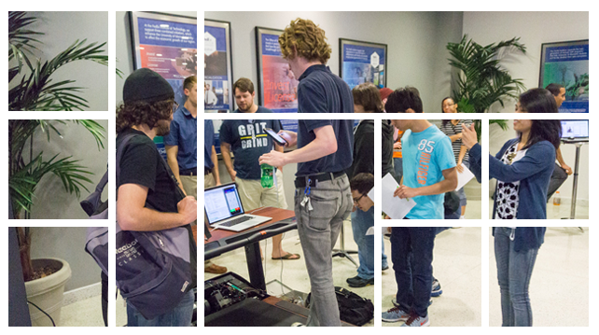

Chair’s Message  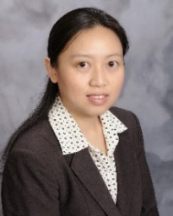  I’m very happy to be serving as the Department’s new chair. This spring, our faculty were involved in the hiring efforts for three new Assistant Professors, and we look forward to welcoming Drs. Nirman Kumar, Thomas Watson, and Kan Yang in the new academic year. A separate instructor search is also currently ongoing, and we recently hired Ms. Kendra Tillis as our new Business Officer.  Our research productivity has maintained its extraordinarily high pace. The amount of our funded projects is nearly $18M, the highest in the department’s history. We are also stepping into the area of computer science education, securing a Strengthening Communities grant with community partner CodeCrew and submitting a major NSF proposal to increase the number of local high school teachers who can teach the new AP Computer Science Principles course.  We continue to be proud of our students, who have received various awards and secured employment at global companies including Facebook, Google, Intel, and Microsoft, as well as local employers like FedEx and International Paper. The new Graduate Student Association, led by doctoral student Austin Henley, successfully organized our annual CS Research Day this year.  I look forward to many productive years to come!  Prof. Lan Wang  Department Chair |  | Strengthening Communities Grant with CodeCrew    The Department has been awarded a Strengthening Communities Initiative capacity building grant with community partner CodeCrew to develop a game design curriculum for high school students.  The funded project, named TigerCrew, is an education initiative that seeks to equip high school students in the Binghampton neighborhood (part of Midtown Memphis) with the skills and experience to fully participate in the increasingly STEM-reliant economy. Hosted at the CLOUD901 Teen Learning lab at the Memphis Public Library, the program will employ game development to teach high school students computer science concepts and programming skills, together with soft skills including leadership and public speaking.  The curriculum will be aligned with game development courses offered at the University of Memphis to help students transition smoothly into college. TigerCrew's team members include Meka Egwuekwe of CodeCrew (a non-profit youth coding group), along with U of M Computer Science faculty members Kriangsiri Malasri and Vinhthuy Phan.  TigerCrew is funded with $18,500 from the Strengthening Communities Initiative (SCI), sponsored by the U of M's School of Urban Affairs and Public Policy.
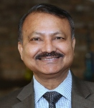
Faculty Highlights
Prof. Dipankar Dasgupta presented a research paper at the Cyber and Information Security Research (CISR) Conference held at Oak Ridge National Laboratory in April. He also gave a keynote at the Regional Symposium on Graduate Education and Research in Information Security at Binghamton University, NY on March 8, and he gave two other invited talks at the University of Tennessee (Knoxville) and the University of Louisville.

He organized a Cybersecurity Certificate Course foundational program at the FedEx Institute of Technology from February 1-5, and he received NSA funding to organize two GenCyber Bootcamps for high and middle School students during the summer. He was also featured in a Feb. 19 FOX13 Memphis news story about security threats in mobile software.

Prof. Santosh Kumar was invited by the National Academies of Sciences, Engineering, and Medicine to its meeting of experts on the Internet of Things commissioned by the U.S. Government Accountability Office.
(Continued on Page 2)
SPRING 2016 NEWSLETTER

New Industry Advisory Board  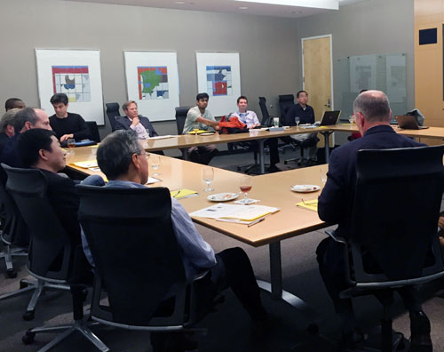  The Department completely refreshed its Industry Advisory Board this spring. The new members are Mike Anderson (International Paper), Brett Doty (Versant Supply Chain), Meka Egwuekwe (Lokion/CodeCrew), Naga Gurumoorthy (Intel), Xuan Liu (FedEx), John Marsalis (FNC), Mark McMath (Methodist LeBonheur Healthcare), Mark Moffett (Cisco), and Tim Whitehorn (Asentinel). The first board meeting was held on April 8 at the FedEx Institute of Technology.  CS Research Day  Computer Science faculty and students gathered on Friday, April 1 in the FIT Fishbowl for the annual CS Research Day. Presentations were made by over 20 participants in a variety of exciting research areas. We awarded the top three places in each category; however, all of the participants did an excellent job. Each of the first place winners received tablets and second and third place winners received Amazon gift certificates.  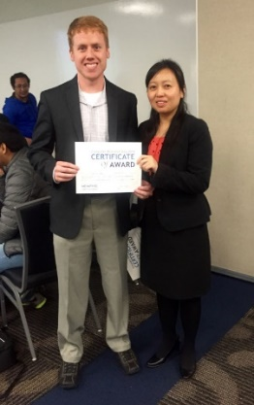  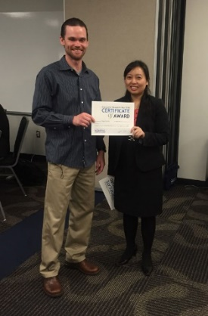  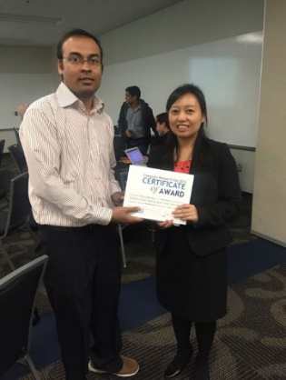  Special thanks to the panel of faculty judges: Profs. Nasir Ali, Bernie Daigle, Dipankar Dasgupta, Scott Fleming, Max Garzon, Zhuo Lu, Vinhthuy Phan, Vasile Rus, Deepak Venugopal, and Lan Wang. Thanks also to Profs. Santosh Kumar and Scott Fleming, Graduate Student Association president Austin Henley, and Administrative Secretary Lyndsey Rush for organizing and making the event possible.  Oral Presentations  - Austin Z. Henley (above left), Yestercode: Improving Code-Change Support in Visual Dataflow Programming Environments  - Borhan Samei, A Novel Framework for Adapting Text-trained NLP Models with ASR Errors  - Hillol Sarker, Finding Significant Stress Episodes in a Discontinuous Time Series of Rapidly Varying Mobile Sensor Data  Poster Presentations  - Abhijit Kumar Nag (above center), An Adaptive Approach towards the Selection of Multi-factor Authentication  - Swaroop Sudheer Goli, MSPARK: A Scalable Lifted Inference for MLNs  - Nam Sy Vo, Leveraging Known Genetic Variants to Improve Variant Detection  Undergraduate Poster Presentations  - Robert Edstrom (above right), Puzzle Based Learning in Cyber Security Education  - Benjamin Murphy (Graduate Partner: Minsheng Zhang), Exploring a Data-Centric Approach to Securing Smart Homes  - Berkeley Willis (Graduate Partner: Sujit Shrestha), Web Application Security Exercise and Testing Platform |  | Faculty Highlights  (Continued from Page 1)  Dr. Kumar was also selected by NSF as one of 12 scientists to represent the U.S. in a U.S.-India workshop on smart and connected communities. In addition, he received two new grants from NIH: an $848K grant from Rice University to eliminate tobacco-related disparities in African-American smokers, and a NIDA project to use cocaine detection methods in the nationwide clinical trials network.  Prof. Zhuo Lu has received a 2016 Early Career Research Award from the U of M College of Arts and Sciences. Prof. Lu directs the Communications, Security, and Analytics Lab and has received over $150K in research funding in his short time with the Department.  Prof. Lan Wang was awarded a $200K supplement from NSF for her Named Data Networking project.  Student Achievements  Nazir Saleheen, a Ph.D. student in Prof. Santosh Kumar's group, had a regular paper accepted in ICML.  Hillol Sarker, a Ph.D. candidate in Prof. Santosh Kumar's group, presented a full paper in the ACM CHI conference.  Undergraduate Herve Aniglo won the Association for Management Information Systems 1st Annual techUP! Competition held on April 9.  Undergraduate Heather Duke was selected as a 2016 Scholar to attend the Grace Hopper Celebration of Women in Computing.  New Business Officer  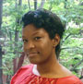  The Department welcomed Business Officer Kendra Tillis this spring. She comes to us with extensive experience in grants accounting.

CS Students Win at University Research Forum  Computer Science students have continued the tradition of doing very well in this year's University Research Forum held on March 30. Our awards (in the Math and Computer Science category) included:  Undergraduate Division  First place went to undergraduate EECE student Ashlesh Gawande and Ph.D. student Muktadir Chowdhury, for their work on "Named Data Networking on Autonomous Vehicles" under Prof. Lan Wang.  Second place went to undergraduate Kevin Townsend, for his work on "Large-Scale Microarray Data Integration for Improved Differential Expression Analysis" under Prof. Bernie Daigle.  Graduate Division  Second place went to Ph.D. student Abhijit Nag for his work on "Design and Implementation of Adaptive Multi-factor Authentication Framework" under Prof. Dipankar Dasgupta.  ACM Updates    The new ACM officers for 2016-17 are:  President: Kareem DaSilva  Vice President: Kevin Williams  Secretary: Edward Prins  Treasurer: Josh Hatcher  Webmaster: Irfan Rahman |  | Undergraduate Students in Cyber Security Research  The Center for Information Assurance (CfIA) at the University of Memphis, under the leadership of Prof. Dipankar Dasgupta, is at the forefront of cyber security research, education, and outreach in the state of Tennessee and the Mid-South region.  The CfIA has established a successful student-centered research environment involving both undergraduate and graduate students from a variety of different disciplines. These students are involved in a number of diverse projects, including cutting-edge research in authentication for educational game-based puzzle exercises and research-driven training material for cybersecurity outreach activities.  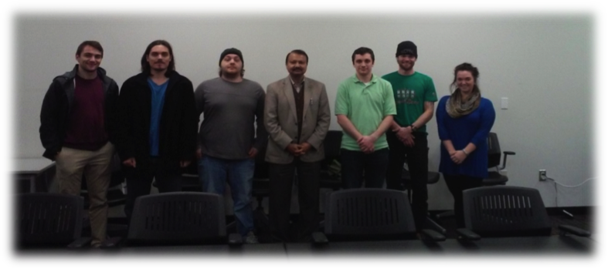
Upcoming Summer Camps
The Department will host several activities this summer for middle and high school students. For more information and to register, please see our website at www.memphis.edu/cs

The second annual Creative Game Design Camp for high school students will introduce participants to game design and programming using the RenPy visual novel framework for Python. The camp will be held from June 6-10, and tuition is $250. A limited number of scholarships are available.
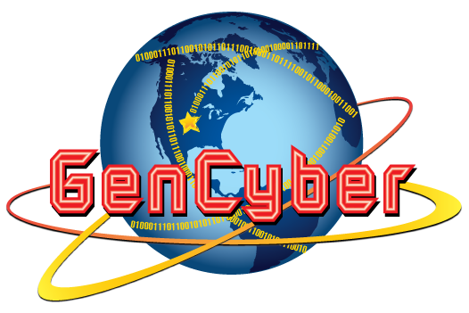

Two GenCyber Boot Camps to introduce cyber security skills will be offered: one for high school students from June 20-24, and one for middle school students from July 25-29. These camps are sponsored by the National Security Agency, and there is no charge for attendees.

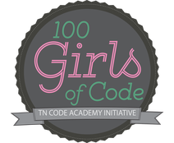

Two free one-day workshops for 100 Girls of Code will be offered on June 11 and July 30, for girls ages 10-18. These events will introduce computer science using Scratch and website creation with HTML and CSS.



Spring 2016 Graduates
B.S.  Christopher Hall  Justin Hiller  T. Daniel Long  Matthew Maddox  Enyil Padilla Valle  David Puckett  Austin Reynolds  Victor Rockwell | Cameron Roe  Drew Stabenow  Jeremy Thomas  Kevin Townsend  Landon Van Frank  Michael Vance  Cameron Wood  William Wood | M.S.  Sindhu Anantha Narayana  Marc Badrian  Neeta Bharti  Kyle Cherry  Venkata Chikkala  Shanshan Gao  Vincent Nkawu  Chaitanya Pochampally | Ph.D.  Md M Rahman  M.S. (continued)  Rashmi Prakash  Rahul Vemuri  Qiong Yu

Student Spotlight: Austin Henley  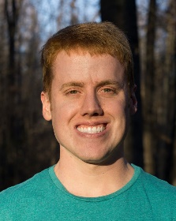  Ph.D. student Austin Henley will be interning at Microsoft Research in Redmond, WA this summer with the Tools for Software Engineers team. Austin has been working with Prof. Scott Fleming since 2012, taking a human-oriented approach to software engineering tools. His work aims to help improve the usability of code editors and provide more efficient means of navigating source code. He has also collaborated with Oregon State University and IBM Research.  Previously, he did an internship with First Tennessee in 2012, where he worked on overhauling the software that bank tellers and call agents use in over 170 bank locations. He then interned with National Instruments in 2014 and 2015 where he extended the LabVIEW development environment with tools to make programming easier. Having completed his master's in 2013, Austin plans to finish his graduate certificate in cognitive science this Fall while continuing his Ph.D. work. In addition to his research, Austin serves as the president of the recently formed CS Graduate Student Association.  Colloquium / Undergraduate Colloquium Talks |  | Student Updates  Marc Badrian is working at Mosaik Solutions in Memphis.  Shanshan Gao is continuing her studies as a doctoral student in the Department. She is interning at Facebook over this summer.  Matthew Maddox, Enyil Padilla Valle, and Michael Vance accepted full-time positions at FedEx Services, where they interned as students.  Md Rahman has accepted a research position at Nokia’s Digital Health Lab.  William Wood is working at Sedgwick in their Application Support and Development division.  Minsheng Zhang is planning to work at Google after defending his master’s thesis this summer.
  Feb. 5 | Increasing Experimental Power by Integrating Heterogeneous Biological Datasets  Bernie J. Daigle, Jr.  Asst. Professor, Depts. of Biology and Computer Science, University of Memphis
  Feb. 12 | NoSQL and the Wild West of Database  Mark Gillenson  Professor, Dept. of Business Information and Technology, University of Memphis
  Mar. 25 | Secure and Efficient Encrypted Image Search with Access Control  Shucheng Yu  Asst. Professor, Dept. of Computer Science, University of Arkansas at Little Rock
  Mar. 28 | The Real Curriculum: What You Should Actually Be Learning in College  Mark Cooper, Ph.D.  Technical Fellow, FedEx Services
  Apr. 25 | On the Crossroads of Cyber Security and Big Data Analytics  Lu Wang  Manager of Information Security, FedEx Services
Department of
Computer Science
University of Memphis
375 Dunn Hall
Memphis, TN 38152-3240

Phone: 901.678.5465
Fax: 901.678.1506

Email: info@cs.memphis.edu
Web: www.cs.memphis.edu

