Part-Time Faculty Hiring Justification Form

Answers to the following questions are required to help ensure that part-time vacancies are strategically and efficiently filled as needed. The answers should be short bullets with the primary focus on data such as faculty teaching loads, the number of part-time and full-time faculty teaching in the department, enrollment trends over the last 2 years, and the number of students in each course and section.
- Provide name of proposed part-time employee requested to teach, title of course/course# and term.

- Provide current teaching load course per part-time faculty and full-time faculty within the department and the number of students taught by each faculty member. (Include faculty name, course# and the number of students per course). Please provide this information in the below format:
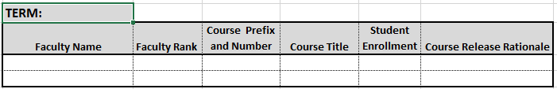

- Describe and provide justification as to why the teaching responsibility could not be shifted to other full-time faculty or other part-time faculty within the departmental unit.

- Provide course enrollment trends using OIR data www.memphis.edu/oir for the last 2 years within the department.

- Will any of the new spring part-time faculty within your department require an exception? If so, why and what type of an exception is requested?

Please submit this completed form to facultyservices@memphis.edu. Include faculty member’s name and department that you are requesting to hire.

