Senior Project
Final Report for

<Project Name>

in the partial fulfillment of
TECH 4945

<Your name>
submitted <submission date>

Executive Summary
The executive summary should be done after you have written the rest of this document! The point of the executive summary is that the person reading the document should be able to a) understand at a high level what the objectives of the project were, b) determine if the logic behind the project made sense and c) determine if they want to keep reading. For your final project report, the executive summary should a very brief overview of the project and its ultimate results. This should be a two or three (at the most) paragraph overview of what your project does and a summary of the results of the project (did it work, did it exceed expectations, etc.).
Some don’ts for your executive summary are:
- Get too detailed – your reader can read the rest of the proposal if they want more info.
- Use flippant or cliché terms/phrases – you run the risk of not being taken seriously.
- Dwell on only one part of the project – you need to briefly discuss your entire project in broad brush strokes.
- Get too long winded – remember, this is a SUMMARY. If it helps, think of this as an abstract.
<Your executive summary>

Table of Contents
Executive Summary i
Table of Contents ii
Table of Figures iii
Table of Tables iii
Introduction 1
Review of Objectives 1
Review of Deliverables 1
Technical Implementation 1
Evaluation of Plan of Work 3
Evaluation Results 3
Conclusions 4
References 5
Appendix A – Detailed Testing Results 6
Appendix B – Detailed Drawings (as needed) 6
Appendix C – Developed manuals, instructions, etc. (as needed) 7

Table of Figures
Figure 1. Sample of how appendices should be formatted. 5

Table of Tables
No table of figures entries found.

Introduction
For your final report, your introduction should inform the reader of what the project was, what the goals and objectives were, and what was to be delivered. The introduction doesn’t need to be long – in fact it might be better if it wasn’t as the bulk of the effort put forth in this document should be related to discussing what you did (your technical implementation), the results from your evaluation/testing efforts (your evaluation results), and the take-aways (your conclusions) from the project.
The goal of the introduction, and the report in general, is not to generate a bunch of busy work, but to share the results of what you learned with the reader. To that end, your introduction can include much of the introduction from your proposal. You are welcome to copy and paste text from your proposal into this document. However, if you do, be sure to update the tense (make sure you talk in terms of past tense, not future tense).
Once you have provided a brief recap of your project for the reader, you need to make sure to include a concise review of the objectives and deliverables. And that’s it. Do not drone on about your qualifications, how your plan of work ended up being unrealistic, or how your project ended up being something other than what you had thought it would be.
<Your intro here>

Review of Objectives
A single short paragraph discussing and listing the objective(s) of your project. Once again, this can be copied from your proposal with updates for tense. Something to the effect of “The objectives for this project were…” is sufficient.
<Your review of your objectives>

Review of Deliverables
A single short paragraph discussing and listing the deliverables of your project. Once again, this can be copied from your proposal with updates for tense. Something to the effect of “The deliverables for this project were…” is sufficient. Since a number of you didn’t necessarily include your deliverables within the objectives section of your proposal, make sure you have pulled a full list of deliverables from where ever they were in your proposal.
<Your review of your deliverables>

Technical Implementation
This is a discussion of what you did, any deviations from your technical plan, any major hurdles/learning moments that were encountered, and what is needed in order to reproduce your project. This is not necessarily a step by step set of instructions, but instead is a discussion of what worked, what didn't and what was changed to make things work. Much like the proposal, this section is going to differ based on your FOS.

Automation and robotics – We have your final solution – don’t print out your code and put that here since we already have that as appendix (if appropriate). Instead show a final block diagram of how the system works and how the various components interact as well as properly composed pictures (neat background, in focus, wiring organized, etc.) of the final product if appropriate. Pictures of “good” and “bad” parts should also be included. If you have generated a video of your project in action, include the full URL. Final flowcharts, logic tables, and other design decisions should be discussed. References to “as-built” and/or “final layout” drawings (which will be in the appendices) should be used to help with your discussions. Partial prints and smaller scale layouts can be included in this section as well if necessary. Any hardware configuration information can go in this section if there are only a few items or can be placed in the Appendix if there are a lot of updated/altered parameters. In either case, you need to ensure that you are indicating what the default configuration looked like and what you had changed. A discussion of why the changes were affected should be included as necessary.
Microcontrollers - We have your final solution – don’t print out your code and put that here since we already have that as appendix. Instead show a final block diagram of how the system works and how the various components interact as well as properly composed pictures (neat background, in focus, wiring organized, etc.) of the final product. Final flowcharts, logic tables, and other design decisions should be discussed. Any hardware configuration information can go in this section if there are only a few items or can be placed in the Appendix if there are a lot of updated/altered parameters. In either case, you need to ensure that you are indicating what the default configuration looked like and what you had changed. A discussion of why the changes were affected should be included as necessary.
Product realization - A discussion of any design iterations that occurred (including why the subsequent iteration was needed) should be included. You don’t need to include the part prints (of either the iteration or the final version) in this section unless it makes sense.
Software - We have your final solution – don’t print out your code and put that here since we already have that as appendix. Instead show a final block diagram of how the system works and how the various components interact. Final flowcharts, logic tables, and other design decisions should be discussed. If you have developed any project specific algorithms, you should discuss them here. Any hardware configuration information can go in this section if there are only a few items or can be placed in the Appendix if there are a lot of updated/altered parameters. In either case, you need to ensure that you are indicating what the default configuration looked like and what you had changed. A discussion of why the changes were affected should be included as necessary.
<Your technical details of what you actually did>

Evaluation of Plan of Work
This is a discussion of the plan of work and a comparison of the proposed plan of work from TECH 4943 and the actual timeline of the project completion. Discuss differences between the actual and proposed timeline and what lessons were learned concerning estimating timelines for future projects and how issues can be avoided on future projects.
< Your discussion of the plan of work vs actual project timeline>

Evaluation Results
This is a discussion of the results that you obtained as a part of the evaluation of your project, as outlined in your proposal. For the most part, you should be putting aggregated (e.g. sums, averages, ranges, etc.) results in this section. The detailed results shall go in Appendix A, although you can include small samples in this section.
For example, imagine that your project was to build a plastic mold and one of your stated methods of evaluating the success of your project was to measure the finished size of five parts being generated by the mold. You would could include the average size, weight, etc., of the parts that the mold produced in this section. You would describe whether the measured results were within acceptable tolerances and if corrective action were needed in this section. However, the individual dimensional results for each of the five parts would be listed in Appendix A. As a part of this section you could discuss the causes of any errors, but would need to wait until the Conclusions section of the report before discussing the implications of any part variation.
Likewise, if your project involved collecting GPS coordinates from a microcontroller project, you might list the average amount of locational error your system experienced, but you would list the raw locational data that was collected over some period of time in Appendix A. Within this section, you would discuss the possible causes of the locational error, and what could be done to fix it, but would refrain from discussing the implications of the error. That discussion would occur in the Conclusions section of your report.
In general, your Evaluation of Results should only include your quantitative analysis. If your project does not have any quantitative testing, you could discuss any subjective results, but need to consult with your technical advisor(s) and the professor(s) of record for the class to determine how they would like for you to proceed.
“Pass/fail” evaluations for deliverables such as documentation, the existence of 2D or 3D CAD models, production documentation, etc., should be excluded from this section, but “pass/fail” evaluations for functionality (e.g. project successfully mounts on the car, software successfully accepts properly formatted input, etc.) should be discussed. In general, you will probably have to use your best judgement, along with consultations with your instructors, to determine if specific “pass/fail” items should be discussed here.
<Your discussion of the results from your testing – evaluation results>

Conclusions
Your report conclusions are not just a summary of what you have previously discussed, but are where you will be able to discuss the implications of what you found. For more traditional research, authors would normally include the implications of their research, a discussion of next steps, and how the research could be applied to a broader audience within their conclusion. Since your project is more applied in nature, your conclusions should be a summary of what worked, what did not work, and how your project is was applicable to your overall degree.
Issues (problems) can be discussed here as well as the repercussions of those issues. For example, during the testing of your project you found that your ability to accurately identify a location via GPS was seriously compromised when on the UofM campus. As mentioned in the previous section, you would only report the inaccuracy within the Evaluation of Results section of your report. The discussion of what this lack of accuracy means to the broader GPS equipped public would be addressed in the Conclusions section.
<Your project conclusions>

References
Only include this if you actually have references in your document. They are not required for the final report. However, as you discuss issues encountered and solutions attempted, you may find yourself making a statement along the lines of “… according to Billy Joe Smartguy at www.allmyanswers.com, if problem ‘X’ occurs, the solution is ‘Y’…” then you need to do a proper citation.
<References if needed>

Appendix A – Detailed Testing Results
The results from all of your quantitative tests should be organized and included in Appendix A. Pay particular attention to formatting and readability; poorly organized data will result in a confusion by the reader and ultimately a lower grade. All appendices shall have a “first” page indicating the appendix letter and an identifier as to what the contents are and the actual contents shall start on a new page.

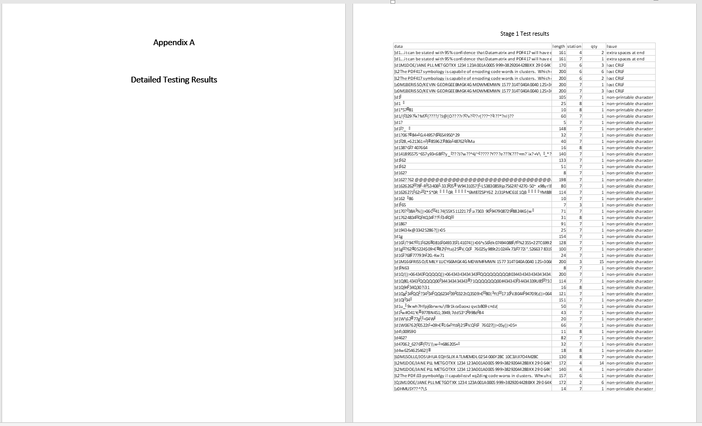
Figure 1. Sample of how appendices should be formatted.

Appendix B – Detailed Drawings (as needed)
Include drawings, as needed, scaled such that they can be printed on letter sized paper or plan to “Z” fold ‘B’ sized (11x17) sheets of paper. All drawings should be done professionally (boarders, title blocks, appropriately scaled text, correctly dimensioned, etc.) and should be such that someone could build the item being documented.
If there are no drawings required for your project (e.g. a software project), then you can delete this section and Appendix C would be reidentified as Appendix B.

Appendix C – Developed manuals, instructions, etc. (as needed)
Any other documentation that was identified as a deliverable should be included starting after Appendix A (if you have drawings, they would be placed in Appendix B and you would begin the additional documentation at Appendix C). Each logical type of documentation should receive its own appendix. For example, if your project included as-built part prints, a general user manual, and a set of data sheets for some of embedded components, you would have the drawings in Appendix B, the user manual in Appendix C, and the data sheets in Appendix D. Another example might be for a software or microcontroller project that resulted in an instruction manual and a lot of custom programming. Your instruction manual would be put in Appendix B and the source code would be included on the USB stick only.

