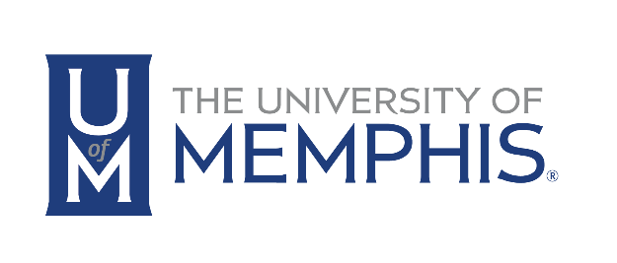

FOR IMMEDIATE RELEASE
June 14, 2016

FOR MORE INFORMATION
Contact: Mary Ann Dawson
901.678.1592
mdawson@memphis.edu

FedEx Institute of Technology Welcomes Another Community Partner
June 14, 2016 – The FedEx Institute of Technology has made a significant impact on the Memphis technology community during the last year. With targeted research clusters, strategic community outreach, and world-class technology skills training, the Institute is making the world take notice of the technology innovation hub that is Memphis.
To advance these efforts the FedEx Institute of Technology introduced the Community Partners Program in April of 2016. This program, designed to create strategic alliances with the community organizations impacting technology trends in Memphis, was initiated with a signing ceremony between the University and two key partners, Memphis Technology Foundation and Tech901. Since that signing, the close partnership between the University of Memphis and the local organizations committed to advancing technology skills and resources in Memphis has grown significantly.
In the spirit of this we are pleased to welcome our newest community partner, Memphis PASS (Professional Association of SQL Server) Chapter. PASS is an independent, not-for-profit organization run by, and for, the community. With a growing membership of more than 100K, PASS supports data professionals throughout the world who use the Microsoft data platform.
PASS strives to fulfill its mission by:
- Facilitating member networking and the exchange of information through our local and virtual chapters, online events, local and regional events, and international conferences
- Delivering high-quality, timely, technical content for in-depth learning and professional development
PASS was co-founded by CA Technologies and Microsoft Corporation in 1999 to promote and educate SQL Server users around the world. Since its founding, PASS has expanded globally and diversified its membership to embrace professionals using any Microsoft data technology
The Memphis PASS Chapter was founded in March 2009 and is an official chapter associated with the Professional Association for SQL Server (PASS). Our mission is to provide our members in the Mid-South area with a forum for education, facilitate networking, and guidance around best practices in SQL Server and related products and services. We normally meet on the second Thursday of every month. Membership in the group, as well as attendance to our monthly meetings, is free.
The Institute is changing the way the world views Memphis. If you have a passion for emerging technologies and the role that technology has in shaping the future of Memphis, come join us at the Institute. Memphis is Innovation.

