In the summer of 2015, students can grant a parent or other individual access to certain portions of their financial aid record. These individuals are known as proxy users. Through the MyMemphis portal, students can create proxy user account and assign access to specific pages within MyMemphis allowing proxy users to view a student's financial aid information.
After students set up a proxy account, the proxy user will receive email instructions on how to access the proxy system. See below for more information on setting up a proxy account.
Proxy User Setup Steps
- Log into MyMemphis.
- Click the Account$ tab. In the Financial Aid Awards Channel, click “Financial Aid Awards”. Next click on the Proxy Access tab
- Click Add Proxy.
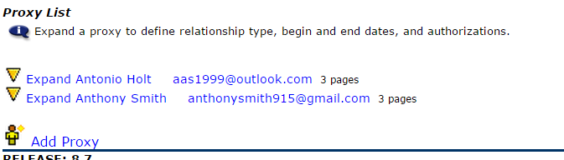
- Enter your proxy user's first name, last name, and email address in the appropriate fields and click Add Proxy.
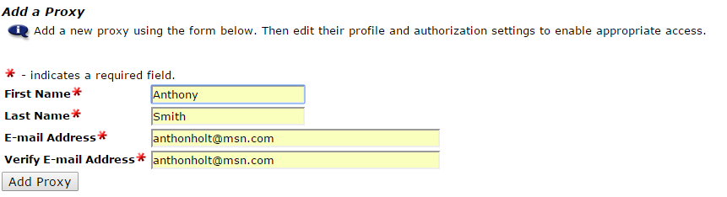
- Once you have entered the required information, click on your proxy user's name to expand their information and continue the process.
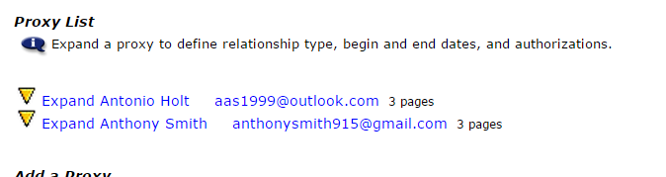
- On the Profile tab, use the description field to add a personal note describing this proxy user (Parent or Other). This description is for your use only and will not be included in any communications to your proxy user.
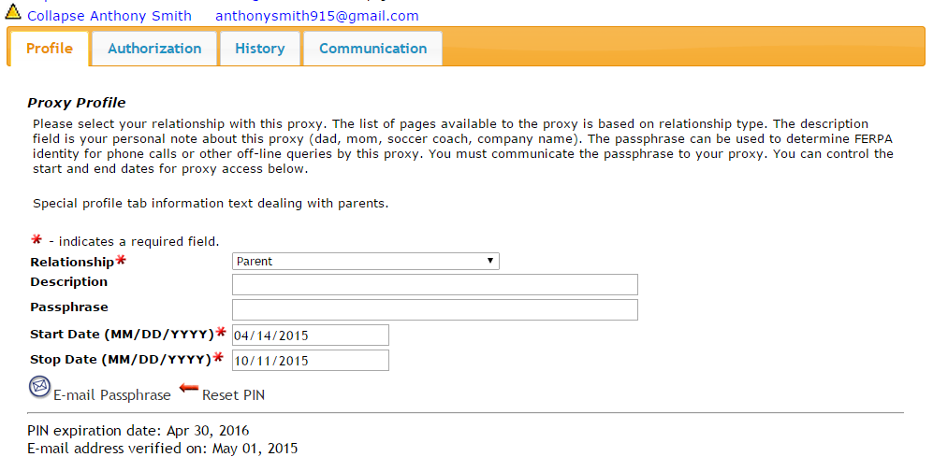
- You will see start and stop dates that have been pre-populated. The start date will reflect today's date and the end date will be years into the future. These dates control the window during which your proxy will have access to your information. If at any point in time you wish to cut off access to your information, simply set the end date to a date prior to today.
- Click the Authorization tab. This is where you will determine which pages your proxy user has access to. Select the check boxes next to the pages for which you wish to grant access. You have the ability to grant or revoke access to specific pages at any time. Any action taken on your part is reflected immediately for your proxy user.
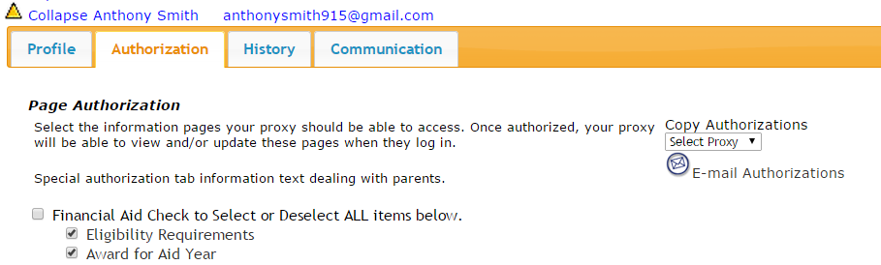
- You have now completed your proxy user setup!

What Else Should I Know?
- FERPA Implications - Granting proxy access does not authorize any staff to discuss your academic records with your proxy user. The Proxy Access system is simply an easy way to allow individuals of your choosing to view your information.

- History Tab - Located in the proxy system, you will see a History tab next to the Authorization tab you used to define access for your proxy user. This tab lists the history of all authorizations you have made for this proxy user as well as all times that user has accessed your information. Actions of Enable or Disable refer to you granting or revoking authorizations. Actions of Login or View refer to the actions of your proxy user as they have accessed your information.

- Communications Tab - Located in the proxy system, you will see a Communications tab next to the History tab described above. This tab lists all communications that have been sent to this proxy user (newest to oldest). The Action Date refers to the date the proxy activated the URL within that particular message (only pertains to certain communications). The Expiration Date refers to when the URL within the message will no longer be active. You can resend any communications to your proxy user by clicking the envelope icon in the Resend column for that particular communication.

- Password Reset - If your proxy user loses his or her password, you can generate a password reset email for that user. Log into the proxy system and expand the user in question. On the profile tab, click Reset Password under the Save button. This will send your proxy user email instructions on how to reset their password.

- HELP!?!? - If, after reading the instructions above, you still have some unanswered questions, don't worry...we're here to help. Just email us at proxyaccess@memphis.edu and we'll be more than happy to answer any questions you might have.
Proxy User
- Check your email. Once a student has declared a proxy an email with your log in information is sent.
This email contains the Proxy Access link along with your username and password needed to access your account. The action password in this email will also be used as the “old pin” used to create a new password.
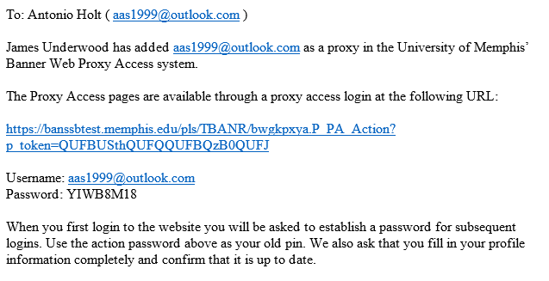
- Complete your profile information.

- Click on the tab with the student’s name whose information you would like to view. In this tab you will see the links that the student granted you access to.
Once you click on the link another windows will open containing the information you wish to view. Please know that as a proxy user you are not allowed to update or change any of the student’s information. If you access an area or make a change that is unauthorized you will receive an error message and a prompt to re-enter your login information.
