Namuum Batbaatar: Student Research Forum - 1st Place - Life & Health Sciences
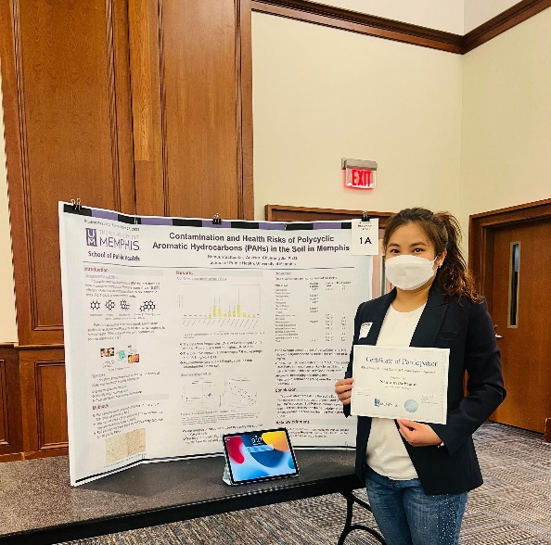
Namuum Batbaatar is a thriving graduate student at the University of Memphis. Although she calls Mongolia home, she loves the Memphis area.
Spring 2022, she was announced as the 1st place winner of the Graduate Student Research Forum in the Life & Health Sciences category. With the help of one of her favorite professors, she tested and assessed the risk associated when factors like traffic, carcinogens, and other hazardous substances get into the Memphis soil. She compared her findings to studies, research, and results from the United States Environmental Protection Agency to assess the soil contamination level and the possible risk. The process helped her learn how to work with numerous data sets, learn what to look for, use the tools from her statics class to understand her findings, and most importantly cultivated her desire to want to become a professor one day.
She attributes her 1st place in this category to several professors at the UofM who always make the learning come alive in simple yet interesting ways and push her to reach her full potential. She wants to pay it forward and do the same for other students.

