Posting to the OnLegalGrounds Blog
*Note – some of the screenshots might differ from what you see on your screen
If you are making an announcement about an upcoming event, don’t forget to also make an event type post for the calendar.

Step 1: Login to your Account
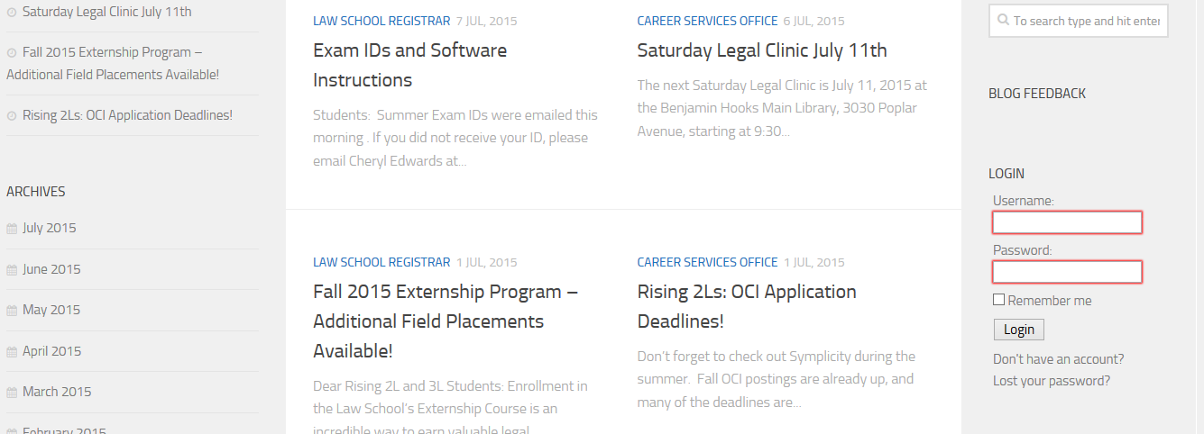
To find the Login option, scroll to the bottom of the main page of the blog and look on the right hand side of the page.

Step 2: Get to the Page to Create a New Post.

A new menu bar will now be at the top of the blog.

Hovering the mouse over “+ New” will reveal a drop down menu.
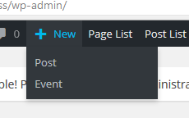

From this Menu, Click on “Post.” This will open up a page that allows you to fill in your post information.

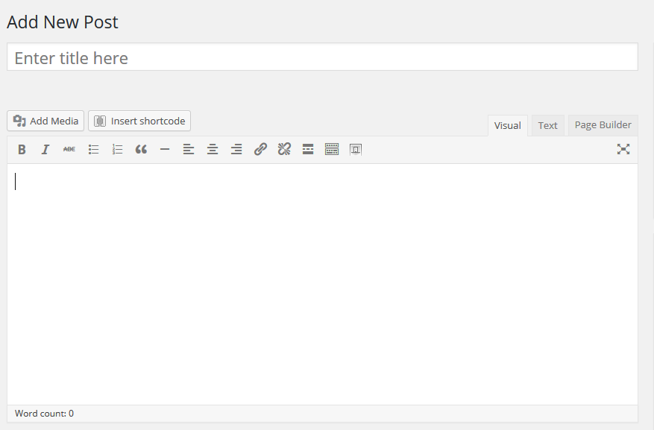

The top bar is where you will enter the title of your post. The lower box is where the content of your post will go.

After both boxes have been filled in, look to the right hand side of the screen and scroll down until you see the categories listed.

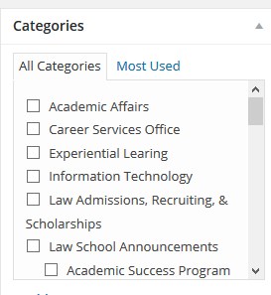
Select the appropriate category by scrolling down until the proper category is visible and clicking the small box next to the category.

After the category has been selected, scroll back up and until you see the publish options at the top of the page. It will be located on the right-hand side.
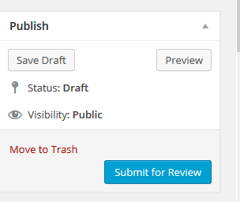

Click the blue “Submit for Review” button and the post will be submitted for approval. If you want to make sure that your post looks how you want it, you can click the preview button from the above screenshot to see how the final post will look once it is approved and posted to the blog.

