Updating Time Zone in Outlook

Online -

Login to your account.

From there, hover the mouse over the gear icon in the top right corner of the page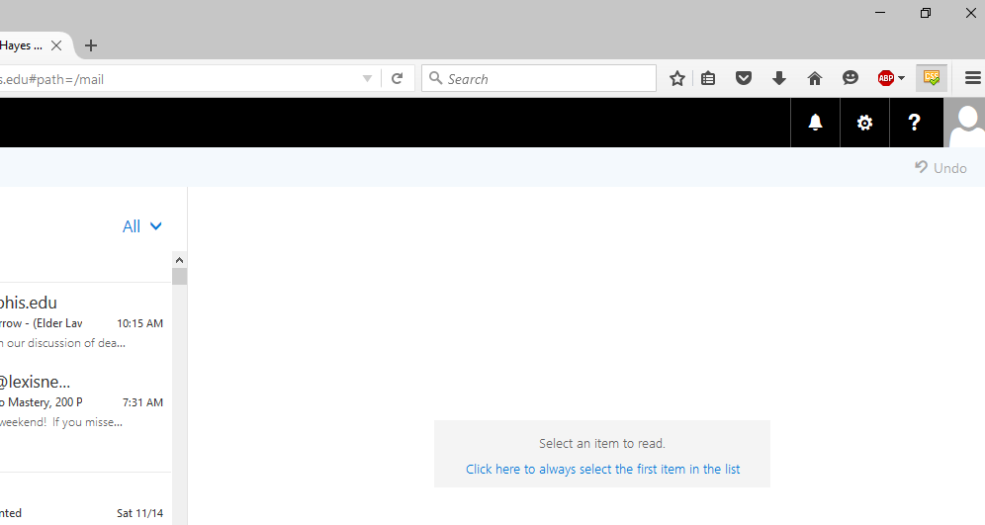

This will cause a drop down settings menu to appear. Click on Options.
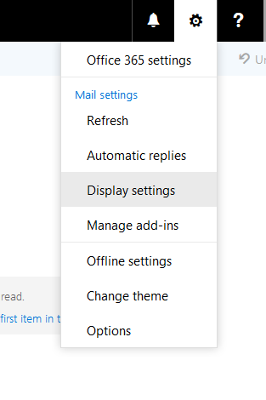

This will take you to a page where a list of types of settings are displayed on the left side of the screen. You first want to click on “General.”
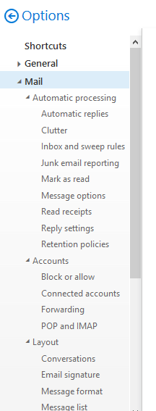

Clicking on “General” results in a list of the general settings. To change your time zone, click on “Region and Time Zone.”

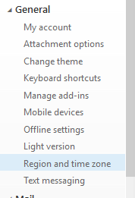
This will allow you to set your time zone. You want to make sure that “Current Time Zone” is set to “Central Time (US & Canada).” If you setting currently displays another time zone, click in the box that hold the time zone setting and select “Central Time.”
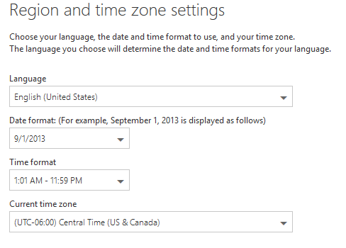
Don’t forget to click save to save your new time zone.

These buttons will be at the top of the menu and, once you change a setting, the save button will turn blue and allow you to click on it.

Now, your time zone is correct. To guarantee that this will be reflected in your calendar events, scroll down on the left side menu to calendar settings.

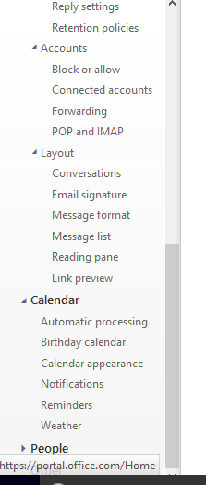
If you do not see the options listed under “Calendar,” click on the bold “Calendar” text to expand the menu.

From there, click on “Calendar Appearance.”
Once you get to this screen, if you haven’t already selected for the time zone to remain constant in your calendar, you will see a check box that says something along the lines of “Set Current Time Zone (Central) as your permanent time zone.” Once you check that box and save, your screen should look like this. The checkbox you need to select will appear in the same location as the “Note: Current Time Zone is . . .” text in the following image.
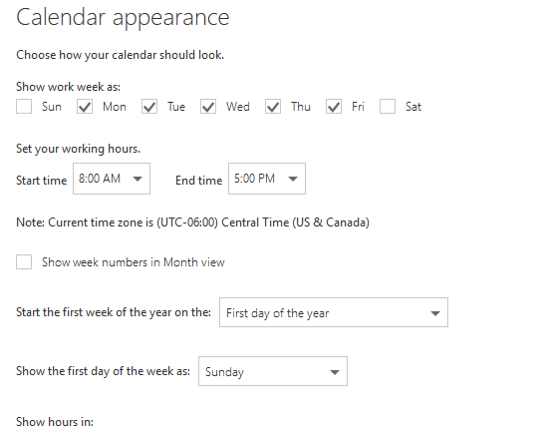
After you select the check box, be sure to click the save button that is above the “Calendar appearance” label.

Outlook 2013 and 2010

Outlook 2013 was used for these screenshots, so if you are using Outlook 2010, the appearance might differ, but the instructions should be the same.

First click “File” in the top left corner and that will bring up the following menu.
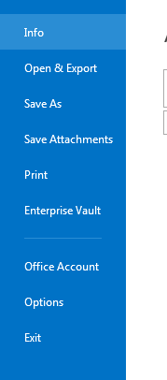

From here, click on “Options.” This will cause a dialog box to open. There will be a list of menu options on the left side of the dialog box that looks similar to this:
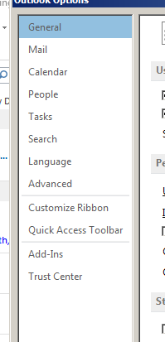

Click on “Calendar.”

The full set of Calendar options will then be in the right-hand side of the dialog box. Scroll down until you see “Time Zones.”

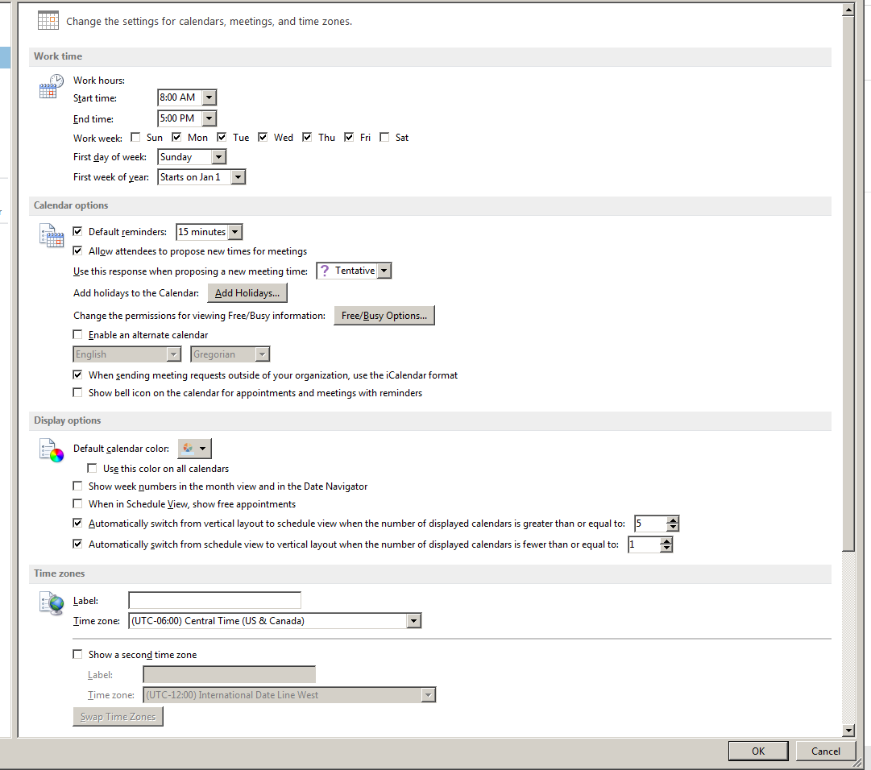

If the time zone currently selected in your Outlook is not “UTC-6:00 – Central Time (US & Canada),” click the arrow to get the drop-down menu to open and select Central Time as your time zone.

Click the “OK” button at the bottom of the dialog box to save your settings.

