Creating an Event and Sending an Invitation in Outlook 2013

Start by clicking on “New Item” in the upper left corner.
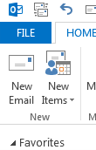

This will create a drop down menu. Click on “New Appointment,” which will open a separate window to create the event.
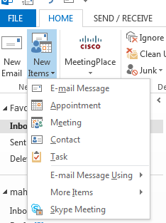

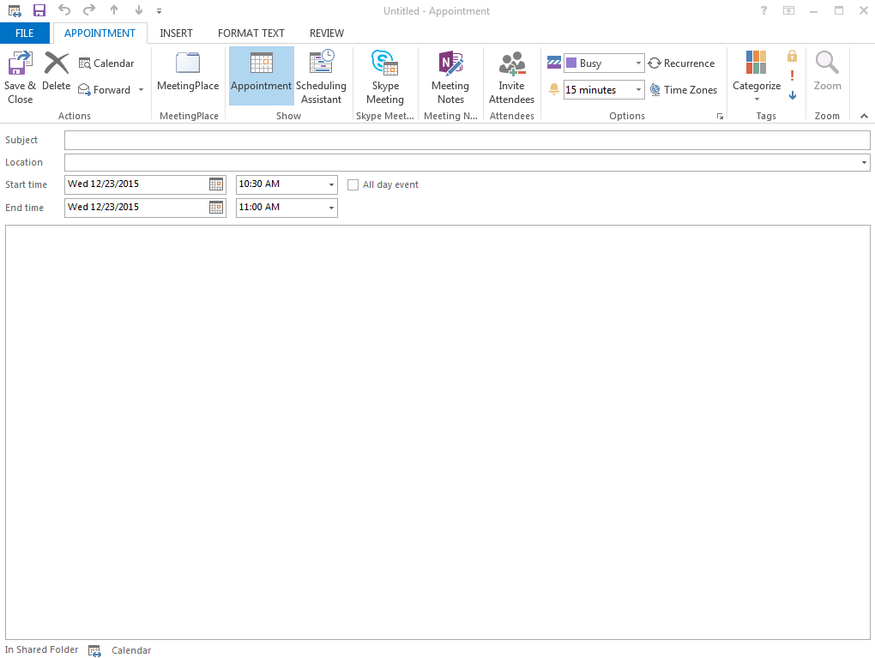

Fill in the details asked for on the event screen.
- Enter the subject of the meeting.
- Enter location (usually Dean Aden’s office, #258).
- Select the correct start and end date and time.
- For the description in the big box at the bottom, you may include any information about the meeting that you would like Dean Aden to know in advance.

After verifying that that information is correct, click on the button towards the middle of the window that says “Invite Attendees.”

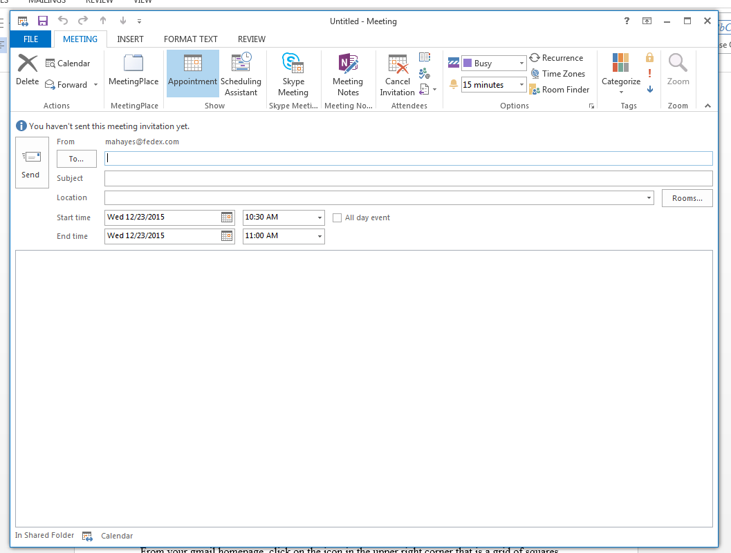

This will copy over the subject, date and time, location, and body of the event. You will need to put Dean Aden’s email address (maden@memphis.edu) in the “To:” box. Once all of that information has been entered and is correct, click “Send.

