Posting an Event to the OnLegalGrounds Blog
*Note – some of the screenshots might differ from what you see on your screen
It is recommended that an announcement type post is made when you make an event to alert students that the event is on calendar.

Before making an event type post, please verify with Ms. Bounds that your room has been properly reserved.

Step 1: Login to your Account
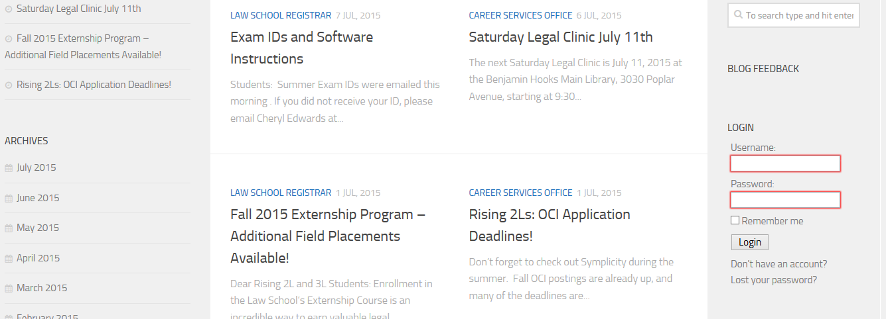
To find the Login option, scroll to the bottom of the main page of the blog and look on the right hand side of the page.

Step 2: Get to the Page to Create a New Post.

A new menu bar will now be at the top of the blog.

Hovering the mouse over “+ New” will reveal a drop down menu.
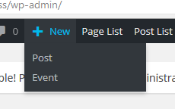

From this Menu, Click on “Event.” This will open up a page that allows you to fill in your event information. The top bar is where the event title will go and the content of the information about the event, such as the speaker and if food is available, will go in the bigger box below.

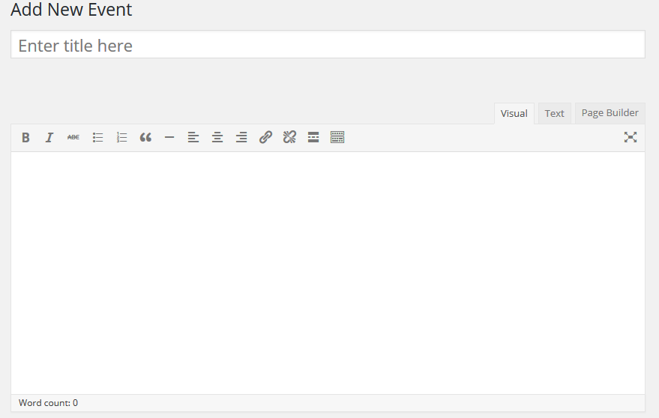
Event Information goes here

After filling in the information about your event, scrolling down on the page will reveal the options for selecting the date and time of the event, so that it can be properly displayed on the calendar. The drop down menus will allow you to set the time of the event.

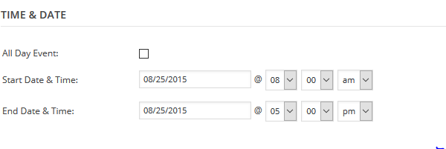

Clicking in either of the date boxes will bring up a calendar to pick the date of the event by clicking on that date.

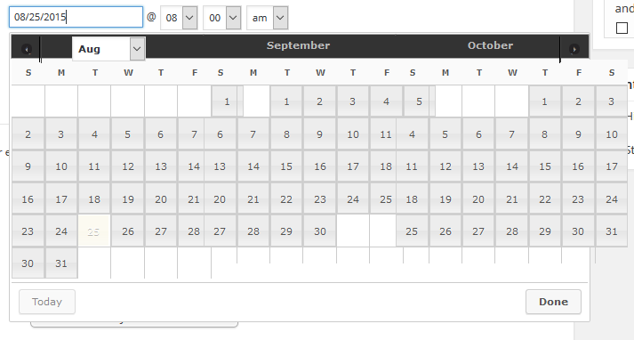

The event categories will be in a menu that is to the right of the date and time selection options. Be sure to select the proper event category so that the event will show up on not only the general calendar, but a specific calendar for your organization. Scrolling down in the category box will reveal all of the categories.

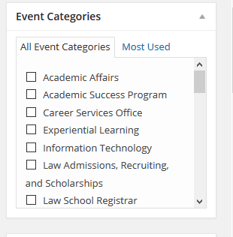

Scrolling down from there will show the venue selection options, directly underneath the date and time selection options.
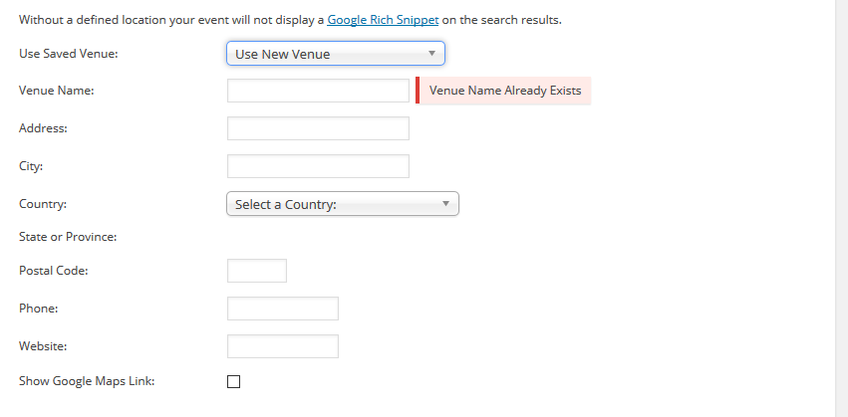

You will NOT be creating a new venue, click on the option where it says “Use New Venue” and a dropdown menu will show up.

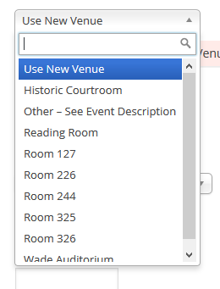
You will be able to select one of the options. If you are holding an event that is not in a location listed, use the option “Other – See Event Description” and include the relevant information in the content of the event. For example, if your event will be at Bardog or if the event is similar to the school supply drive and there are places to drop off items in the lobby, that information should be in the content of the event.

Underneath the options for venue, there will be the ability to select an organizer.

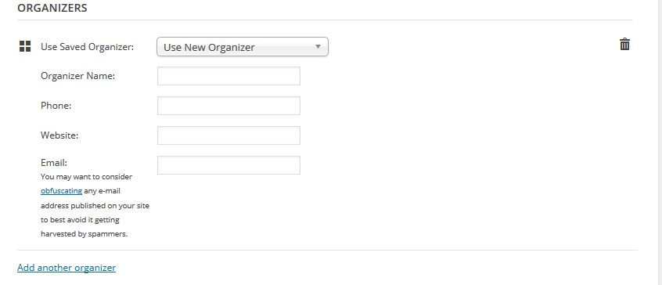

You will NOT be adding new Organizers, only selecting from the dropdown menu.
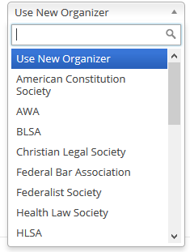

If the event is organized by multiple organizations, just click on the blue link “Add another organizer” that is at the bottom the Organizer block and use the dropdown menu again to select the other organizer.

After you have completed all of the above, you are ready to review your event and submit it for approval. Scroll back up to the top of the page and next to the text box the content of the event was entered into you should see the publish options.

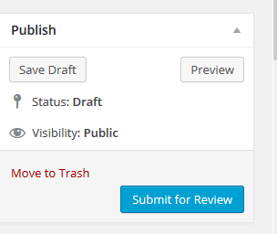

Click “Preview” if you wish to review all the information you entered and see what the final post will look like. After doing any review you wish to do and making any changes needed, click the blue “Submit for Review” button to submit the post.

