INSTRUCTIONS FOR REGISTERING FOR WESTLAW, TWEN & THE LEGAL METHODS TWEN COURSE

All 1Ls will use Westlaw and TWEN during the fall semester. To gain access to TWEN, you must first register for Westlaw access. After you register for Westlaw access, register for the Legal Methods TWEN Course.

Registering for Westlaw/TWEN Access

- Obtain your Westlaw Password from Linda Hayes.
- Go to www.lawschool.westlaw.com.
- Click the Register link located on the right.
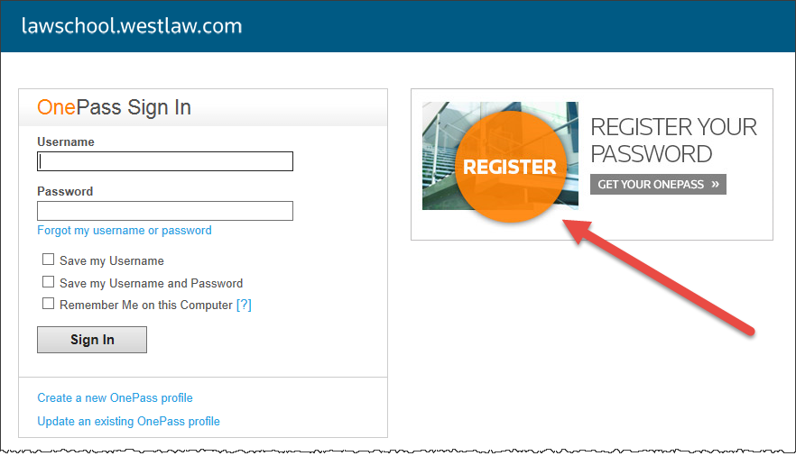
- Select No in response to whether you have an existing OnePass profile.
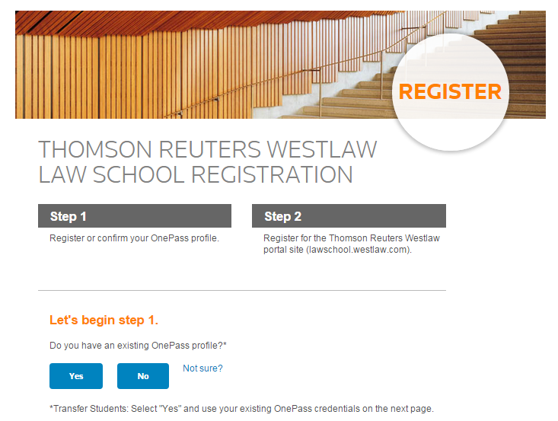
- Fill in the Westlaw Registration Key provided to you by Linda Hayes and your preferred email address in the appropriate boxes. Click Continue.
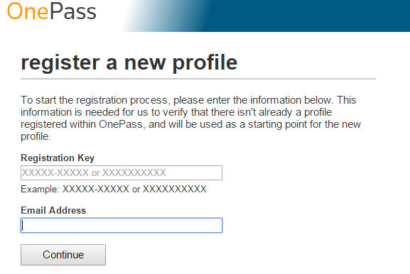
- Fill out the registration information. Click Create Profile.
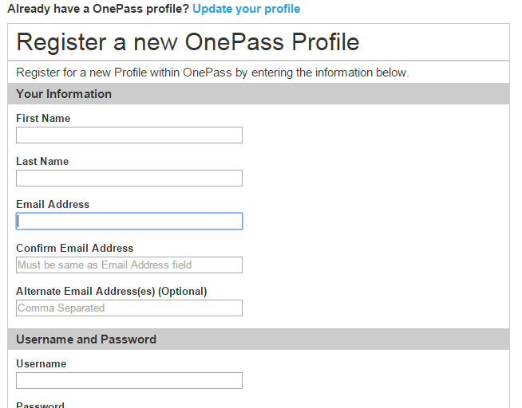
- You are now registered for Westlaw and TWEN. Later in the semester, you will learn how to conduct legal research on Westlaw.
- If you have problems registering for Westlaw, contact Westlaw technical support at (800) 850-WEST.

Enrolling in the Legal Methods TWEN Course
- Go to www.lawschool.westlaw.com.
- Enter your OnePass Username and Password. Click Sign In.
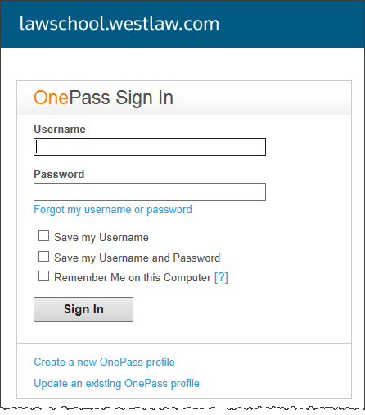
- You should now see the Westlaw “Home” page. Click TWEN at the top of the page.
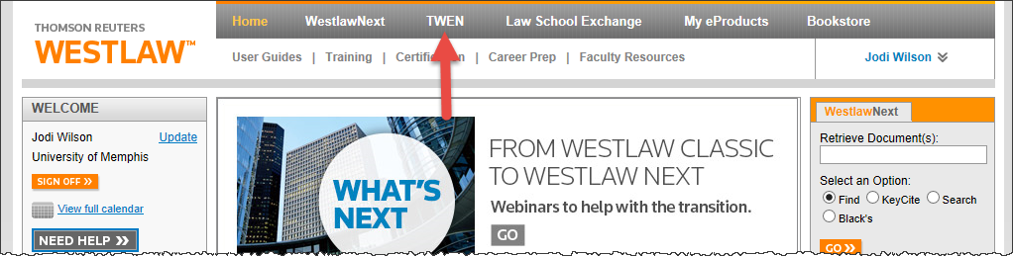
- You should now see the “My Courses” page. Click Add Course at the top of the My Courses page.
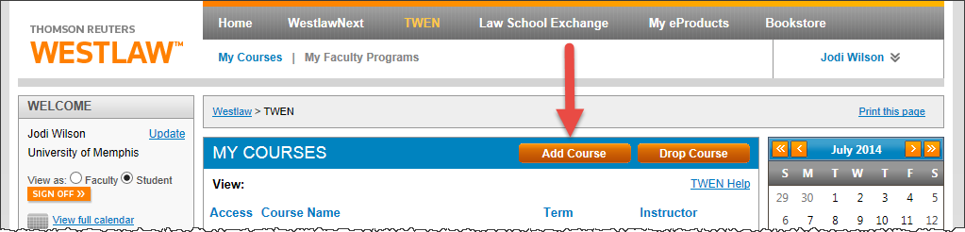
- The TWEN courses that are available for you will be displayed. Under University of Memphis, you should see a course named LEGAL METHODS – Wilson (Full Year 2016-2017). Click Add.
  - NOTE: If your other professors are also using TWEN, you may want to add those courses now too.
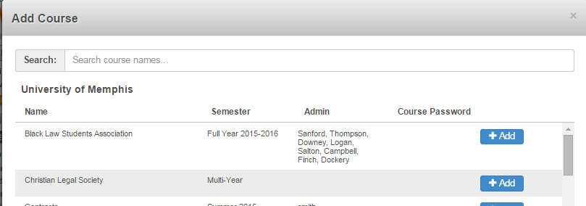
- Scroll to the bottom of the window and click Close.
- This will take you back to the My Courses page. You should see all of the courses you added.
- On your My Courses page, click the link for LEGAL METHODS – Wilson (Full Year 2016-2017) to enter the Legal Methods TWEN Course.
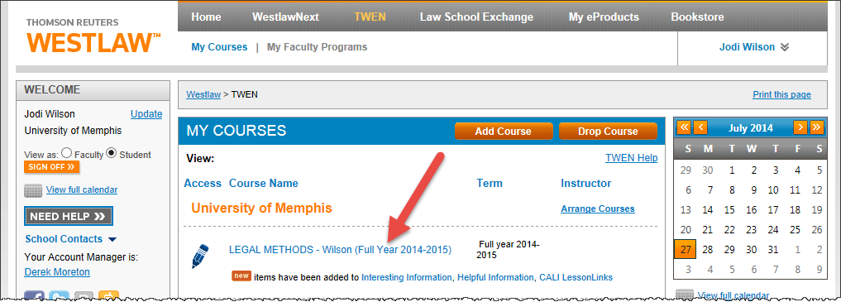
- If you have problems registering for TWEN Courses, contact Westlaw technical support at (800) 850-WEST.

Several other classes will also use TWEN. Please review the first assignments and syllabi for your other classes to determine whether you need to register for additional TWEN Courses.

