CRITICAL READING FOR LAW STUDENTS WORKSHOP HANDOUT

Watching obscure movies can be a hit or miss proposition! Some obscure movies are hidden gems, while others are obscure for very good reason. Many shy away from watching an obscure movie because the script may be poorly written, the unknown actors may be talentless, and the overall cinematography may remind you of a home movie. For those who are willing to take the risk, however, the rewards are many!
From the early work of a skilled and now-famous actor or director, cinematography so beautiful it hurts to stories that resonate for days after, obscure movies hold the promise of a new and wonderful discovery. Of course, obscure movies can be divided into the usual genres, including science fiction, romance, drama, comedy, and action. Among the science fiction options, Under the Moon stands out. Starring none other than Natalie Portman as a young woman who preys on men in rural Virginia, the underlying message about what makes us human is haunting. Once Again My Love presents a lighter science fiction option, mixing time travel with romance and suspense in an early work by well-known screenwriter Ray Bradbury. In the drama genre, The Driver and the Cocoon has spectacular cinematography to go along with a moving, true story of a man who is trapped in his own body following a car accident. Starring Idris Elba, the drama The Light intertwines two distinct storylines as it follows a former soldier seeking healing and redemption after war. If you like action, you can’t go wrong with Game On, an action-packed film that pulls elements from video games to give the viewer a fun, if mindless, ride. All of these movies are fantastic, but if you’re only going to take a chance on one obscure movie, watch Garbage. This comedy tells the bizarre but hilarious story of a homicidal trash can. You’ve never seen a movie like this before, and you owe it to yourself to watch it.

Excerpted from R. Wilson Freyermuth, Jerome M. Organ & Alice M. Noble-Allgire,
Property & Lawyering xvii (3d ed. 2011).

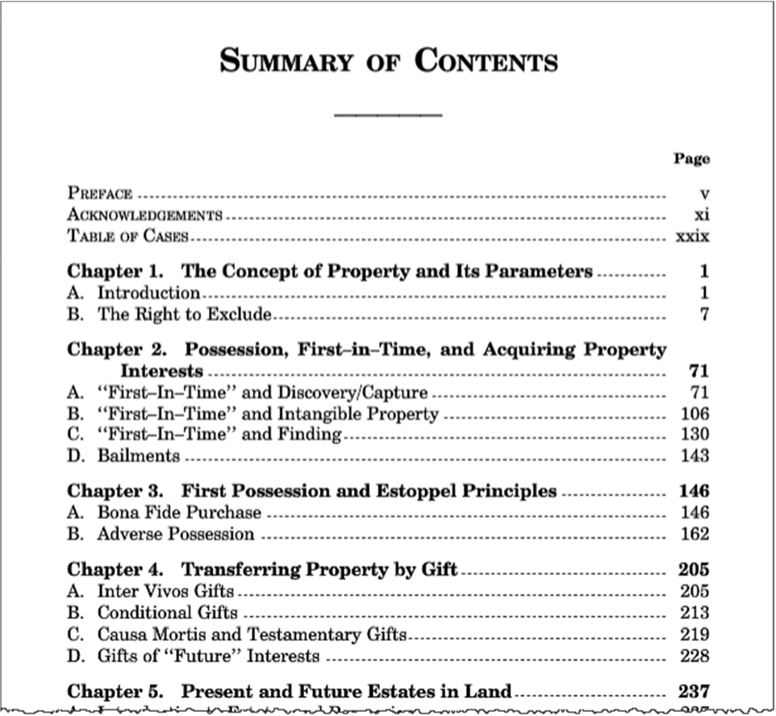

Freyermuth, Organ, and Nob... Wilson, Jodi 5 pages
3
Excerpted from R. Wilson Freyermuth, Jerome M. Organ & Alice M. Noble-Allgire,
Property & Lawyering 205-209 (3d ed. 2011).

C HAPTER 4

TRANSFERRING PROPERTY BY G IFT

• • •

. . .
Previous chapters highlighted several ways one can acquire an inter­ est in property (e.g. capture, discovery, creation, finding, bailment, and even adverse possession). More commonly, however, one acquires a prop­ erty interest by sale or gift. We reserve more detailed treatment of the transfer of land by sale until Chapter 9, but we take up the transfer of property by gift in this chapter for two reasons. First, the concept of " possession" (explored throughout Chapters 1- 3) plays a significant role in the law governing transfers by gift. Thus, the law of gifts provides a logical context for further study of the scope and significance of "posses­ sion" in resolving property disputes. Second, the law regarding gifts provides a gentle introduction to the means of conveying property (su ch as deeds, wills, and t ru sts ), which should help prepare you for the material on estates and future interests in land in Chapter 5.

A. INTER VIVOS GIFTS
The most common type of gift (e.g. , the typical Christmas , Hanukkah, birthday, or wedding gift) is an inter vivos gift- literally, a gift " between the living." For such a gift to be legally effective to transfer ownership, there are three requirements: (1) the donor must have donative intent (i .e., the intent to make an immediately effective gift); (2) the donor must deliver the object of the gift, and (3 ) the donee must accept the object of the gift .
Most gifts occur in personal and family relationships and take place without dispute. In some cases, however, a dispute arises regarding whether a valid gift occurred. As in the next case, these disputes often arise after the would-be donor's death and involve an argument over whether the donor made an effective delivery of the gift during the donor's life. As you read the following case, consider why the delivery requirement matters and what actions are (or should be) necessary to constitute an effective delivery.

205

Freyermuth, Organ, and Nob... Wilson, Jodi 5 pages
IN RE ESTATE OF EVANS
Sup reme Court of Pennsylvania. 467 Pa. 336, 356 A.2d 778 (1976).

Nrx, J USTICE. Appellant, Vivian Kellow, [argues that] . . . certain contents of a safe deposit box were the subject of an inter vivos gift to her from Arthur Evans, the deceased, and, consequently, should not have been included in his estate .
Appellant, the niece of Arthur Evans' deceased wife, began working for the Evans family when she was 16. For several years she took care of Mrs. Evans who for some years prior to death was an invalid. Appellant cooked meals for the Evanses, cleaned their house, did their laundry and generally cared for Mrs. Evans. She received adequate compensation for performing these needed services. When Mrs . Evans died, appellant con­ tinued to cook at least one hot meal a day for Mr. Evans, do his laundry and make sure his house was tidy. After appellant was married, she continued to perform these same services and visited Mr. Evans once a day. In May of 1971, following one of his four hospitalizations, the deceased moved into appellant's home.
Although at times Mr. Evans was confined to his bed because of water in his legs, he frequently took walks, had visits with his lawyers and made trips to his bank. On October 22, 1971, appellant's husband drove Mr. Evans and a friend of his, Mr. Turley, to town so that Mr. Evans might go to the bank. Turley testified that Mr. Evans spent about one hour going through the contents of his safe deposit box. Before leaving the bank, the deceased obtained both keys to the box.
Various witnesses presented by appellant testified to seeing the keys to the safe deposit box beneath appellant's mattress and to statements by Mr. Evans to the effect that the contents of the safe deposit box had been given to appellant. Mr. Evans entered the hospital for the last time on November 5, 1971. During this last hospital stay, Reverend Cunnings visited with him and was told that Mr. Evans was giving the Reverend's church $10,000.00 and that he had given the rest of his possessions and the keys to his safe deposit box to appe llant. Mr. Evans expired on November 23, 1971.
Appellant relinquished the keys to the safe deposit box to a bank officer, but not without protesting that the contents of the box were hers. The box revealed a holographic will of Mr. Evans dated September 16, 1965, and approximately $800,000.00 in bonds, preferred and common stock and several miscellaneous items. 1
The lower court correct ly noted that the requirements for a valid inter vivos gift were donative intent and delivery, actual or constru ctive. With respect to donative intent, the court found: "Turning to the facts of
1. Th e will was uncontested and under its terms provided for a $1,000.00 bequest to appellant.

©2011 West Academic Publishing

Freyermuth, Organ, and Nob... Wilson, Jodi 5 pages
5
this case, certainly no one can reasonably argue that Arthur Evans lacked sufficient motive to make a gift to Vivian. The record clearly manifests, both by his conduct and his statements , donative intent , the first prerequi­ site."
Nevertheless, the court ruled that no delivery had been made. This result was predicated upon a finding that the deceased had not divested himself of complete dominion and control over the safe deposit box . . . .
Appellant now asserts . . . that the lower court erred in ruling there was insufficient delivery to sustain the inter vivos gift.... We find these arguments unpersuasive and, therefore, affirm the decision of the lower court ....
.. . In Allshouse' s Estate, 304 Pa. 481, 487-488, 156 A 69, 72 (1931),
we elaborated on the requirement of delivery:
. . . In In re Campbell's Est., 7 Pa. 100, 47 Arn.Dec. 503, Chief Justice Gibson stated: "A gift is a contract executed; and, as the act of execution is delivery of possession , it is of the essence of the title. It is the consummation of the contract which, without it, would be no more than a contract to give, and without efficacy for the want of consideration." ...
We have recognized that in some cases due to the form of the subject matter of the gift or due to the immobility of the donor actual, manual delivery may be dispensed with and constructive or symbolic delivery will suffice. In Ream Estate, 413 Pa. 489, 198 A.2d 556 (1 964), for example, the Court found there had been a valid constructive delivery of an automobile where the donor gave the keys to the alleged donee and also gave him the title to the car after executing an assignment of it leaving the designation of the assignee blank. The assignment was executed in the presence of a justice of the peace and the evidence was overwhelming that the name of the donee was to be inserted upon the death of the decedent.
In Elliott's Estate, 312 Pa . 493, 167 A 289 (1933), we held there was a valid constructive delivery of the contents of a safe deposit box where the donor turned over to the alleged donee the keys. There, however, just prior to the delivery of the keys a doctor had informed the non-ambulatory donor that death was imminent . Under those circumstances manual delivery was impossible.
Appellant relies heavily on Leadenham's Estate , 289 Pa. 216, 137 A 247 (1927), and Leitch v. Diamond National Bank, 234 Pa. 557, 83 A 416 (1912). These decisions, however, support the Court's finding that there was no delivery in the instant case. In Leadenham's Estate , supra, the donor had rented a separate safe deposit box in the name of the intended donee, put the contents of his box into the newly rented one and delivered the keys to it to the donee. On those facts we held that the constructive delivery of the keys was sufficient to sustain the inter vivos gift because the donor had divested himself of dominion and control and invested the donee with complete dominion and control.

Freyermuth, Organ, and Nob... Wilson, Jodi 5 pages
6
In Leitch v. Diamond National Bank, supra, the donor and donee were husband and wife and had lived together harmoniously for many years. The husband had three safe deposit boxes registered in his name and the name of his wife and he designated one of them as his wife's. He gave her the keys to that box. The Court found that she had complete control over that box and that he only entered it with her permission. Since she had complete control over the access to the box the Court found there was a valid delivery of the contents of the box to her.
In both of these cases, the determinative factor was that the donee had complete dominion and control over the box and its contents. In that posture we ruled that giving the keys to the box to the donee was a valid constructive delivery. In the instant case, appellant did not have dominion and control over the box even though she was given the keys to it. The box remained registered in Mr. Evans' name and she could not have gained access to it even with the keys. Mr. Evans never terminated his control over the box, consequently he never made a delivery, constructive or otherwise.
Although appellant suggests that it was impractical and inconvenient for Mr. Evans to manually deliver the contents of his box to her because of his physical condition and the hazards of taking such a large sum of money out of the bank to her home, we need only note that the deceased was obviously a shrewd investor, familiar with banking practices, and could have made delivery in a number of simple , convenient ways. First , he was not on his deathbed. He was ambulatory and not only went to the bank on October 22, 1971, but took walks thereafter and did not enter the hospital until November 5, 1971. On the day he went to the bank he could have rented a second safe deposit box in appellant 's name, delivered the contents of his box to it and then given the keys to appellant. He could have assigned the contents of his box to appellant. For that matter, he could have written a codicil to his will.
The lower court noted that the deceased was an enigmatic figure. It is not for us to guess why people perform as they do. On the record before us it is clear that regardless of Mr. Evans' intention to make a gift to appellant, he never executed that intention and we will not do it for him. On these facts, we are constrained to hold that there was not an inter vivos gift to appellant and that the contents of the safe deposit box were properly included in the inventory of Mr. Evan s' estate. . . .
ROBERTS, J USTICE (dissen ting ) .... First, there is no doubt in this case that donor intended a gift. He told many people that he had given the contents of the box to appellant. In fact, there is competent testimony that donor directed donee to display the keys, hidden under her matt ress, to several witnesses.
Second, it is apparent from the record that donor believed undisputed and unconditional delivery of the keys to be sufficient to complete the gift. Most of this Court's cases dealing with inter vivos gifts of the contents of safe deposit boxes turn on the delivery or nondelivery of the keys to the

©2011 West Academic Publishing

Freyermuth, Organ, and Nob... Wilson, Jodi 5 pages
7
box to the donee. If the key was delivered, the gift was normally upheld; if the key was not delivered, the gift was set aside, whether or not the box was jointly leased. I have found no case which turned on the presence or absence of a joint lease. Given this line of authority, and accepting the majority 's conclusion that donor was sophisticated in these matters , it must be concluded that donor believed delivery of the keys to the box completed the gift. If this were not so, why would donor cause donee to take several witnesses into her bedroom to show them that she had the keys and why would he speak in terms that indicated a completed gift-"! gave to Vivian . . . the keys and the contents are hers." Because it is donor's intention to transfer title which is crucial to a valid delivery, and because this donor intended to transfer title, I dissent from the majority's conclusion ....
NOTES

1. The Delivery Requirement and the Significance of " Dominion and Control." The majority opinion in Evans concluded that Evans did not deliver the contents of the box because he neither placed them beyond his "dominion and control" nor invested Kellow with "dominion and control" over them. This conclusion is typical of many common law decisions holding that a donor must deliver physical possession of an object to the donee to make an effective gift . Simply saying " I want you to have the contents of my safe deposit box" is not enough. Why not? What purpose(s) does Evans identify as being served by requiring a manual delivery of the object of the gift? Can you think of any other purposes that might be served by the requirement? You will find additional hints in the other cases in this chapter. See Philip Mechem, The Requirement of Delivery in Gifts of Chattels and of Choses in Action Evidenced by Commercial Instruments, 21 Ill. L. Rev. 341, 348-49 (1926 ).
2."Constructive" and " Symbolic" Delivery. In some cases, actual physical delivery (i.e., handing over ) of the object of the gift is impossible. For example, few donors could pick up and hand over a car, a safe, or a heavy article of furniture. Under these circumstances, the common law relaxed the manual delivery requirement and recognized acts sufficient to constitute a " const ruc­ tive" delivery or a "symbolic" delivery. Symbolic delivery occurs when the donor gives the donee an object that symbolizes or represents the gift, such as a photograph, a bill of sale, a deed, or a letter . Constructive delivery occurs when the donor gives the donee something that provides the donee with access to, or control over, the gift. For example, suppose that Sara hands her son the keys to her car and says, " I want you to have this car as a gift from me." Although Sara cannot physically hand the car to her son, the keys give him the means to exercise dominion and control over the car.2 Given this standard, is the majority's decision in Evans defensible? Evans gave Kellow
2. A caveat is in order with respect to cars. In all states today, cars are covered by certificate of title statutes. As a result, in some states , the law may require delivery of the title certificate to transfer title to a car. Compare Johnson u. Daughtridge, 1979 WL 794 (Ark. 1979) (no gift when alleged donor retained title certificate) with Smith u. Smith, 650 S.W.2d 54 (Tenn. App. 1983) (intention of parties, not certificate of title , determines effectiveness of gift of car).

