Template to follow: http://www.memphis.edu/ce/people/smishra3.php
Content to be placed

Dr. Ranganathan Gopalakrishnan
Assistant Professor, Mechanical Engineering
Phone 901-678-2580
Email rgplkrsh@memphis.edu
Fax 901-678-4180
Office 320 Engineering Science Building

<Add Potrait Picture>

About me
Professional Experience:
• Lecturer, Department of Mechanical and Industrial Engineering, The University of Iowa
August 2015 to May 2016
• Postdoctoral Scholar in Chemical Engineering, University of California at Berkeley.
October 2014 to July 2015
Research Supervisor: Prof. David B. Graves
• Postdoctoral Scholar in Chemical Engineering, California Institute of Technology.
September 2013 to September 2014.
Research Supervisor: Prof. Richard C. Flagan

Education:
• Ph. D., University of Minnesota – Twin Cities, Minneapolis, MN, U. S. A. August 2013.
• Bachelor of Technology (Mechanical Engineering), National Institute of Technology, Tiruchirappalli, India. May 2008.

I am an Assistant Professor in the Department of Mechanical Engineering at the University of Memphis.
Our research focuses on applying aerosol science and technology to Additive Manufacturing (AM) processes as well as fundamental aspects of aerosol science. In our group, we do broadly two types of research:
- Aerosol Spray Coating Processes for low-cost processing of coatings of diverse materials for renewable energy, biomedical and defense applications.
- Precision Deposition of Nanoparticles for template-free, etch-free fabrication of next generation electronic and plasmonic devices.
By applying basic principles of aerosol particle motion, we pursue a “table-top” approach to engineering wherein we develop models validated by rigorous experimental testing to advance aerosol-based AM. We also work on fundamental problems in aerosol science to understand the transport and dynamics of particles and to exploit them for manufacturing applications. We make extensive use of Computational Fluid Dynamics (CFD), Molecular Dynamics (MD), Brownian Dynamics (BD), Monte Carlo (MC) simulation methods modeling aerosol dynamics. These simulations are used to guide our experiment design and validation. Our lab is equipped with state of the art aerosol measurement facilities that includes:
- several designs of Differential Mobility Analyzers (“long” and “nano”) for real-time sizing of 1.9 nm to 500 nm aerosols,
- Condensation Particle Counters (TSI 3760 and Kanomax FMT 3650) capable of counting individual particles down to 10 nm and 1.9 nm respectively
- Optical Particle Sizer (TSI 3330) that is capable of real time monitoring of 0.3 to 10 μm particles in air.
We have a well-stocked lab space (700 sq. ft.) with an internal network for standardized, particle-free compressed air for particle research (Quincy QOF3), chemical fume hood, several high-precision translation stages for manufacturing research, aerosol generation apparatus such as electro-hydrodynamic (EHD) spray units, powder dispersers, tube furnace, aerosol nebulizers, and necessary safety gear to pursue dry and wet chemistry as part of our aerosol based AM research.
If you would like to know more details about our various projects, feel free to contact me at rgplkrsh@memphis.edu

Currently Active Projects (updated January 2018)
Etch-free, Template-free Nanopatterning
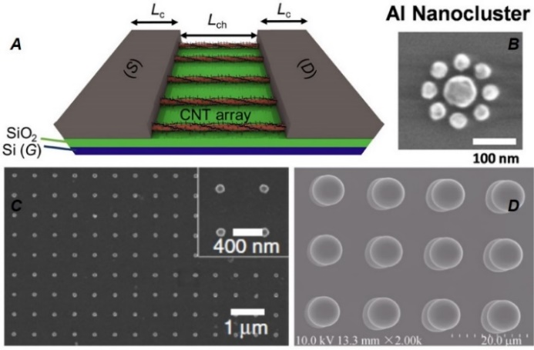
Examples of Nanoparticle (NP) Arrays in Devices.
Placing nanoparticles at a desired location is the one of the most challenging issues in the fabrication of 2D and 3D nanostructures and nanodevices. Nanostructures for electronic and plasmonic devices are a major need for the present and upcoming technological advancements. There are numerous applications of nanoparticles in different fields such as biomedical, renewable energy, electronics, environment and health care. Some specific applications could be transistors, sensor applications, data storage, logic circuits and light-emitting devices. This research focuses on applying electrostatic fields to guide and deposit nanoparticles at digitally defined locations for producing individual nanoparticle patterns.
Students: Rayhan Ahmed (PhD track)
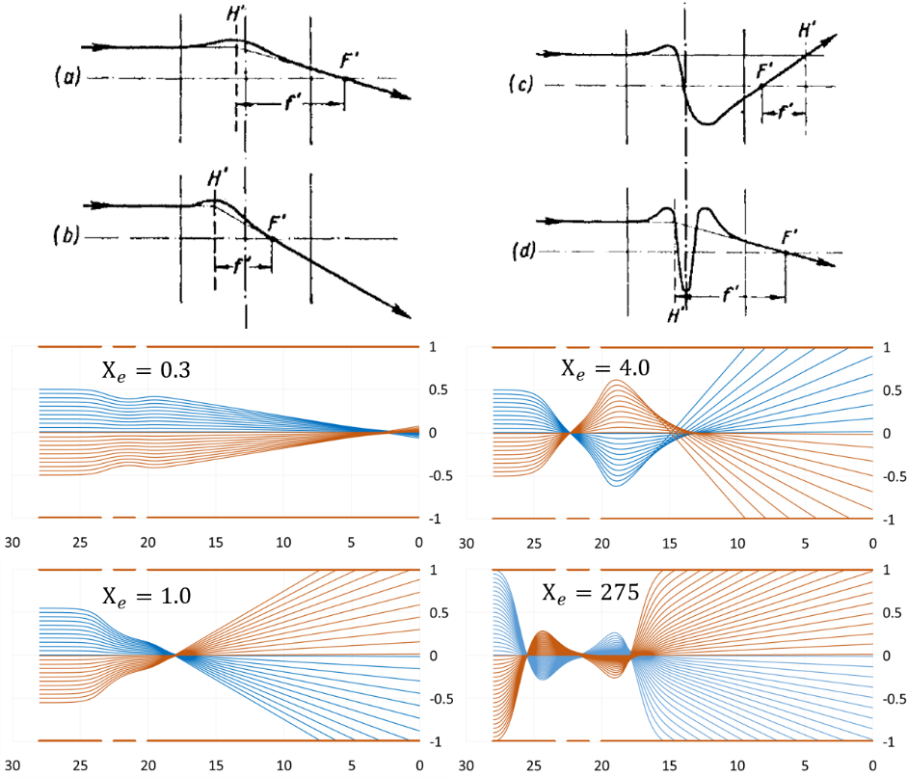
Collaborators: Dr. Sanjay Mishra (Physics, UoM), Dr. Thang Ba Hoang (Physics, UoM), Dr. Lenwood Fields (Engineering Technology, UoM)
Funding Source: Dr. Gopalakrishnan’s research startup funds
Publications on this topic:
- Rayhan Ahmed and Ranganathan Gopalakrishnan, “Parametric Study of an Einzel-type Electrostatic Lens for Aerosol Particle Focusing” (Manuscript in preparation for Journal of Electrostatics)

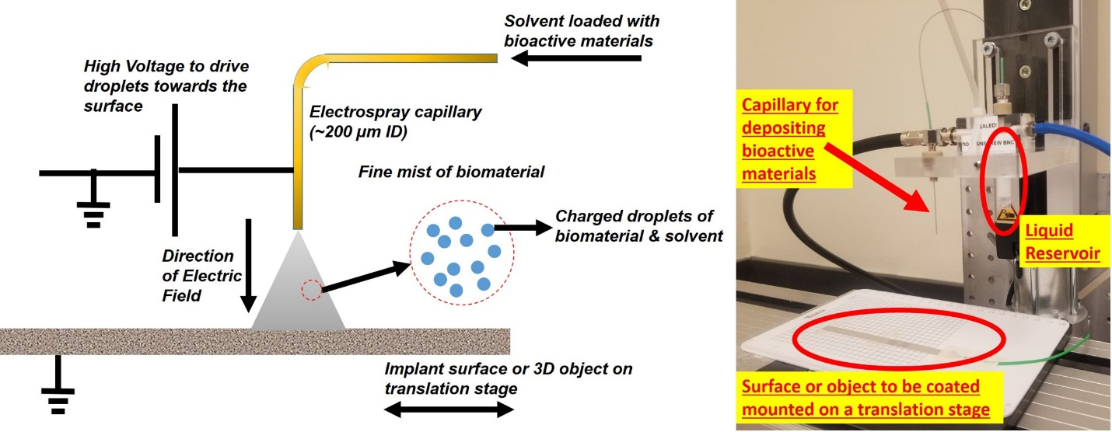
Biomedical Implant Surface Functionalization via Electrospray AM
Electrospray coating technologies provide an additive manufacturing technique to endow biomedical implant surfaces with new properties to improve their performance by controlled deposition of different materials, compounds and or agents in the form extremely fine nano or micro sized particles on the surface of implant devices under relatively mild conditions. This project focuses on the development of an electrospray additive manufacturing technology to coat dental and orthopedic devices with novel implant coatings that have potential to promote implant integration and prevent/inhibit bacterial attachment. We have developed processes to electrospray several polymer or polymer-ceramic composite coatings in a controlled manner onto implant materials and these coatings have much potential for incorporating drugs and/or growth factors and/or nanoparticles for the effective control of the local delivery of these agents to the implant-tissue interface. For example, these coatings may provide a mechanism for the controlled release of two or more growth factors over time to mimic natural growth factor sequences for healing as well as providing agents that inhibit or prevent bacterial attachment. Development of novel electrospray manufacturing technologies have the potential to add to or enhance implant-tissue interactions that lead to improved implant performance and dramatically reduce infectious complications of implants devices; major challenges to implant device success. This project would have natural interest and collaborations with UTHSC, and the Memphis biomedical implant device and manufacturing companies.
Students: Ewe Jiun Chng (MS track)
Collaborators: Dr. Joel Bumgardner (Biomedical, UoM), Dr. J. Amber Jennings (Biomedical, UoM)
Funding: Dr. Gopalakrishnan’s research startup funds
Publications on this topic:
- Ewe Jiun Chng, Kevin Patel, Joel D. Bumgardner and Ranganathan Gopalakrishnan, “Mechanical Characterization of Electrosprayed Chitosan Coatings on Titanium surfaces” (Manuscript in preparation)
Aerosol Processed Dye-Sensitized Solar Cells
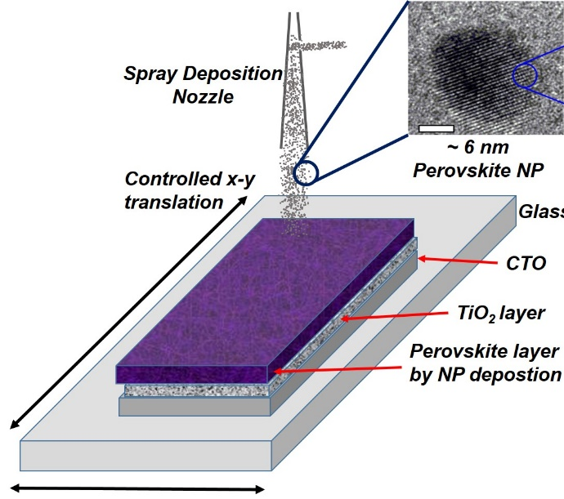
In this project, an earth abundant and environmentally friendly material called Perovskite that has generated a lot of interest recently is proposed for building solar cells through an innovative direct printing technique. Unlike current manufacturing methods, i.e. mounting the prepared solar panels onto surfaces, the proposed approach involves direct spray coating of solar cells on a surface (on top of the painted surface as a thin layer) with a very small energy and environmental footprint. For this purpose, Perovskite has been synthesized as nanoparticles and sprayed onto surfaces using the Aerosol Deposition Technique. The resulting solar cells will have strong adhesion with the surface, light weight that is critical for many mobile applications, and low cost for mass production. The proposed approach does not require any device mounting and modification to the existing design of a surface and can be used to turn an entire fleet of vehicles or buildings into mobile power stations that can result in significant savings.
Students: Lekhnath Pokharel (MS track), Li Li (PhD track)
Collaborators: Dr. Jingbiao Cui (Physics, UoM)
Funding: Dr. Gopalakrishnan’s research startup funds, Fedex DRONES Grant, UoM Green Fee Funds
Publications on this topic:
- Lekhnath Pokharel, Li Li, Jingbiao Cui and Ranganathan Gopalakrishnan, “TiO₂ coatings on FTO glass using the aerosol deposition method for solar applications” (Manuscript in preparation)
Fundamental Research on Aerosol Science
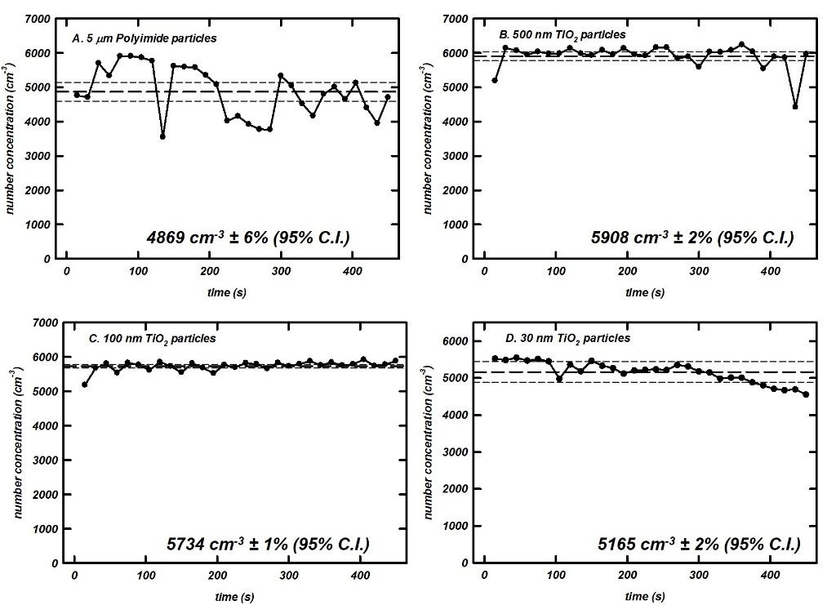
Generation of aerosols from dry cohesive powders: One of the requirements of doing aerosol based AM research is the necessity of an aerosol source that can feed raw materils in the form of discrete particles (~ few 10’s of microns to a few 10’s of nanometers in size) at a steady concentration over extended periods of time (~few hours if necessary). In our lab, we have developed an in-house technique to disperse dry powders at a constant rate. The main challenge in doing so is that powders love to stick to surfaces due to their high adhesion energy and are difficult to aerosolize. We have developed a technique that is currently prepared for patenting to generated aerosols from dry powders at high concentrations for AM over long periods of time (see figure).

Students: Lekhnath Pokharel (MS track), Ewe Jiun Chng, (MS track), Prashant Parajuli (MS track) and Li Li (PhD track)
Funding: Dr. Gopalakrishnan’s research startup funds, Fedex DRONES Grant, UoM Green Fee Funds
Publications on this topic:
- Lekhnath Pokharel, Li Li, Prashant Parajuli, Ewe Jiun Chng and Ranganathan Gopalakrishnan, (Manuscript in preparation for Aerosol Science and Technology journal)

Collision dynamics in aerosols and dusty plasmas: the role played by long range potential interactions in the collisions between gas phase entities such as particles, ions, electrons in aerosols and plasma systems is a topic of research that has both fundamental and technological interest. We use Brownian dynamics (BD) simulations to carry out ab initio simulations of particle-ion dynamics and develop descriptive models for collision processes. building on my prior work on this topic from the University of Minnesota, currently we are looking at the collisions between entities dominated by attractive coulombic interactions (for. Eg. collisions between unlike charged particle and ion at a certain pressure of background gas). This problem has a long history in the fields of aerosol and plasma science in the context of particle charging and coagulation and for material synthesis in nanotechnology applications. Recently, we have made significant progress on developing a closed form expression for the collision rate constant between unlike charged particles and are currently preparing it for publication. Please contact rgplkrsh@memphis.edu if you are interested in knowing more about this exciting fundamental work.
Students: Harjindar Singh Chahl (MS track)
Publications on this topic:
- Harjindar Singh Chahl and Ranganathan Gopalakrishnan, “A self-consistent model for describing the collisions between unlike charged entities in dilute systems” (Manuscript in preparation for Physical Review Letters)

Publications
# | Year | Citation
10 | 2016 | Gopalakrishnan, R., Kawamura, E., Lichtenberg, A. J., Lieberman, M. A., & Graves, D. B., (2016) Solvated electrons at the atmospheric pressure plasma-water anodic interface J. Phys. D: Appl. Phys. 49 295205.  Selected by the Editorial Board of J. Phys. D: Appl. Phys. to feature in Highlights of 2016: http://iopscience.iop.org/journal/0022-3727/page/Highlights-of-2016
9 | 2015 | Gopalakrishnan, R., McMurry, P. H., & Hogan, C. J., (2015). The Bipolar Diffusion Charging of Nanoparticles: A Review and Development of Approaches for Non-Spherical Particles. Aerosol Science and Technology 49(12): 1181-1194.
8 | 2015 | Gopalakrishnan, R., McMurry, P. H., & Hogan, C. J., The electrical mobilities and scalar friction factors of modest-to-high aspect ratio particles in the transition regime. Journal of Aerosol Science 82:24-39.
7 | 2013 | Gopalakrishnan, R., Thajudeen, T., Ouyang, H. & Hogan, C. J., The Unipolar Diffusion Charging of Arbitrary Shaped Aerosol Particles. (2013). Journal of Aerosol Science 64:60-80.
6 | 2013 | Gopalakrishnan, R., Meredith, M. J., Larriba, C. & Hogan, C. J., Brownian Dynamics Determination of the Bipolar Steady Charge Distribution on Sphere and Non-spheres in the Transition Regime. (2013). Journal of Aerosol Science 63:126-145.
5 | 2012 | Ouyang, H., Gopalakrishnan, R. & Hogan, C. J. (2012), Nanoparticle Collisions and Growth in the Gas Phase in the Presence of Singular Attractive Potentials. Journal of Chemical Physics. 137: 064316.
4 | 2012 | Thajudeen, T., Gopalakrishnan, R. & Hogan, C. J. (2012), The Collision Rate of Non-spherical Particles and Aggregates for all Diffusive Knudsen Numbers. Aerosol Science and Technology, 46:11, 1174-1186.
3 | 2012 | Gopalakrishnan, R., & Hogan, C. J. (2012), Coulomb-Influenced Collisions in Aerosols and Dusty Plasmas. Phys. Rev. E 85, 026410.
2 | 2011 | Gopalakrishnan, R., Thajudeen, T. & Hogan, C. J. (2011), Collision limited Reaction Rates for Arbitrarily Shaped Particles across the entire Diffusive Knudsen Number Range. Journal of Chemical Physics. 135: 054302.
1 | 2011 | Gopalakrishnan, R., & Hogan, C. J. (2011), Determination of the Transition Regime Collision Kernel from Mean First Passage Times. Aerosol Science and Technology.45: 1499-1509.

Papers under Review
Wong, C., Gopalakrishnan, R., & Goree, J., Experimental demonstration that a free-falling aerosol particle obeys a fluctuation theorem. (Submitted to Physical Review Letters for peer-review)

Conference Proceedings
# | Year | Citation
15 | 2017 | Fendley, A. & Gopalakrishnan, R., Combined Diffusion and Field Charging of Aerosol Particles. 31st Annual National Conference on Undergraduate Research, University of Memphis – April 6-8, 2017.
14 | 2015 | Graves, D., Gopalakrishnan, R., Kawamura, E., Lieberman, M., Hydrated Electrons at the Plasma-Water Interface. APS Meeting Abstracts, Published 2015/9.
13 | 2015 | Kawamura, E., Lieberman, M.A., Lichtenberg, A. J., Graves, D. B., Gopalakrishnan, R., Particle-in-Cell Simulations of Atmospheric Pressure He-H2O Discharges. Bulletin of the American Physical Society, Vol. 60, Published on 2015/10/13.
12 | 2015 | Graves, D. B. (Presenter), Gopalakrishnan, R., Kawamura, E., & Lieberman, M., Hydrated Electrons at the Plasma-Water Interface. Gaseous Electronics Conference GEC-68/ICRP-9/SPP-33 Honolulu, Hawaii, 12-16 October 2015.
11 | 2015 | Gopalakrishnan, R., (Presenter) Prediction of the Alignment, Preferred orientation and Electrical Mobility of Nanoparticle Agglomerates during Electrical Mobility Classification. American Association for Aerosol Research Conference, Minneapolis, MN, USA, October 12th – 16th, 2015.
10 | 2014 | Gopalakrishnan, R., McMurry, P. H., & Hogan C. J. (Presenter), Experimental Bipolar Diffusion Charging of Spherical and Cylindrical Aerosol Particles with Detailed Characterization of the Charging Ions. American Association for Aerosol Research Conference, Orlando, FL, USA, October 20th – 24th, 2014.
9 | 2013 | Gopalakrishnan, R. (Presenter), & Hogan C. J., Study of the Unipolar and Bipolar Diffusion Charging of Arbitrary Shaped Aerosol Particles by Brownian Dynamics Simulations. American Association for Aerosol Research Conference, Portland, OR, USA, September 30th- October 4th, 2013.
8 | 2013 | Gopalakrishnan, R., & Hogan C. J. (Presenter), The Unipolar Charging Rate and Bipolar Charge Distribution for Nonspherical Particles. European Aerosol Conference, Prague, Czech Republic, September 1st – 6th, 2013.
7 | 2012 | Gopalakrishnan, R. (Presenter), McMurry, P. H., & Hogan C. J., Drag Measurements of Cylindrical Aerosol Particles in the Transition Regime. American Association for Aerosol Research Conference, Minneapolis, MN, USA, October 8th – 12th, 2012.
6 | 2012 | Gopalakrishnan, R., Thajudeen, T., & Hogan, C. J., Diffusion Charging of Non-Spherical Aerosol Particles from Brownian Dynamics Simulations. American Association for Aerosol Research Conference, Minneapolis, MN, USA, October 8th – 12th, 2012.
5 | 2012 | Ouyang, H., Gopalakrishnan, R., & Hogan, C. J., Potential Enhanced Particle Growth in the Transition regime. American Association for Aerosol Research Conference, Minneapolis, MN, USA, October 8th – 12th, 2012.
4 | 2012 | Hogan, C. J. (Presenter), Gopalakrishnan, R. & Ouyang, H., Determination of the Transition Regime Collision Rate in the Presence of Potential Interactions from Mean First Passage Time Calculations. European Aerosol Conference, Granada, Spain, September 2nd – 7th, 2012.
3 | 2011 | Gopalakrishnan, R. & Hogan, C. J. (Presenter), A revised model of Aerosol Diffusion Charging. American Association for Aerosol Research Annual Conference, Orlando, FL, October 3rd – 7th, 2011.
2 | 2011 | Gopalakrishnan, R. (Presenter), Thajudeen, T., & Hogan, C. J., A Shape Independent Collision Kernel Valid for All Knudsen Numbers. European Aerosol Conference, Manchester, United Kingdom, September 4th – 9th, 2011.
1 | 2010 | Gopalakrishnan, R. (Presenter), Thajudeen, T., McMurry, P. H., & Hogan, C. J., Bipolar and Unipolar Charging of Non-Spherical Particles using Brownian Dynamics Simulations. International Aerosol Conference, Helsinki, Finland, August 29th – September 3rd, 2010.

Currently Active Research Grants:
- DRONES Research Award
  - Title: Multi-layer Aerosol Deposition for converting a UAV’s body into a solar panel
  - Amount: $10,000
  - Awarded by: FedEx Institute of Technology
  - Duration: February 1, 2017 – June 30, 2018
  - Role: Principal Investigator

- Herff Faculty Research Grant
  - Title: A Novel Electrostatic Deposition Technique for Manufacturing Next Generation Single Nanoparticle Transistors and Sensors
  - Amount: $6,000
  - Awarded by: Herff College of Engineering
  - Duration: July 1, 2017 – June 30, 2018
  - Role: Principal Investigator

- Green Fee Fund Campus Improvement Grant
  - Title: Sprayable Solar Cells for Campus Lighting and Safety
  - Amount: $27,000
  - Awarded by: University of Memphis Green Fee Allocation Committee
  - Duration: July 1, 2017 – June 30, 2018
  - Role: Principal Investigator

Teaching:

Courses Taught at The University of Memphis:
MECH 4309/6309 Gas Dynamics (Fall 2016)
MECH 4990/6990 Aerosol Engineering (Spring 2017)
MECH 7341/8341 Engineering Analysis I (Fall 2017)
MECH 7378/8378 Introduction to Computational Fluid Dynamics (Spring 2018)

Courses Taught at The University of Iowa:
ME 3351 Engineering Instrumentation (Fall 2015)
ME 4080 Experimental Engineering (Fall 2015, Spring 2016)
ME 4086 Mechanical Engineering Design Project (Spring 2016)
ME 3052 Mechanical Systems (Spring 2016)

Courses taught at University of Minnesota – Twin Cities:
- Teaching Assistant for ME 4031W: Basic Mechanical Measurements Laboratory
Course Instructor: Prof. Peter H. McMurry
Terms: Fall 2009, Fall 2010, Spring 2011, Fall 2011, Spring 2012
- Teaching Assistant for ME 3332: Thermal Sciences II
Course Instructor: Prof. Christopher J. Hogan Jr.
Term: Spring 2010

Student Advising:
• PhD Candidates:
1. Rayhan Ahmed (Expected Graduation: Summer 2021)
2. Li Li (Expected Graduation: Summer 2022)
• MS Candidates:
1. Ewe Jiun Chng (Expected Graduation: Spring 2018)
2. Lekhnath Pokharel (Expected Graduation: Spring 2018)
3. Harjindar Singh Chahl (Expected Graduation: Spring 2019)
4. Prashant Parajuli (Expected Graduation: Spring 2019)
• Undergraduate Research
1. Andrei Fendley (Freshman year, 2016-17)
2. Christopher Xavien Chattman (Summer 2017)
• Senior Design Projects
1. Laura Lynn Philips (2016-17)
2. Daniel Tardugno (2016-17)
3. Christopher Xavien Chattman (2017-18)
4. Amro Danial Abujaber (2017-18)
5. Joshua Vickers (2017-18)
6. Kyler Trosclair Klatt (2017-18)

