
Developing the mindset of a lifelong learner and problem solver.

6th Grade English Language Arts Summer Assignment

Section One: Reading and Note-Taking

Step One: Read “Sometimes a Dream Needs a Push” by Walter Dean Myers. As you read this fictional text, take notes on Chris’ father’s characterization (what he says, thinks, his actions, etc.) How does his characterization develop (change) over the course of the story? Explain how it changes and what causes it to change. You may write your notes in the box below or on a separate sheet of notebook paper.

Step Two: Read “A Quick Note on Getting Better at Difficult Things” by Ta-Nehisi Coates. As you read this non-fiction text, take notes on the obstacles that the author faces and how he overcomes them. You may write your notes in the box below or on a separate sheet of notebook paper.

Section Two: Comprehension Check

Directions: Read questions 1-4 and select the best answer choice based on “Sometimes a Dream Needs a Push” by Walter Dean Myers.

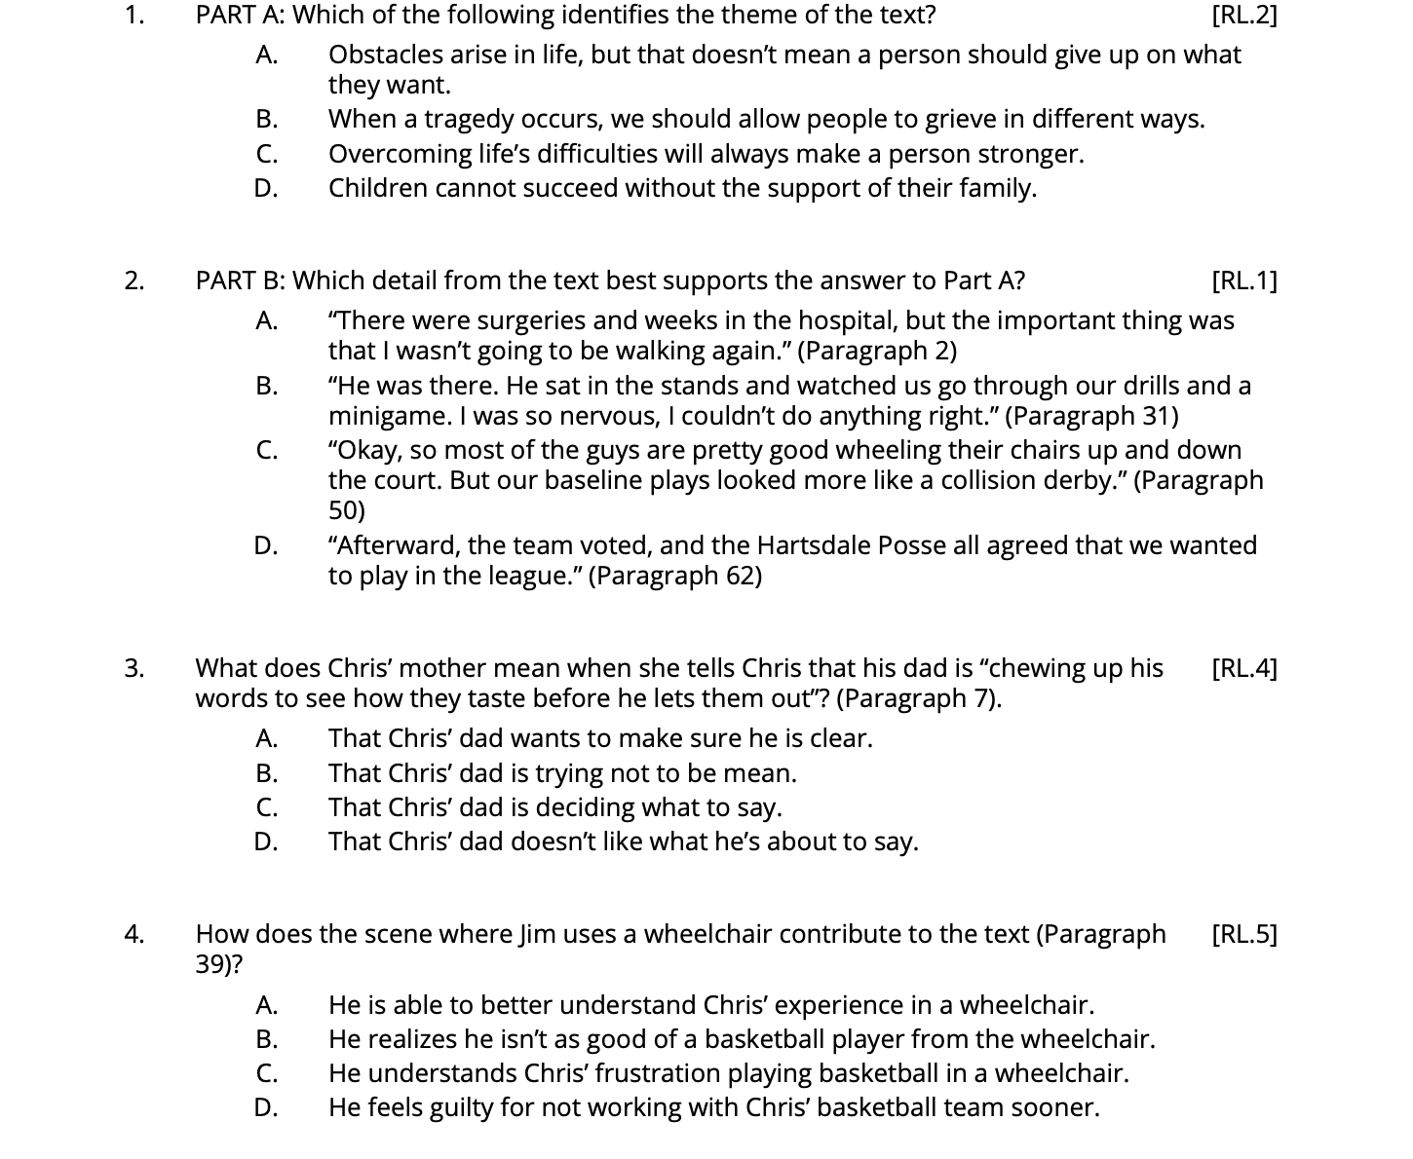

Directions: For this second set of questions 1-4, select the best answer choice based on “A Quick Note on Getting Better at Difficult Things” by Ta-Nehisi Coates.

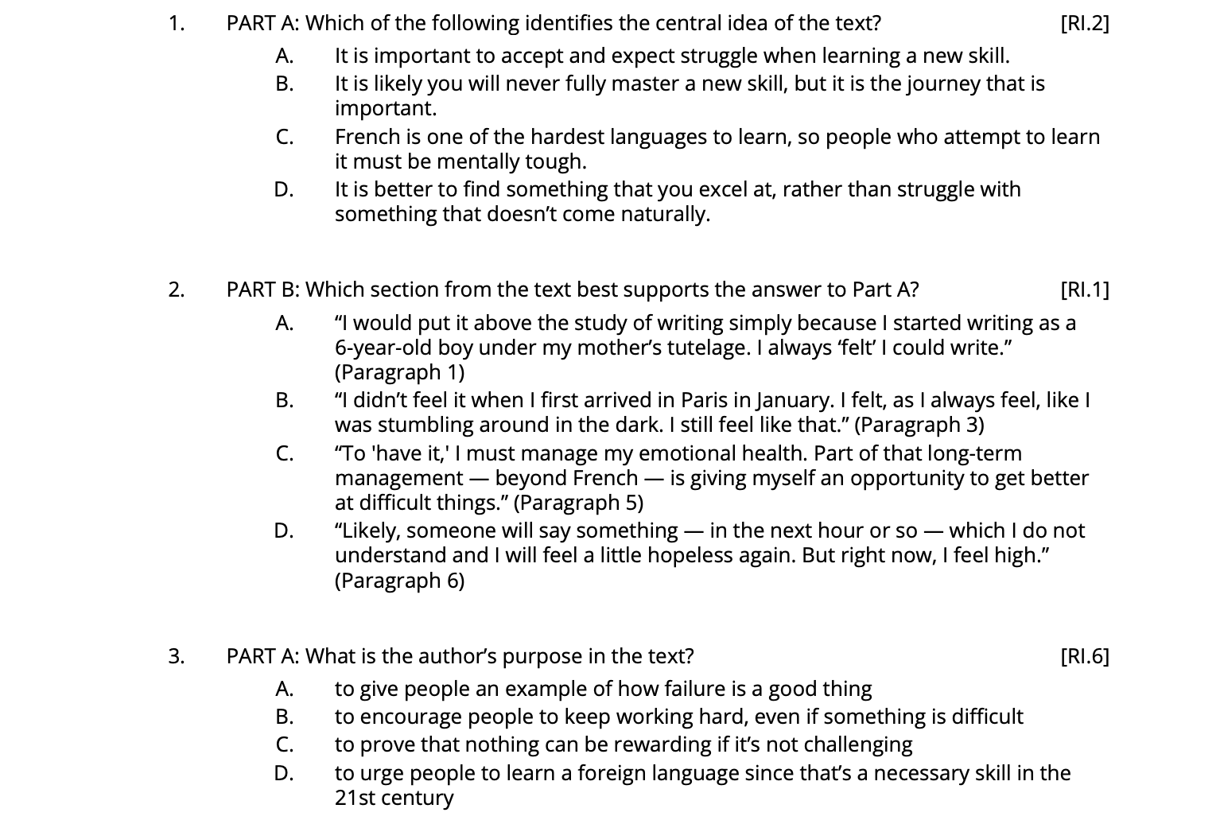

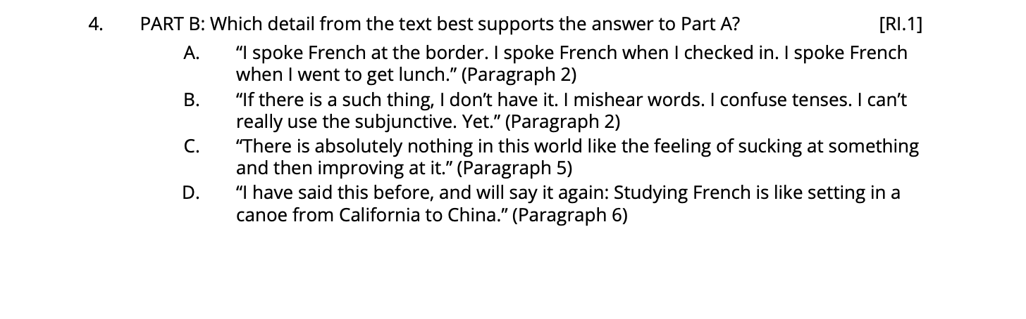

Section Three: Discussion and Writing

1. Have you ever tried to do something that didn’t come naturally easy to you? (Examples: a sport, a subject in school, learning a new language, etc.) What was your experience like? How does this experience relate to what the author discussed in “A Quick Note at Getting Better at Difficult Things?” Feel free to keep writing on a separate sheet if needed!

__________________________________________________________________________________________________________________________________________________________________________________________________________________________________________________________________________________________________________________________________________________________________________________________________________________________________________________________________
__________________________________________________________________________________________________________________________________________________________________________________________________________________________________________________________________________________________________________________________________________________________________________________________________________________________________________________________________

2. Research the words adversity and perseverance using a dictionary or online web search. How does adversity and perseverance serve as themes in both “Sometimes a Dream Needs a Push” and “A Quick Note on Getting Better at Difficult Things?” Feel free to keep writing on a separate sheet if needed!

__________________________________________________________________________________________________________________________________________________________________________________________________________________________________________________________________________________________________________________________________________________________________________________________________________________________________________________________________
______________________________________________________________________________________________________________________________________________________________________________________________________________________________________________________________________________

Section Four: Lessons for Life

Think back to the years you spent in elementary school. I bet you can think of lessons in math, reading, science, social studies, and more that you learned! While you learned many lessons in these core subjects, I bet there were probably some life lessons that you learned in the mix.

As you reflect on those years, think about how much you grew as an individual because of all that you learned, discovered, and encountered. In this section, you will reflect on a life lesson you learned in elementary school that you will carry into middle school. Why is this lesson important and how will you use it to help you navigate through middle school?

Your response should include an introduction, at least 1 body paragraph, and a conclusion.

Here are some sentence starters with an example to help:

- In elementary school I learned that it’s okay to ask for help when I need it. (Choose your own lesson)
- I learned this when… (Discuss what happened)
- This lesson will be helpful in navigating middle school because… (Elaborate on how this lesson will help you in middle school)

__________________________________________________________________________________________________________________________________________________________________________________________________________________________________________________________________________________________________________________________________________________________________________________________________________________________________________________________________________________________________________________________________________________________________________________________________________________________________________________________________________________________________________________________________________________________________________________________________________________________________________
____________________________________________________________________________________________________________________________________________________________________________________________________________________________________________________________________________________________________________________________________________________________________________________________________________________________________________________________________________________________________________________________________________________________
____________________________________________________________________________________________________________________________________________________________________________________________________________________________________________________________________________________________________________________________________________________________________________________________________________________________________________________________________________________________________________________________________________________________
______________________________________________________________________________________________________________________________________________________________________________________________________________________________________________________________________________________________________________________________________________________________________________________________________________________________________________________________________________________________________________________________________________________________________________________________________________________________________________________________________________________________________________________________________________________________________________________________________________________________________________________________________________________________________________________________________________________________________________________________________________________________
__________________________________________________________________________________________________________________________________________________________________________________________________________________________________________________________________________________________________________________________________________________________________________________________________________________________________________________________________________________________________________________________________________________________________________________________________________________________________________________________________________________________________________________________________________________________________________________________________________________________________________

