NEWS AND ANNOUNCEMENTS
Ali Dogan receives the
Departmental Outstanding
Teaching Award, May 2015

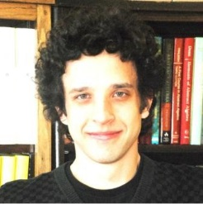
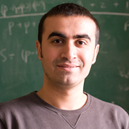

Ali Dogan and Kamil Popielarz
are the recipients of the Dr. Ralph Faudree Award in Mathematics, 2015
Nominees to the Dr. Ralph Faudree Award in Mathematics: Ali Dogan; Merve Kester; David Lewis; Kamil Popielarz; Julian Sahasrabudha; Richard Snyder and Yury Sokolov
Mathematics Research Day: April 30. Schedule of talks and abstracts are available here.
Nominees to the Outstanding Teaching Award: Kusi-Appiah Akwasi, Ali Dogan, Richard Johnson , Stephen Smith.
Awards Ceremony and get-together: May 8 at 4:00pm.

