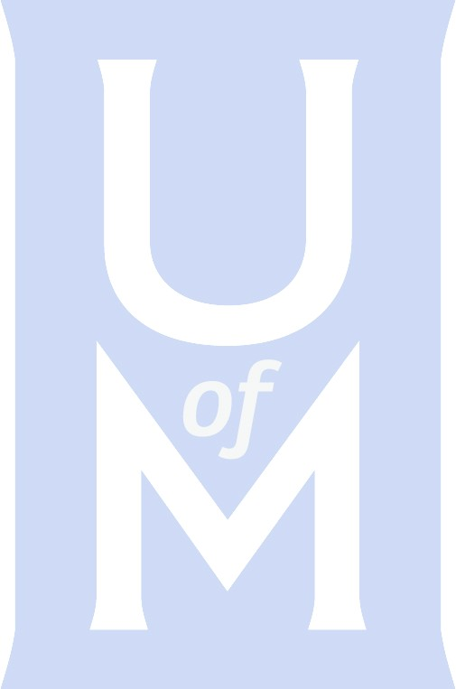
SoM Acceptance Letter Sample
Dear Directors,

Thank you so much for your continued support of the University of Memphis Honor Band. This event happens because of your backing, and for that, we are truly grateful!

Based on your submissions, we are accepting the following students:

(List of students)

Please go to the following link to complete your payment for your participating students. You may pay via credit card, or you may choose the “invoice” option to bring a check when you arrive on Thursday, February 3. The cost is $40 for each student, which covers their dinner on Friday evening. Link to make payment: XXXX

If you have any cancellations, please notify us before January 28 so that we can prepare for all participating students.

Placement auditions will begin on Thursday, February 3 at 3:00 pm. In order to have everyone heard on time please arrive before 3:00 pm. For auditions, students will be asked for a prepared selection of their choice (All-West music, etudes, and solos are appropriate), scales and sight-reading.

We would like to invite you to a luncheon on Friday, February 7 at 11:30 am. Please rsvp to XXX@memphis.edu. It is always a wonderful time to connect with our guest clinicians and other band directors.

The 2022 Honor Band Schedule is attached. Please do not hesitate to contact us at 901.678.XXX, if you have any questions.

Thank you!

XXXX

Rudi E. Scheidt School of Music
The University of Memphis
123 Music Building
3775 Central Ave
Memphis, TN 38152
901-678-2541
memphis.edu/music/

