Captain David Neal
Professor of Naval Science, Mid-south NROTC Consortium

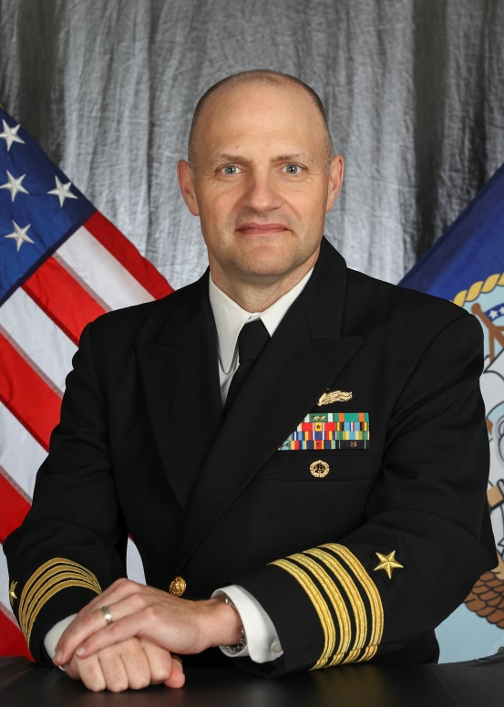
CAPT David Neal received his commission from Officer Candidate School in 1995. After completing his Nuclear Power training and Surface Warfare Division Officer School in Newport, RI, he served as a shift officer and Machinery Division officer on the USS Harry S. Truman (CVN 75).

Subsequent sea assignments have been aboard the USS Elrod (FFG 55) (First Lieutenant), the USS Harry S. Truman (Reactor Training Assistant), the USS Wasp (LHD 1) (Training Officer), and the USS Harper's Ferry (LSD 49) (Executive Officer). He also completed an individual augmentation assignment as a liaison officer to Combined Task Force 150 located in Manama, Bahrain.

CAPT Neal’s shore assignments included Deputy Force Nuclear Propulsion Officer for Commander Naval Air Forces, Pacific, in San Diego, CA, Masters Education from the Naval Postgraduate School in Monterey, CA, and Joint Professional Military Education at the Army Command and General Staff College in Fort Leavenworth, KS.

CAPT Neal served as Executive Officer and Commanding Officer of Navy Recruiting District Atlanta. Following his command tour, he served as the Assistant Reactor Officer in the USS Abraham Lincoln (CVN 72), overseeing the ship’s completion and transition from her mid-life Refueling Conversion and Overhaul (RCOH).

He currently is the Professor of Naval Science and Commanding Officer of the Naval Reserve Officer Training Mid-south Consortium including The University of Mississippi and The University of Memphis.

CAPT Neal’s awards include four Meritorious Service Medals, three Navy and Marine Corps Commendation Medals, the Navy and Marine Corps Achievement Medal, and various other unit and service awards. He is originally from Hampton, AR, and is a graduate of the University of Arkansas with a Bachelor’s of Science in mechanical engineering and the Naval Postgraduate School with a Master’s of Science in mechanical engineering. His wife and three children reside in Collierville, TN.

