  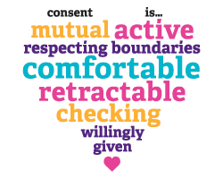
    - Thursday, November 19, 2015
  Community Conversation on CONSENT.
  A special free multi-campus training event for memphis-area students and youth to address and understand CONSENT.
  Hosted by the Memphis Sexual Assault Kit Task Force, Memphis Says No More, Memphis Area Women’s Council, and The University of Memphis.
  The University of Memphis,
  University Center, River Room
  7pm-9pm
  C__
  You don’t want to miss this event! Special guests from Men as Peacemakers will lead the conversation.
  FREE Event!
  FREE Parking in the Zach Curlin Garage with student ID!
  The University Center, River room
  499 University
  Memphis, TN 38152
  For further information or to reserve space-email dchubb@memphiswomen.org

