Defensive Driving Courses
DDC4 & DDC8
(U of M Millington Campus)

IMPORTANT INFORMATION – PLEASE READ

YOU MUST BE ON TIME TO CLASS. The doors will be locked after class starts, and you will not be admitted. You will not be eligible for a refund or for paying the class change fee. In order to take the class, you will have to re-register and pay the full fee.

BRING A PEN OR PENCIL. You will need it.

YOU MUST ATTEND THE FULL CLASS IN ORDER TO GET YOUR CERTIFICATE. Certificates will not be provided for partial attendance.

YOU MUST HAVE A PHOTO ID IN ORDER TO BE ADMITTED TO CLASS. You will not be allowed to attend the class without proof of identification, and you will not be eligible for a refund or for paying the class change fee.

LOCATION
The class will be held at the Millington Center, located on 6500 Navy Road. Please see the map/directions attached for specific directions.

REFUNDS
We do not provide refunds for Defensive Driving, but your registration fee can be applied to a future section if you are not able to make the section for which you initially registered. However, you must notify the office at least 48 hours in advance of the class if you wish to reschedule. You will be assessed a $10 fee for rescheduling. If you must reschedule more than one time, you will be assessed the full class fee.

If you have questions, please contact our office Monday through Friday, 8 AM to 4:30 PM at 901.678.6000. The phones will not be answered outside business hours.

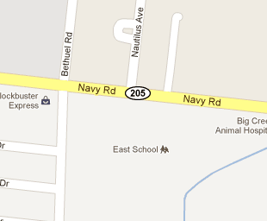

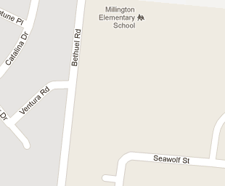

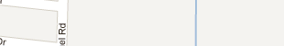

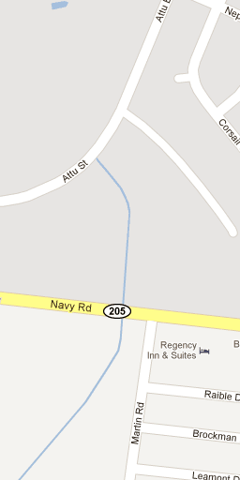

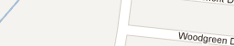















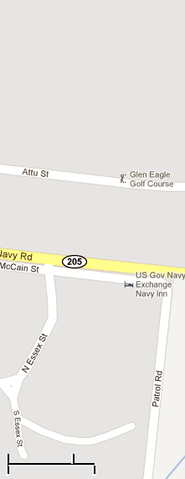



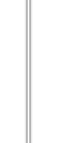





6500 Navy Road, Millington, TN 38053

