Society of Physics Students T-Shirt Contest!
Winner receives free T-Shirt!
- Must fit within front and back torso space
- Must have a Physics theme
- Ink and color of shirt discussable
- Must mention Society of Physics Students and University of Memphis on it

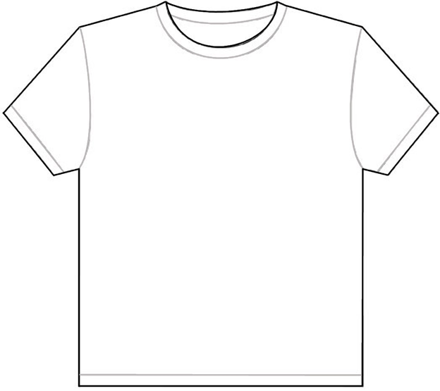

EXAMPLE:

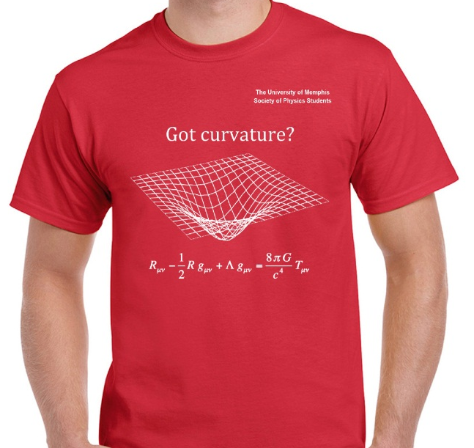

Contact: Catherine Boatwright at cmbtwrgh@memphis.edu

