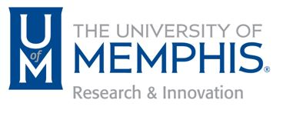

University of Memphis Research Council
Meeting Agenda
May 2nd, 2019
2:00 – 4:00 p.m.
UC Senate Chamber

2:00 p.m. Call to Order and Opening Remarks from Dr. Dhaliwal

Consideration of Minutes – February 6th, 2019

Division News and Upcoming Initiatives

Task Forces Updates/Reports

- Update Engaged Scholarship (Dr. Dhaliwal)
- New Task Force: Research Centers, Institutes and Labs (Deborah Hernandez)
- Council Bylaws (Leader, John Evans)
- Research Policies: Sponsored Programs, Grants, Contracts & Agreements
(Leader, Alfred Hall)
- Strategic Research Plan (New Leader, Brian Waldron)

Open Forum / Other Business

4:00 p.m. Adjournment

