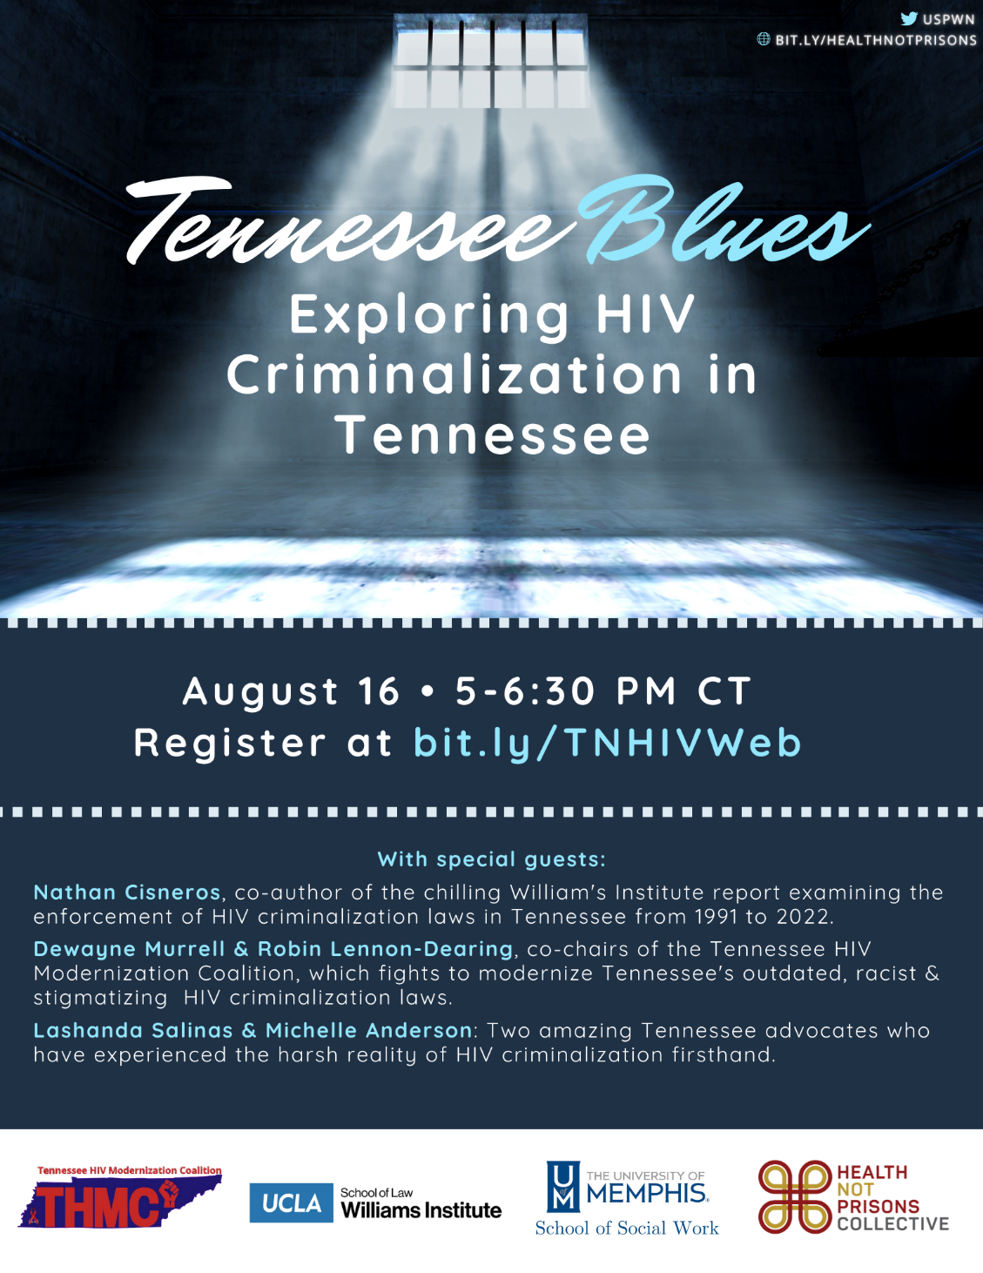
Tennessee Blues: Exploring HIV Criminalization in Tennessee
In anticipation of Southern HIV/AIDS Awareness Day on August 20th, this webinar will explore the disparate impact that HIV criminalization has on Black women in Tennessee. We will have special guests from The Williams Institute, who just released a groundbreaking report on the impact of HIV criminalization in Tennessee as well as guests from the Tennessee HIV Modernization Coalition.
Join us on August 16th from 5-6:30 CT/ 6-7:30 ET for this important conversation and find out how you as a Tennessean can engage more in the work to end HIV criminalization in Tennessee.
Time: Tuesday, August 16, 2022 at 5:00 PM (Central Time)
https://bit.ly/TNHIVWeb

