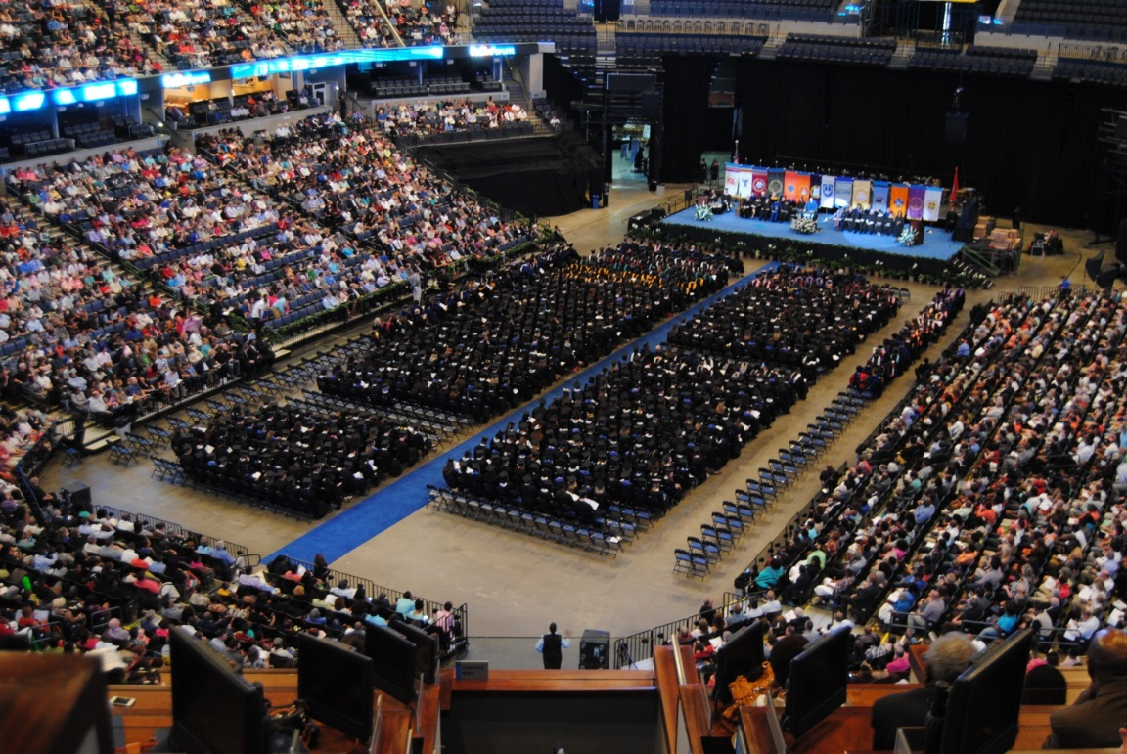
Achieve Your Academic Goals with Support from SHS

The Students Helping Students Program:

‘Response to Intervention’ in Higher Education

What is Students Helping Students?
Students Helping Students, SHS, is a Tennessee Board of Regents grant funded project that began in the 2014-2015 academic school year. Undergraduate students are assessed through reading, writing, study skills, and social emotional screeners. SHS features discipline specific individual or group mentoring provided by Masters-level social work students to at-risk undergraduate social work students. Undergraduate students who participate in the program receive screenings in writing skills, organization skills, study skills, stress, and social emotional support needs. If deficits are identified, the students are offered individual and/or group programming tailored to the student’s specific needs. Continuous assessments are conducted to ensure that the students benefit from the programming as well as that programming only continues until the student’s needs are met. Weekly group or individual meetings offer an interactive atmosphere for this 12 week program modeled after the RTI instructional process.
Program Goals
- Improve retention rate
- Accelerated progression to graduation
- Improve rates of progression to the Masters of Social Work program
- Increase undergraduate students’ writing skills, reading fluency skills, and study skills
- Reduce undergraduate students’ stress and increase coping skills

Referral Process
- Self-referral: email us or come by to set up an appointment for a screening
- Advisors: Advisors have the ability to refer any student they feel would benefit from SHS services

Groups and Individual Sessions

SHS uses a 12 week curriculum that focuses on educational skills and social emotional skills.

Current Program Findings
The study participant’s results indicated success in the short-term goals of improved writing skills, study skills, reading fluency, coping skills, and reduced stress. Additional data identifying the program’s effectiveness and the long-term goals of improving retention and accelerated progression to graduation, and improved rates of progression to the master’s program are currently being gathered.
Current Graduation Statistics
- Currently, only 55.7% of college students who enter four year institutions graduate within six years (Ginder & Kelly-Reid, 2013).
- Without adequate preparation and supports, students are at risk for drop out or delayed graduation
- One study of attrition found that colleges and universities collectively lose $16.5 billion in revenue due to attrition (Raisman, 2013).
- Six-year graduation rates for African American and Latino students are only 37.4% and 48.3% respectively (Ginder & Kelly-Reid, 2013).
- Dennis, Calvillo, and Gonzalez (2008) found that low social support, low self-confidence, low commitment to school, or a history of low achievement contribute to risk for ethnically diverse students.
- In a study of African American college students at a traditionally white university, Schwitzer, Griffin, Ancis, and Thomas (1999) found that students experienced a sense of underrepresentedness, direct perceptions of racism, and hurdles around approaching faculty.
- The study sought to use the RtI model to address the academic and social emotional needs of undergraduate students and improve retention, progression, and graduation rates.

Significance to Social Work

This study represented both a significant contribution to knowledge and a potential solution to the practical problem of college student retention. This pilot study is conducted with social work students. Social work majors are an ideal population for piloting such an intervention because they are a diverse group of students with many risk factors for drop out. Of the current social work majors at the University of Memphis, 84 percent are non-traditional age (mean 29.5), 76 percent are African-American or Latino, and 90 percent are women (Office of Institutional Research, 2013a). The average ACT composite score for new social work majors over the last three years was 19.12 compared to 22.24 for the entire University. The mean family income for new social work majors was $48,299.01 compared to $75,614.40 for the entire University (Office of Institutional Research, 2013b).
Faculty
Gregory Washington, Principle Investigator (Project Director)
Susan Neely-Barnes, Co- Principle Investigator
Susan Elswick, Co- Principle Investigator
Robin Lennon-Dearing, Co- Principle Investigator

Contact Us
Office: Browning 111 (please email for office hours as they change each semester)
Or
Email: studentshelpingstudents@memphis.edu



