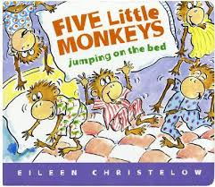
This book is a story that takes the readers on an amazing ride of what bedtime looks like in the home of five monkeys and their mama. It allows the readers to see the monkey’s routine such as taking a bath, brushing their teeth, and putting on their pajamas. This book creates an excellent way for parents to work on the child’s recognition of letter, rhyming, fluency, and cardinality.
FIVE LITTLE MONKEYS JUMPING ON THE BED
By Eileen Christelow

Video of book: https://www.youtube.com/watch?v=kNKtHXcJ5xs

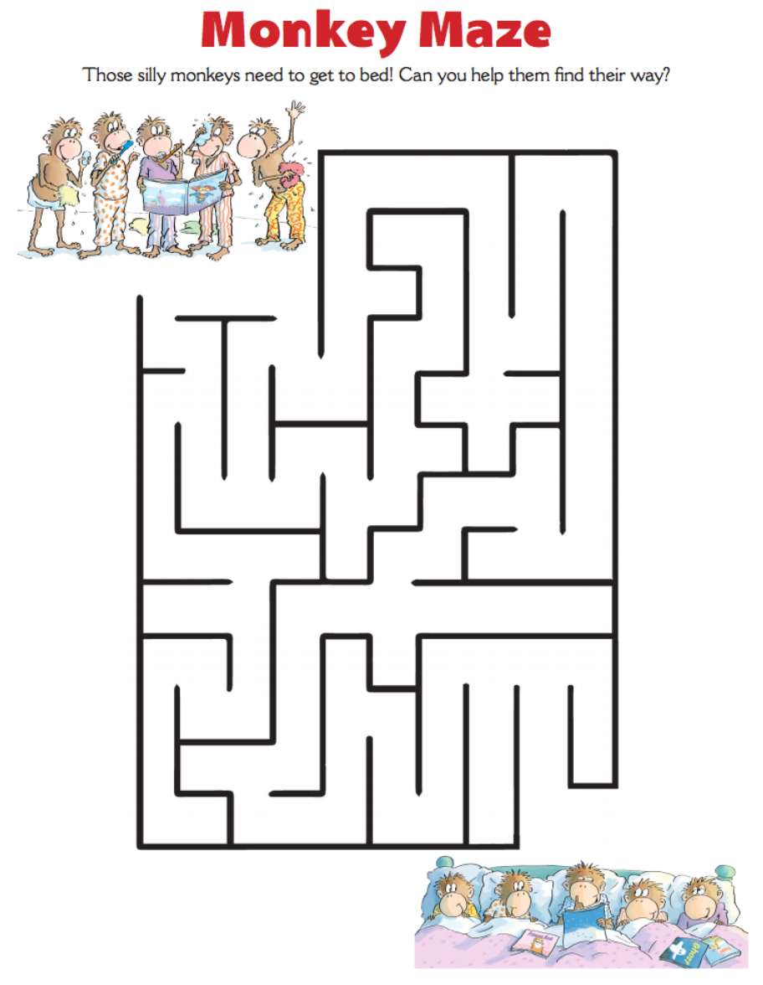
LET’S BEGIN: Start of by asking your child what was learned at school that day. Read Five Little Monkeys Jumping On the Bed to your child. After reading the book, discuss the number of monkeys in the book (have them count it out to you). Then ask your child what letter monkey begins with. Next have your child name things that start with the letter M and discuss each one. Now reread the book and have your child read it with you if they can. After reading, have your child point to things and items in the home that begin with the letter M. Finally complete the activities below.

Activity Time: These silly monkeys have a hard time getting to bed! Can you help them find their way to their way by bedtime?
Activity Time: Monkey’s need it to be quite to sleep and so do you! Print out the sign below and put it on your door to let your family know you are sleeping! You can also make your own similar to this!
