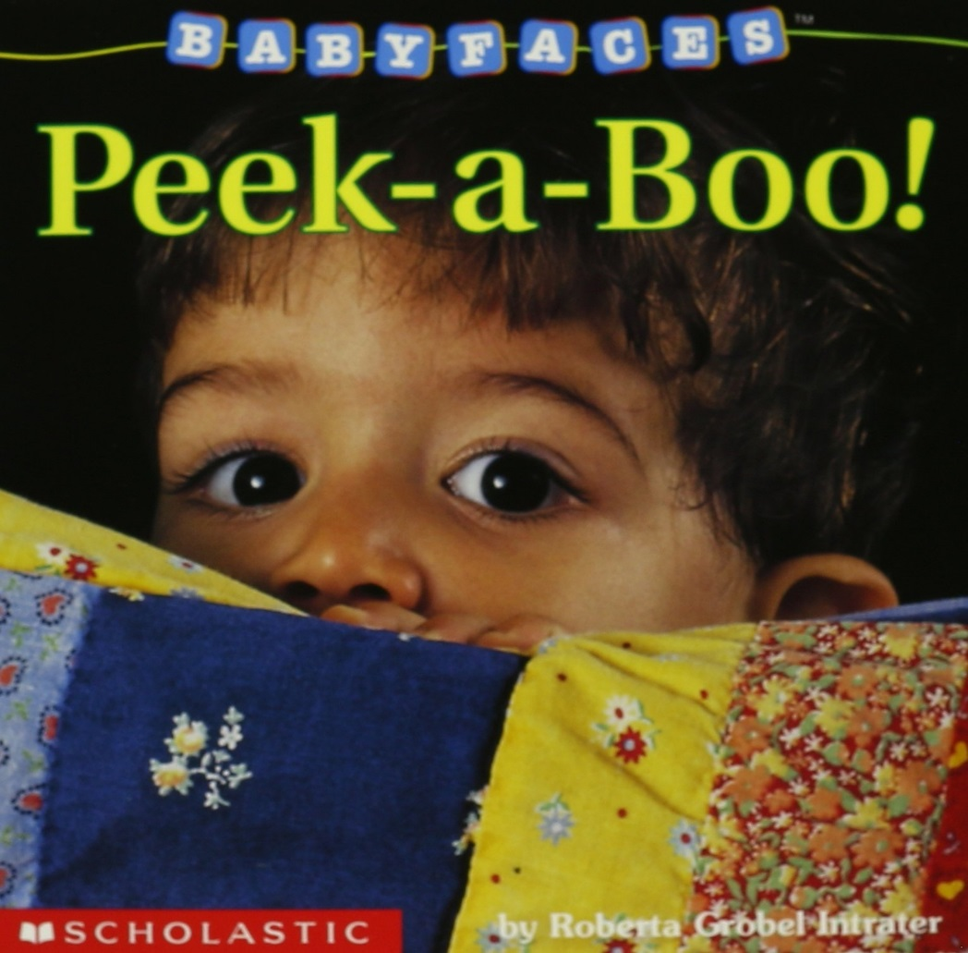
Baby Faces: Peek-a-Book
By: Roberta Grobel Intrater
A book of different baby faces showing many feelings with simple words describing the emotion. This book also shows the faces of babies of different children and different emotions. Each page is a close up of a baby face with a black background and colored border. The simple text illustrating the emotion of the pictured baby helps the parent to discuss emotions with their child. This is an excellent book for introducing emotions to young children.

Video: https://youtube.com/watch?v=3d0EtRXQjEY
LET’S BEGIN: Read Baby Faces: Peek- a Book to your child. After reading the book talk about the different emotions with your child and the pretend to show the emotions shown in the book and watch your child’s reaction. Parents should allow their child to participate in the reading experience, even if they can’t read. Let them turn the page. Ask them what is on the page. Point to the word they identify.
Activity Time: When you read to your baby, don’t just read the words. Talk about the pictures. Describe what is going on. Hold a book upside-down and talk about how you can’t read it. Before you begin a book, look at the cover and think about what the book is about. Answer your baby’s babbles by repeating them and then adding a new sound. Try singing too. Songs and rhymes help children learn similar words based on their sound. Learning nursery rhymes is an important literacy skill.
Mirror Activity: Sit with your child in front of a mirror. Give your child a few minutes to notice him/herself. Let your child touch the mirror with their hands and mouth. Let them do this for a few minutes. Afterwards, make faces like; happy, sad, excited, etc. at the mirror and tell your child what kind of faces you are making. You can also say things like I see you in the mirror and look at your great smile. You want to make sure to talk back to your child’s babbles to build their vocabulary and identify language.
Last Activity- Family Puppets:

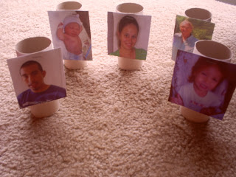

It is so important for your child to be able to recognize family members faces. What a neat way for your child to identify family members and for toddlers to use them in pretend play. Staple or tape pictures to toilet paper rolls. If you are worried about your little one ripping off the pictures, use packaging tape and cover the roll (bending the picture around the tube).

Other Ideas:
Ask your child, “Where is ____?”.
Sort the tubes into two piles, boys and girls.
Count the tubes.
Hide the tubes and identify the person on it when you find it.
Make it a listening activity. Can you put Dad first? Mom second? Grandma third?
Put a piece of paper in between each tube and stack them to make a tower.

